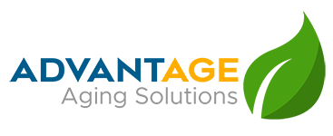
Your Local Leaders in the Aging Network
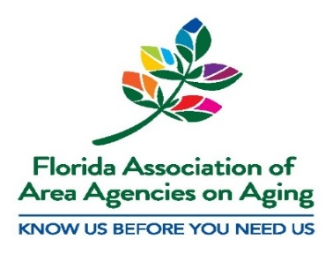
Who We Are
Created by the federal Older Americans Act of 1965, we are one of eleven Area Agencies on Aging (AAA) in Florida and we members of a large national network of over 615 Area Agencies on Aging. The Florida Area Agencies on Aging (F4A) are also Aging and Disability Resource Centers, established in Florida Statute Chapter 430. Designated by the Florida Department of Elder Affairs (DOEA), each Area Agency on Aging in Florida is a local, private nonprofit organization serving a distinct region. The Area Agency on Aging for North Florida, Inc. (AAANF) d/b/a Advantage Aging Solutions serves fourteen North Florida Counties which include: Bay, Calhoun, Franklin, Gadsden, Gulf, Holmes, Jackson, Jefferson, Leon, Liberty, Madison, Taylor, Wakulla, and Washington.

Roles and Responsibilities
As Area Agencies on Aging, we are each responsible for:
- Identifying the needs of older adults and caregivers in our regions.
- Developing plans to address the needs.
- Competitively procuring local service partners to deliver home and community based services such as congregate and home delivered meals, homemaker, personal care, and respite. The AAANF currently contracts with eight Community Care for the Elderly Lead Agencies and 10 Older Americans Act service providers as a result of contract awards following our 2021 RFP process.
- Ensuring tax dollars are spent wisely, which includes:
- Providing training and assistance to the providers.
- Monitoring our providers’ programs and budgets.
- Ensuring funds earmarked for senior services are of high quality and spent appropriately and effectively.
- Serving as advocates for the older adults living in our service area.
As Aging and Disability Resource Centers, we each:
- Operate local Helplines staffed with certified, trained professionals who provide vital information and resources to older adults, persons with disabilities and their caregivers so they can live and age with independence and dignity.
- Screen and assess people for the various programs for which they may be eligible, often connecting them to crucial resources they were not aware existed.
- Manage the Assessed and Prioritized Consumer List for various DOEA programs, ensuring those most frail and in need receive the services as funding is made available.
- Assist clients through the complicated process of obtaining benefits for which they are eligible.
Why Area Agencies on aging are essential
- We are the Department of Elder Affairs’ (DOEA) privatized regional partners which allows state mandated work to be accomplished at the local level efficiently and effectively.
- Our local perspective and focus mean we understand the local needs that can be matched with the local resources.
- Our area plans are tailored to the needs of our region resulting in local oversight, rapid response and reliable accountability.
- We are efficient and effective resulting in:
  - streamlined access to care and support for the hundreds of thousands of older adults, persons with disabilities and their caregivers,
  - efficient use of funding for direct services while minimizing administrative costs – on average, area agency on aging administrative cost is 5.6%.
Why Area Agencies on Aging are Important
The eleven Florida Area Agencies on Aging and Aging and Disability Resource Centers
- Are here when there is an emergency or disaster, helping with preparations as well as aftermath response. This includes hurricanes, tornadoes, pandemics and more. As the local leader for all issues affecting our aging population, we partner with others in our communities to respond quickly and appropriately, including on-site assistance at Disaster Recovery Centers, partnering with Emergency Operations Centers, delivering meals and water and supplies, and more.
- We leverage local resources and the relationships with our community partners to meet and often exceed what is needed so the greatest number of older adults and caregivers can be served.
- Because we can promptly respond to local constituents’ requests for assistance, we bring dignity, empowerment and independence to the older adults in our lives and communities.

For more information or constituent assistance, please contact the Elder Helpline:
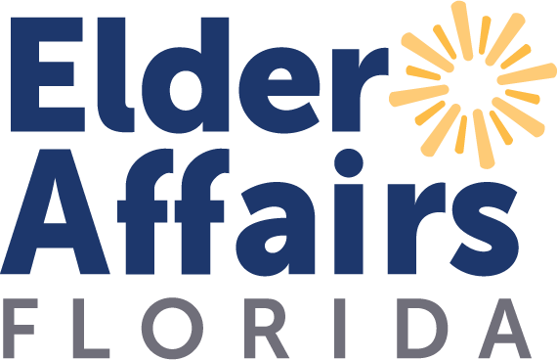
1-866-467-4624 or Statewide at 1-800-963-5337

