HOW TO LOG IN TO ISL SURVEY MONKEY PLANNING GRANTS WEBSITE
Notes: If you run into any issues during the application process or need troubleshooting, please email either our help email at isl@fsu.edu or email ISL’s administrative assistant, Victoria Simon, directly at vsimon@fsu.edu

- Visit https://isl-fsu-sm.smapply.us/
- Under Log In at the Top Right Corner, Click FSU ID and sign in with your FSU ID/password.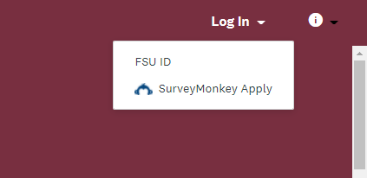
- Click on View Programs once the screen loads. 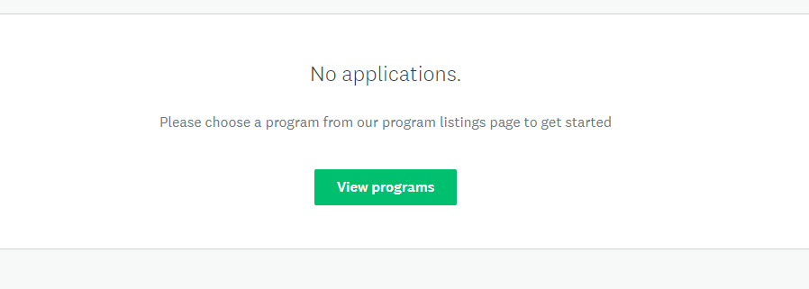
- Click the ‘More’ Tab under ISL Planning Grant 2022-2023 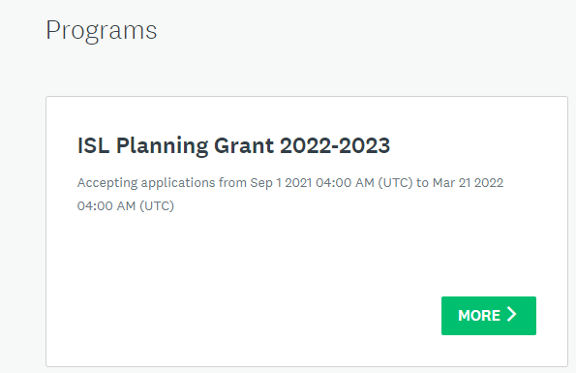
- Click Apply at the right-hand side of the screen. 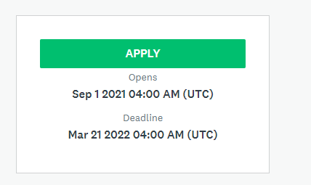
- Your Tasks will be listed in center of the screen. Click Upload Abstract. 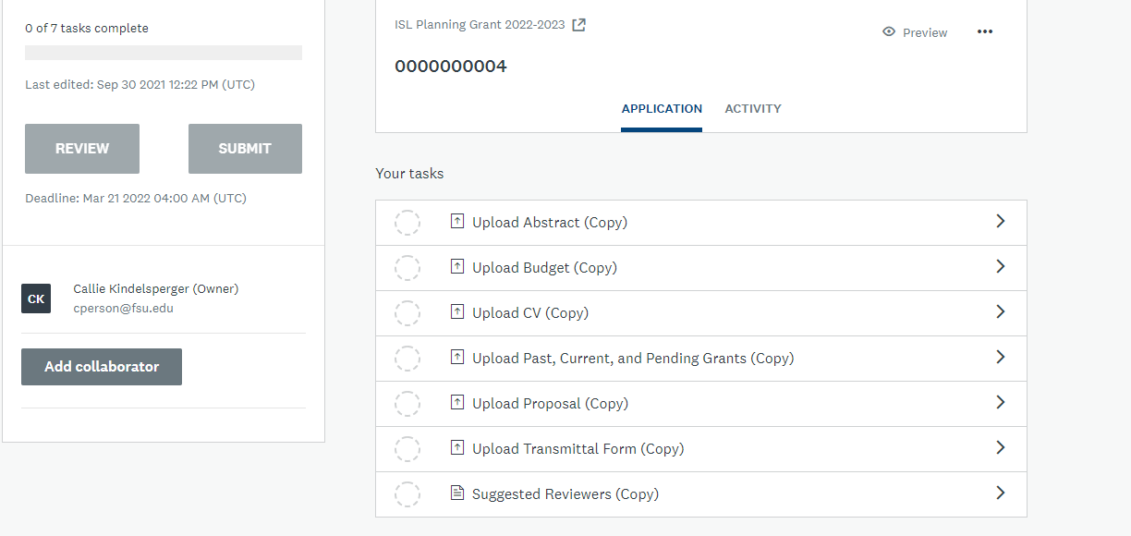
- Click Attach File.
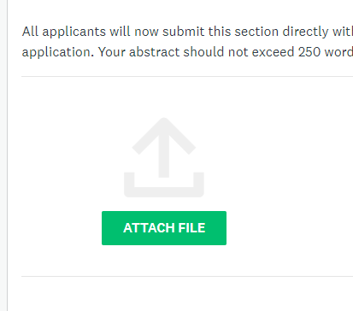
- Once the document as uploaded, click Mark as Complete.

- At the Left Side of the screen, Click Upload Budget. You will repeat the same steps for the rest of the tasks as what I just listed above, but with the appropriate documentation. 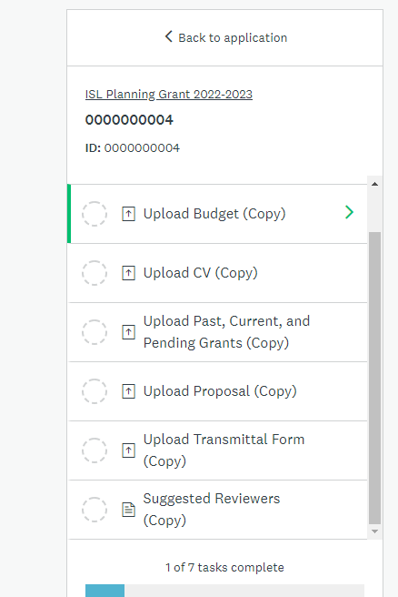
- Once you have uploaded all your required documentation and clicked Mark Complete, you can have the choice to Review or Submit. If you’re ready to Submit, click Submit. 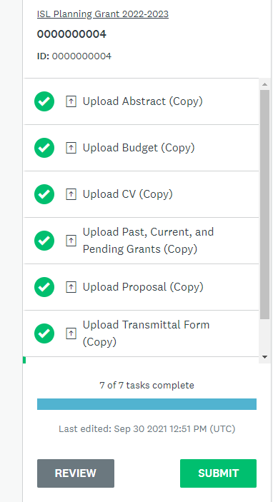
- A Message will prompt you to either Review or Submit. If you’re ready, hit Submit. 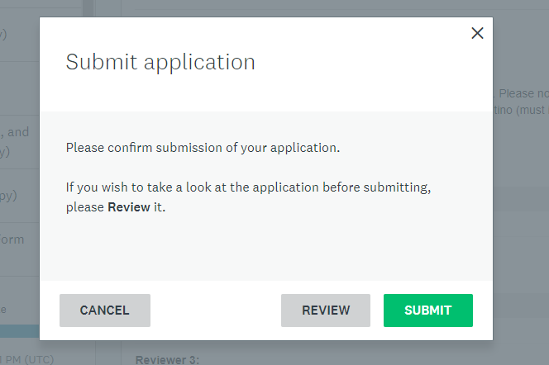
- You have the choice to see your application status once submitted by clicking Go to My Applications. 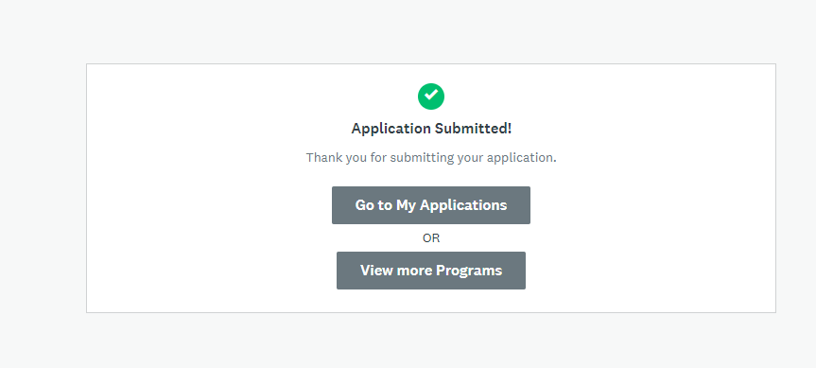
- You can check on the status of your application by clicking ‘View.’ 