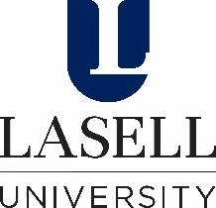
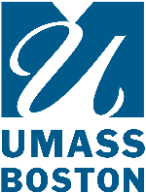
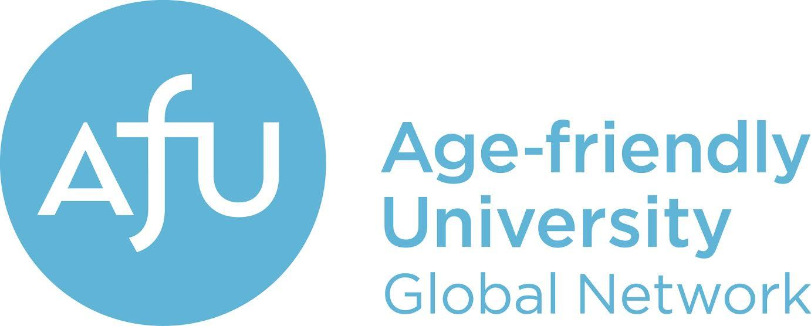

Dear Colleague,
We are writing to seek your input. We recently completed the study, Taking the Pulse of Age-Friendliness in Higher Education in the US Today, funded by the RRF Foundation for Aging. Contributions from diverse campuses provided valuable information about age-friendly practices and perceptions that served as the basis for our new RRF-funded study, Moving from Age-Friendly Principles to Practices in U.S. Higher Education: Strategies to Enhance Learning and Workplace Environments.
This study takes the next step of developing strategies to expand age-friendly campus practices related to three institutional functions the first study identified as high-impact, high-need areas: teaching and learning, personnel, and student affairs. The study will use a focus group methodology that draws on the perspectives of campus administrators, staff, faculty, and older students to develop practical age-friendly strategies.
Participation involves attending a virtual focus group to discuss potential strategies related to one of the targeted functions: teaching and learning (e.g., strategies for engaging faculty to infuse aging content into their course curriculum and increasing pedagogical skills in teaching age diverse classrooms), personnel (e.g., strategies for supporting aging-related needs of faculty and staff), and student affairs (e.g., strategies for supporting the advising needs and career development of age diverse students).
We are asking you for recommendations of faculty, administrators/staff, and older students whom you think would make informative contributions to the focus groups. Participants need not have specific expertise in aging. While such expertise would be useful, we are interested in gathering participants with broader expertise in higher education practices for this study. Participants may also be asked to read some background information prior to participating in the focus group to which they are assigned and to complete a follow-up survey. Participants will receive a $50 gift card for their time and effort.
Please send us the names and contact information for individuals that you think would fit the roles described below. You may submit their names and contact information using this LINK.
We will contact individuals to tell them about the study, include your name as the person who recommended them, and invite them to participate. In addition, if you would like to participate, certainly include your name as well. Please note that we aim to have a wide range of participants from multiple institutions. As such, we may not select all the individuals that have been recommended.
Below are the descriptions of eligibility for each focus group. Thank you for taking the time to recommend qualified participants.

Teaching and Learning Focus Group
Faculty participants should be experienced instructors (5+ years) at the undergraduate and/or graduate levels.
Staff and administrators should have significant experience in instructional support, representing units such as Centers for Teaching and Learning, tutoring programs, academic advising, or similar instructional enhancement programs.
Students can be full-time or part-time degree-seeking nontraditional-age (25+) or older (50+) undergraduate students or graduate students; preferably, student participants would also meet one or more of the criteria for “nontraditional student” as defined by the National Center for Education Statistics, including delayed enrollment into postsecondary education, part-time enrollment, full-time employment, dependents, or GED.
Personnel Focus Group
Faculty participants can represent a variety of disciplines, career stages (recent hires, mid-career, etc.), and position types (e.g., tenure-track, adjunct); ideally, they would have some additional experience with specific personnel-related tasks, such as chairing hiring and promotion committees or participating in formal mentoring programs.
Staff and administrators can also represent a variety of campus units and career stages, but ideally should have experience related to personnel functions, such as aiding with hiring, benefits management, and retirement planning.
Student Affairs Focus Group
Faculty participants can represent a variety of disciplines, career stages (recent hires, mid-career, etc.), and position types (e.g., tenure-track, adjunct); ideally, they should have some additional interactions with student affairs activities, such as experience partnering with career-oriented programming, advising student organizations, or contributing to program recruitment and admissions processes.
Staff and administrators should represent career services, financial aid, admissions, residence life, or similar student-facing units.
Students participants can be full-time or part-time degree-seeking nontraditional-age (25+) or older (50+) undergraduate students or graduate students; preferably, student participants would also meet one or more of the criteria for “nontraditional student” as defined by the National Center for Education Statistics, including delayed enrollment into postsecondary education, part-time enrollment, full-time employment, dependents, or GED.
We are happy to address any questions, and we look forward to collaborating with you as we move forward in this important phase of advancing age inclusivity in higher education and the AFU initiative. Feel free to send your questions or comments to us at: UMass.AFUStudy@umb.edu
Thank you for your time and consideration,
(PI) Nina M. Silverstein, PhD
Professor of Gerontology
John W. McCormack Graduate School of Policy and Global Studies
University of Massachusetts Boston
nina.silverstein@umb.edu

(Co-PI) Susan Krauss Whitbourne, PhD
Professor Emerita of Psychology
University of Massachusetts Amherst
and Adjunct Professor/Faculty Fellow, Institute of Gerontology
University of Massachusetts Boston
Susan.whitbourne@umb.edu

(Co-PI) Joann M. Montepare, PhD
Professor of Psychology
Director, RoseMary B. Fuss Center for Research on Aging and Intergenerational Studies
Lasell University
jmontepare@lasell.edu

(Co-PI) Lauren Marshall Bowen, PhD
Associate Professor of English, College of Liberal Arts
University of Massachusetts Boston
Lauren.Bowen@umb.edu

(Research Assistant) Shu Xu, PhD Candidate
University of Massachusetts Boston
Shu.Xu@umb.edu

