jOHNS hOPKINS aLZHEIMER’S dISEASE rESOURCE cENTER fOR mINORITY aGING rESEARCH

2022-2023 Pilot FUNDING INFORMATIONAL WEBINAR
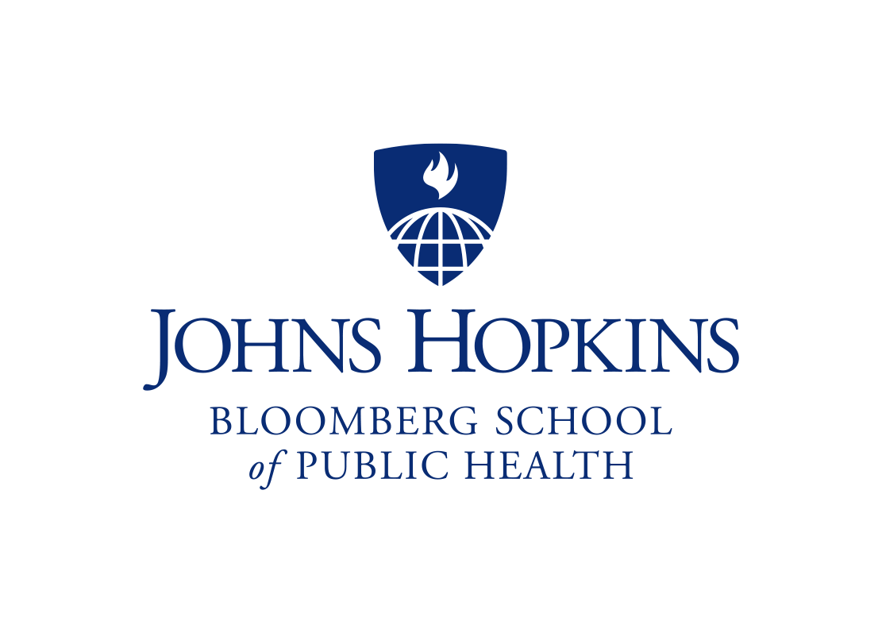  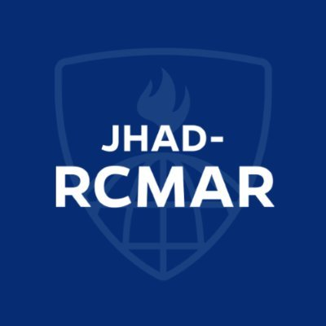 |  | JHAD-RCMAR funds are available to encourage innovative research focused on basic, clinical, psychosocial, or health services aspects of minority aging, Alzheimer’s disease, or related disorders (ADRD) and health disparities.  Join us for an information session to learn about application requirements, eligibility, and funding opportunities.
November 30, 2021 3-4 pm EST
Registration required to attend.
Click Here to register and receive Zoom information.

