**Alzheimer’s Association Interdisciplinary Summer Research Institute 2021**

**Email Toolkit**

*When distributing this message, please adhere to the* [*CAN-SPAM Act*](mailto:https://www.ftc.gov/tips-advice/business-center/guidance/can-spam-act-compliance-guide-business) *and other federal regulations of commercial emails.*

**Subject:** Apply Now | Interdisciplinary Summer Research Institute

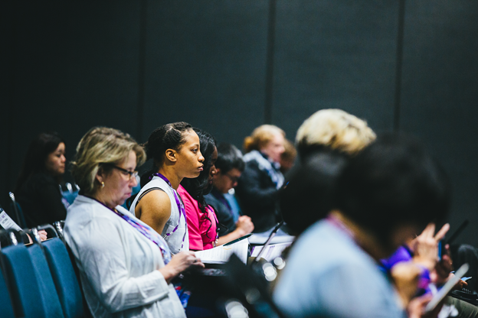

**Advance your career and the future of dementia research.**

The [Alzheimer’s Association® Interdisciplinary Summer Research Institute (AA-ISRI)](http://www.alz.org/summerinstitute) is an immersive, no-cost opportunity for early career researchers in psychosocial care and public health to launch a career in dementia science and accelerate breakthroughs in the field. Join us in Chicago, August 9-13, 2021, where experts will offer diverse perspectives on ground-breaking research through group sessions and individual mentoring.

Applications are due **April 8, 2021.** Twenty-four applicants will be selected for this exclusive experience — attend the AA-ISRI to:

* Gain knowledge of basic clinical and biological aspects of Alzheimer’s and dementia.
* Hone essential research skills and learn about emerging research designs and analytical methods.
* Make connections with leaders and peers in the field.
* Develop a research proposal for Association and NIH funding.

[Learn about the AA-ISRI schedule, faculty and more.](http://www.alz.org/summerinstitute)

Psychosocial and public health postdoctoral students and early career researchers are eligible for the AA-ISRI — individuals from diverse backgrounds are encouraged to apply. Please share this invitation with potential candidates in your network.

[Submit your application now.](http://www.alz.org/summerinstitute)

*This opportunity is supported by the National Institutes of Health under award #1R25AG069678-01.*