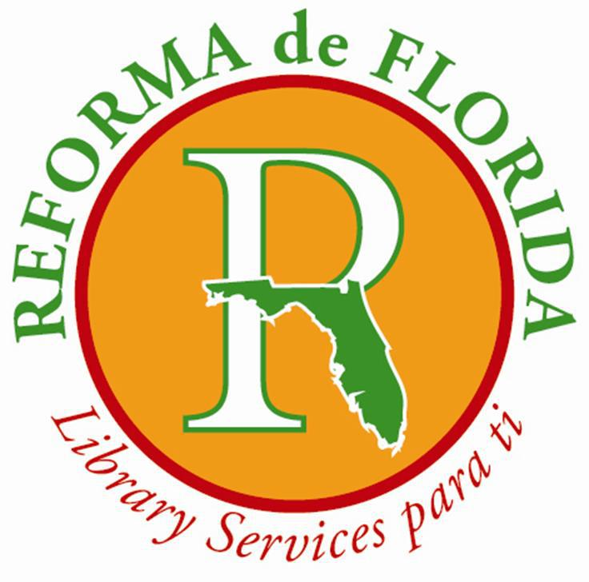

**\*\*2025 CALL FOR NOMINATIONS\*\***

Attention, current members of REFORMA de Florida! Are you looking to energize our chapter with fresh ideas? Are you ready to join a dynamic group dedicated to developing, supporting, and enhancing library services and programs for the Latinx and Spanish-speaking communities in Florida? Do you know someone who could contribute to our mission?

**\*\*WE WANT TO HEAR FROM YOU! \*\***

Take action and nominate yourself or a deserving friend for one of the following Executive Board positions:

\*\***President\*\***

Lead Executive Board and Membership meetings with authority.

Appoint Chairpersons to spearhead key committees.

Serve as the chapter representative on REFORMA National’s Board of Directors.

Represent REFORMA de Florida on the FLA Board of Directors.

Prepare an annual report detailing REFORMA de Florida’s achievements and activities for the annual ALA meeting, and keep REFORMA National informed of chapter events and updates.

**\*\*Vice President/President-Elect\*\***

Step up in the absence or disability of the President, executing all necessary duties.

Actively assist the President and perform additional responsibilities as mandated by the by-laws and the Executive Board.

Chair the Membership Committee and drive engagement.

Keep the President and Secretary updated on new members.

**\*\*Secretary\*\***

Take charge of minutes for Executive Board, Advisory Board, and Membership meetings.

- Ensure that minutes from previous meetings are readily available to all members.

- Handle chapter correspondence efficiently.

- Archive and preserve all REFORMA de Florida minutes and reports for future reference.

**\*\*Treasurer\*\***

Command responsibility for all REFORMA de Florida funds.

Maintain precise records of receipts and disbursements.

Deposit all chapter funds in a bank chosen by the Executive Board without fail.

Deliver an oral or written financial report at each Executive Board and Membership meeting.

Collaborate with REFORMA National and chapter officers to ensure proper collection of membership dues.

Work hand in hand with Regional Delegates to effectively manage funds generated by each region.

**\*\*RESPOND NOW\*\***

Submit your nominations to REFORMA de Florida at [reformafl@gmail.com](mailto:reformafl@gmail.com) between April 1 and April 15, 2025.

Let’s shape our chapter's future together!