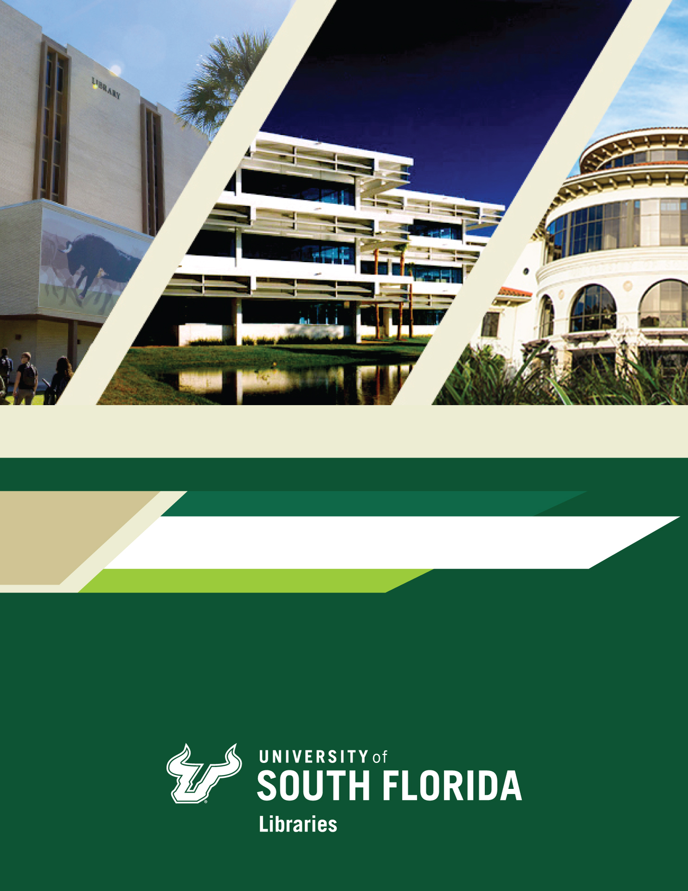
Curator, Digital Collections
lib.usf.edu
USF LIBRARIES – Tampa Campus
Curator, Digital Collections
USF LIBRARIES – Tampa Campus
The USF Libraries serve the University of South Florida, with campuses in Tampa, St. Petersburg, and Sarasota-Manatee. In 1960, USF’s founding president, John Allen, referred to the Library as “the heart of the University,” and we pride ourselves on continuing to be at the center of a highly engaged university community today.

Our collective mission is to inspire research, creativity, and learning, partnering with students and globally recognized faculty to produce meaningful, impactful research. Together, we aim to provide the freedom and resources to create a vision for the future.

POSITION AVAILABLE: Curator, Digital Collections, Tampa campus

POSITION SUMMARY:

The University of South Florida (USF) Libraries seeks a focused and experienced professional to serve as Curator of Digital Collections. This position administers born-digital and digitized digital collections in the USF Libraries Digital Commons @ University of South Florida repository. The Digital Commons, which include nearly 70,000 items from the USF Libraries and its partners, comprises rare and archival documents, photographs, oral histories, sheet music, digital 3-D models, maps, books, serials, and online exhibits. Current, strategic efforts to further develop and enhance the Libraries’ Digital Collections centering on the Florida Environment and Natural History Collections (FLENH).

Under the direction of the Director, Special Collections, the successful candidate will be responsible for coordinating, enhancing, growing, and sustaining digital collections through effective acquisition, processing, description, preservation, promotion, and interpretation of the collection. This includes creating online exhibits, delivering lectures, and creating publications. This position plays a key role in supporting the Libraries’ digital repository, the Digital Commons @ University of South Florida, and ensuring the successful migration of digital collections out of the Libraries’ legacy platforms. An energetic and enthusiastic professional with experience acquiring, using, or promoting digital collections will coordinate and supervise personnel on the Tampa campus and collaborate with key faculty and librarians across the Tampa, St. Petersburg, and Sarasota-Manatee campuses. Detail-oriented candidates who are invested in building high-impact, curated, thematic collections are actively sought. This new position is a 12-month, non- tenure-track faculty position, located on the Tampa campus.

Responsibilities include, but are not limited to:
- Plan, direct, manage, and set strategic priorities and goals for the acquisition, organization, description, display, preservation, promotion, and use of digital collections in alignment with the USF Libraries’ Strategic Directions.
- Oversee and monitor the conversion, migration and reformatting of born-digital, current, and legacy physical media
- Direct staff, volunteers, and/or interns engaged in the digitization, ingest, conversion, migration, organization, description, and preservation of digital collections.
- Design virtual exhibits including writing and editing accompanying program notes
- Work collaboratively, across units and departments, to enhance and expand access to digital collections.
- Establish processes for prioritizing, ingesting, reviewing, and making available collections that directly support the Libraries’ strategic collecting areas.
- Work with the Metadata Team to determine appropriate schema for relevant metadata and provide item and collection descriptions.
- Establish an inclusive vision for the digital collections by fostering diverse and culturally rich collections.
- Evaluate and contextualize existing and new collections to support research and curricular use of digital collections.
- Continuously assess the digital collections program and report on activities relative to the collection, including budget and impact measures.
- Provide reference, research, and library instruction services.
- Direct the maintenance and expenditure of accounts of endowments and/or collection budgets.
- Work with the Assistant Director for Communications & Marketing to prepare promotional materials publicizing collections and exhibits in both print and online formats, including social networks.
- Communicate with external institutions/organizations such as libraries, vendors/dealers, or collectors to address their requests related to the collection(s), including patron digitization requests.
- Prepare periodic reports on activities relative to the collection(s) including budget and statistical summaries of impact measures.
- Maintain an active program of professional development, scholarship, and service in areas of relevant expertise. Engage in research and peer reviewed publications as required for promotion.

Minimum Qualifications:
- Ph.D. from an accredited institution in an appropriate and relevant field, or an ALA accredited degree in library and/or information science.
- Two years as a librarian, curator, or academic with responsibility for at least one of the following: acquiring research collections; the care and maintenance of research collections; facilitating access, use and promotion of research collections
- Demonstrated knowledge of standards and best practices for accessioning, ingesting, converting, migrating, organizing, describing, or disseminating digital assets.
- Demonstrated ability to oversee and coordinate projects and personnel in a collaborative team environment.
- Evidence of professional growth through publication, association activities, or other contributions to the field.

Preferred Qualifications:
- Digital Archives Specialist (DAS) certificate from the Society of American Archivists.
- Strong commitment to interdisciplinary and transdisciplinary education, research, and outreach.
- Substantial experience working with digital asset management, digital repository, and/or digital library systems, such as BePress.
- Demonstrated record of innovation in developing, implementing, or promoting library collections and services.
- Experience designing instructional content and online displays and exhibits.
- Experience with physical and digital archives and special collections.
- Familiarity with digital preservation frameworks and tools.
- Demonstrated initiative in fostering new ideas.
- Ability to build and maintain a positive workplace culture, fostering and contributing to an environment of diversity, inclusion, and accessibility.
- Excellent oral, written, and interpersonal communication skills.

Applications must be submitted through the Careers@USF website, Job ID 29179, and include a cover letter and CV. Please go to www.lib.usf.edu/employment for more information. We are open to all levels of excellence. USF is an equal opportunity, equal access academic institution that embraces diversity in the workplace.

UNIVERSITY OF SOUTH FLORIDA

The University of South Florida is one of Florida’s three preeminent state research universities and is America’s fasted-rising university (U.S. News & World Report, 2021). Founded in 1956, USF is a relatively young university with rich traditions and opportunities for students, academic excellence, groundbreaking and innovative research, and service to our communities.

USF has earned widespread national recognition
for its success in graduating underrepresented minority and limited-income students, at rates equal to or higher than national averages. USF is strongly committed to a culture of equity and inclusion across the institution. These and other core values are captured in the university's five Principles of Community:

EXCELLENCE WITH EQUITY We affirm the value of excellence. Our essential pursuit of truth and
wisdom depends upon fairness and equity. We recognize that individual and collective
excellence entails a responsibility to ensure that every member of our community has the
opportunity to succeed.

DIVERSITY WITH INCLUSION We affirm the value of diversity, individual dignity, equity, and our
common humanity. Diversity of lived experiences, thought, and values enriches our lives and
our whole university community. We seek the intentional inclusion of the broadest possible
range of these perspectives essential to a university with local, state, national, and global
impact.

FREEDOM WITH RESPONSIBILITY We affirm the value of academic freedom and the inherent value
of people's right to express themselves respectfully, freely, safely, and with civility. We reject the demeaning acts of bullying, violence, prejudice, and discrimination as they undermine the
community we aspire to be.

DIALOGUE WITH RESPECT We affirm the value of evidence and seek perspectives to foster
productive communication, dialogue, and constructive disagreement. We listen respectfully and reject language that demeans any member of the community. We embrace differences by
learning through open debate in a spirit of curiosity.

TRANSPARENCY WITH ACCOUNTABILITY We affirm the value of a clear and transparent working and
learning environment that promotes honesty, fairness, and trust. We commit our time, talents, and resources to building a culture of caring that promotes the integrity of our relationships and the
sustainable well-being of the entire community. We are personally responsible, across every level,
for treating each other with respect, candor, and accountability.

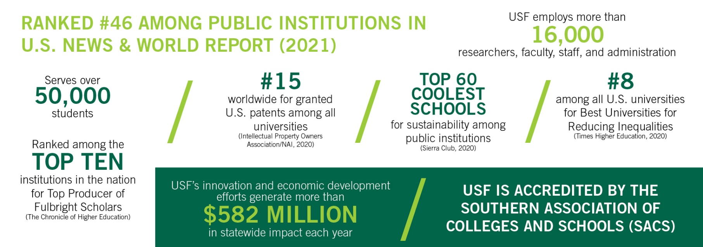
LIFE IN TAMPA BAY

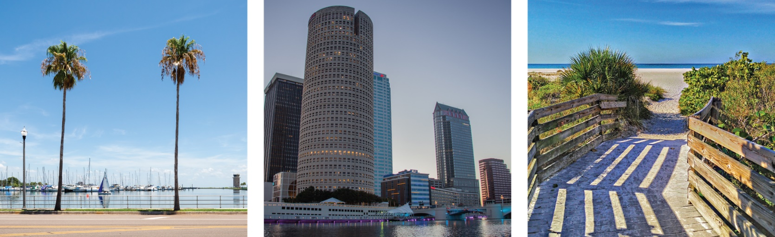

The University of South Florida is located in the Tampa Bay area with campuses in Tampa, St. Petersburg, and Sarasota-Manatee. Situated along Florida’s gulf coast, the Tampa Bay area is celebrated for sunshine, mild winters, world-renowned beaches, miles of beautiful bay views, and a diverse food scene.

In addition to over 165 parks and beaches, Tampa Bay is home to several museums, theme parks, attractions, and music, art, and cultural festivals, including Busch Gardens, Zoo Tampa at Lowry Park, the Florida Aquarium, the Dali Museum, and the John and Mable Ringling Museum of Art. Sports fans cheer for hometown favorites including the three-time Stanley Cup champions the Tampa Bay Lightning (NHL), two-time Super Bowl champions the Tampa Bay Buccaneers (NFL), the Tampa Bay Rays (MLB), and of course our beloved USF Bulls!

Our rich culture is thanks to our diverse communities, particularly our thriving Hispanic population both in the city and at USF. With deep Cuban roots, Tampa is nicknamed, “Cigar City,” as it was once the cigar capital of the world (our Cuban sandwich is pretty famous, too). The Tampa International Airport has ranked best of U.S. airports, and was most recently named in the top 3 by Condé Nast.

Tampa Bay has a vibrant economy, no state income tax, and is 8% below the national average for cost of living. It is home to some of the best healthcare facilities in the U.S., including H. Lee Moffitt Cancer Center and Research Institute (located on the USF Tampa campus) and three hospitals ranked as “America’s Best Hospitals” by U.S. News and World Report.

We welcome you and your family to call Tampa Bay home.

