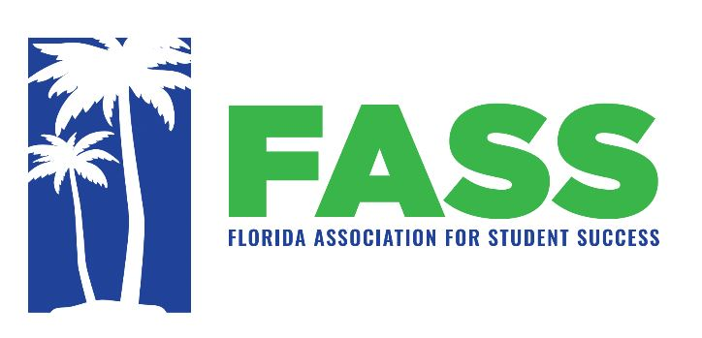

**Conference Presentations**

Florida Association for Student Success Annual Conference

Carlisle Inn, Sarasota, FL October 19 – 20, 2023

<https://myfass.net/>

Below are some of the presenters and presentation titles:

* Mike Sfiropoulos – Director of Academic Affairs, Division of Florida Colleges -*Department of Education Update*
* Kiaira McCoy – Florida Student Success Center, Director – “Florida Pathways Institute: Scaling Pathways throughout the State with Targeted Support.”
* Jeremy Caplan – Keynote Speaker – “The Craft of Creative Pedagogy: Teaching Effectively and Enjoyably” (workshop to follow)
* Dr. Patrick Saxon – National Research Expert – “Research and Graduate Study: SHSU’s HEDL/Developmental Education Doctoral Program”
* Dr. Paul Nolting – National Math Success and Student Retention Expert – “Improve Success: Integrate Self-regulated Learning with Study Skills”
* Julie Pactor & Shannon Dew – “Increasing Library Engagement with a Self-Enrolling Canvas Course”
* Sarah Stuart – “The Powers and Perils of New Tech: How AI is Transforming the Educational and Professional Landscape”
* Patrick McDermott & Shakonda Diggs – “Student Success and Leadership through Civic Engagement after COVID”
* Dr. Paul Nolting – National Math Success and Student Retention Expert – “Round Table Discussions on Current Topics to Improve Student Success – FASS Board Members Will Lead Table Discussion”

|  |
| --- |
|  |