Numerical exploration of the ocean circulation on icy moons
John Marshall
Department of Earth, Atmospheric and Planetary Sciences
Massachusetts Institute of Technology
GFDI/DSC seminar with John Marshall
Wed Oct 18 3:30, DSL 499 4th floor Dirac Building

Subsurface oceans on the icy moons of our Solar System, such as Enceladus and Europa, are receiving increasing attention in the search for extraterrestrial life. It is thus important to understand the dynamics of these oceans and identify circulation pathways and timescales. Here, we use numerical simulations to explore likely ocean circulations if the primary energy source is geothermal heating from below. Codes developed in Julia and deployed on GPUs are used.
We describe the phenomenology of the resulting circulation patterns as the assumed rotation rate and ocean depth is varied. Key non-dimensional numbers are identified, and used to organize our study, informing speculations about the nature of the circulation of real icy moons. Based on best estimates of controlling non-dimensional parameters, we argue that the ocean circulations on Europa and Enceladus are likely to be very strongly influenced by rotation and manifest multiple alternating bands of zonal currents flowing in opposite direction, with distinctly different tropical and extratropical regimes. The likely nature of the small-scale turbulence and convection excited by bottom heating, which energizes the zonal jets, is also described.
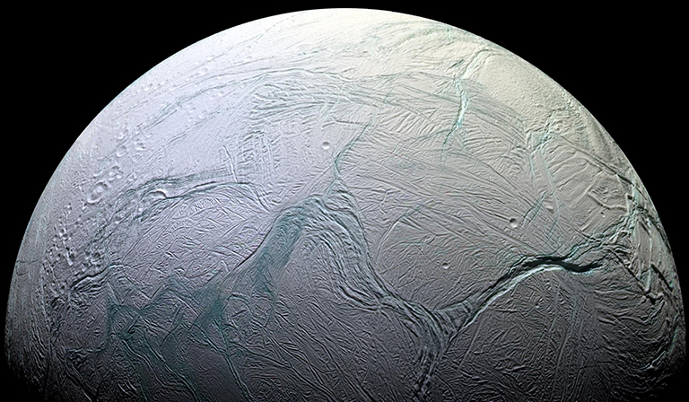
This enhanced color view of the surface of Enceladus, an icy moon of Saturn,
shows much of the southern hemisphere. (NASA)

