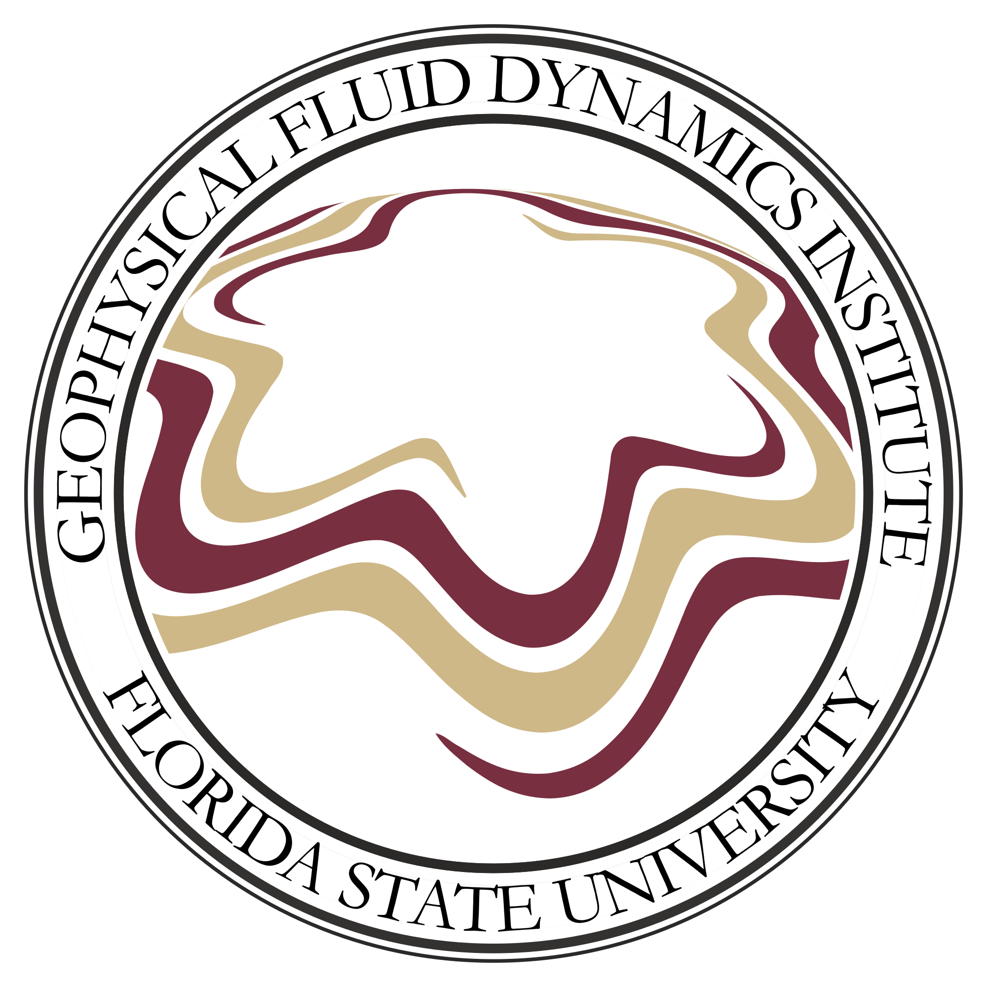GFDI Colloquium
Title
“Climate impact of the Drake Passage opening: lessons from a minimalistic laboratory experiment”

Speaker
Dr. Miklos Vincze
Senior Research Fellow
MTA-ELTE Theoretical Physics Research Group
Eötvös Loránd University Budapest, Hungary

Time and Place
12:00 PM, Tuesday, September 7, 2021
Melvin Stern Seminar/Reading Room – 18 Keen Building
Refreshments will be served at 11:30

Abstract - The differentially heated rotating annulus is a widely studied experimental set-up designed to model mid-latitude circulation in the atmosphere and the ocean. By installing an insulating "meridional" barrier in this cylindrical tank, one can construct a minimal model of the large-scale flow phenomena in the Southern Ocean with a closed Drake Passage, imitating the situation before the Eocene-Oligocene transition (EOT) ca. 34 million years ago. We find that in this "closed" case a persistent azimuthal temperature gradient emerges whose magnitude scales linearly with the "meridional" temperature contrast. Furthermore, seemingly contradicting paleoclimatic data, the presence of the barrier appears to yield lower values of "sea surface temperature" in the tank than those in the "opened" control experiments (whereas the actual opening of the passage coincides with a major cooling event). This difference points to the importance of the role ice-albedo feedback plays in an EOT-like transition, an aspect that is not captured in the laboratory setting. This idea appears to be confirmed by numerical simulations conducted in a medium complexity GCM, where the comparison of "closed" on "opened" configurations could be made both with and without sea ice feedback. These runs indeed yielded opposite effects on sea-surface temperature and are therefore consistent with both the laboratory experiment and the paleoclimate data. This finding may well be relevant for the better understanding of the actual EOT dynamics.

