|  |  |  |
| --- | --- | --- |
| Region II Latin Forum  January 28th, 2023 | | |
| 7:30-8:15 | Forum Registration  Project Registration  Creatives Registration | Auditorium  Room 23-212  Cafeteria |
| 8:00-8:15 | Parent/Chaperone Meeting | Stage |
| 8:15-8:30 | Opening Assembly | Auditorium |
| 8:30-9:00 | Test Distribution, all students | Auditorium |
| 9:30-9:45 | Judges’ Meeting: Creative Contests | Room 23-212 |
| 9:00-10:45 | Testing: Students taking two  written tests | Auditorium |
| 9:00-9:45 | Testing: Students taking one written test and one creative contest | Cafeteria |
| 9:45-11:30 | Creative Contests – Speeches & Costumes | Rms. 23-112, 23-110, 23-108, 23-104, 23-102 |
| 10:30-11:30 | Olympika: All participants will sign up on the field as their event is called.  Agon | Field  Rms 23-211, 23-209, 23-208, 23-207, 23-203, 23-204 |
| 11:00-12:00 | Lunch | Cafeteria area |
| 12:00 | Certamen: All moderators meet in room 23-202 at 11:45 | Rms. 23-211, 23-209, 23-208, 23-207, 23-203, 23-204 |
| 12:15-1:15 | Impromptu Art/Service Project | Room 23-107 |
| 1:30-2:30 | Latin Open Mic Event - TBD | Auditorium |
| 2:30-2:45 | Project Pick-up | Room 23-212 |
| 2:15-3:30  *or when Certamen is finished | Awards Assembly: Olympika, Creative, Certamen, Academic;  Sweepstakes | Auditorium |

Judges and Chaperones

Thank you for all you do to make the Region II Latin Forum a success!!

Please visit Hospitality in Room 23-205 for sustenance and coffee! 😊

Pledge of Allegiance

*Fidem meam obligo vexillo Civitatum Americae Foederatarum et Rei Publicae, pro qua stat, uni nationi, Deo ducente, non dividendae, cum libertate iustitiaque omnibus.*

JCL Creed *Revised 2022

We, We, the members of the Junior Classical League, strive to promote the study of Greek, Latin, and ancient cultures. We believe this study will help us examine the world and expand our understanding of literature, language, arts, sciences, and humanity. *\*in a louder, more enthusiastic voice\** We affirm the JCL experience develops leadership, fosters community, promotes enthusiasm, encourages competition, inspires dedication, and enriches our total growth!

NJCL Song: “The Purple and Gold” *Revised 2022

Seeking to learn, with wisdom our goal,  
Looking for lessons through stories of old.

Searching the realms of the ancient past,  
We study the classics' works so vast.

​

In knowledge, service, and fellowship, we're growing everyday  
The friendly hand of **J C L** aids in every way.

​

We'll join our arms and sing along  
With every dear colleague.

And forever we'll hold to the Purple and Gold,  
of the Junior Classical League!

Participating Schools & Teachers

Christ Classical Academy

Megan Soper, Hospitality

Classical Conversations, Tallahassee

Becky Ream, Impromptu Art

Ben Ream, Olympika & Certamen

Florida State University School

Joanna Piris, Creative Contests

Florida Virtual School

Dr. Craig Bebergal, Judge & Testing Distribution

Holy Comforter Episcopal School

Brian Burton, Proctoring

Leon High School

Al Kummer, Certamen

Libertas

Sherri Cox, Proctoring & Scoring Room

Lincoln High School

Alex Ramsey, Creatives & Lunch

Maclay School

Emma Perry, Creative Contests

Kristen Youngblood, Registrar & Scoring Room

Midtown Classical

Kevin Cox, Proctoring

Rickards High School

Robert Amstutz, Facilities

St. John Paul II Catholic High Sch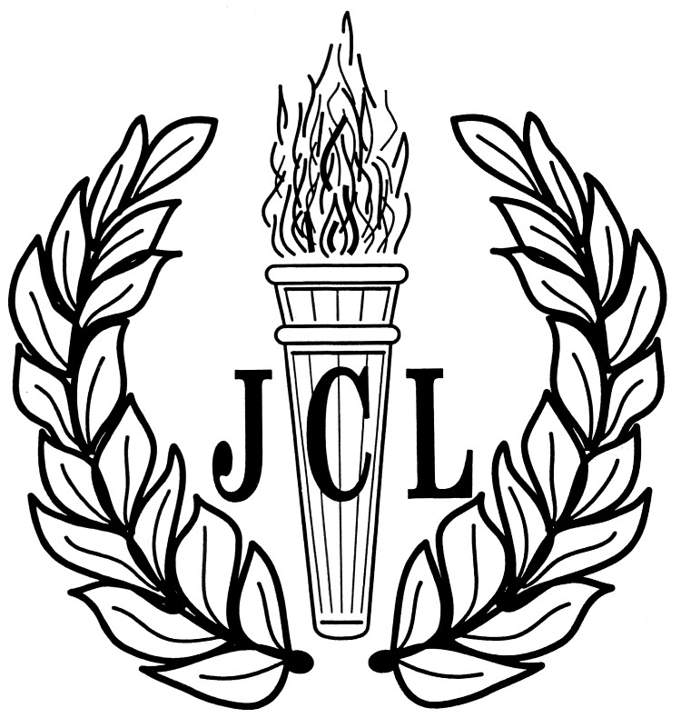ool

Ethan Ream, Olympika

Tallahassee Classical School

Alex Stephens

,

|  |
| --- |
| Region II Latin Forum  January 28th, 2023 |