FLORIDA STATE UNIVERSITY
CONGRESS OF GRADUATE STUDENTS
THIRTY-SECOND CONGRESS OF GRADUATE STUDENTS
Assembly Meeting
June 17, 2024
6:30pm
Agenda
Call to Order:
Pledge of Allegiance:
Roll Call:
Reading and approval of the Minutes:
Petitions into the Assembly:
Special Introductions and Student Comments:
Messages from Student Government:
Report from the Office of Governmental Affairs:
Report of Officers:
- Report of the Speaker:
- Report of the Deputy Speaker for Finance:
- Report of the Deputy Speaker for Communications:
- Report of the Deputy Speaker for Judicial Affairs:
- Advisor Announcements:
Committee Introductions and Reports:
- Internal Affairs:
- Student Advocacy:
- Student Affairs:
Funding Requests:
Unfinished Business:
New Business:
New COGS Logo Discussion
Pending Elections Bill for next meeting
Round Table:
Adjournment:
Next Meeting: July 1, 2024 at 6:30 p.m. via Zoom

COGS Financial Report, Fiscal Year 2023-2024
ACCOUNT | ALLOCATION AMOUNT | DESCRIPTION | AVAILABLE
UNALLOCATED | $21,318 | For RSO funding requests at COGS meetings | $541.30
LSC | $61,000 | Funding allocations from Law School Council to Law School Student Organizations | $828.47
MSC | $84,817 | Funding allocations from Medical School Council to Medical School Student Organizations | $4,659.35
PRESENTATION GRANTS (Jul-Oct) | $66,250 | Presentation Grant balance for the July-October funding period | $0
PRESENTATION GRANTS (Nov-Feb) | $75,000 | Presentation Grant balance for the November-February funding period | $0
PRESENTATION GRANTS (Mar-Jun) | $58,750 | Presentation Grant balance for the March-June funding period | $840.04
ATTENDANCE GRANTS (Jul-Oct) | $9,000 | Attendance Grant balance for the July-October funding period | $0
ATTENDANCE GRANTS (Nov-Feb) | $9,000 | Attendance Grant balance for the November-February funding period | $0
ATTENDANCE GRANTS (Mar-Jun) | $7,500 | Attendance Grant balance for the March-June funding period | $816.12

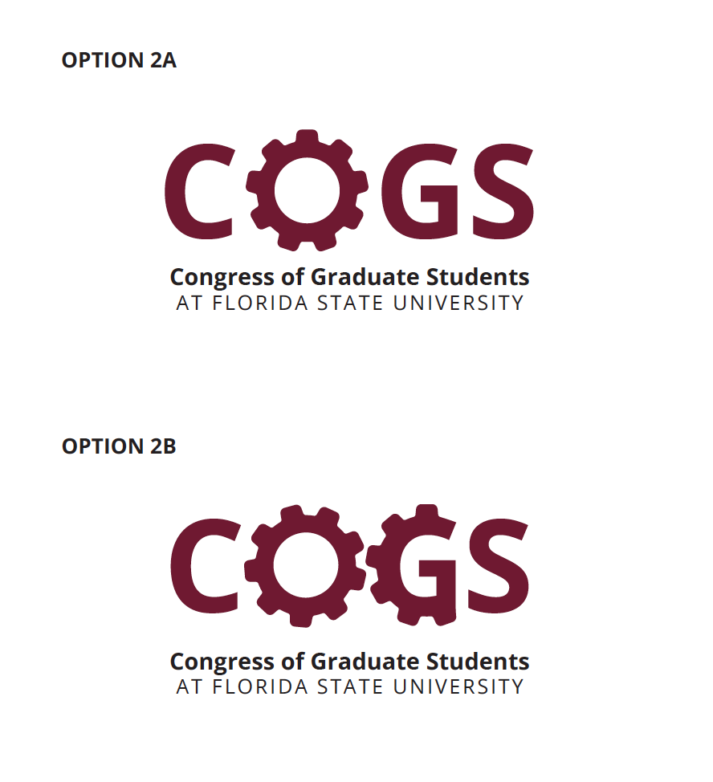

FLORIDA STATE UNIVERSITY
CONGRESS OF GRADUATE STUDENTS
Statute Revision or Addition

32nd Congress of Graduate Students

Bill #:

Sponsored by: Speaker Rowan

Date:

Purpose & Description: A Bill to Reform the COGS Elections Process to Increase Independence, Reduce Bureaucracy, and Make COGS More Accessible.

Be it enacted by the Thirty-Second Congress of Graduate Students:

Section 1: Chapter 111 of the COGS Administrative Code is hereby amended to read:
- The COGS Executive Committee SGA Supervisor of Elections shall be responsible for conducting elections for the Congress of Graduate Students. If COGS chooses to participate in the SGA election process, then they fall under the Student Government Election Code and are responsible for following all requirements. The Congress agrees that its elections shall be governed by the Student Government Election Code, as laid out in Student Body Statutes Title VII, except that the following procedures shall control for COGS elections, notwithstanding conflicting provisions of the Election Code:
  - COGS elections shall be non-partisan,
  - Candidates for COGS do not need to attend the Candidate Seminars,
  - Candidates for COGS shall file a combined Campaign Finance Statement by the Final Expense Statement deadline, as set out in Title VII, which shall include:
    - An itemized list of all campaign contributions and expenditures, or
    - A statement, under penalty of disqualification, that the candidate received no contributions, nor made any expenditures.
  - Any ties in a COGS election shall be resolved by a vote of COGS immediately upon the convening of the new Congress, taken by secret ballot, with the tied candidates being on the secret ballot.
- COGS shall be composed of forty-three (43) seats with the following allocation:
  - Thirty (30) seats for the members of each college/academic unit, except for the College of Applied Studies and Special Students, apportioned annually through the D’Hondt Method, based on the most recent annual population data for each college, as provided by the University.
    - By the second COGS Assembly meeting of the Fall Semester, the SGA Supervisor of Elections shall provide the Assembly, by memo and personal appearance at the meeting, with a list detailing the number of seats apportioned to each college/academic unit, as well as an accounting of the calculations used to determine the apportionment. Should the list not be provided by this deadline, the COGS Executive Board shall be empowered to facilitate the apportionment in the Supervisor’s place.
    - Should there be a discrepancy that results in the erroneous allocation of seats, the Assembly may move to reject the apportionment and request that the Supervisor (or COGS Executive Board, if providing the list under sub-subsection (1)) provide a corrected apportionment to the Assembly at their next meeting. Such motion requires a two-thirds (2/3) vote to pass and is debatable.
    - If no motion to reject is passed, the apportionment shall become official upon adjournment of the Assembly meeting in which it is presented.
  - Six (6) advocate seats under the following titles: Graduate Student Housing Advocate, International Student Advocate, LGBTQ+ Student Advocate, Minority Student Advocate, Veteran’s Advocate, and Student with Disabilities Advocate. Any graduate student, regardless of college, may serve as an Advocate,
  - Six (6) At-Large seats, which may be filled by any graduate student, regardless of college, and
  - One (1) seat for the combined grouping of Special Students, the College of Applied Studies, and the Panama City Campus. Should this seat be filled, attendance by the representative will count towards quorum, but failure to attend will not count against quorum.
- The Deputy Speaker for Communication Supervisor of Elections shall advertise the seat allocation information at least twenty-four (24) hours before the first day of the Declaration of Candidacy date, as specified by the Student Government Election Code. The Deputy Speaker of Communications shall also advertise the seats up for election on the Congress’s social media pages. Seat allocation information shall be advertised by email as well.
- Elections will be held in conjunction with the regular fall semester Student Government elections.
- All enrolled graduate students are eligible to vote in COGS elections.
- Election appeals shall be made to the Student Government Elections Commission, as specified by Title VII. Appeals from the Elections Commission shall be to the Florida State University Student Supreme Court. first to the COGS Executive Committee. Further appeals shall be made to the full Assembly. If COGS chooses to participate in the SGA election process, appeals shall follow the procedures under the Student Government Election Code.
- Regular elections to the Assembly shall take place only during the fall semester.
- Elections of the officers for COGS shall take place on the first meeting of the newly convened Congress. Members of the COGS Executive Committee A Speaker and two other members of the COGS Executive Committee must be elected before the first meeting adjourns.
- COGS officer election procedures shall be the following:
  - Members of the COGS Executive Committee shall be elected from among the membership of COGS. Election shall be by secret ballot and shall require a majority vote in order to elect a candidate. Quorum of the Congress must be present for the election of each member of the COGS Executive Committee.
  - An elected member of the SGA Executive Branch The most senior member of COGS who was a member of the previous Congress, based on date of swearing in (ties broken by alphabetical order of last name), shall act as the Temporary Chair for the first meeting of the new Congress until the Congress elects a Representative to the Office of the Speaker, at which time the Speaker shall be sworn in and chair the Congress. The Temporary Chair shall have the right to cast a vote for election of the Speaker in such cases where his/her vote would be decisive.
    - The COGS Advisor shall, with the assistance of the Deputy Speaker for Communications, maintain a list noting the order of seniority among members of COGS.
    - If all members who were a member of the previous Congress are candidates for Speaker, the Student Body President shall act as the Temporary Chair.
  - Nominations for Officers shall be taken from the floor and shall require a second. Each candidate may accept or decline the nomination. After receipt of nominees, the Chair shall close the floor for nominations, only after ensuring that no other nominations are to be made. If only one candidate is nominated, that candidate shall be declared to be elected by acclamation. The elected officer shall then be allowed to make a brief statement to the Congress. Candidates who accept their nomination shall be allowed, in alphabetical order, to address the Congress for no more than two (2) minutes. The Chair shall allow three (3) minutes of questions per candidate. No “con” debate shall be permitted during the election process. All nominees not addressing or taking questions from the Congress shall remain outside the COGS Chambers. Candidates shall not be present during debate on the candidates. Debate on the candidates shall take no more than five (5) minutes. Motions to extend time for opening addresses, questions and discussion of the candidates may be made by Representatives in the Chambers and pass by a majority vote of the Representatives in the Chambers. Once the question has successfully been called to vote on the position, all nominees may enter the Chambers and cast their own secret ballots with the rest of the Congress.
  - If there are two or more candidates who accepted their nomination, each Candidates who accept their nomination shall be allowed, in alphabetical order, to address the Congress for no more than two (2) minutes. The Chair shall allow three (3) minutes of questions per candidate. No “con” debate shall be permitted during the election process. All nominees not addressing or taking questions from the Congress shall remain outside the COGS Chambers. Candidates shall not be present during debate on the candidates. Debate on the candidates shall take no more than five (5) minutes. Motions to extend time for opening addresses, questions and discussion of the candidates may be made by Representatives in the Chambers and pass by a majority vote of the Representatives in the Chambers. Once the question has successfully been called to vote on the position, all nominees may enter the Chambers and cast their own secret ballots with the rest of the Congress.

FLORIDA STATE UNIVERSITY
CONGRESS OF GRADUATE STUDENTS
THIRTY-SECOND CONGRESS OF GRADUATE STUDENTS
Assembly Meeting
June 3, 2024
6:30pm
Minutes
Call to Order: 6:34pm
Pledge of Allegiance: N/A
Roll Call:
Present: Alleyne, Balogun, Beavon, Barber, Bethke, Cyrille, Ebuara, Fermin, Hussain, Medarev, Rowan, Sabbagh, Siegel, Vaughn
Present-Late: Strickland
Reading and approval of the Minutes: Siegel, 2nd - Hussain
Petitions into the Assembly:
Jake Aboulhosn, Business Seat 1
Noticed there was an open seat and wanted to get more involved on campus. Would be interested in joining student advocacy.
Questions:
Bethke - Will you be available on Mondays for Summer, Fall, and Spring? How long would you like to stay in COGS? I am available and am able to serve until I graduate.
Hussain - What aspects of student advocacy are you interested in? I'm interested to learn the process and if there are negotiations involved. I want to see what I can do with the committee. I'm curious about the committee.
Pros -
Bethke - He's a great guy and it's a great step in getting a business school seat filled.
Vaughn - Is it okay if he is part time? Rowan - I will check on that but he should be okay with 6 hours.
Call to Question - Alleyne; Balogun - 2nd
Vote: 14-0-1
Swearing in.
Special Introductions and Student Comments: N/A
Messages from Student Government: N/A
Report from the Office of Governmental Affairs: N/A
Report of Officers:
- Report of the Speaker: Sorry about the last minute changes to the agenda. I will be out for our next meeting, so Chris will be taking over. All of our grants will start on July 1st from our budget. Thank you to Lauren for serving on the Garnet and Gold Commission. Thank you to Diego, Jared, and Shezin for being a part of the SGA working group.
- Report of the Deputy Speaker for Finance: There are some bills on the agenda for the grants since we have had several applications during the past few weeks.
- Report of the Deputy Speaker for Communications: The Summer 2024 involvement Fair registration will be held on Sunday, June 30th 2024, from 4-6pm in the Union and we need volunteers. We also need a new COGS logo, so please look at these options on screen and give us your feedback so that we can take a vote on which one to use moving forward. I will also send everyone an email with this information.
- Report of the Deputy Speaker for Judicial Affairs: I am getting many questions from prospective representatives moving forward. Let's keep up this work. We also are working to address how we have representative seats within the code, so please consider this carefully.
- Advisor Announcements: Had a Student Government Institute Conference this past weekend. COGS contributed some merch. It was fun to talk about COGS because not all institutes have involvement for graduate students.
Committee Introductions and Reports: N/A
- Internal Affairs:
- Student Advocacy:
- Student Affairs:
Funding Requests:
Bill #39: Presentation Grant Transfer
Looking to move $9,000 from unallocated to presentation grants. We have about 51 that have not been approved yet. As we go through this, we will need more money.
Questions: N/A
Pros: Rowan - Thank you Chris for the work you are putting into the grants because this is a beast of a project. This will help us deplete our unallocated and this is great to see our funds spent.
Call to Question - Strickland; 2nd - Hussain
Vote: 15-0-1
Bill #40: Attendance Grant Transfer
Same thing as the presentation grants. I was able to get through most of these, but we will need more funds to cover the rest of them.
Questions: N/A
Pros: Rowan - Will also be supplemented with $1,200 from the Speaker's funds
Bethke - Call to Question; 2nd - Hussain
Vote: 15-0-1
Unfinished Business:
New Business:
Bill #38: COGS Apportionment Process Reform
Passing the Speaker role to Rep. Cyrille.
Rowan - We talked about this last meeting on fixing the language on apportionment. There were some errors this past year with Law gaining a seat and Medicine losing a seat. Our current code is wording oddly where it is done differently than SGA. These edits are working to make it more accessible for graduate students. Several colleges have empty seats and we are working to cut back some of those seats that will be brought back as at-large seats that anyone can fill. I have a spreadsheet that I can share with the formula. We are keeping all advocate seats and will be adding at-large seats. There will be one seat that merges the seats for the College of Applied Sciences and Panama City campus. Added language clarifying the process and timeline for the apportionment process. Also adds checks and balances to make sure the process that happens last fall doesn't happen again.
Question:
Bethke - With this, do the apportionments need to be voted on? Rowan - The supervisor will let us know the amount and if we see errors, we can motion to disapprove the process to recalculate the seats.
Fermin - Have you ran a projection of what this looks like? Rowan - Yes. Here is the sample spreadsheet based on the numbers from Spring 2023. Rep. Rowan breaks down and explains the spreadsheet and numbers being shown.
Ebuara - How did subsection 1 and 2 different from what we currently have? Rowan - No changes have been made here, but in July I would like us to talk about the elections process. We have been on the SGA elections process for a long time, but we need to talk more about that as a whole.
Pros:
Vaughn - This is great because the process wasn't clear last year and we had some surprises with the changes in seats. This makes sure that there are no surprises.
Siegel - Consistency is key and this matches closer to what SGA does.
Strickland - Call to question; Alleyne - 2nd
Vote: 16-0-0
Rowan - Why we aren't matching SGA is their method does lead to the supervisor of elections making last minute decisions.
Round Table:
Adjournment: 7:26pm
Next Meeting: June 17, 2024 at 6:30 p.m. via Zoom

