FLORIDA STATE UNIVERSITY

CONGRESS OF GRADUATE STUDENTS



**THIRTY-SECOND CONGRESS OF GRADUATE STUDENTS**

Assembly Meeting

April 1, 2024

6:30pm

Agenda

**Call to Order:**

**Pledge of Allegiance:**

**Roll Call:**

**Reading and approval of the Minutes:**

**Petitions into the Assembly:**

Diego Fermin - Social Sciences and Public Policy Seat 3

**Special Introductions and Student Comments:**

Dr. Leventhal - Graduate Student Resource Center

**Messages from Student Government:**

**Report from the Office of Governmental Affairs:**

**Report of Officers:**

* Report of the Speaker:
* Report of the Deputy Speaker for Finance:
* Report of the Deputy Speaker for Communications:
* Report of the Deputy Speaker for Judicial Affairs:
* Advisor Announcements:

**Committee Introductions and Reports:**

* Internal Affairs:
* Student Advocacy:
* Student Affairs:

**Funding Requests:**

*Bill #31: Mechanical Engineering Graduate Student Association*

*Bill #32: Bangladeshi Student Association*

*Bill #33: MAAPPA*

**Unfinished Business:**

**New Business:**

*Resolution #2: Bangladeshi Student Association*

**Round Table:**

**Adjournment:**

Next Meeting: **April 15, 2024 at 6:30 p.m. Senate Chambers (3rd floor Student Union)**

**COGS Financial Report, Fiscal Year 2023-2024**

|  |  |  |  |
| --- | --- | --- | --- |
| **ACCOUNT** | **ALLOCATION AMOUNT** | **DESCRIPTION** | **BALANCE** |
| UNALLOCATED | $21,318 | For RSO funding requests at COGS meetings | $34,174.30 |
| LSC | $61,000 | Funding allocations from Law School Council to Law School Student Organizations | $5,636.54 |
| MSC | $84,817 | Funding allocations from Medical School Council to Medical School Student Organizations | $9,775.55 |
| PRESENTATION GRANTS (Jul-Oct) | $66,250 | Presentation Grant balance for the July-October funding period | $0 |
| PRESENTATION GRANTS (Nov-Feb) | $75,000 | Presentation Grant balance for the November-February funding period | $0 |
| PRESENTATION GRANTS (Mar-Jun) | $58,750 | Presentation Grant balance for the March-June funding period | $24,650.01 |
| ATTENDANCE GRANTS (Jul-Oct) | $9,000 | Attendance Grant balance for the July-October funding period | $0 |
| ATTENDANCE GRANTS (Nov-Feb) | $9,000 | Attendance Grant balance for the November-February funding period | $0 |
| ATTENDANCE GRANTS (Mar-Jun) | $7,500 | Attendance Grant balance for the March-June funding period | $5,100 |

FLORIDA STATE UNIVERSITY

CONGRESS OF GRADUATE STUDENTS



**Allocation, Revision, or Transfer**

**32nd Congress of Graduate Students**

**Bill #:** 31

**Sponsored by:** Profilia Nord

**Date:** 04/01/2024

**Amount:** $581

**From (account name):** COGS Unallocated

**To (account name):** Mechanical Engineering Graduate Student Association

**Purpose & Description:** MEGSA is an organization that aims to promote engagement and interaction among the graduate students from the mechanical engineering department. This organization currently has 30 active members. They will be hosting their second poster competition event; this is an event that is designed to sharpen and refine the presentation skills of those who participate. The previous year they had more than 65 participants and featured 13 presenters. The funding they are requesting will cover the expenses for food and awards. They plan to via email, social media and flyers. This is a free event open to all FSU students.

**Itemized Expenditures:**

|  |  |  |
| --- | --- | --- |
| **Quantity** | **Description** | **Unit Price** |
| 3 | Awards | 491.85 |
| 1 | Food | 88.85 |

Total: $581

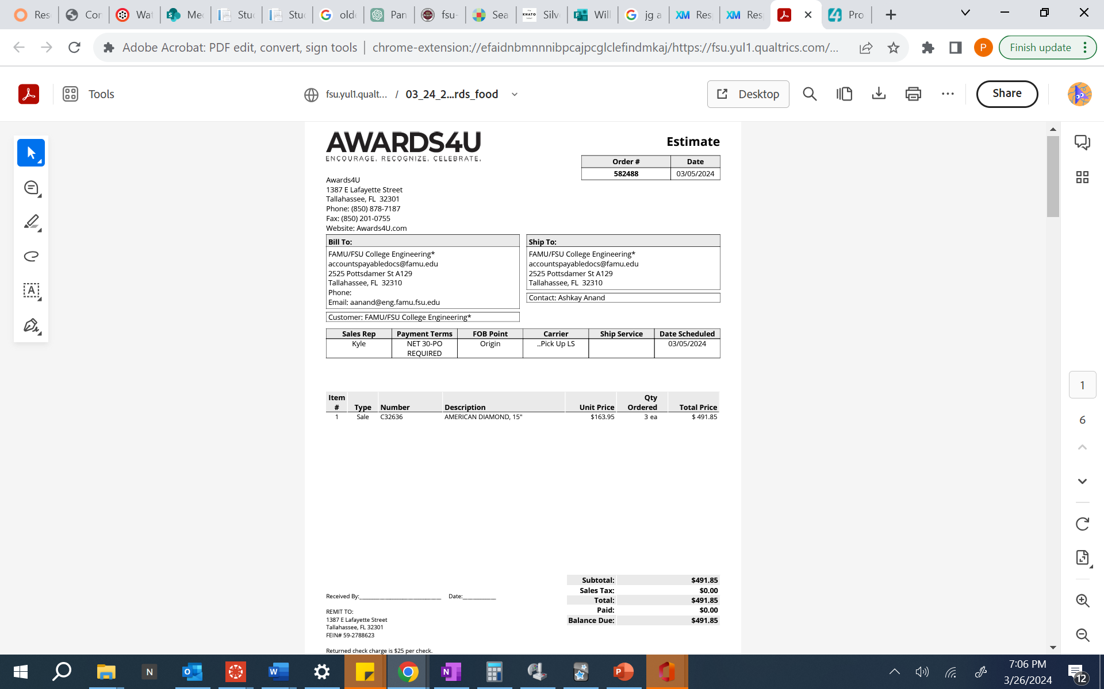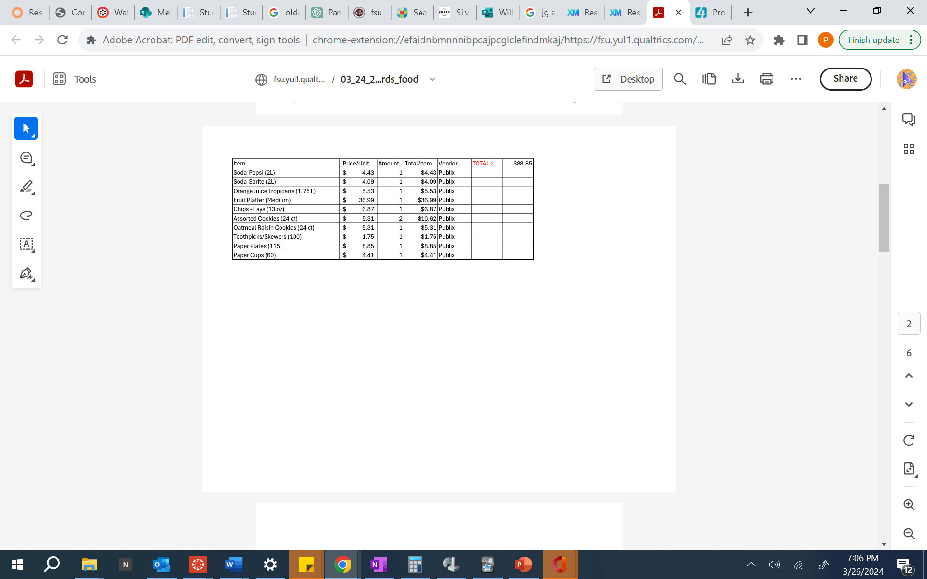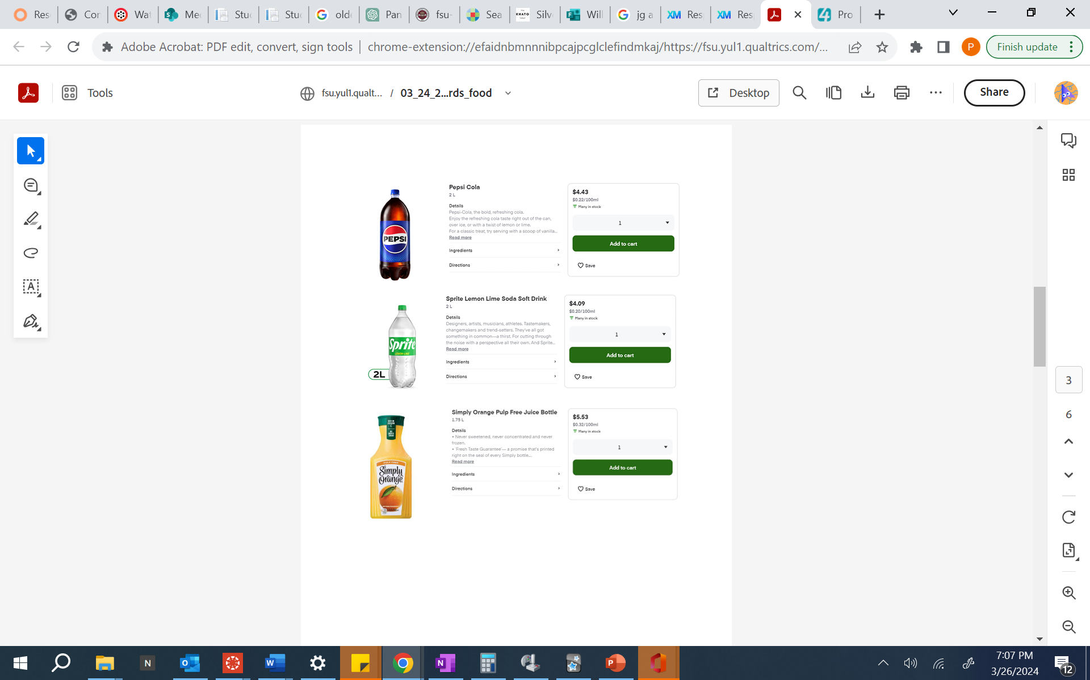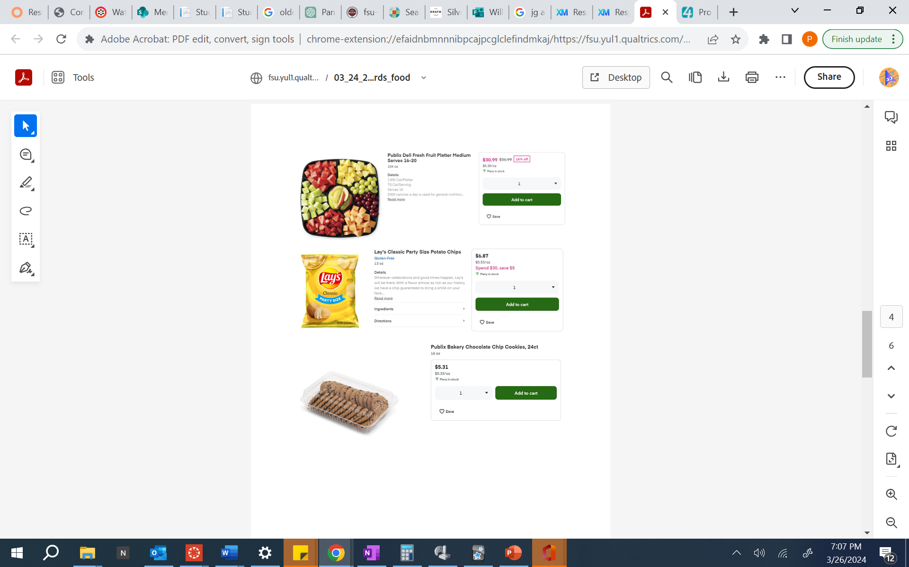

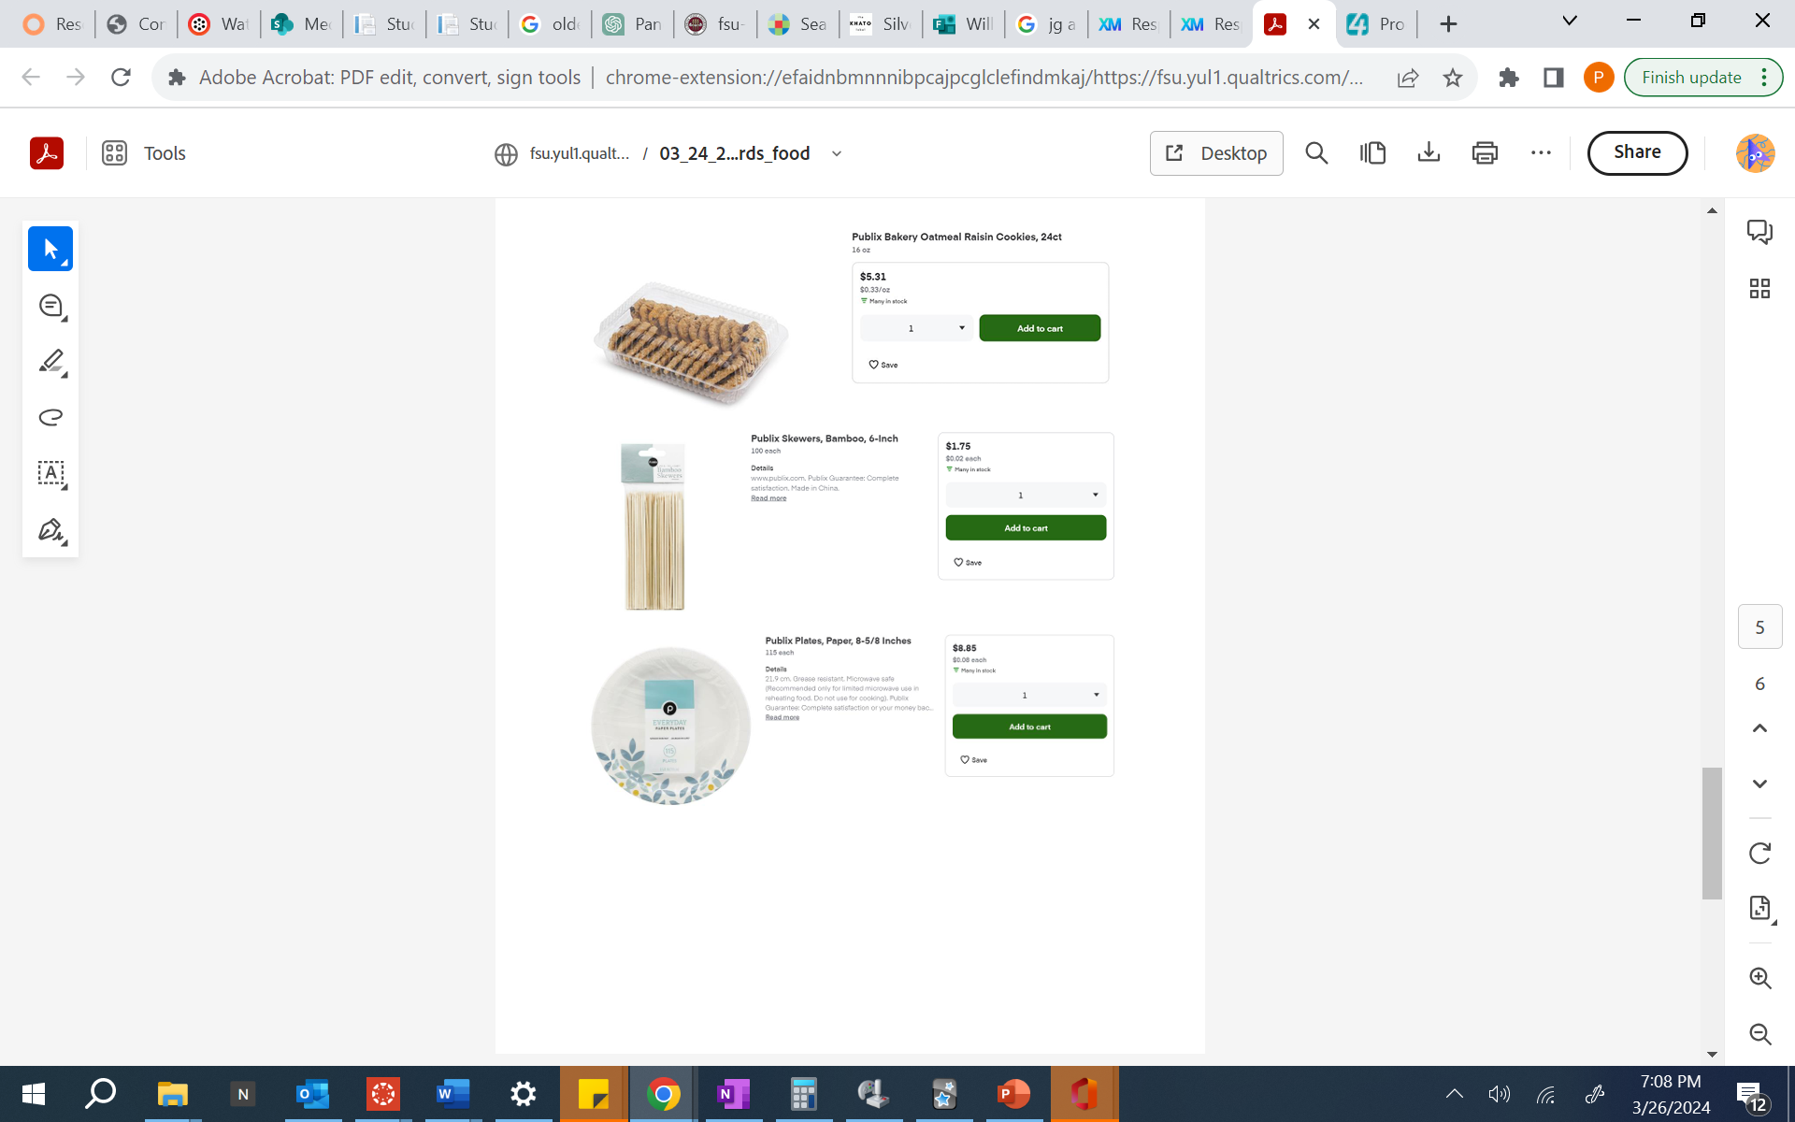

FLORIDA STATE UNIVERSITY

CONGRESS OF GRADUATE STUDENTS



**Allocation, Revision, Or Transfer**

**32nd Congress of Graduate Students**

**Bill** #: 32

**Sponsored by:** Shezin Hussain

**Date:** April 1, 2024

**Amount:** $ 1774

**From (account name):** COGS Unallocated

**To (account name):** Bangladeshi Student Association

**Purpose & Description:**

The Bangladeshi Students Association at Florida State University (BSA) requests support from COGS for the “Annual Soccer Tournament” program, which will be held from June 22, 2024, to June 23, 2024. This program fosters community, camaraderie, and healthy competition among Bangladeshi students studying abroad. Additionally, the tournament aims to promote physical fitness, teamwork, and sportsmanship among participants while celebrating the love for soccer, a sport deeply cherished in Bangladeshi culture.

Soccer is deeply popular among Bangladeshi students, transcending geographical boundaries and cultural differences. With a fervent passion for the sport passed down through generations, soccer is a unifying force among Bangladeshi youth, offering a shared language of excitement and camaraderie. Every weekend, members of the BSA play soccer, which helps break free from the weekday workload and rejuvenate their mental and physical health.

The main purpose of the event is:

* **Community Building:** The tournament allows Bangladeshi students to come together, bond, and build lasting friendships beyond academic settings.
* **Cultural Exchange:** Through the shared love for soccer, the tournament serves as a platform for cultural exchange, allowing participants to share their experiences, traditions, and values with peers from diverse backgrounds.
* **Physical Health and Well-being:** Encouraging participation in sports promotes physical activity and a healthy lifestyle among students, contributing to their overall well-being and academic success.
* **Skill Development:** The tournament offers a platform for players to hone their soccer skills, develop teamwork abilities, and learn valuable lessons in leadership, discipline, and resilience.
* **Networking Opportunities:** Beyond the field, the tournament provides networking opportunities for students to connect with peers, alumni, and professionals, fostering personal and professional growth.
* **Promoting Bangladeshi Identity:** By organizing events that celebrate Bangladeshi culture and interests, such as soccer, the association helps promote a sense of pride and identity among Bangladeshi students living abroad.

The two events will consist of four matches and a prize-giving ceremony. The tournament will have four teams consisting of 9 members. The first two matches will be a knockout match where the winners will move to the finals. The next will be the final match and a 2nd runner-up decider match. The winners will be given medals and a championship cup. At the end of the event, a light refreshment will be provided.

Organization Members: 91

Date: June 22, 2024 to June 23, 2024

Location: James Messer Sports Complex

Estimated Attendance of Event: 100

**Advertisement:**

To ensure widespread awareness and participation, we will advertise this event via various channels, including our Facebook page, Instagram account, emails, and Telegram group. We also plan to distribute flyers to promote the event, continuing our traditional advertising approach.

**Funding Request:**

They request support from the Congress of Graduate Students for **$1774** to host the matches and a post-tournament refreshment for the event. They will use the funds to buy necessary items and awards to organize the tournament properly. The post-tournament refreshment will act as a celebration of the game and bonding among the players and spectators.

**Itemized Expenditures:**

|  |  |  |
| --- | --- | --- |
| **Item** | **Description** | **Unit Price** |
| **Food** | **Light Refreshment (Publix)**  **Soft Drinks**  **Gatorade**  **Banana** | **1136.22** |
| **Playing Kits** |  | **344** |
| **Awards** |  | **293.4** |
| **Total** |  | **1773.62** |

This document contains the quotes for the refreshment, kits, and awards, which will be provided at the “Annual Soccer Tournament” Program.

1. **Food Quote:**
2. **Refreshment from Publix**

1. **Gatorade**

1. **Soft Drinks**

1. **Banana**

|  |  |  |  |  |
| --- | --- | --- | --- | --- |
| Item | Details | Unit price | quantity | Price (USD) |
| Refreshment from Publix | Publix Chicken Tender whole sub | 10.49 | 60 | 629.4 |
| Publix Tuna Salad whole sub | 8.49 | 40 | 339.6 |
| Soft drinks | Coca-Cola Mini (Publix) | 8.85 | 10 | 63.4 |
| Gatorade | Gatorade | 5.53 | 14 | 77.42 |
| Banana |  | 0.33 | 80 | 26.4 |
| Total |  |  |  | **1136.22** |

1. **Kits**

|  |  |  |  |  |
| --- | --- | --- | --- | --- |
| Item | Details | Unit price | quantity | Price (USD) |
| Soccer Ball | Addidas Unisex Adult tango glider soccer ball | 24 | 1 | 24 |
| Gloves | Adidas Copa Club Goalie Gloves | 21 | 2 | 42 |
| Vest | Reversible Numbered practice vest | 64 | 4 | 256 |
| cone | Pro disc cones | 22 | 2 | 22 |
| Total |  |  |  | **344** |

1. **Awards**

|  |  |  |  |  |
| --- | --- | --- | --- | --- |
| Item | Details | Unit price | quantity | Price (USD) |
| Championship Trophy | 15” soccer trophy | 13.5 | 1 | 13.5 |
| Runners up trophy | 3D blast through soccer trophy | 16.95 | 1 | 16.95 |
| Awards | Motion Male Soccer Trophy | 10 | 2 | 20 |
| Soccer star trophy | 12.95 | 1 | 12.95 |
| Medals | Wreath medallion | 5.75 | 40 | 230 |
| Total |  |  |  | **293.4** |

FLORIDA STATE UNIVERSITY

CONGRESS OF GRADUATE STUDENTS



**Allocation, Revision, or Transfer**

**32nd Congress of Graduate Students**

**Bill #:** 33

**Sponsored by:** Susan Rogowski

**Date:** April 1st, 2024

**Amount:** $181

**From (account name):** COGS Unallocated

**To (account name):** Masters in Applied American Politics and Policy Association

**Purpose & Description:** To purchase a banner for use during tabling events to promote MAAPPA and the MAAPP Program.

**Itemized Expenditures:**

|  |  |  |
| --- | --- | --- |
| **Quantity** | **Description** | **Unit Price** |
| 1 | Retractable Display Banner | $180.20 |

Total: $181



FLORIDA STATE UNIVERSITY

CONGRESS OF GRADUATE STUDENTS



**Resolution**

**32nd Congress of Graduate Students**

**Resolution #:** 2

**Sponsored by:** Hussain

**Date:** April 1, 2024

*Whereas*: COGS Code Chapter 201.6 regarding COGS General Restrictions on Spending states that “All events funded in whole, or in part, by COGS Funds or derivative resources must be equally accessible to all enrolled graduate students at Florida State University or serve a legitimate academic purpose. All purchases for events held off of the Florida State University campus require the approval of the Assembly by resolution in a majority vote[,]” and

*Whereas*: The Bangladeshi Students Association has requested to and been funded by COGS to host the BSA’s Annual Soccer Tournament at James Messer Park, and

*Whereas*: The BSA has regularly shown its ability to hold high-quality events with high turnout, such as their annual cricket tournament, therefore

**Be it resolved by the Thirty-Second Congress of Graduate Students**: That the Congress of Graduate Students hereby waives COGS Code § 201.6 for the Bangladeshi Students Association to have their Annual Soccer Tournament at James Messer Park on June 22-23rd, 2024, and

**Be it finally resolved**: That a copy of this resolution be sent to:

Dr. Felicia Williams, Director of Student Engagement,

Laurel McKinney, SG&A Business Manager,

Joshua Burns, COGS Deputy Speaker for Finance, and

S M Mushfiqul Hoque, Bangladeshi Students Association President.

FLORIDA STATE UNIVERSITY

CONGRESS OF GRADUATE STUDENTS



**THIRTY-SECOND CONGRESS OF GRADUATE STUDENTS**

Assembly Meeting

March 18, 2024

6:30pm

Minutes

**Call to Order:** 6:39 pm

**Pledge of Allegiance:** Rep. Strickland

**Roll Call:**

**Present:** Alleyne, Balak, Balogun, Cyrille, Delva, Galeano, Hussain, McCraney, Medarev, Nord, Pakdehi, Rogowski, Rowan, Schumm, Siegel, Solmaz, Strickland, Velez, Wardlow, Wesner, Wheeler

**Absent-Excused:** Barber, Bethke, Burns, Ebuara, Vaughn

**Reading and approval of the Minutes:** Wesner, 2nd by Nord

**Petitions into the Assembly:** none

**Special Introductions and Student Comments:**  none

**Messages from Student Government: none**

**Report from the Office of Governmental Affairs:**

**Report of Officers:**

* Report of the Speaker:

- COGS Spring Retreat on March 23rd at 10am for new/11am returning

Reps, if you can’t come out, please let Rowan know.

* Report of the Deputy Speaker for Finance: Rowan giving on Burns’s behalf. Budget week is next week, application has been extended to Wed 3/20 deliberations on Friday.
* Report of the Deputy Speaker for Communications: Rowan giving on behalf of Vaughn. Email sent out on Graduate workshops and university libraries. Dr. Leventhal will be here on April 1st.
* Report of the Deputy Speaker for Judicial Affairs: reiterate to make sure everyone attends the retreat. We will be going through the rules and procedures.
* Advisor Announcements: No announcements

**Committee Introductions and Reports:**

* Internal Affairs: Balak (spring break, no class)
* Student Advocacy: next meeting is on 25th
* Student Affairs: Wesner next meeting is 25th

**Funding Requests:**

*Bill #28: League of Graduate Artists*

* Rep Schumm is reading the purpose and description.
* Balak speaking in favor of bill: he thinks it’s essential to support people in building their portfolio, it can take years to do this so any amount of help we can give will be good
* Motioned by: Rep Pakdehi
* Seconded by: Solmaz
* 21 – 0 - 0

*Bill #29: Civil and Environmental Engineering Graduate Student Association*

* *Rep Pakdehi this is from CEEGSA this event is for introduction, introducing the members the goals, the goals include the future job descriptions, networking and the discussing their studies. They need the fund for food, drinks and shirts*
* *Rep Rogowski is very impressed with Pakdehi’s willingness to use COGS money, Rowan is also happy to see any event at the college of engineering since it bridges the gap between famu*
* Motioned by: Solmaz
* Seconded by: Rogowski
* Closing remarks by Pakdehi 130 attendees estimated and the event is open all
* 20-0-1

**Unfinished Business:** *none*

**New Business:**

Bill #30: Transfer of Funds

* Rep Cyrille reads purpose and description and opened up questions for Rowan to respond
* Rogowski is asking if the account is running out of money and how much the account currently has inside
* Rep Schumm asked what an attendance grant and Rowan is answered.
* Motioned by: Balogun
* Seconded by: Pakdehi
* 21-0-0

**Round Table:**

**Adjournment:** 7:18pm

Next Meeting: **April 1, 2024 at 6:30 p.m. Senate Chambers (3rd floor Student Union)**