FLORIDA STATE UNIVERSITY
CONGRESS OF GRADUATE STUDENTS
THIRTY-SECOND CONGRESS OF GRADUATE STUDENTS
Assembly Meeting
March 18, 2024
6:30pm
Agenda
Call to Order:
Pledge of Allegiance:
Roll Call:
Reading and approval of the Minutes:
Petitions into the Assembly:
Special Introductions and Student Comments:
Messages from Student Government:
Report from the Office of Governmental Affairs:
Report of Officers:
- Report of the Speaker:
- COGS Spring Retreat on March 23rd at 10am for new/11am returning
reps
- Report of the Deputy Speaker for Finance:
- Report of the Deputy Speaker for Communications:
- Report of the Deputy Speaker for Judicial Affairs:
- Advisor Announcements:
Committee Introductions and Reports:
- Internal Affairs:
- Student Advocacy:
- Student Affairs:
Funding Requests:
Bill #28: League of Graduate Artists
Bill #29: Civil and Environmental Engineering Graduate Student Association
Unfinished Business:
New Business:
Bill #30: Transfer of Funds
Round Table:
Adjournment:
Next Meeting: April 1, 2024 at 6:30 p.m. Senate Chambers (3rd floor Student Union)

COGS Financial Report, Fiscal Year 2023-2024
ACCOUNT | ALLOCATION AMOUNT | DESCRIPTION | BALANCE
UNALLOCATED | $21,318 | For RSO funding requests at COGS meetings | $34,174.30
LSC | $61,000 | Funding allocations from Law School Council to Law School Student Organizations | $5,636.54
MSC | $84,817 | Funding allocations from Medical School Council to Medical School Student Organizations | $9,775.55
PRESENTATION GRANTS (Jul-Oct) | $66,250 | Presentation Grant balance for the July-October funding period | $0
PRESENTATION GRANTS (Nov-Feb) | $75,000 | Presentation Grant balance for the November-February funding period | $0
PRESENTATION GRANTS (Mar-Jun) | $58,750 | Presentation Grant balance for the March-June funding period | $24,650.01
ATTENDANCE GRANTS (Jul-Oct) | $9,000 | Attendance Grant balance for the July-October funding period | $0
ATTENDANCE GRANTS (Nov-Feb) | $9,000 | Attendance Grant balance for the November-February funding period | $0
ATTENDANCE GRANTS (Mar-Jun) | $7,500 | Attendance Grant balance for the March-June funding period | $5,100

FLORIDA STATE UNIVERSITY
CONGRESS OF GRADUATE STUDENTS
Allocation, Revision, or Transfer

32nd Congress of Graduate Students

Bill #: 28

Sponsored by: Rep. Schumm

Date: March 18, 2024

Amount: $198

From (account name): COGS Unallocated

To (account name): League of Graduate Artists

Purpose & Description: To fund minor maintenance of LGA’s Working Method Contemporary Gallery throughout the year. The Gallery provides a free forum for FSU students and members of the community to showcase their art and build a competitive portfolio. The Gallery is run by students in the MFA in Studio Arts program, with regular collaborations from the BFA program. The gallery is regularly open on Fridays during the periods where collections are on display.

Itemized Expenditures:

Quantity | Description | Unit Price
Click or tap here to enter text. | Gallery Maintenance Supplies from Home Depot | $176.03
Click or tap here to enter text. | Gallery Maintenance Supplies from Amazon | $21.97
Total: $198.00

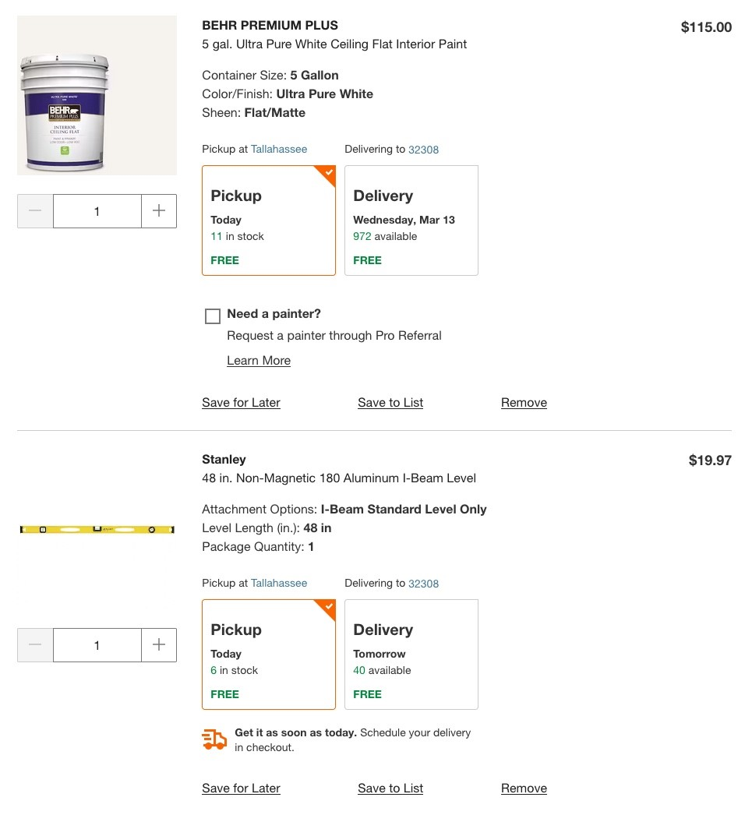
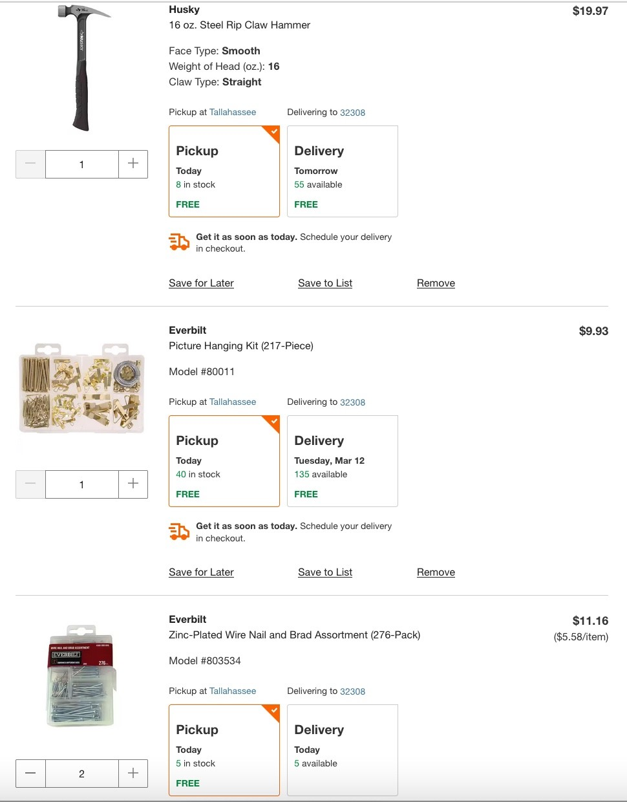

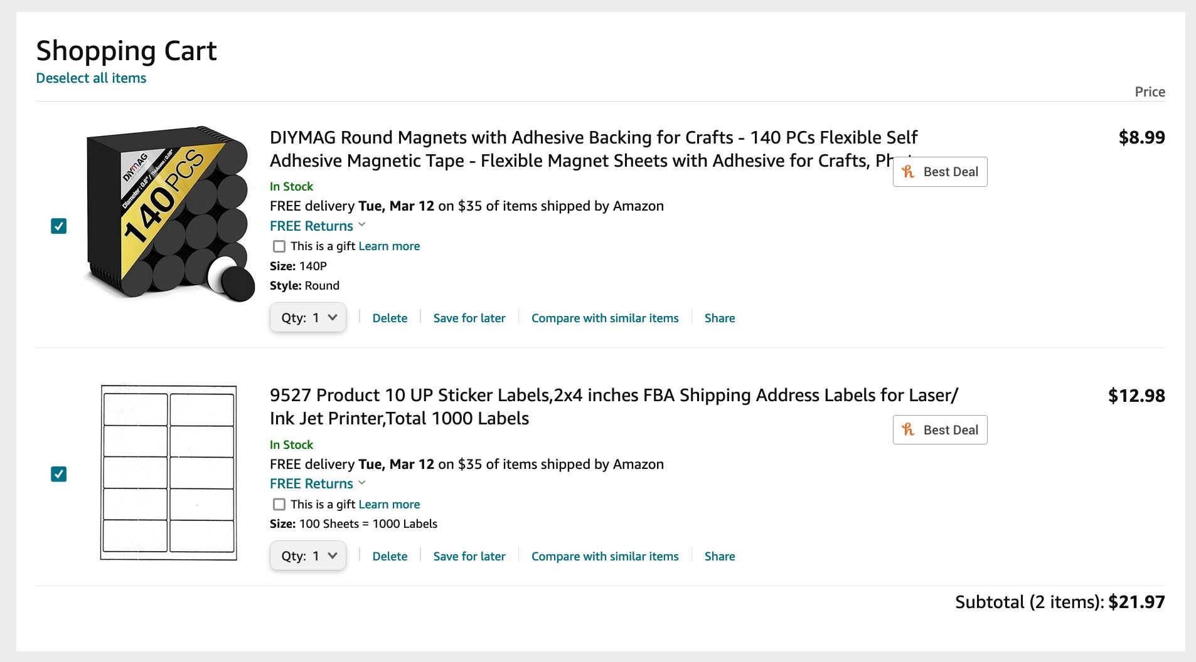
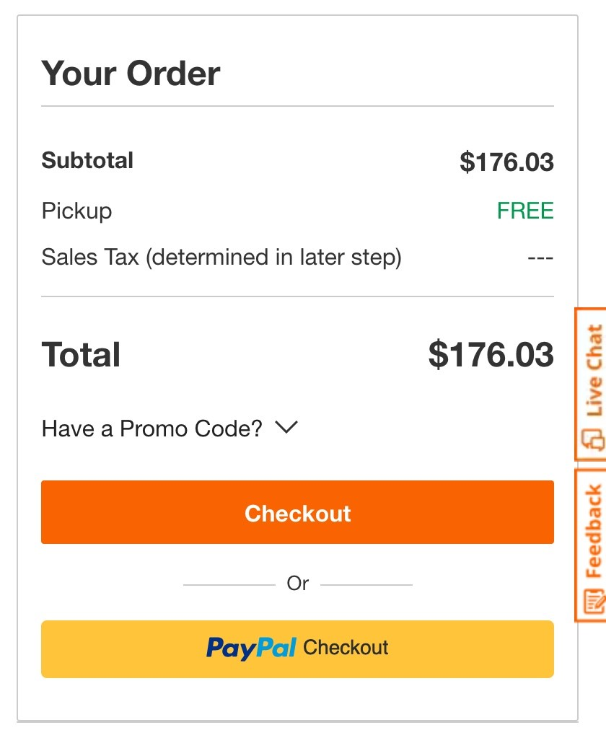
FLORIDA STATE UNIVERSITY
CONGRESS OF GRADUATE STUDENTS
Allocation, Revision, or Transfer

32nd Congress of Graduate Students

Bill #: 29

Sponsored by: Maryam Pakdehi

Date: March 18, 2024

Amount: $ 1,899

From (account name): COGS Unallocated

To (account name): Civil and Environmental Engineering Graduate Student Association (CEEGSA)

Purpose & Description: CEEGSA is dedicated to fostering a supportive and enriching environment for graduate students pursuing studies in civil and environmental engineering. Their primary goals include promoting academic excellence, professional development, and community engagement among graduate students within their department. CEEGSA also enhances their career development initiative through various events and seminars. To achieve these objectives, they are planning a series of events and initiatives throughout the academic year.
Embarking on their journey, they're excited to announce their inaugural event, an introduction of CEEGSA to the vibrant community of graduate students, faculties, and staff. It's a chance for them to break the ice, presenting their dedicated graduate student officers and laying out the ambitious goals they aim to achieve as an association.
Number of attendees: 130 people: CEE students, faculties, and staff.
Location of the event: College of Engineering (COE)_ Class B221
Advertisement:
We will advertise this event via social media, email, Nole central and distributing flyers.

Funding Request:
To make this kick-off truly memorable and impactful, they're reaching out for support from the Congress of Graduate Students (COGS). They're looking to cover essential expenses:
- Firstly, for the Launch Event, they need funds to secure logistics, and provide the necessary food and refreshments, ensuring a welcoming atmosphere for all.
- Secondly, they aim to provide souvenir T-shirts to attendees as a token of appreciation for their support and participation in their organization.
With your help, they can set the stage for a successful beginning, fostering connections, and laying the groundwork for a vibrant and engaged association.

Itemized Expenditures:

Quantity | Description | Unit Price
Food | Dinner from Momos Pizza | $634
Publix | Refreshment | $96
Clothing & Awards | T-shirts | $1169
Total: $ 1899
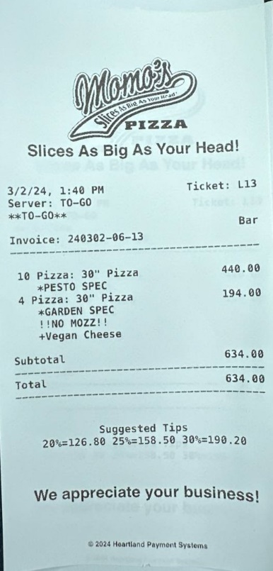
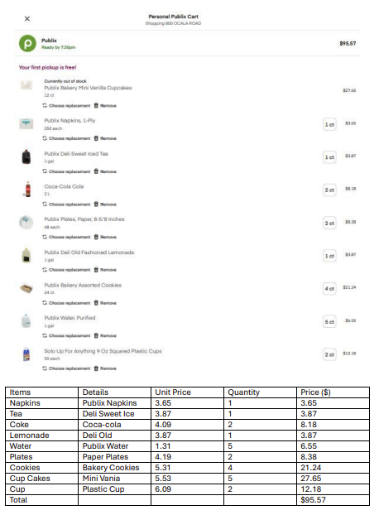
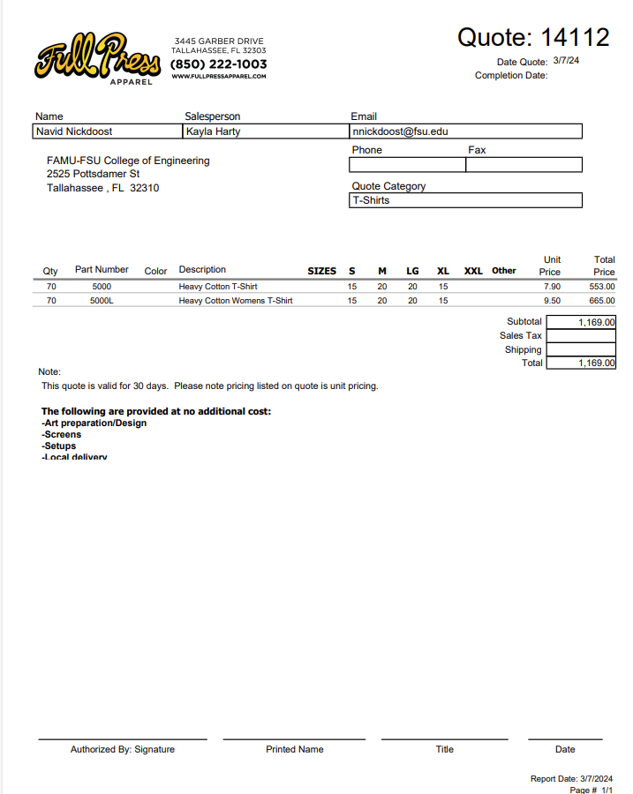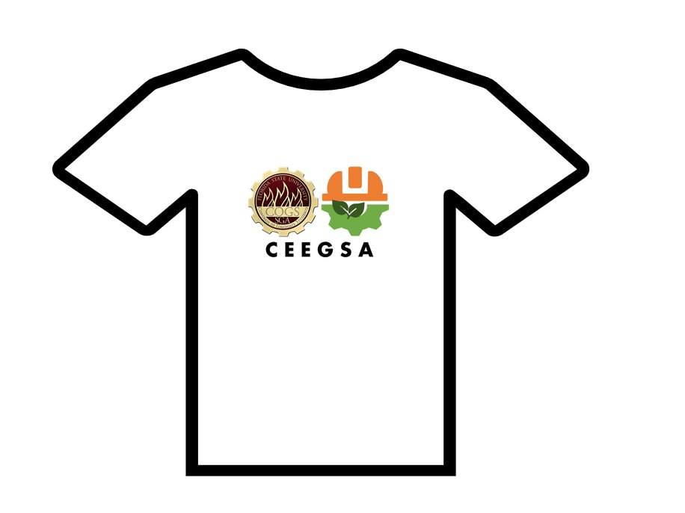

FLORIDA STATE UNIVERSITY
CONGRESS OF GRADUATE STUDENTS
Allocation, Revision, or Transfer

32nd Congress of Graduate Students

Bill #: 30

Sponsored by: Representative Burns

Date: March 18, 2024

Amount: $3,000

From (account name): Unallocated

To (account name): Attendance Grants (March – June 2024)

Purpose & Description: Transfer funds from the unallocated account to the March – June 2024 attendance grants account.

FLORIDA STATE UNIVERSITY
CONGRESS OF GRADUATE STUDENTS
FLORIDA STATE UNIVERSITY
CONGRESS OF GRADUATE STUDENTS
THIRTY-SECOND CONGRESS OF GRADUATE STUDENTS
Assembly Meeting
March 4, 2024
6:30pm
Minutes
Call to Order: 6:43pm
Pledge of Allegiance: Rep. Burns
Roll Call:
Present: Allenye, Balogun, Barber, Bethke, Burns, Cyrille, Delva, Hussain, Pakdehi, Rowan, Schumm, Siegel, Vaughn, Wesner,
Present, Late: Wardlow, Wheeler
Absent Excused: Balak, Ebuara, Galeano, McCraney, Medarev, Rogowski, Solmaz, Velez
Absent Unexcused: Nord
Reading and approval of the Minutes: Siegel; 2nd - Bethke
Petitions into the Assembly:
Lauren Strickland - College of Education Seat 5
First year Masters student in the Higher Education Program. UG and Community College in Pensacola. Interested in COGS because of childcare and diversity on campus. Is a non-traditional student and wants to encourage diversity within the campus and congress.
Questions:
Burns - Which committee are you interested in serving? Student affairs or advocacy.
Balogun - Are you available every Monday? Yes.
Rowan - Are you financially certified? Yes.
Pros:
Vaughn - She has a lot of passion for what she believes in and would be a great addition.
Rowan - I like her interest in the childcare center who can help work with that issue moving forward.
Balogun - She is prepared and knows what she is going to do within COGS.
Schumm - She is very genuine and kind and has great energy.
Pakdehi - Call to Question; Wesner - 2nd.
Vote: 14-0-0
Swearing in of Lauren Strickland
Special Introductions and Student Comments:
Bangladeshi Student Association President - I am a Ph.D. Candidate in Civil Engineering and today I want to present information about our organization who will be requesting funding for an EID event tonight. The organization was started in 2014 and the goal is to serve students from Bangladesh to help them adjust to FSU and Tallahassee. We also promote our history and culture through events during the year. We have run several activities during the year such as the Freshers Reception, Global Cafe, and sports tournaments. Here are some photos from the different events we have had over this past year. Showed photos from Walk with BSU, Game Nights, Friendsgiving Potluck, Spring Celebration, International Bazar, Cricket Tournament. COGS and BSA has had a good relationship and we have been able to hold many events because of COGS such as past EID events.
Messages from Student Government: N/A
Report from the Office of Governmental Affairs: N/A
Report of Officers:
- Report of the Speaker: A budget deal has been struck with SGA as of last week. If the agreement gets passed, administration will waive overhead costs. What does this mean for us? We will not have to pay extra fees before being given the budget. We will have $300,000 extra dollars in the budget if the current agreement is approved. It is Spring break next week, so it's understandable if there are no committee meetings next week. If you hear anything from RSOs about purchase orders and Publix, please refer them to Laurel McKinney.
- Report of the Deputy Speaker for Finance: Updated report is on the agenda. There are 9 bills for internal funding transfers within COGS, so this report will look differently during the next meeting. I have emailed RSOs about extra funding available for the end of the semester. Let me know if you are interested in seeing this email. For the budget process, we have our committee confirmed and the process has started today. RSOs can start filling out the survey for funding for next year. This will be promoted through email and Instagram. RSOs have until March 18th to submit a budget for us. March 25-29 is when presentations will be given and March 29th is deliberations. The fiscal year is July 1-June 30. Balogun - Can RSOs make requests after the deadline? We are trying to have a cutoff because there is a process. Hopefully spring break will provide time to discuss the budget. We will work with students to organize budgets.
- Report of the Deputy Speaker for Communications: Meeting with Dr. Leventhal last Friday. Overall goal - one stop shop for grad student resources for success tools. With the QEP, first urgency is a website with consolidated information for grad students (professional development, academics, basic needs, health and wellness, events); setting up a travel grants program - have it up and running by July; In the fall - doing a resource fair after Labor Day and in the meantime, start up a resource workshop series (online and in person); Would like our help and support in sharing out awareness about the center & workshops from other departments; She will be talking at the COGS meeting on April 1st.
- Report of the Advisor: I want to encourage everyone to come to the budget meetings if you can.
Committee Introductions and Reports:
- Internal Affairs: Went over the final plan for the COGS Spring Retreat. March 23rd for all new reps who did not attend the fall retreat. Start time is 10am until 3pm. If you are a returning rep, please come from 11am-3pm. Breakfast and lunch will be provided. Please let us know ASAP if you are not able to come. We will be discussing what our overall goals are for the Congress. There will be speakers from across campus.
- Student Advocacy: Met Feb. 26th. Has created a Qualtrics to see how Advocacy can help graduate students - will be sent out. Transportation will meet with committee members. Issue with transcript fees and students from Africa - fee has been waived. Advocate for grants to be increased - will analyze past information. Has created a Teams account. Next meeting is March 25th at 7pm
- Student Affairs: Met on the 26th. Taylor has a t-shirt idea we will be moving forward with. Have Bowling scheduled for April 12th - mark your calendars. Food trucks the week before finals week. Will try to meet again before the next COGS meeting on the 18th.
Funding Requests:
Bill #17: Graduate Women in STEM
Requesting funding to make sure that they can have prints and placards. Annual event to showcase the beauty of STEM through art.
Questions: Burns - Is rapid press a vendor? Yes.
Pros: Burns - I love the interdisciplinary nature of the bill. I'm excited to see what comes out of it.
Hussain - I have attended their events and it had a great turn out. This event will promote the organization and their partnership with the College of Art.
Cons: Call to question - Wheeler; 2nd - Hussain
Closing: None
Vote: 16-0-0
Bill #18: Bangladeshi Student Association
Seeking funding for EID and Pohela Boishakh Event. This is a cultural celebration. Will help to share information about community and culture. Will host a lunch. 91 members and the event will be at the FSU Rez. There will be students and friends from FSU community. Will promote through social media and word of mouth. Will be using funding from the annual budget and this request covers the remaining amount. Will cover food, t-shirts, and decorations. Event will start at 12pm.
Questions: Bethke - Why are 250 shirts being printed? Will keep extra for new students coming in next Fall.
Pakdehi - How many people will attend? More people joined this year, so we are expecting more people.
Bethke - Was this event held last year as well? Yes. It was held the past two years at the Rez. We are continuing tradition.
Pros: Pakdehi - I think this is a great celebration. They have many events and we should support them.
Balogun - This benefits COGS by helping to promote COGS on the t-shirts. We should support them.
Rowan - Thank you to the organization for working with me on this event. Tell your RSOs if they know they have funds because not all RSOs know they have funds from the previous year.
Cons: Call to Question - Pakdehi; 2nd - Burns
Closing: I think the timing is great to celebrate two events and I hope for you to join this event and share the culture and New Year. It will be fun and you will get to have wonderful food.
Vote: 16-0-0
Unfinished Business:
Deputy Speaker for Judicial Affairs - call for nominees
Burns: I would like to nominate Ridwan Balogun; 2nd - Strickland
Closing the floor to nominations: Burns; 2nd - Allenye
Swearing in of Rep. Balogun as Deputy Speaker for Judicial Affairs
New Business:
Bill #19 - LSC Funding
To give overall context, with the end of the semester, we need to move around funding so it can be best used. This bill is to LSC so they can have some extra funding for the rest of the year.
Pro: Siegel - this would be very helpful to the LSC because we have so many RSOs and 7 weeks left of the semester.
Rowan - They had to make a lot of cuts in the budget process, so they could use this money.
Call to question - Pakdehi; 2nd - Delva
Vote: 16-0-0
Bill #20 - MSC Funding
Same as the LSC bill, but for MSC to fairly distribute funding.
Question: Pakdehi - Why this much money? We did the math and wanted to have money allocated out so it could be spent.
Pro: Rowan - MSC also could use the extra money.
Call to question: Bethke; 2nd - Wheeler
Vote: 16-0-0
Bill #21 - COGS Admin
This will help to fund the end of the year events such as bowling and the food trucks.
Question: Balogun - Will this be enough? Yes based on our calculations.
Pros: Balogun - Bowling last year was a great event and let's sustain it.
Call to question: Wesner; Pakdehi - 2nd
Vote: 16-0-0
Bill #22 - Attendance Grants
This will need to be amended. The grants will need funding.
Pros: Pakdehi - It's important to move the grants.
2nd Round of Pro: Strickland - replace presentation with attendance; 2nd - Delva
Vote: 15-0-0
Bill #23 - Presentation Grants
Same as previous bill, but moving presentation funding.
Call to Question: Allenye; 2nd - Hussain
Vote: 15-0-0
Bill #24 - Funding for merch
This is to move funds for COGS merch items.
Question: Pakdehi - Why are we moving attendance grant money? We did the math and we are trying not to have too much money that isn't used. Our current attendance grants should be fine.
Call to question: Wesner; 2nd - Hussain
Vote: 16-0-0
Bill #25 - Funding for merch
Same as the past bill, but taking funds from presentation grants. If we need more money for presentation grants, we can make that happen.
Call to question: Bethke; Balogun - 2nd
Vote: 16-0-0
Bill #26 - Funds from sweepings to unallocated
Moving unused funds from sweepings into unallocated.
Rowan - Thank you Josh for working on this sweepings issue. I wish more people had applied for it, but at least some people did get funds.
Call to question: Balogun; 2nd - Hussain
Vote: 16-0-0
Bill #27 - Funds from sweepings to unallocated
Same as the last bill. This puts a lot of money into unallocated, so lets give it out to RSOs.
Call to Question: Wesner; 2nd - Hussain
Vote: 16-0-0
Round Table:
Adjournment: 7:54pm
Next Meeting: March 18, 2024 at 6:30 p.m. Senate Chambers (3rd floor Student Union)

