FLORIDA STATE UNIVERSITY
CONGRESS OF GRADUATE STUDENTS
THIRTY-SECOND CONGRESS OF GRADUATE STUDENTS
Assembly Meeting
March 4, 2024
6:30pm
Agenda
Call to Order:
Pledge of Allegiance:
Roll Call:
Reading and approval of the Minutes:
Petitions into the Assembly:
Lauren Strickland - College of Education Seat 5
Special Introductions and Student Comments:
Messages from Student Government:
Report from the Office of Governmental Affairs:
Report of Officers:
- Report of the Speaker:
- Report of the Deputy Speaker for Finance:
- Report of the Deputy Speaker for Communications:
Committee Introductions and Reports:
- Internal Affairs:
- Student Advocacy:
- Student Affairs:
Funding Requests:
Bill #17: Graduate Women in STEM
Bill #18: Bangladeshi Student Association
Unfinished Business:
Deputy Speaker for Judicial Affairs - call for nominees
New Business:
Bill #19-27: COGS Funding Transfers
Round Table:
Adjournment:
Next Meeting: March 18, 2024 at 6:30 p.m. Senate Chambers (3rd floor Student Union)

COGS Financial Report, Fiscal Year 2023-2024
ACCOUNT | ALLOCATION AMOUNT | DESCRIPTION | BALANCE
UNALLOCATED | $21,318 | For RSO funding requests at COGS meetings | $19,718.30
LSC | $61,000 | Funding allocations from Law School Council to Law School Student Organizations | $1,936.54
MSC | $84,817 | Funding allocations from Medical School Council to Medical School Student Organizations | $5,275.55
PRESENTATION GRANTS (Jul-Oct) | $66,250 | Presentation Grant balance for the July-October funding period | $20,500
PRESENTATION GRANTS (Nov-Feb) | $75,000 | Presentation Grant balance for the November-February funding period | $15,023.62
PRESENTATION GRANTS (Mar-Jun) | $58,750 | Presentation Grant balance for the March-June funding period | $34,850.00
ATTENDANCE GRANTS (Jul-Oct) | $9,000 | Attendance Grant balance for the July-October funding period | $9,150
ATTENDANCE GRANTS (Nov-Feb) | $9,000 | Attendance Grant balance for the November-February funding period | $4,774.63
ATTENDANCE GRANTS (Mar-Jun) | $7,500 | Attendance Grant balance for the March-June funding period | $4,050

FLORIDA STATE UNIVERSITY
CONGRESS OF GRADUATE STUDENTS
Allocation, Revision, or Transfer

32nd Congress of Graduate Students

Bill #: 17

Sponsored by: M. Siegel

Date: March 4, 2024

Amount: $750

From (account name): Unallocated

To (account name): Graduate Women in STEM (Expense)

Purpose & Description: An allocation to Graduate Women in STEM to provide additional prints and placards of art submitted for their 10th ART in STEM event. Normally, the event receives 20 art submissions, but the RSO is anticipating 40 this year because it is their 10th year. This is GWIS’s largest event of the year and is being held in partnership with the College of Arts & Sciences, as well as University Libraries. The total cost of the printing is $1,250, but GWIS already has $500 in expense from the current budget.

Date: April 24th, 2024
Location: Dirac Library

Itemized Expenditures:

Quantity | Description | Unit Price
1 | Printing Art Submissions for GWIS ART in STEM Event | $750
Total: $750

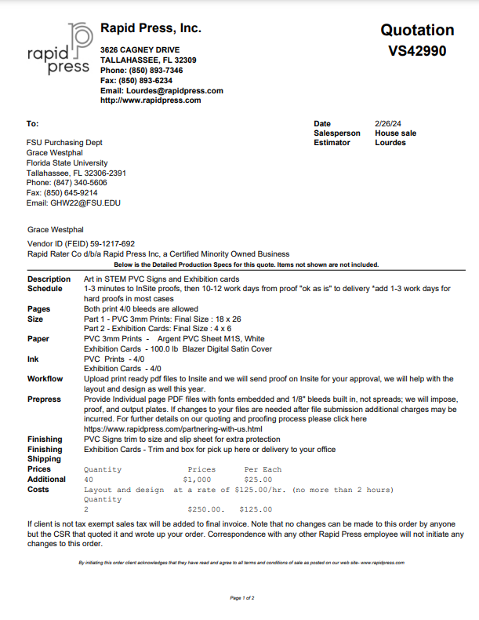

FLORIDA STATE UNIVERSITY
CONGRESS OF GRADUATE STUDENTS
Allocation, Revision, or Transfer

32nd Congress of Graduate Students

Bill #: 18

Sponsored by: Rep. Hussain

Date: March 4, 2024

Amount: $ 3044
From (account name): COGS Unallocated
To (account name): Bangladeshi Student Association
Purpose & Description:
The Bangladeshi Students Association at Florida State University (BSA) requests support from COGS for the “Eid & Bengali New Year” program, which will be held on April 14, 2024. This program is designed to unite students from Bangladesh and the broader university community to celebrate two significant cultural events in a joyous and inclusive atmosphere.
Eid, also known as Eid al-Fitr, is a joyous Islamic festival celebrated by millions of Muslims worldwide. The festival marks the end of Ramadan, the holy month of fasting and prayer. Eid is a time for Muslims to come together with family and friends, expressing gratitude for the blessings received during Ramadan and seeking forgiveness for any shortcomings. The day begins with a special prayer, often held in large congregations, followed by festive gatherings, feasting, and the exchange of gifts.
Pohela Boishakh, the Bengali New Year, is a vibrant and colorful celebration with immense cultural significance for Bengali communities. The festival marks the beginning of the Bengali calendar year and is observed with enthusiasm and traditional festivities. Pohela Boishakh typically falls in mid-April, and lively processions, cultural performances, traditional music, dance, and an array of delicious Bengali cuisine characterize its celebration.
The fusion of Eid and the Bengali New Year serves multiple aims, fostering a sense of unity, cultural exchange, and community engagement:
- Cultural Fusion and Identity Celebration: This fusion allows students to express their religious and cultural identity in a cohesive manner, emphasizing the harmony between religious traditions and cultural festivities. It becomes a unique platform to share the multifaceted aspects of Bangladeshi heritage with the broader university community.
- Community Building and Inclusivity: It provides an opportunity for students to come together, celebrate their shared cultural background, and strengthen the bonds of friendship and community. The event promotes inclusivity and cross-cultural understanding by extending the invitation to fellow students, faculty, and staff at the university, fostering connections beyond the Bangladeshi community.
- Educational and Cross-Cultural Exchange: Through interactive displays, traditional performances, and cultural exhibitions, the event aims to enlighten attendees about the significance of both Eid and Pohela Boishakh. This cross-cultural exchange contributes to a more informed and culturally aware university environment, breaking down stereotypes and promoting unity in diversity.
- Global Engagement and Representation: By organizing joint events for Eid and Pohela Boishakh, the Bangladeshi student community actively participates in the university's broader cultural landscape. This global engagement contributes to a more inclusive and interconnected campus, fostering an environment where students from diverse backgrounds can learn from and appreciate each other's traditions.
The one-day event will consist of a Bengali New Year parade, a lunch, and a cultural event, which will promote understanding and appreciation of Bangladesh's rich heritage. Additionally, the program serves as an educational platform for the broader university community, allowing them to learn about and engage with the cultural diversity that Bangladeshi students bring to campus. By organizing such events, the Bangladeshi Students Association not only celebrates their cultural identity but also contributes to the multicultural fabric of the university.
Organization Members: 91
Date: April 14, 2024
Location: FSU Lakefront Park & Retreat Center
Estimated Attendance of Event: 200
Advertisement:
To ensure widespread awareness and participation, we will advertise this event via various channels, including our Facebook page, Instagram account, emails, and Telegram group. To promote the event, we also plan to distribute flyers, continuing our traditional advertising approach.
Funding Request:
They are requesting support from the Congress of Graduate Students for $3044 to host a lunch, decorate the event, and distribute t-shirts for the event. This fund will be combined with the previously allocated funds from COGS (RSO’s Budget), which is $2500. The total budget ($5543.02) will be used to arrange this program. The lunch serves as a meal for the guests attending the event, which will also help to connect with Bangladeshi cuisines, tastes, and traditions. The T-shirt will be provided to all the event attendees and act as promotional merchandise promoting the activities of COGS and BSA. They will also use COGS funding to create decorative props used in the parade and photoshoots.

Itemized Expenditures:
Item | Description | Unit Price
Food | Lunch (Persis):  Soft Drinks  Dessert | 2759.23
T-shirts | With association logos | 2175.00
Utensils | Plate  Spoon and Forks | 79.25
Decorations |  | 529.54
Total |  | 5543.02
Available Funds in Nole Central |  | 2500
Resquested Fund |  | 3043.02
This document contains the quotes for the lunch, T-shirts, and decorations, which will be provided at the “Eid & Pohela Boishakh” Program.
Flyer:

- Food Quote:
- Lunch from Persis
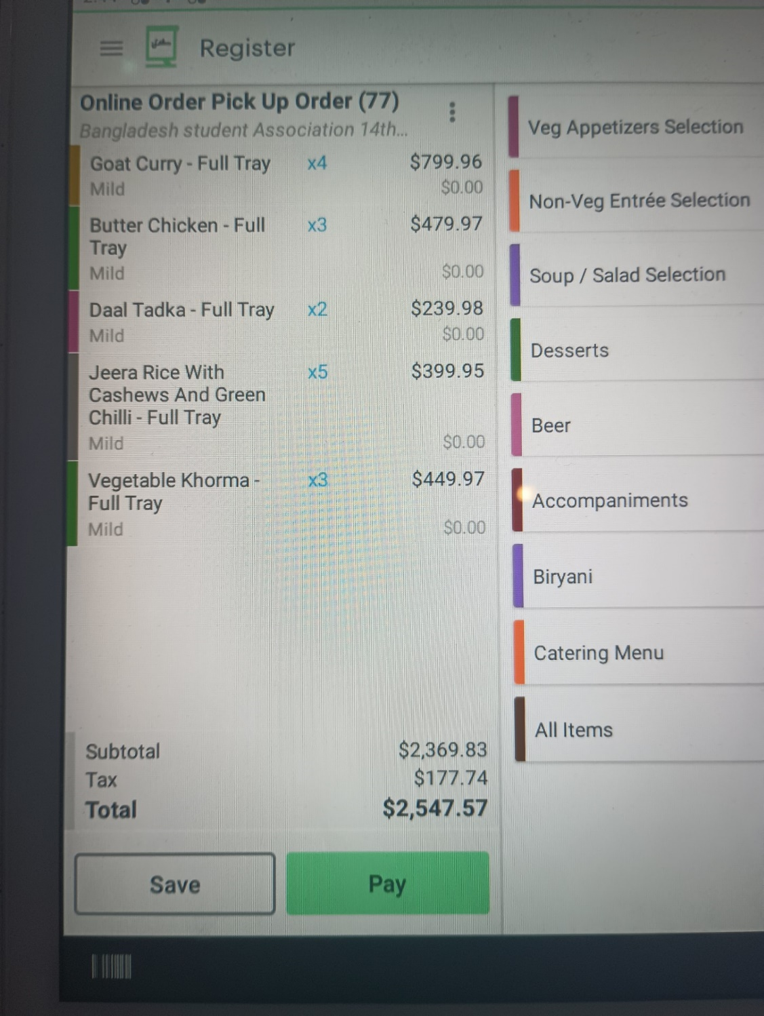

- Dessert: Rice pudding
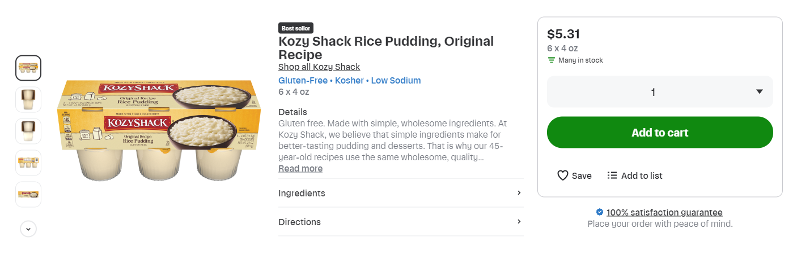
- Soft Drinks
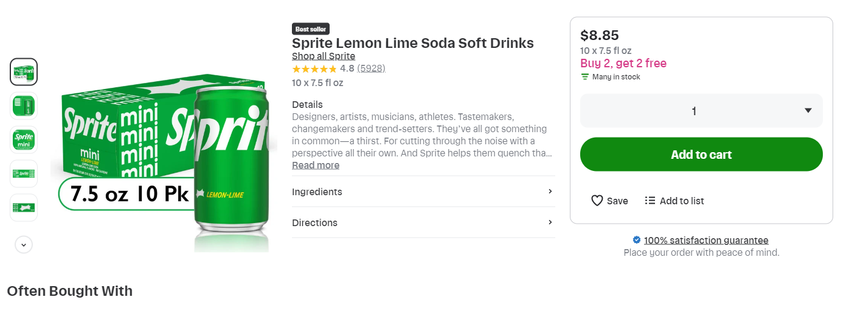
Item | Details | Unit price | quantity | Price (USD)
Lunch from Persis | Jeera Rice, Vegetable Korma, Butter Chicken, Goat Curry, and Dal Tadka |  |  | 2369.83
Dessert: Rice Pudding | Kozy shack original recipe rice pudding (Publix) | 5.31 | 40 | 158.8
Soft drinks | Coca-Cola Mini (Publix) | 8.85 | 10 | 63.4
 | Sprite mini (Publix) | 8.85 | 10 | 61.08
Total |  |  |  | 2759.23

- Utensil Quote:
- Plates
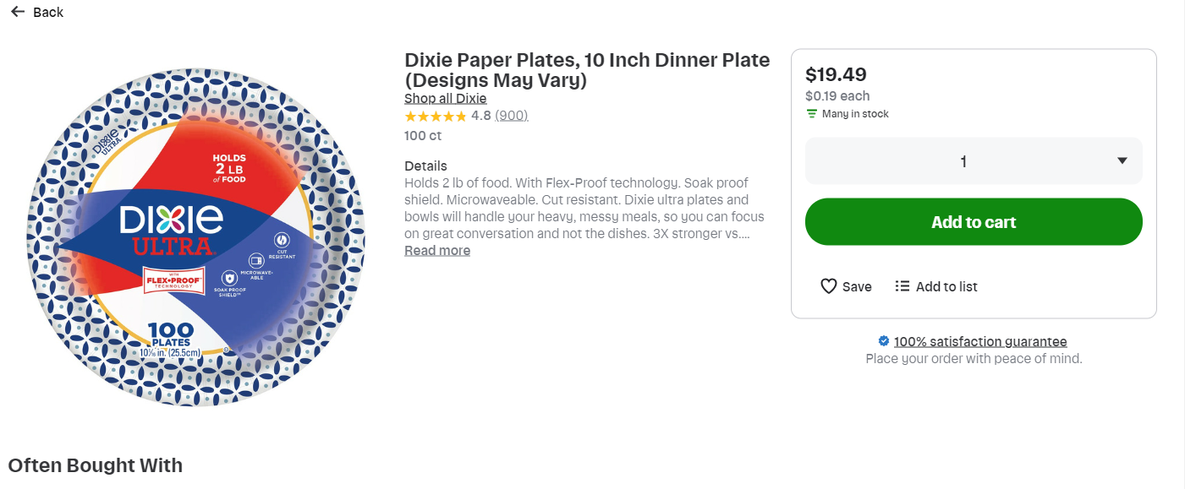
- Spoon and forks
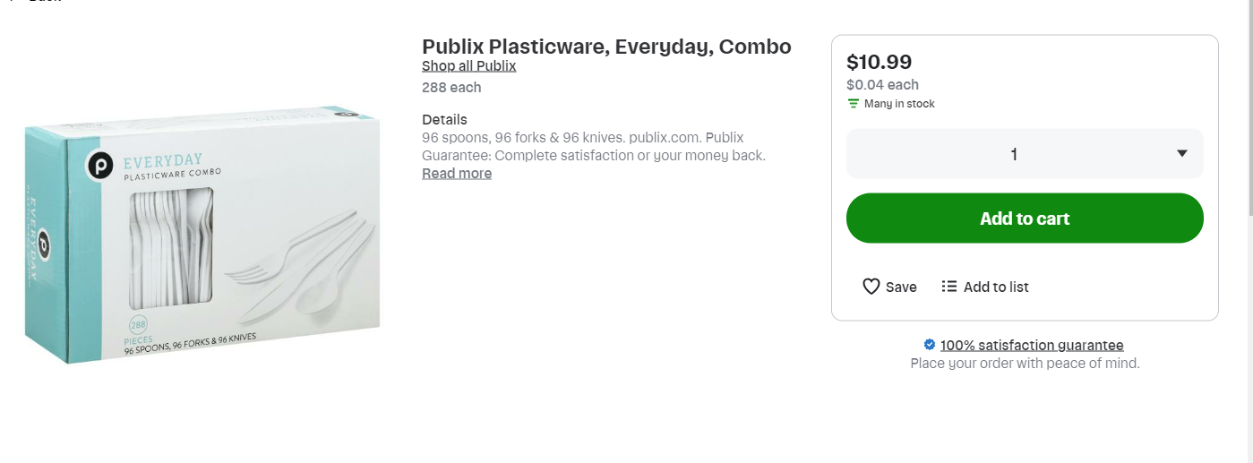
- Napkins
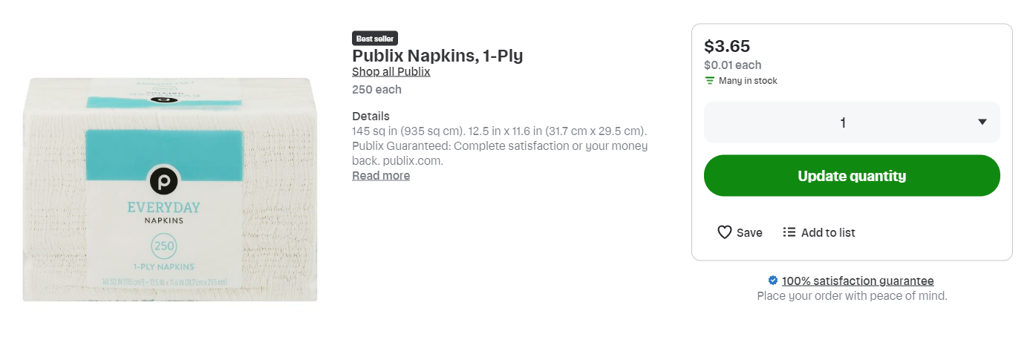
Item | Details | Unit price | quantity | Price (USD)
Plates | Dixie Paper plates | 19.49 | 2 | 27.96
Spoon and Forks | Publix Plasticware, Everyday, Combo | 10.99 | 3 | 20.64
Napkin | Publix Napkins | 3.65 | 2 | 7.3
Total |  |  |  | 79.25

- T-shirt Quote
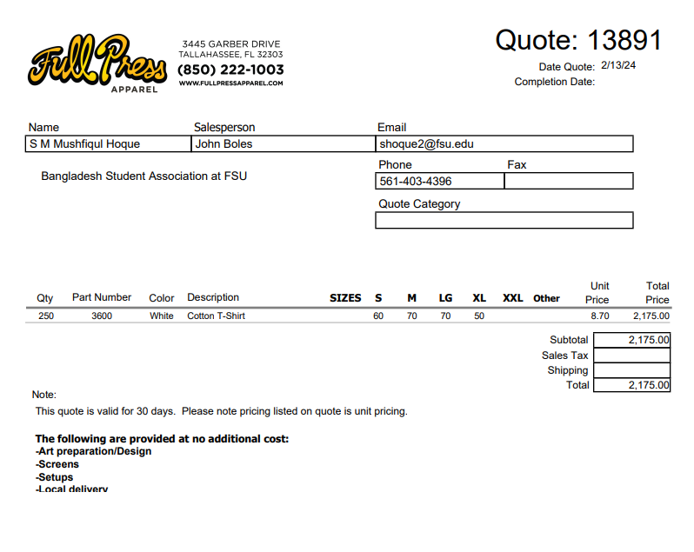
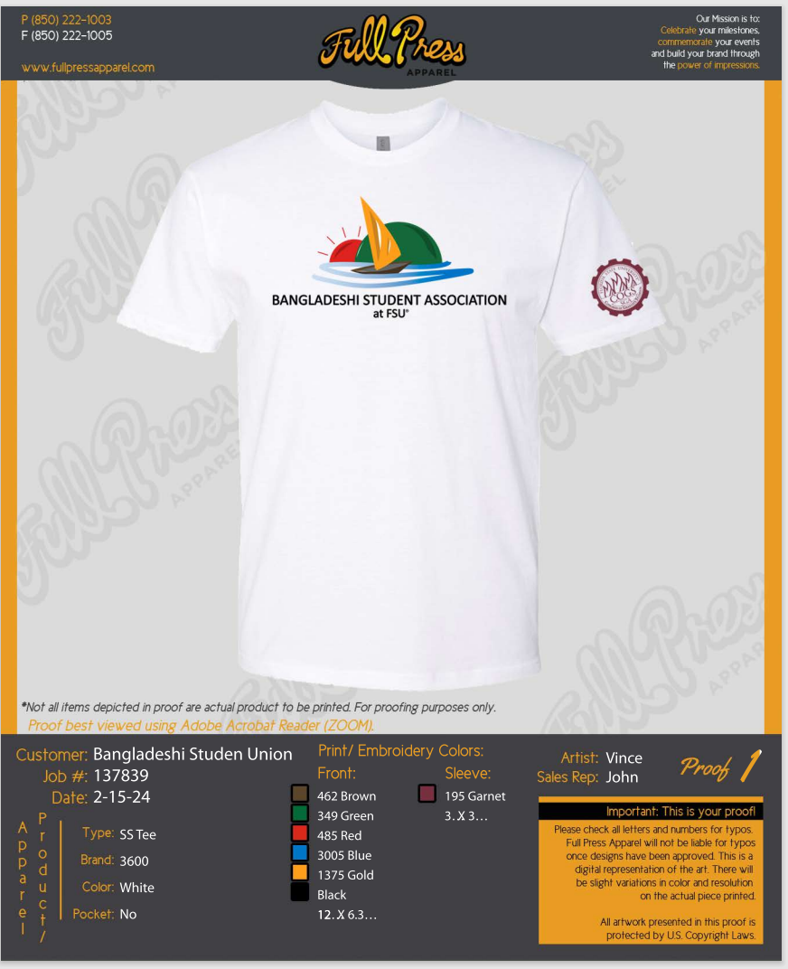

- Decoration Quote
Item | Details | Unit price | quantity | Price (USD)
Bubble solution | Sunny days 6 pack bubble solution | 7.04 | 2 | 14.08
Masks | BULU animal masks | 9.99 | 1 | 9.99
 | SSZS animal party masks | 15.95 | 2 | 31.9
Pinwheels | 12-pack rainbow pinwheel | 9.99 | 2 | 19.98
Flower Garland | BUSOHA 4 pack Tissue flower garland | 13.99 | 2 | 27.98
Picture Frame Prop | LUOEM Party frame Photo | 9.99 | 2 | 19.98
Colored tissue paper | Colored tissue paper bulk | 14.99 | 1 | 14.99
Board Sheets | 10 chipboard sheet | 9.99 | 1 | 9.99
Colored Paper | A4 Colored paper sheets | 10.99 | 2 | 21.98
Scotch Tape | Clear Tape Rolls | 11.96 | 1 | 11.96
Color | Colorations washable paints | 19.73 | 1 | 19.73
Glue Sticks | Amazon Basics Glue | 9.53 | 1 | 9.53
Streamers | 8 roll creep paper streamers | 7.99 | 3 | 23.97
Flower hanging | Paper pompoms flower hanging | 14.99 | 3 | 44.97
Fringe Curtain | CHRORINE 2pcs Tinsel Foil Fringe Curtain | 12.99 | 2 | 25.98
Paper Lanterns | Zilue paper lanterns | 16.99 | 1 | 16.99
 | Eid Mubarak Lanterns | 9.99 | 1 | 9.99
Banner | Eid Mubarak Banner | 9.97 | 1 | 9.97
Permanent marker | Colorful permanent markers | 11.99 | 1 | 11.99
Chalk | Amazon Basics Dustless chalk | 11.99 | 1 | 11.99
Photobooth prop | LUOEM photobooth props | 11.89 | 3 | 35.67
Decoration Garland | Navy blue gold moon star decoration garland | 13.99 | 2 | 27.98
Game Set | 3-set carnival game combo set | 39.99 | 1 | 39.99
Plush animal toy | Axbotoy Plush animal toy | 28.98 | 2 | 57.96
Zip tie | Zip tie 8 inch | 16.99 | 1 | 16.99
Total |  |  |  | 546.53

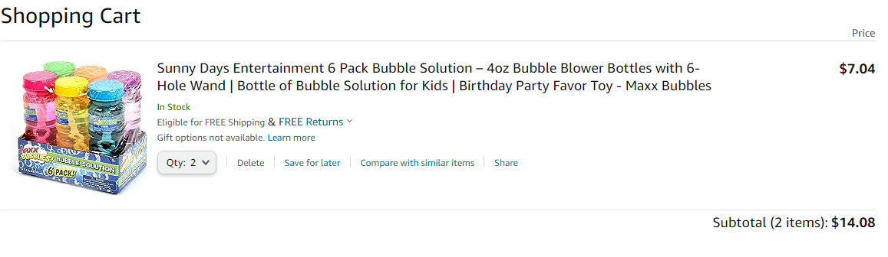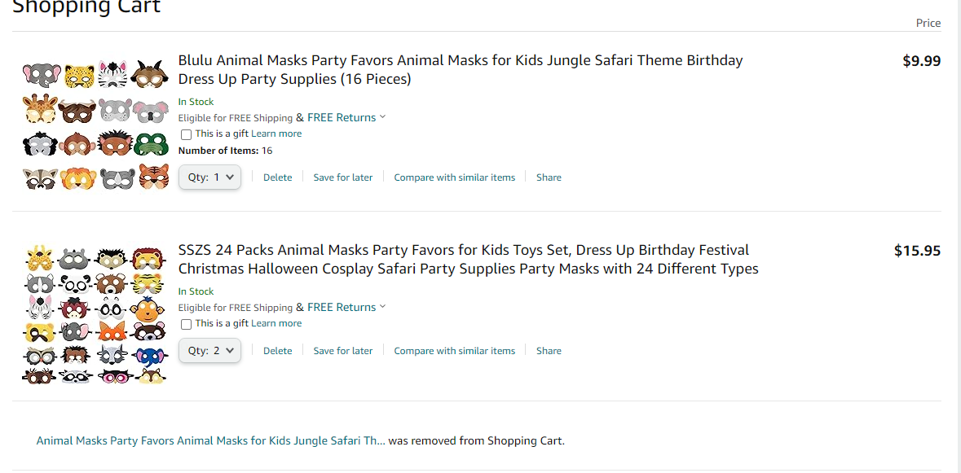
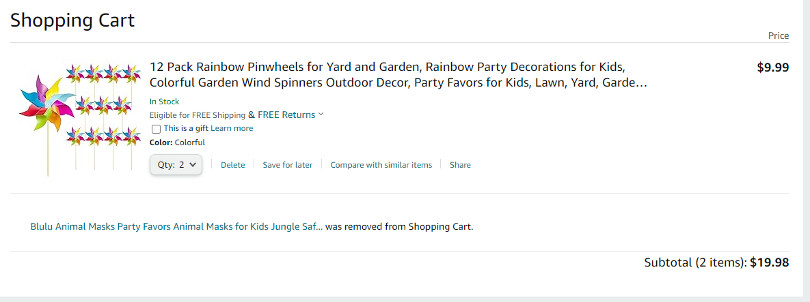
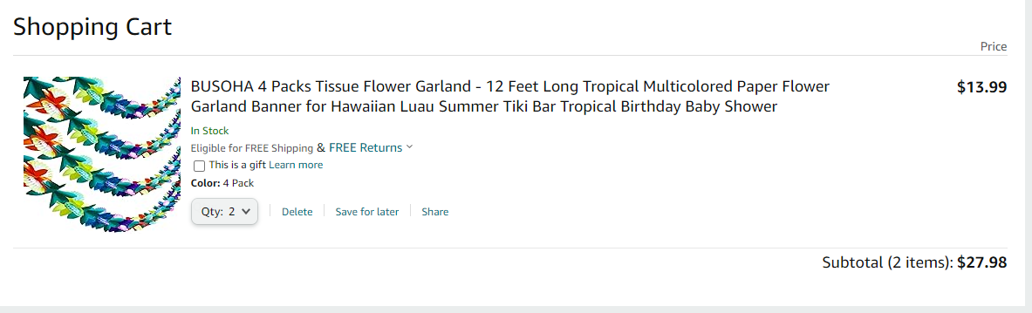
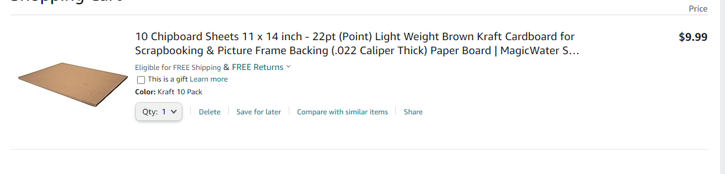
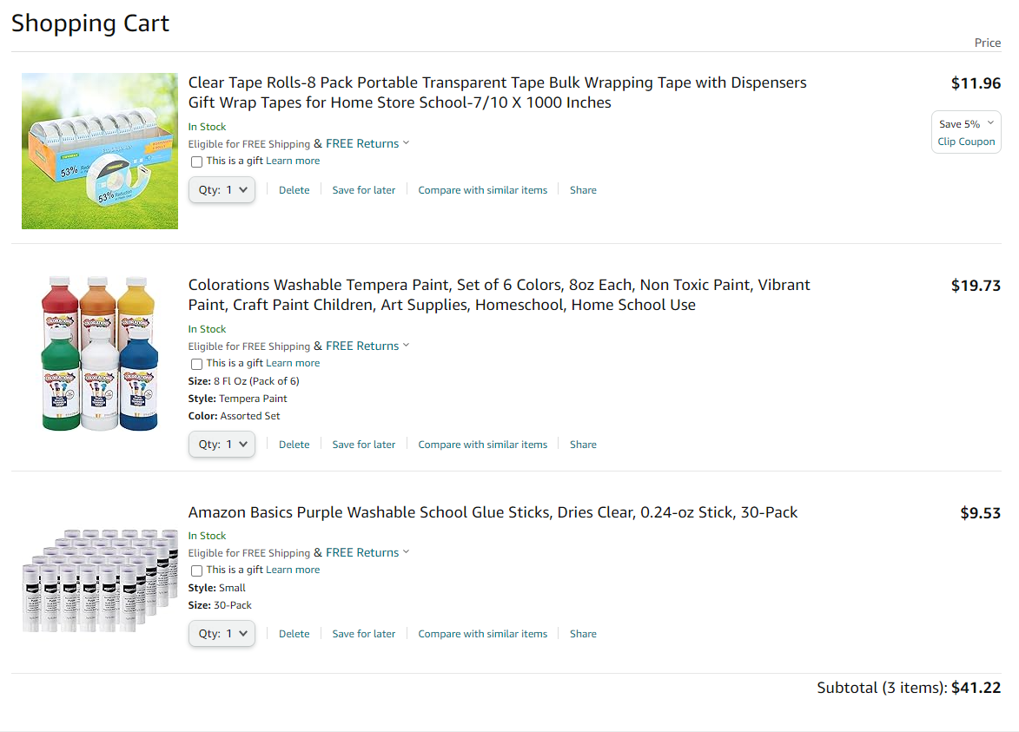
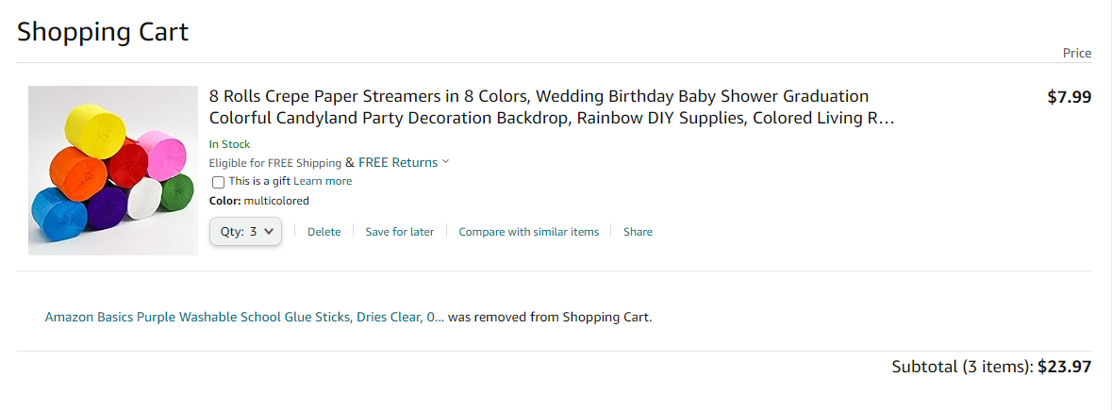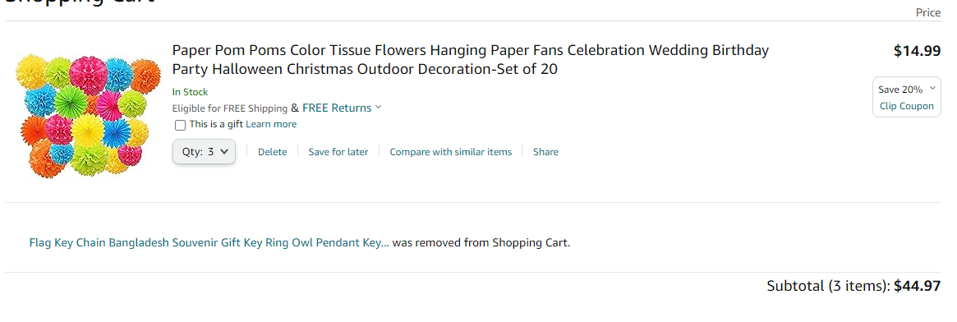

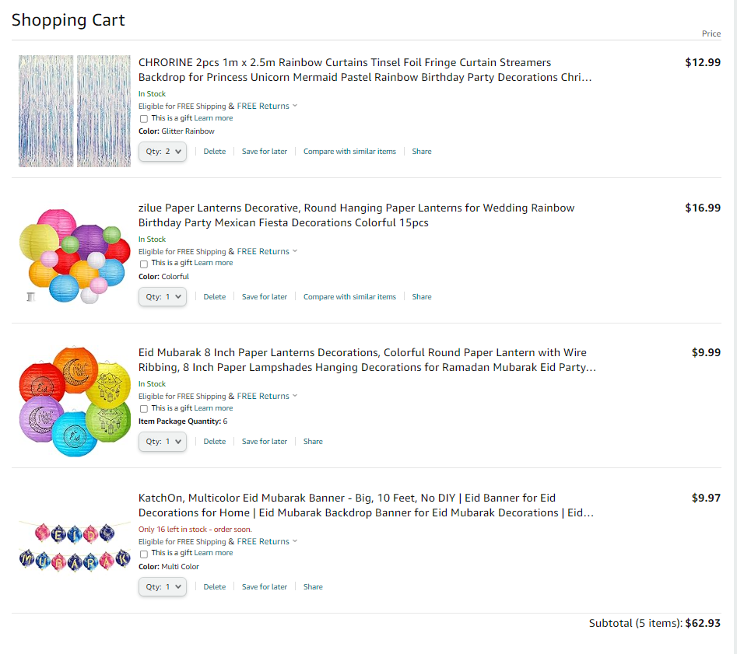
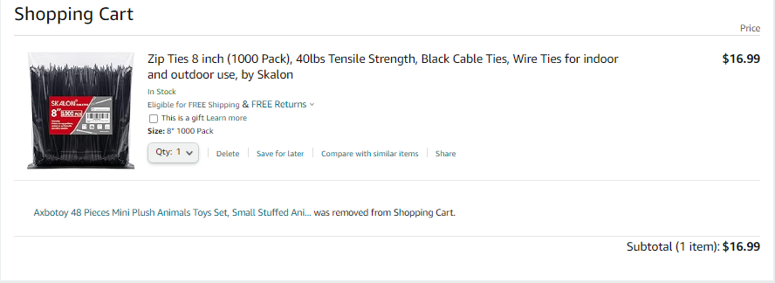
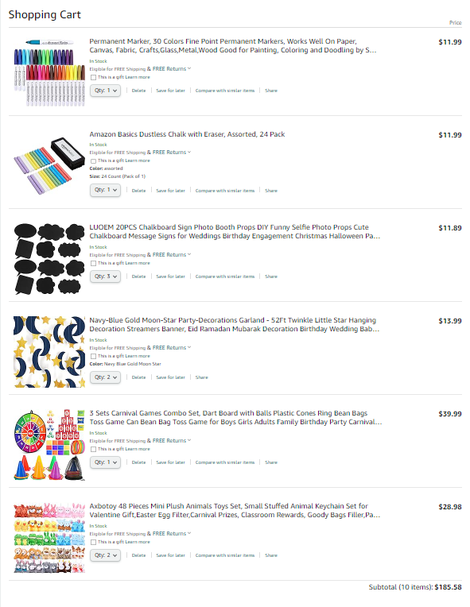

FLORIDA STATE UNIVERSITY
CONGRESS OF GRADUATE STUDENTS

Allocation, Revision, or Transfer

32nd Congress of Graduate Students

Bill #: 19

Sponsored by: Representative Burns

Date: March 4, 2024

Amount: $4,500

From (account name): Unallocated

To (account name): LSC

Purpose & Description: To transfer funds from the unallocated account to the Law Student Council account.

FLORIDA STATE UNIVERSITY
CONGRESS OF GRADUATE STUDENTS

Allocation, Revision, or Transfer

32nd Congress of Graduate Students

Bill #: 20

Sponsored by: Representative Burns

Date: March 4, 2024

Amount: $4,500

From (account name): Unallocated

To (account name): MSC

Purpose & Description: To transfer funds from the unallocated account to the Medical Student Council account.

FLORIDA STATE UNIVERSITY
CONGRESS OF GRADUATE STUDENTS
Allocation, Revision, or Transfer

32nd Congress of Graduate Students

Bill #: 21

Sponsored by: Representative Burns

Date: March 4, 2024

Amount: $2,400

From (account name): Unallocated

To (account name): COGS Administration

Purpose & Description: To transfer funds from the unallocated account to Congress of Graduate Students Administration account.

FLORIDA STATE UNIVERSITY
CONGRESS OF GRADUATE STUDENTS
Allocation, Revision, or Transfer

32nd Congress of Graduate Students

Bill #: 22

Sponsored by: Representative Burns

Date: March 4, 2024

Amount: $3,000

From (account name): Attendance Grants (November 2023 – February 2024)

To (account name): Presentation Grants (March – June 2024)

Purpose & Description: To transfer funds from the November 2023 – February 2024 attendance grants account to the March – June 2024 attendance grants account.

FLORIDA STATE UNIVERSITY
CONGRESS OF GRADUATE STUDENTS
Allocation, Revision, or Transfer

32nd Congress of Graduate Students

Bill #: 23

Sponsored by: Representative Burns

Date: March 4, 2024

Amount: $7,000

From (account name): Presentation Grants (November 2023 – February 2024)

To (account name): Presentation Grants (March – June 2024)

Purpose & Description: To transfer funds from the November 2023 – February 2024 presentation grants account to the March – June 2024 presentation grants account.

FLORIDA STATE UNIVERSITY
CONGRESS OF GRADUATE STUDENTS

Allocation, Revision, or Transfer

32nd Congress of Graduate Students

Bill #: 24

Sponsored by: Representative Burns

Date: March 4, 2024

Amount: $1,474.63

From (account name): Attendance Grants (November 2023 – February 2024)

To (account name): COGS Administration Clothing & Awards

Purpose & Description: To transfer funds from the November 2023 – February 2024 attendance grants account to Congress of Graduate Students Administration Clothing & Awards account.

FLORIDA STATE UNIVERSITY
CONGRESS OF GRADUATE STUDENTS
Allocation, Revision, or Transfer

32nd Congress of Graduate Students

Bill #: 25

Sponsored by: Representative Burns

Date: March 4, 2024

Amount: $8,023.62

From (account name): Presentation Grants (November 2023 – February 2024)

To (account name): COGS Administration Clothing & Awards

Purpose & Description: To transfer funds from the November 2023 – February 2024 presentation grants account to Congress of Graduate Students Administration Clothing & Awards account.

FLORIDA STATE UNIVERSITY
CONGRESS OF GRADUATE STUDENTS
Allocation, Revision, or Transfer

32nd Congress of Graduate Students

Bill #: 26

Sponsored by: Representative Burns

Date: March 4, 2024

Amount: $9,150

From (account name): Attendance Grants (July – October 2023)

To (account name): Unallocated

Purpose & Description: To transfer funds from the July – October 2023 attendance grants account to the unallocated account.

FLORIDA STATE UNIVERSITY
CONGRESS OF GRADUATE STUDENTS

Allocation, Revision, or Transfer

32nd Congress of Graduate Students

Bill #: 27

Sponsored by: Representative Burns

Date: March 4, 2024

Amount: $20,500

From (account name): Presentation Grants (July – October 2023)

To (account name): Unallocated

Purpose & Description: To transfer funds from the July – October 2023 presentation grants account to the unallocated account.

FLORIDA STATE UNIVERSITY
CONGRESS OF GRADUATE STUDENTS
THIRTY-SECOND CONGRESS OF GRADUATE STUDENTS
Assembly Meeting
February 19, 2024
6:30pm
Minutes
Call to Order: 6:38pm
Pledge of Allegiance: Rep. McCraney
Roll Call: Present: Alleyne, Balak, Balogun, Barber, Burns, Cyrille, Delva, Ebuara, Galeano, Hussain, McCraney, Medarev, Nord, Rogowski, Rowan, Siegel, Solmaz, Vaughn, Velez, Wardlow
Absent Excused: Pakdehi, Wesner, Wheeler
Reading and approval of the Minutes: Burns, 2nd - Rogowski
Petitions into the Assembly:
Elisabeth Schumm, Students with Disabilities Advocate
First year masters student in the Higher Education department. Got undergraduate degree at FSU. Has served as an officer within various RSOs. Works in Housing. Has seen the hurdles students with disabilities have at this institution. With ADHD, understands the struggle of where to start to access resources on campus. It can be different from student's undergrads. FSU has made positive strides, but there is room for more accessibility on campus. There are cramped classrooms and not enough signs. Wants to implement meaningful change for accessibility. Wants to work with those on campus to make change.
Jared Bethke, Social Sciences and Public Policy Seat 2
First year Masters student. Went to FSU for undergrad. Experience with Student Government through the Union Board. Has experience with budgeting and has experience with working with RSOs. Wants to continue to engage and give back to FSU. Always interested in serving as a public servant. Passionate to let students know about the resources that are on campus. Wants to spread the word about access to resources that can help them. Passionate about transportation and wages.
Q&A for both:
Rowan - What committee are you interested in joining? Schumm - Student Affairs; Bethke - Student Affairs or Internal Affairs
Rowan - Would you be interested in joining the budget committee? Both - yes
Rogowski - Are you free on Mondays? Both- yes
Ebuara - How long will you be there? Both - a year and a half as they finish their program.
Rowan - Are you financially certified? Schumm - yes; Bethke - working on it.
Pros: Cyrille - They were both very prepared and I hope they put that same effort into COGS.
Balak - They both spoke well and had good plans. Schumm spoke about needing more visibilities for disability assistance which is good.
Solmaz - It is good that Bethke has experience with budget.
Burns - I am in the higher ed program with Liz and I think she will do a great job.
Galeano - They have very clear short term goals which is important.
Barber - I think both are wonderful and I would like someone else from my college.
Delva - They have previous experience on campus which is useful coming into COGS. I'm positive they will be a good influence in COGS.
Rogowski - Call to Question; Solmaz - 2nd
Vote: Schumm - 20-0-0
Bethke - 20-0-0
Swearing in of new representatives.
Special Introductions and Student Comments: N/A
Messages from Student Government: N/A
Report from the Office of Governmental Affairs: N/A
Report of Officers:
- Report of the Speaker: Internal Affairs is working on a spring retreat. The preferred date was March 23rd, but we will put out a poll about that event. Staying in communication with the SGA Treasurer. The deal is still being worked on. This will not impact our budget process. You may have gotten an email about the childcare center over the past week or seen information on the GroupMe. Here is some information so that you know what is going on. I toured the childcare center back at the start of the semester. They mentioned that many students get work experience there. It is a huge part of the COGS budget and we wanted to try to decrease the burden on COGS and find other ways to help the childcare center get funding. We met with the DSA in late January for support in asking academic deans to help fund the center. DSA did not provide support during that meeting. Instead, we were asked to make a promise that the funds for the childcare center would not be cut. We could not make this promise because it is the budget committee who approves it. An email was sent to the parents suggesting that COGS might have zero funding. This is not true. We are trying to keep the funding the same and look for more stable funding to help the center. I am concerned by the response this has generated. They have the right to be concerned. We have tried to set the record state through an email response. I am concerned about this response from the DSA. During the budget process, many people will ask for things. It is the budget committee that sets the budget. We will have the budget process over the next few weeks. Even if you aren't on the committee, I encourage you to attend the deliberations on March 29th so that you know what the process is. If you have questions about the childcare center, please speak to myself or Josh.
- Report of the Deputy Speaker for Finance: Are there any questions about what Jack just said about the childcare center? Delva - thank you for sharing that because I had classmates come up to me about this. Vaughn - Point of information, the Childcare Center has gotten grants. Delva - Can we send all of the parents this correction email? Rowan - We do not have the list of who was sent this. We can share out the form letter with representatives so everyone knows what we are saying. Hussain - I also had those questions. I think having that statement will be good to have. Alleyne - Have you reached out to the College of Social Work and College of Ed? Rowan - We have only gotten a response and meeting with the College of Communications. Balak - What do next steps look like? Rowan - We will see if any colleges are willing to help, but otherwise it will go to the budget committee. Delva - How did the misunderstanding happen? Rowan - I can't speak for the motivations of administrators within DSA. Solmaz - Why can't we throw them under the fire? Why are we protecting these Deans? It feels horrible to be in this position. Rowan - I understand that and at this point, this issue is wrapped up in other financial issues. I will speak for myself, but I think right now we are trying to correct the record. We want to make sure that everyone has the correct information. Vaughn - We did not see the initial email and it took a long time for us to see it. Rowan - We started to see emails last week all at once. Nord - What did you say and how was it stated in the email? Burns - We could not make any promises about the budget because we do not have that power. We shared that the budget committee would be who makes that decision. Personally, I think it is a concerning place to be in. Rowan - It is the concern that this funding is part of the budget committee and that is why we are looking at other sources. Colleges have more stable positions and understanding. COGS changes every year. Nord - could this be put into code that the childcare center gets so much money? Rogowski - no line items are put into Code and this should not be because our allocation changes every year. Our amount goes up or down every year. Rowan - The instability of funds was talked about in a past task force because it is problematic for the Globe and Childcare to get so much money from COGS. Alleyne - How long have they been getting money from COGS? Rogowski - not long. It was because of amendment 10. There has been a lot of miscommunications between COGS and the center. We are giving them a lot of money per head to benefit some graduate students. Rowan - The funding is going to students using the center who are undergraduate as well. There is no funding on the Senate side. Solmaz - I'm confused about how many graduate students are using the center. Rogowski - We like to know how much money goes per person for events. Rowan - 70 children of graduate students are at the center at this moment. Rogowski - it's $200,000 for 70 children of graduate students. Balak - How did we start paying for this? Rogowski - We have always paid part of it. In order to pass amendment 10 which gave us more access to A&S fees, we took on the center and the Globe. Rowan - There was a net benefit at the time, but now wages have increased and problems has arisen. Delva - A few years back, there were talks about there needing to be 50% of those in the childcare center being children of graduate students. We did fund the center, but every time we talk about them, something happens. The conversations are always difficult. They always want the guarantee, but we can't do that. Alleyne - Their website doesn't say that tuition is free for students. Rowan - Every student gets free tuition. Vaughn - Lots of programs do not list that they have free things online to keep the amount of people going lower. Rowan - Please let us know if you have more questions later on. Burns - Our financial report is updated now. Our unallocated is higher due to sweepings funds. Our reimbursements for the grants is covered and the rest has been put into unallocated. This number might increase as well by the next meeting. Please share out funding with your RSOs. We will be approving the budget committee later on. We currently do not have an international student on the committee and we would like to if possible. Ebuara - I would like to be on the committee.
- Report of the Deputy Speaker for Communications: OGFA Event on February 29th - see email; name tags are in; making progress on our events for April
Advisor Announcements: Nothing currently that hasn't already been said. We are trying to support you about the emails.
Committee Introductions and Reports:
- Internal Affairs: Balak - we talked about the spring retreat. We have a bill tonight that is an addendum to the last meeting.
- Student Advocacy: Hussain - We talked about how to split up issues. I had collected signatures for the GAU and invited them to come to COGS. We should also pick up former issues. Our pending tasks have been listed and we will collect graduate student needs - will go out in a Qualtrics survey. We will meet the last Monday of the month.
- Student Affairs: Vaughn - We are continuing to work on events for April like the food trucks and bowling event.
Funding Requests:
Bill #15: Iranian Student Association
This is a little different type of bill. They are requesting funding for an event, but plan to refund this amount back to COGS through tickets being sold to non-student attendees. The event is Nowruz which is the Iranian New Year and first day of Spring. They will be sharing cultural history and they hope to unite students, faculty, and the community together. They will showcase arts like music and poetry. The event will be in the Student Union. The attachment has all the details.
Questions:
Balogun - I have a lot of questions because this is a huge funding. Have you organized this in the past and how many people attended? Is COGS giving this out as a loan? What if you do not have enough tickets sold? Rowan - There are provisions that A&S fees can be used to fundraise and then be reimbursed. This is what will happen here. If funded, the logistics will be discussed. Balogun - What about past events attendance? In the previous year, we had similar numbers. More graduate students came this year. We had Yalda Night and that helped us come up with the Nowruz number. Past events also helped come up with number. Past tickets have been higher and with the COGS funding, the tickets can be lower.
Motion to extend time by 5 min - Rogowski; Delva - 2nd.
This event was held outside the campus in the past. It's not just for Iranians. There are other countries that share in this celebration.
Hussain - I see things about fish tanks, is this part of the culture? Yes.
Rogowski - I'm still confused about the fundraising portion. Rowan - they estimate that they will make around $3,000 that will go back into Unallocated. I almost think about it as an advance where they will pay some of it back. Rogowski - Why bother and just not ask for the money back, and have the event be free? Rowan - We can discuss this. Rogowski - Would you be comfortable having the event free for all? We would like to, but we also know that there will be many community members attend.
Balogun - I agree with Susan, but if we are expecting something back, will we get it back and will this add pressure?
Solmaz - How many graduate students will attend? Around 100.
Pros:
Rogowski - We have $27,000 in Unallocated. We will have more going in. I'm all for big ticket items and I don't want money to go to sweepings. This is cross cultural. I want to sponsor the whole thing.
Galeano - This will benefit graduate students and we don't want orgs to worry about graduate student families. We should just fund everything and not worry about them collecting money. This is their New Year holiday.
Delva - I agree with both of them. It seems like at least 50% will be graduate students there, so it should follow the code. It's a great way for graduate students to learn.
Balogun - We need more students organizing programs like this. We want students to have fun. We should support the whole bill.
Con:
Galeano - if tickets are sold, then some people might not go.
Rowan - we can add a proviso that no tickets will be sold.
Pro:
Rogowski - motion to amend to add proviso language that says "The Iranian Student Association will not sell tickets for the event"; 2nd - Galeano.
Motion passes.
Hussain - Why is the RSO paying the student union? It's because of the ballroom being used.
Con: Rogowski - call to question; Hussain - 2nd.
Vote: 21-0-1
Unfinished Business:
Deputy Speaker for Judicial Affairs - call for nominees: N/A
New Business:
Approval of the Budget Committee
Joshua Burns, Chris Cyrill, Jack Rowan, Maddie Siegel, Frank Velez, Francis Ebuara, Elisabeth Schumm, Jared Bethke
Motion to Approve - Rogowski; 2nd - Hussain
Committee will meet at the end of the meeting.
Bill #16: C-SAC Glitch Fix
Remember last week's bill? We didn't delete everything about C-SAC and this fixes it.
Questions: None
Pros: None
Cons: Call to Question - Galeano; 2nd - Alleyne
Vote: 21-0-0
Round Table:
Adjournment: 7:59pm
Next Meeting: March 4, 2024 at 6:30 p.m. Senate Chambers (3rd floor Student Union)

