FLORIDA STATE UNIVERSITY

CONGRESS OF GRADUATE STUDENTS



**THIRTY-SECOND CONGRESS OF GRADUATE STUDENTS**

Assembly Meeting

February 19, 2024

6:30pm

Agenda

**Call to Order:**

**Pledge of Allegiance:**

**Roll Call:**

**Reading and approval of the Minutes:**

**Petitions into the Assembly:**

*Elisabeth Schumm, Students with Disabilities Advocate*

*Jared Bethke, Social Sciences and Public Policy Seat 2*

**Special Introductions and Student Comments:**

**Messages from Student Government:**

**Report from the Office of Governmental Affairs:**

**Report of Officers:**

* Report of the Speaker:
* Report of the Deputy Speaker for Finance:
* Report of the Deputy Speaker for Communications:

**Committee Introductions and Reports:**

* C-SAC:
* Internal Affairs:
* Student Advocacy:
* Student Affairs:

**Funding Requests:**

*Bill #12: Iranian Student Association*

**Unfinished Business:**

*Deputy Speaker for Judicial Affairs - call for nominees*

**New Business:**

*Approval of the Budget Committee*

*Bill #13: C-SAC Glitch Fix*

**Round Table:**

**Adjournment:**

Next Meeting: **March 4, 2024 at 6:30 p.m. Senate Chambers (3rd floor Student Union)**

**COGS Financial Report, Fiscal Year 2023-2024**

|  |  |  |  |
| --- | --- | --- | --- |
| **ACCOUNT** | **ALLOCATION AMOUNT** | **DESCRIPTION** | **BALANCE** |
| UNALLOCATED | $21,318 | For RSO funding requests at COGS meetings | $27,010.30 |
| LSC | $61,000 | Funding allocations from Law School Council to Law School Student Organizations | $2,584.76 |
| MSC | $84,817 | Funding allocations from Medical School Council to Medical School Student Organizations | $6,344.55 |
| PRESENTATION GRANTS (Jul-Oct) | $66,250 | Presentation Grant balance for the July-October funding period | $24,150.00 |
| PRESENTATION GRANTS (Nov-Feb) | $75,000 | Presentation Grant balance for the November-February funding period | $15,523.62 |
| PRESENTATION GRANTS (Mar-Jun) | $58,750 | Presentation Grant balance for the March-June funding period | $52,650.00 |
| ATTENDANCE GRANTS (Jul-Oct) | $9,000 | Attendance Grant balance for the July-October funding period | $6,250.00 |
| ATTENDANCE GRANTS (Nov-Feb) | $9,000 | Attendance Grant balance for the November-February funding period | $4,924.63 |
| ATTENDANCE GRANTS (Mar-Jun) | $7,500 | Attendance Grant balance for the March-June funding period | $6,300.00 |

FLORIDA STATE UNIVERSITY

CONGRESS OF GRADUATE STUDENTS



**Allocation, Revision, or Transfer**

**32nd Congress of Graduate Students**

**Bill #:** 12

**Sponsored by:** Gizem Solmaz

**Date:** February 19, 2024

**Amount:** $ 7,292 (Some of this money will be reimbursed through selling tickets to families)

**From (account name):** COGS Unallocated

**To (account name):** Iranian Student Association (ISA)

**Purpose & Description:** The FSU Iranian Student Association is planning to host a Nowruz Celebration at *Student Union Ballroom E* on *March 15th (from 6:30 PM - 11 PM)* to share the rich cultural heritage of Iran with the Florida State University community.

Nowruz, also known as the Persian New Year, marks the first day of spring and the beginning of the year in the Iranian calendar. Falling on the vernal equinox, Nowruz is a celebration of nature's rebirth, symbolizing new beginnings, renewal, and the revitalization of life. This ancient festival, which has roots in Zoroastrianism, is one of the oldest and most cherished festivities celebrated by Iranians and many other countries around the world.

Number of attendees: 260 people: We anticipate 150 students, 120 Iranian and 30 non-Iranian guests, plus 110 families, reflecting the multicultural celebration of Nowruz.

The Nowruz Celebration aims to:

**Educate**: Provide insights into the history, significance, and rituals associated with Nowruz, promoting a deeper understanding of this ancient celebration.

**Unite**: Bring together students, faculty, staff, and the broader Tallahassee community to foster cultural exchange and mutual respect.

**Showcase Art**: Highlight the rich cultural tapestry of Iran (Persia) through traditional music, dance, and visual arts.

**Build Community**: Strengthen the sense of community among Iranian students and those interested in Iranian culture through shared experiences and celebrations.

**Celebrate Key Themes**: Focus on themes of renewal, hope, and the joy of life, which are central to the spirit of Nowruz.

The Nowruz Ceremony is more than just an event; it’s a deep dive into the culture that has celebrated the Iranian New Year for thousands of years. At the heart of Nowruz, which is the most important celebration for Iranians, lies the Sofreh Haft Seen. This is a special setup with seven items, each starting with the letter "Seen" (س) in Persian. These items represent important wishes for the new year, like happiness, health, and wealth. Our goal is to create a space that not only showcases the tradition of Nowruz but also spreads its messages of renewal and togetherness.

**Advertisement:**  
We will advertise this event via various channels including our Facebook page, Instagram account, email, and our Telegram group to ensure widespread awareness and participation. To promote the event, we also plan to distribute flyers, continuing our traditional advertising approach.

**Funding Request:**

We kindly request a fund of $7,292 to support the Nowruz Celebration organized by the FSU Iranian Student Association. The funds will be used to cover expenses such as food for the participants and supplies for specific Nowruz decoration and activities like poetry recital.

The celebration of Nowruz allows us to highlight an important part of Iranian heritage and promotes cultural diversity and inclusiveness at FSU. Your contribution will help create a meaningful event that brings people together.

* Ticket prices for families will be $35 for adults and $15 for children. We've explored ticket sales through Zelle or Venmo, aiming for a straightforward transaction process where funds are deposited directly into the COGS account. We intend to issue receipts for these transactions, record guests' names, and confirm attendance at the door.

**Itemized Expenditures:**

|  |  |  |
| --- | --- | --- |
| **Quantity** | **Description** | **Unit Price** |
| Food | Dinner from 64Tally | $5,355 |
| Amazon | Necessary cultural items of the event | $638 |
| Publix | Flowers and Decoration for the event | $424 |
| Venue | Student Union Ballroom E | $875 |

Total: $ 7,292

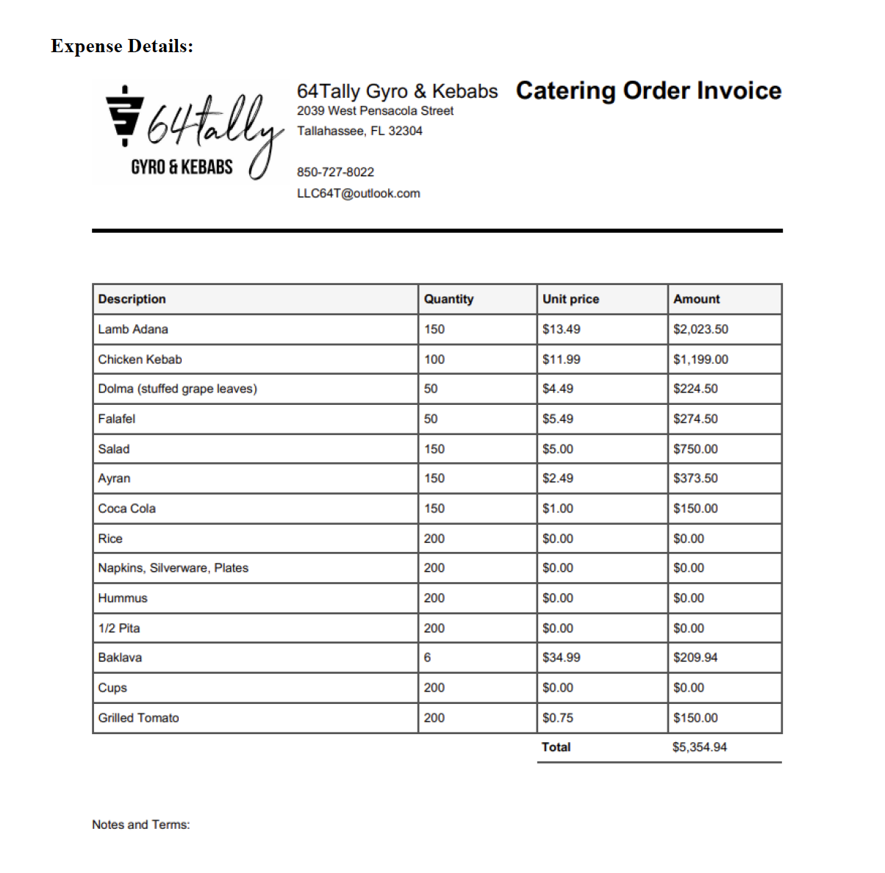

Total Price: $637.64



FLORIDA STATE UNIVERSITY

CONGRESS OF GRADUATE STUDENTS



**Statute Revision or Addition**

**32nd Congress of Graduate Students**

**Bill #:** 13

**Sponsored by:** Felix Balak

**Date:** February 19, 2024

**Purpose & Description:** A bill to remove the remainder of COGS Code language regarding C-SAC.

**Be it enacted by the Thirty-Second Congress of Graduate Students**:

**Section 1**: Chapter 210 of COGS Code shall be stricken, as follows:

~~C) If a speaker has been contracted by the Organization for the event for which funds were embargoed, this shall constitute sufficient assurances under §210.4, though sufficient assurances may be demonstrated in other ways as well.~~

~~D) If the event does not take place, the embargoed funds shall become available to C-SAC for general allocation.~~

~~210.6 C-SAC shall be empowered to establish guidelines for considering funding requests which may be amended by a majority vote of COGS; such amendments C-SAC may not amend. These guidelines shall be adopted or amended by a twothirds (66%) majority of the total number of C-SAC members. In forming the guidelines C-SAC shall keep in mind the unique mission of the Congress of Graduate Students and emphasize programs which expand academic opportunity over those which are purely social in nature.~~

~~210.7 Upon allocating funds, C-SAC shall present a Resolution to COGS for final approval.~~

~~C) This Resolution shall include a description of the allocation that C-SAC has made.~~

~~D) This Resolution shall be sponsored by the Chair of C-SAC who will speak in any instance of objection. If an objection is raised, the allocation is then debated by the Congress and approved by a majority vote.~~

FLORIDA STATE UNIVERSITY

CONGRESS OF GRADUATE STUDENTS



**THIRTY-SECOND CONGRESS OF GRADUATE STUDENTS**

Assembly Meeting

February 5, 2024

6:30pm

Minutes

**Call to Order:** 6:44pm

**Pledge of Allegiance:** Rep. Barber

**Roll Call: Present:** Balak, Balogun, Barber, Burns, Cyrille, Galeano, Hussain, Medarev, Nord, Pakdehi, Rogowski, Rowan, Vaughn, Wesner, Wheeler

**Absent Excused:** Delva, Ebuara, McCraney, Siegel, Solamz, Wardlow

**Late Excused:** Allenye, Velez

**Reading and approval of the Minutes:** Rogowski; 2nd- Cyrille

**Petitions into the Assembly:** N/A

**Special Introductions and Student Comments:**  N/A

**Messages from Student Government:** N/A

**Report from the Office of Governmental Affairs:** N/A

**Report of Officers:**

* Report of the Speaker: Not much tonight. Most everything is budget related. I wanted to say that I was at the FSU Day at the Capitol and SB 494 has passed through the Senate and is making its way through.
* Report of the Deputy Speaker for Finance: Shout out to Frank for bringing in more food. The financial report is attached to the agenda. If you are looking at presenting or attending at a conference, the grants for March-June open on the 7th. We have exciting news for our budget for 2024-25 and it is $1,247,767 which is higher than last year. Thank you to those who replied to the budget committee survey. For those who are interested in being on the committee, thank you for your time and interest. This has a major impact on this campus. We will vote in the members of the Budget Committee during our next COGS meeting. The final bill will be voted on during a meeting of the Congress.
* Report of the Deputy Speaker for Communications: reminder to committees that attendance is required and to let the chair know if you will be absent. Please check emails! Name tags have been ordered. As a reminder for those working on bills, bottled water is not allowed, so if you see that on a funding request, please let the RSO know.

**Committee Introductions and Reports:**

* C-SAC: N/A
* Internal Affairs: Met last Monday and will meet again next Monday. Discussed Bill #12 and #13 with changes to COGS statute and moving around money.
* Student Advocacy: Could not meet due to quorum not being met. Will be deciding on a time soon.
* Student Affairs: Met last Monday and will be meeting again next Monday. Have discussed events in planning during April.

**Funding Requests:**

*Bill #8: Iranian Student Association*

Pakdehi - We are wanting to have traditional cookies for an international bazar. We hope that you will come to the bazar and try the cookie.

Q&A: Rogowski - Does CGE pay for anything? No, they asked us to buy it.

Cyrille - When is the event? February 17th at the Globe.

Pros: Balak - I think FSU stands for all sorts of cultures, so this seems to be in line with that mission statement and I am all for it.

Burns - I think it another great event from the Iranian Student Association.

Cons:

Rogowski - Motion to Call to Question; 2nd - Burns

Closing - Please come to the event and take a cookie. They are very delicious!

Vote - 15-0-2

*Bill #9: Art Society at FSU*

Velez - This is a one year anniversary for the Art Society and they are asking for money to buy some food and drinks. They have a membership of 20 people this Friday. It's a one year anniversary to hang out and celebrate the year they have had.

Q&A: Rogowski - Will we be able to expedite this in time? We should be able to.

Pro: Rogowski - I remember last year when they came to us last year for an event and I am excited to see them back and that we can continue supporting them.

Cons:

Balogun - Call to Question; 2nd - Nord

Closing - I think this is a great event for the club and it's not a lot of money being requested.

Vote - 16-0-1

*Bill #10: Indian Student Association of Tallahassee*

Wesner - The ISAT is holding their Holi Festival on March 31st. They are requesting money for food, colors, Rez fees, etc. They expect a few hundred there. There were 400 people who attended the Diwali event and the same is expected for Holi. This is open for all students at FSU.

Q&A: Pakdehi - where is it? The Rez. Does it include families? It's mostly students.

Balogun - How will you advertise? At the international bazar and through social media.

Rogowski - How did you use the amount you were given during the budget process? It was used for Diwali.

Pros: Burns - I am excited for the event. It is great working with the ISAT. We look forward to next year's budget proposal.

Pakdehi - I think it's a very fun event.

Galeano - This event is amazing and it's been great seeing it grow over the years. It's become a FSU tradition and we should continue to support it.

Rowan - It's been great working with the ISAT and I enjoyed seeing the scale of these events. It's one of the largest events COGS funds.

Hussain - It's a great event because many people attend it who aren't a part of the organization. It's a good place where everyone can learn about their culture.

Cons:

Rogowski - Call to Question; Balogun - 2nd.

Closing - I think it's a rich and distinctive event. I encourage you to vote for it.

Vote - 16-0-1

*Bill #11: LINC Organizing Committee*

Opening: Requesting $1473 for their department’s conference. Were hosting the event in 2019, but had to pause. This is a resumption, very exciting. March 1-2. The committee has been working for a year to make the conference work. Attendance 50-75. Requesting food, contractual services, and expenses.

Org: Want to increase the interdisciplinary aspect by broadening submissions. Will have a joint event with HIGSA on Friday night. 3 panels on Saturday. Very excited. Theme: Rebirth, renewal, revival.

Q&A: Are taxes in the bill? No, just the supporting documents.

Pro: Rogowski: Really like how detailed the proposal is, as well as the diversified funding. Happy they are partnering with HIGSA and seeing orgs partner to make better and bigger events.

Burns: Kudos for bringing the conference back. Super cool that Lucky Goat is providing free cold brew. Maybe other RSOs could see about getting donations in the future.

Nord: The Speakers are really cool. Happy about how diverse the panel is, this brings in the cultural diversity we want to see at FSU.

Con: Wheeler motions to call the question, Maryam seconds. No objections.

Closing: Thank you for considering the bill. Thanks to the RSO for being so organized and working with us to find other funding sources. This is a wonderful bill and they are a fantastic org. Please vote yes.

Vote: 16-0-1

**Unfinished Business:**

*Deputy Speaker for Judicial Affairs - call for nominees*

**New Business:**

*Resolution #1: IROP Changes*

Speaker: This resolution is being moved to be presented before the funding requests. Duties of the Speaker were turned over to Deputy Speaker Burns.

Rowan: This resolution is to make internal rules more readable. It is currently 18 rules without any real order to it. The new rules are broken down into categories in order to make it more easily followed. Other rules have adjusted in order to make the rules of order faster. Instead of having several motions and going through the full debate process, it will be passed if there are no objections. Also clarifies changes to rules of procedure. There has been a change to when bills need to be submitted. This should make things more efficient and take away doing motions for the sake of doing motions.

Q&A: Pakdehi - You said that RSOs should submit before Thursday at noon, can it be Friday at noon? No because there are many behind the scenes processes that need to be done. We try to make sure that the Friday agenda is at best kept the same as Monday.

Rogowski - Point of information - need the time for processing

Pros: Wheeler - I'm in favor of the bill because it makes things more efficient and effective.

Pakdehi - It should save a lot of time with the motions.

Balogun - I agree that it saves time.

Burns - I think it will be great not having to say things we "have" to say because of technicalities.

Wesner - Extinguish time; 2nd - Wheeler

Cons:

Nord - Motion to call to question; 2nd - Balak

Vote: 17-0-0

Responsibilities returned to Speaker Rowan

*Bill #12: COGS Statute Revision*

Burns - The purpose of this bill is to eliminate C-SAC from the code. It was supposed to be a committee that would approve funds that were under $1,000. Ultimately, this committee has not been used in years and is redundant. The money can then be moved into Unallocated.

Q&A: None

Pros: Rowan - CSAC was a good idea in theory in order to reduce bureaucracy, but in actuality, it added red tape to the overall process.

Rogowski - It only created more work for the Deputy Speaker of Finance and COGS representatives in general. I support this bill because it makes more sense to see things on the floor.

Galeano - Anything that increases efficiency and transparency is welcome.

Cons:

Galeano - Call to Question; 2nd - Wesner

Closing: I think this great and creates less work.

Vote: 17-0-0

*Bill #13: Transfer from C-SAC to Unallocated*

Burns - Transfers the money from C-SAC to Unallocated so that we can use it on RSOs and events.

Q&A - None

Pros - Rogowski - 100%. We need to get more money in Unallocated to continue support RSOs.

Pakdehi - Happy for this as an RSO.

Cons -

Hussain - Call to Question; 2nd - Nord

Vote: 16-0-1

*Bill #14: Attendance Grant Transfer*

Burns - Transfers $3,000 into the attendance grants because the amount is getting low. Want to cover the grants.

Q&A - None

Pros - Pakdehi - Sounds good to make sure everyone gets funding for conferences.

Cons -

Galeano - Call to question; 2nd - Hussain

Closing - Make sure to apply for the grants.

Vote: 16-0-1

Pakdehi - 5 min break for food; Vaughn - 2nd

Start: 7:37pm

Break ended at 7:51pm

**Round Table:**

**Adjournment:** 8:23pm

Next Meeting: **February 19, 2024 at 6:30 p.m. Senate Chambers (3rd floor Student Union)**