FLORIDA STATE UNIVERSITY
CONGRESS OF GRADUATE STUDENTS
THIRTY-SECOND CONGRESS OF GRADUATE STUDENTS
Assembly Meeting
February 5, 2024
6:30pm
Agenda
Call to Order:
Pledge of Allegiance:
Roll Call:
Reading and approval of the Minutes:
Petitions into the Assembly:
Special Introductions and Student Comments:
Messages from Student Government:
Report from the Office of Governmental Affairs:
Report of Officers:
- Report of the Speaker:
- Report of the Deputy Speaker for Finance:
- Report of the Deputy Speaker for Communications:
Committee Introductions and Reports:
- C-SAC:
- Internal Affairs:
- Student Advocacy:
- Student Affairs:
Funding Requests:
Bill #8: Iranian Student Association
Bill #9: Art Society at FSU
Bill #10: Indian Student Association of Tallahassee
Bill #11: LINC Organizing Committee
Unfinished Business:
Deputy Speaker for Judicial Affairs - call for nominees
New Business:
Resolution #1: IROP Changes
Bill #12: COGS Statute Revision
Bill #13: Transfer from C-SAC to Unallocated
Bill #14: Attendance Grant Transfer
Round Table:
Adjournment:
Next Meeting: February 19, 2024 at 6:30 p.m. Senate Chambers (3rd floor Student Union)

COGS Financial Report, Fiscal Year 2023-2024
ACCOUNT | ALLOCATION AMOUNT | DESCRIPTION | BALANCE
UNALLOCATED | $21,318 | For RSO funding requests at COGS meetings | $13,615.57
ORGANIZATIONAL (C-SAC) | $3,000 | RSO funding for allocations less than $1000 for the fiscal year | $3,000
LSC | $61,000 | Funding allocations from Law School Council to Law School Student Organizations | $2,584.76
MSC | $84,817 | Funding allocations from Medical School Council to Medical School Student Organizations | $6,344.55
PRESENTATION GRANTS (Jul-Oct) | $66,250 | Presentation Grant balance for the July-October funding period | $30,000
PRESENTATION GRANTS (Nov-Feb) | $75,000 | Presentation Grant balance for the November-February funding period | $17,503.62
PRESENTATION GRANTS (Mar-Jun) | $58,750 | Presentation Grant balance for the March-June funding period | $58,750
ATTENDANCE GRANTS (Jul-Oct) | $9,000 | Attendance Grant balance for the July-October funding period | $10,000
ATTENDANCE GRANTS (Nov-Feb) | $9,000 | Attendance Grant balance for the November-February funding period | $2,073.13
ATTENDANCE GRANTS (Mar-Jun) | $7,500 | Attendance Grant balance for the March-June funding period | $7,500

FLORIDA STATE UNIVERSITY
CONGRESS OF GRADUATE STUDENTS
Allocation, Revision, or Transfer

32nd Congress of Graduate Students

Bill #: 8

Sponsored by: Maryam Pakdehi

Date: February 5, 2024

Amount: $ 180

From (account name): COGS Unallocated

To (account name): Iranian Student Association

Purpose & Description: An International Bazaar is a vibrant event that celebrates global cultural diversity, featuring stalls from various countries. It offers traditional handicrafts, clothing, and unique jewelry. A key attraction is the wide range of international cuisines, giving visitors a taste of different cultures. The event also includes cultural performances such as music, dance, and theater, showcasing the traditions of each participating country. Educational workshops provide deeper insights into various cultural practices. These bazaars are often held in public spaces and support charitable causes, fostering global unity and understanding. Attending this event to introduce Iranian culture would be an excellent opportunity to share Iran's rich heritage, traditional arts, delicious cuisine, and unique customs with a diverse audience, enhancing the multicultural tapestry of the bazaar.

Itemized Expenditures:

Quantity | Description | Unit Price
6 | Food - Koloocheh | $29.94
Total: $ 180
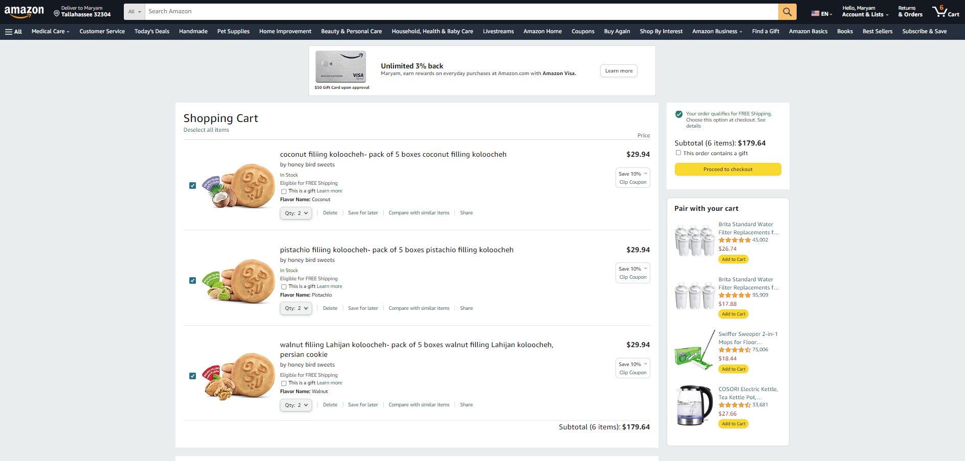

FLORIDA STATE UNIVERSITY
CONGRESS OF GRADUATE STUDENTS
Allocation, Revision, or Transfer

32nd Congress of Graduate Students

Bill #: 9

Sponsored by: Frank Velez

Date: 02/05/24

Amount: $84

From (account name): COGS Unallocated

To (account name): Art Society at FSU

Purpose & Description:

Art Society at FSU is delighted to mark its one-year milestone with an exclusive celebration, inviting members and enthusiasts to revel in the club's extraordinary achievements. This festive occasion promises an indulgence in exquisite cuisine sourced from a local grocery store, adding a touch of culinary delight to the celebration. The event stands as a testament to the club's resounding success, underscoring the significance of community and the artistic milestones reached throughout the past year. It is more than a commemoration; it's an opportunity to collectively reflect on the journey, celebrating the vibrant tapestry of creativity woven by Art Society. As attendees gather, they will immerse themselves in an ambiance of festivity, surrounded by the tangible accomplishments and shared endeavors that have defined the club's inaugural year. The evening encourages a sense of camaraderie, providing a space for members to connect, share insights, and forge lasting bonds. The carefully selected menu featuring exquisite culinary offerings reflects the commitment to providing a memorable experience for everyone present. Each bite becomes a symbol of the club's diverse and enriching journey, mirroring the diverse expressions of art cultivated within the society. In the midst of laughter and shared memories, this celebration is an ode to the collective passion for the arts that unites the members of Art Society. It is a moment to acknowledge the dedication and hard work of individuals who have contributed to the club's growth and success. Join us for an evening that goes beyond the ordinary—a gathering that encapsulates the spirit of Art Society at FSU. As we look back on a year filled with creativity and accomplishment, let us come together to envision the artistic endeavors that lie ahead, fostering a future where the celebration of art continues to thrive.

Organization Member: 20
Name of Event: One year celebration
Advertisement: Social media, email list, and GroupMe
Location of Event: Commons Courtyard
Date of Event: 2/9/24
Time of Event: 12 – 3 pm
Estimated Attendance: 30
Funds Collection: Free and open to all

Itemized Expenditures:

Quantity | Description | Unit Price
1 | Publix (Food, drink, and general food expenditures) | $84
Total: $84

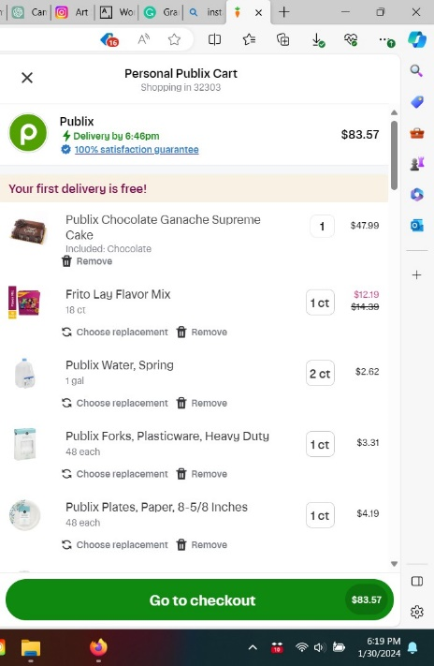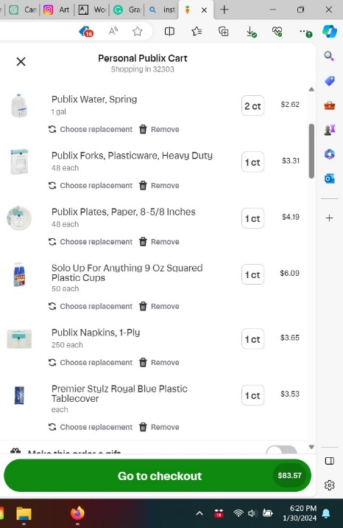

FLORIDA STATE UNIVERSITY
CONGRESS OF GRADUATE STUDENTS
Allocation, Revision, or Transfer

32nd Congress of Graduate Students

Bill #: 10

Sponsored by: Eric Wesner

Date: 2/5/2024

Amount: $3,421

From (account name): COGS Unallocated

To (account name): Indian Students Association at Tallahassee (INSAT)

Purpose & Description: INSAT is hosting Holi, the religious festival of colors, on March 31st at FSU Rez from 11:00 AM to 4:00 PM. This event is open to all FSU students, and they will expect arrangements for 250-300 attendees. They will serve a traditional Indian lunch (with both vegetarian and non-vegetarian options) and play with organic colors at the venue to celebrate this festival. The purpose of the association and event is to preserve the Indian culture at FSU through individual and group activities; and to be actively involved in assisting new incoming Indian students. INSAT organizes a number of events for the Indian student community at FSU, including: Indian Classical Music concerts, Freshers' welcome, an annual cultural event called Glimpses of India, Indian festivals such as Holi and Diwali, Potlucks and Cricket Tournaments.

Itemized Expenditures:
Quantity | Description | Unit Price
1 | Food from Persis Indian Grill | $2,479.86
10 | Color Powder Packs | $599.90
1 | FSU Rez Fees | $75.00
34 | Starry Lemmon lime soda 12 Oz bottles (Publix) | $150.62
1 | Trash bags, 30-gallon (Publix) | $15.49
5 | Paper plates, 115 pack (Publix) | $44.25
6 | Napkins (Publix) | $21.90
10 | Cutlery, 48 pack (Publix) | $33.10
Total: $3421

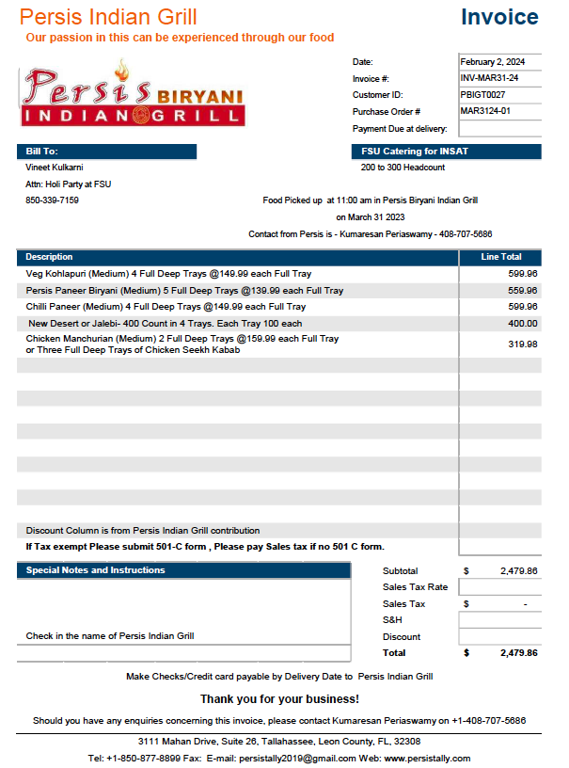
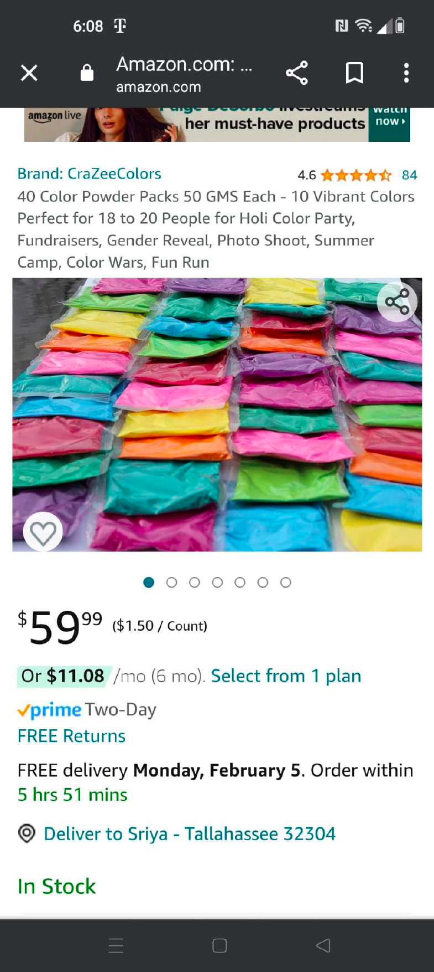
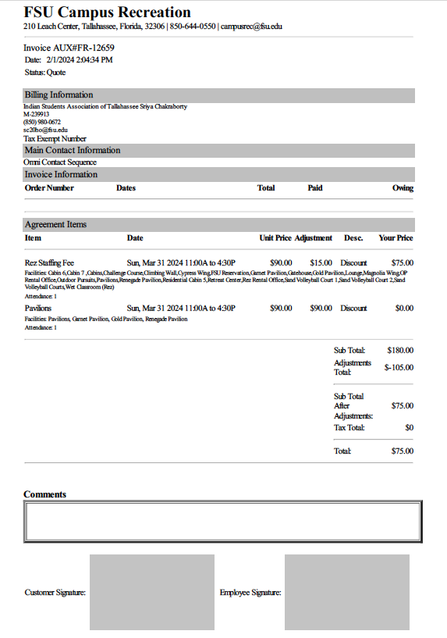

FLORIDA STATE UNIVERSITY
CONGRESS OF GRADUATE STUDENTS
Allocation, Revision, or Transfer

32nd Congress of Graduate Students

Bill #: 11

Sponsored by: Laura Vaughn

Date: February 5, 2024

Amount: $1,473

From (account name): COGS Unallocated

To (account name): Literatures and Linguistics Interdisciplinary Conference for Graduate Students (LINC)

Purpose & Description: 2024 will be the first time hosting the annual graduate student conference within the Department of Modern Languages and Linguistics since 2019. We are proud to reclaim both our organization and conference under a new name: (L)iteratures and Linguistics (In)terdisciplinary (C)onference for Graduate Students (LINC) at Florida State. The theme for LINC 2024 is Rebirth-Renewal-Revival and will take place over two days this spring: Friday, March 1st and Saturday, March 2nd. Our organizing committee has been working since Spring 2023 to make this conference a reality. This RSO is unique in that it is the only one which allows for graduate student collaborations across language programs within the Department of Modern Languages and Linguistics. Expected attendance is 50-75 people.
*See attached documents for full details

Itemized Expenditures:

Quantity | Description | Unit Price
 | Food | $406
 | Contractual Services | $1000
 | General Expenses | $67
Total: $1,473

Estimated budget for MLL LINC 5th Annual Conference March 1-2, 2024
COGS Allocation Request
Event Overview
2024 will be the first time hosting the annual graduate student conference within the Department of Modern Languages and Linguistics since 2019. We are proud to reclaim both our organization and conference under a new name: (L)iteratures and Linguistics (In)terdisciplinary (C)onference for Graduate Students (LINC) at Florida State. The theme for LINC 2024 is Rebirth-Renewal-Revival and will take place over two days this spring: Friday, March 1st and Saturday, March 2nd. Our organizing committee has been working since Spring 2023 to make this conference a reality. This RSO is unique in that it is the only one which allows for graduate student collaborations across language programs within the Department of Modern Languages and Linguistics.
For the conference, we have the following events scheduled and confirmed which informed the points included in our estimated budget. All catering will be provided by Legacy Catering on campus:
Friday, March 1st
- Brown Bag Session (4:30PM-6PM in Diffenbaugh 201)
  - Participants (10-12) in this session, mainly dedicated to works-in-progress and informal discussions, will be invited to give 10-minute lightning talks (6-minute presentations with a 4-minute Q&A).
- Bowling/Billiards sponsored by HiGSA (6PM-8PM at the FSU Student Union Bowling and Billiards Center)
  - Pizza will be provided from Brooklyn Pizza (Legacy Catering) for this event, which will be open to all.
  - HiGSA will be funding the Billiards/Bowling related fees. We will cover the food.
Saturday, March 2nd
- Graduate Student Conference (8AM-6:45PM)
  - We have 14 confirmed speakers to present 15-minute talks throughout the day. Presenters are graduate students from Florida State University, University of Georgia, University of Pittsburgh, UNC Chapel Hill/Duke University, University of Florida and University of Miami.
  - We have two confirmed keynote speakers for the conference on Saturday, March 2nd: Dr. Tenley Bick (Assistant Professor of Global Postwar and Contemporary Art in the Department of Art History at Florida State University) and Dr. Benjamin Hebblethwaite (Associate Professor of Haitian Creole, Haitian and Francophone Studies at the University of Florida).
    - We have allocated funding to offset Dr. Hebblethwaite’s travel expenses from Gainesville, Florida (gas and hotel) via an honorarium.
    - The Contract Form/W9 will be completed once we have confirmed the proposed funding.
  - We will provide lunch and dinner/a closing reception to all attendees of the conference. We anticipate a turnout of between 50-75 people. All quotes were provided for 50 people.
  - Registration for the conference is free, but we are asking for all to register in advance in order to get an accurate headcount for meals before we place all catering orders by Friday, February 16th (2 weeks prior to the conference). Registration will be opened from February 7th to February 14th.
Total Amount Requested = $2,721.87
Total Amount Requested from COGS = $1,472.50
Budget categories and Cost details
Contractual Services $1,000.00 (COGS)
- Dr. Tenley Bick (Florida State University)
  - Estimated Travel Costs: N/A
  - Honorarium: N/A
- Dr. Benjamin Hebblethwaite (University of Florida)
  - Estimated Travel Costs: $500
    - $200/night for 2 nights for a hotel
    - $100 for gas/wear and tear
  - Honorarium: $500
General Expenses $200.00
- Posters/flyers (cost of paper) $37.67 + tax (MLL)
- Name tags and welcome bag contents $79.38 + tax (MLL)
- Canvas tote bags $66.99 + tax (COGS)
Food $1,521.87
- Coffee donated by Lucky Goat Coffee $0
  - Cold Brew for Friday, to be picked up at 3:30PM
  - Cambro for Saturday, to be picked up at 7:30AM

- Pizza for Friday, March 1st $405.51 (COGS)
  - 7 Large Cheese Pizzas - $15.99 per
  - 6 Large Pepperoni Pizzas - $18.24 per
  - Legacy Catering - 15% fee ($33.21)
  - 4 gallons of Iced Water - $1.59 per
  - 3 gallons of Lemonade - $18.19 per

- Lunch for Saturday, March 2nd $516.36 (WK)
  - BYO Pasta Buffet - $10 per person for 50 people
  - 4 gallons of Iced water - $1.59 per

- Dinner for the closing reception on Saturday, March 2nd $600.00 (MLL)
  - Dinner at Proof in the FSU Student Union (~$12/person) for 50 people
Breakdown and explanations
1. Speakers,
Dr. Hebblethwaite will travel from the University of Florida in Gainesville, Florida and be paid $1,000 ($500 honorarium + $500 for travel). Lodging costs are based on average estimates of hotel price in FSU’s vicinity for two nights in March (~$200/night). The estimate for gas and wear and tear (~$100) were provided by Dr. Hebblethwaite in an e-mail thread on Monday, January 22nd.
2. Posters/flyers,
Printing will be free on campus with SGA Student Publications, we just need to provide the paper. Gavin Byrd, one of our Marketing Committee Chairs, spoke on the phone with SGA Student Publications to confirm that the quantities of printed material would be feasible and free so long as we provide the paper. The quote is based on a ream of 11x17 paper for posters ($26.76) and a ream of 8.5x11 paper for flyers ($10.91) from Amazon. Our Department has agreed to purchase all paper.
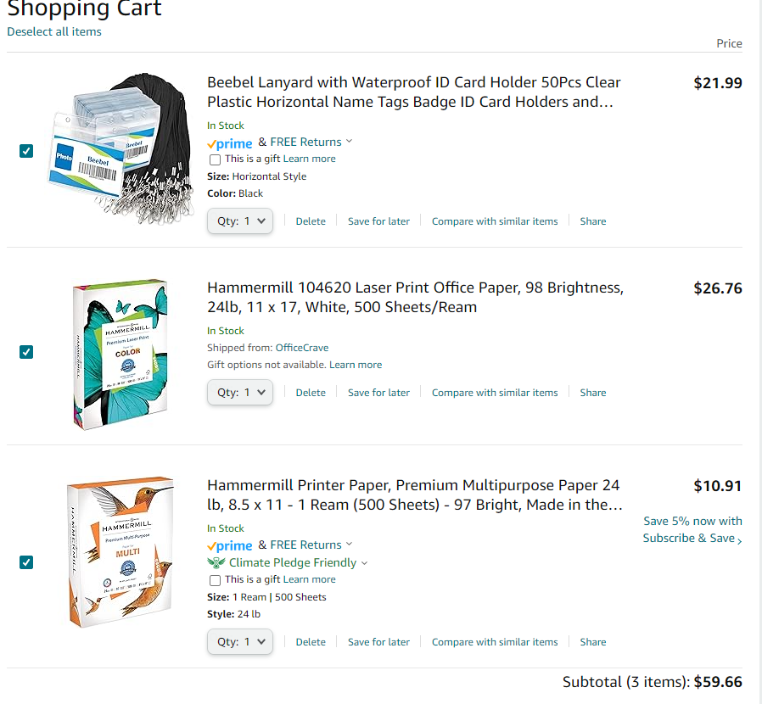
3. Name tags and welcome bags,
Upon (free) registration, we will print out name tags that include each presenter/attendees names, preferred pronouns and institutional affiliation (if relevant). Name badge holders with lanyards ($21.99) will be provided along with a canvas welcome bag ($66.99) which contains a notebook ($33.90), pen ($13.50) and bookmark ($9.99). Our Department has agreed to purchase all items except for the canvas welcome bags.
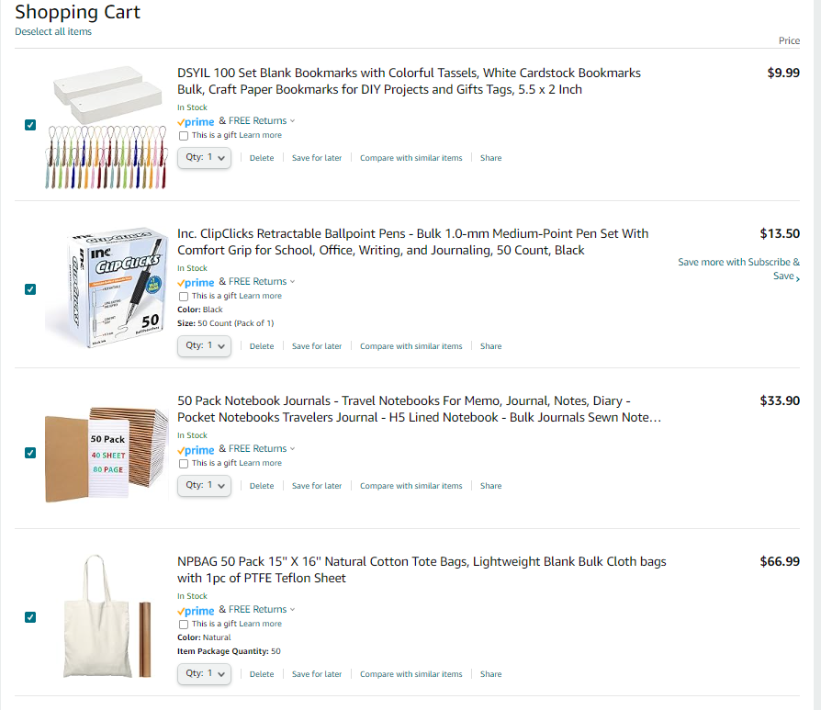
4. Food, during event
Cold brew and a cambro of hot coffee will be donated by Lucky Goat coffee for Friday and Saturday, respectively.
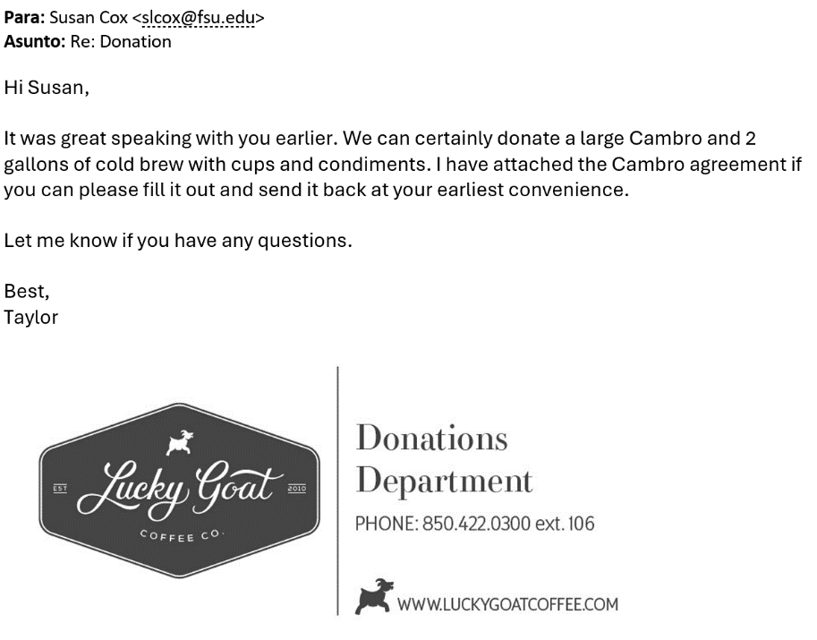

Quotes from Legacy Catering:
- Pizza for Friday, March 1st (Event #28509)
- Lunch for Saturday, March 2nd (Event #28514)
A closing reception/dinner (and non-alcoholic beverages) will be provided for all at Proof in the Student Union (~$12/person) following the conference on Saturday, March 2nd. We are awaiting a quote from Legacy Catering for this event.
Additional Information
Fundraising Plan
We met with Dr. Leushuis, the Chair of the Department of Modern Languages & Linguistics to discuss our funding options through the Department. They agreed to cover the costs of all ‘office supplies’ (i.e., paper, name badges, welcome bag contents), excluding the canvas tote bags. They will also be able to contribute to food-related expenses but are waiting to see how much other funding bodies are willing to contribute before committing to a concrete $ amount.
We have requested meetings with the Winthrop-King Institute, the Middle East Center and Dr. Mark Riley, FSU’s Dean of Graduate Studies for additional funding.
Marketing Plan
For the upcoming events hosted by LINC, marketing has targeted a diverse audience by means of multiple platforms. First, the event has a total of 25 unique presenters coming from various institutions around the country. Second, the department of Modern Languages and Linguistics has five graduate programs with around 50 graduate students total; we expect a majority of the department’s graduate students to attend the events. We have shared events to our listserv, and we have asked the faculty to share the events and encourage participation with their students.

In terms of promotion to people outside the department, the marketing team has reconstructed the organization’s website, Facebook account, and Instagram profile, where information is posted regarding the organization and its members. Over the past two months, marketing has used Instagram to share the call for papers, registration link, and profiles on the organizing members of LINC in addition to the upcoming feature of the keynote speakers. As the event nears, we will print and post flyers on campus in areas regularly frequented by students, such as Strozier, Dirac, Student Union, and Diffenbaugh. As well as the buildings that host related departments, such as Dodd, Williams, Bellamy. Our posters include a QR code/link to our website, time, date, and location of the event, and how to register. During the event itself, we will display posters, distribute merchandise with our organization’s logo, and share live updates via Instagram.
Website: https://mllgraduatestudentconference.wordpress.com/
Instagram: @fsulinc
Our Organizing Committee * indicates financially certified board members
- Faculty Advisor - Dr. Matthew Goldmark
- Executive Board
  - President - Gabrielle Isgar*
  - Vice President - Timothy Lomeli*
  - Secretary - Yeimy Roberto
  - Treasurers - Joachim Adams* and Seyitmuhammet Hallygulyyev
- Marketing Committee Chairs
  - Gavin Byrd
  - Libby Fowler Beegle
- Hospitality Committee Chairs
  - Susan Cox
  - Kehinde Sowunmi
- Abstract Review Committee Chairs
  - Carine Schermann
  - Nerea Delgado Fernandez

FLORIDA STATE UNIVERSITY
CONGRESS OF GRADUATE STUDENTS
Resolution

32nd Congress of Graduate Students

Resolution #: 1

Sponsored by: Rowan

Date: February 5, 2024

Whereas the 32nd Congress of Graduate Students has organized itself and is ready to begin its work, and

Whereas Article IX, Section 4, of the Student Body Constitution grants the Congress the power to set its own procedures, and

Whereas Section 110.1 of the COGS Code mandates that any internal rules of procedure be adopted by a two-thirds vote, and

Whereas the Internal Rules of Procedure have not been updated in several years, leading to outdated requirements and confusing structures, and

Whereas the time has come for the Congress to adopt its Internal Rules of Procedure and to cement the format by which amendments and future IROPs shall be adopted, therefore

Be it resolved by the Thirty-Second Congress of Graduate Students: That the attachment to this resolution shall be the Internal Rules of Procedure for the Thirty-Second Congress of Graduate Students, and
Be it further resolved: That the Congress wishes for the attached IROP to be published on the COGS website as soon as possible, with the addition of the COGS logo, and
Be it finally resolved: That a copy of this resolution be sent to:
Dr. Felicia Williams, Director of Student Governance & Advocacy,
Andy Johnson, Student Governance & Advocacy Student Program Director,
Kyanna Austin, Student Governance & Advocacy Program Manager, and
Ben Young, SGA Webmaster.

Attachment A: Adopted IROP

Thirty-Second COGS Internal Rules of Procedure

Rule 1: Powers of the Speaker
  - The Speaker, or their designee, shall chair all meetings of the Assembly. The Speaker or chair may temporarily name another representative to chair the meeting while the Speaker is the sponsor of or participating in debate of measures. The Speaker or chair may only return to the chair after the measure has concluded.
  - The Speaker, or the chair, shall rule on all questions of procedure, maintain decorum, and recognize members seeking to speak or raise motions/points.
  - Any ruling by the Speaker, or the chair, shall be binding unless appealed by a member. If an appeal is made, the following question shall immediately be put to the Assembly without debate: “Shall the ruling of the Chair be sustained?”. If a majority votes against the question, the ruling is overturned.
Rule 2: Governing Authorities

  - All procedural matters not governed by these Rules, the COGS Code, or the Student Body Constitution and Statutes, shall be governed by Robert’s Rules of Order. If Robert’s is unclear or silent on the issue, the Speaker, or Chair, shall have authority to decide upon the matter.
Rule 3: Meetings of the COGS Assembly

  - The COGS Assembly shall meet in regular session on the first and third Monday of each month at 6:30 PM in the FSU Senate Chambers, unless the time or place of the meeting is otherwise specified by the Speaker no less than twenty-four (24) hours before the meeting. Representatives living outside of Leon County, Florida, may appear by virtual means.
  - Special meetings of the Assembly may be called by the Speaker, with the endorsement of two other members of the Executive Board, or by petition of two-thirds of the COGS membership. All special meetings require twenty-four (24) hour notice to members and the public.
    - Any member seeking a special meeting shall notify the Speaker and Advisor by filing a petition for the special meeting. Such petition must state the date, time, and location of the meeting, and the topics for said meeting.
    - Upon receipt of a petition, the Advisor or Speaker shall poll the COGS membership to determine whether the required number of members are in favor of the meeting. Such a poll shall occur without unnecessary delay.
    - Should two-thirds of the members be in favor of the special meeting, it shall be immediately noticed to all members and the public.
  - No action may be taken at any meeting of the Assembly or its committees unless a quorum is present, except for a motion to adjourn.
  - The Agenda of each meeting shall be as follows:
    - Call to Order
    - Pledge of Allegiance
    - Roll Call
    - Reading and Approval of the Minutes
    - Petitions to the Assembly
    - Special Introductions and Student Comments
    - Messages from Student Government
    - Report from the Office of Governmental Affairs
    - Report of Officers
      - Speaker
      - Deputy Speaker of Finance
      - Deputy Speaker of Judicial Affairs
      - Deputy Speaker of Communications
    - Advisor Announcements
    - Committee Reports
      - Internal Affairs
      - Student Advocacy
      - Student Affairs
    - Funding Requests
    - Unfinished Business
    - New Business
    - Round Table/Final Roll Call
    - Adjournment
  - The agenda for the meeting at which the annual budget is considered shall consist solely of the following:
    - Call to Order
    - Pledge of Allegiance
    - Roll Call
    - Reading and Approval of the Minutes
    - Special Introductions and Student Comments
    - Messages from Student Government
    - Advisor Announcements
    - Report of the Budget Committee
    - Consideration of the Annual Budget
    - Round Table/Final Roll Call
    - Adjournment
  - The Speaker shall have the authority to reorder the Agenda at their discretion, or to insert special items other than business.
  - The Speaker may waive items on the agenda or postpone them to a later meeting subject to a majority (50% plus 1) vote of the Assembly present.
Rule 4: Submission of Bills, Resolutions, and Motions

  - Bills and Resolutions shall be submitted to the Deputy Speaker of Communications and the Advisor by email no later than noon on the Thursday preceding an Assembly meeting, unless this rule is waived by the Speaker, Deputy Speaker of Communications, or a two-thirds vote of the Assembly.
    - Bills and Resolutions must have at least one Representative as a sponsor.
    - Bills must include a statement of the purpose of the bill.
  - Funding Requests from Registered Student Organizations (RSOs) shall be submitted by noon on the Tuesday preceding an Assembly meeting to be considered at the next Assembly meeting.
  - All motions require a second. If no second is made, the motion shall automatically fail. The movant and seconder shall be recorded in the Minutes.
  - All motions are deemed to have been passed by unanimous consent unless a member objects, or a vote on the motion is required under the governing documents.
  - The order of precedence in motions/points from Robert’s Rules shall govern.
  - Only one motion may be considered at any time. If a motion is being considered and a motion of a higher precedence is made and seconded, the original motion shall be set aside while the new motion is being considered. Once the new motion has been disposed of, consideration will return to the original motion, unless the new motion affects the consideration.
Rule 5: Debate

  - Debate of Measures shall be conducted as follows:
    - The sponsor(s) of a bill, resolution, or motion shall explain its purpose to the Assembly for up to three (3) minutes.
      - For bills funding a specific RSO, the Chair may, by their discretion, allow a representative of the RSO, if present, to provide a further explanation, if time permits.
    - The sponsor(s) shall take questions on the measure from members of the Assembly for up to three (3) minutes.
      - For bills funding a specific RSO, the Speaker, or Chair, may direct the questions to a representative of the RSO, if present.
    - Formal debate shall begin and proceed as follows:
      - A three (3) minute round of debate in favor of the measure,
      - A three (3) minute round of debate opposed to the measure,
      - Two (2) further rounds of alternating debate shall be conducted. Motions to amend the measure may be heard at this point.
        - All amendments to proposed legislation which are more than three words in length and include more than an amendment to strike language must be provided in writing or typed with date and reference, to the Deputy Speaker of Communications prior to a vote on the amendment. Prior to asking if there are any objections, the Chair shall allow the sponsor of the amendment to explain the amendment for up to three (3) minutes. If objected to, the motion shall be debated and voted upon like any other measure.
      - Further rounds of alternating debate may be conducted at the discretion of the Speaker, or Chair.
      - During a round of debate in opposition, a member may move to call the question. If objected to, the motion shall be voted on without debate and pass with a two-thirds majority of members present.
    - The sponsor(s) may make a three (3) minute closing statement.
    - The vote shall then be conducted.
  - Any round of debate or questioning period may be extended or extinguished by a non-debatable motion requiring a two-thirds vote, except that the Chair may extinguish time if no member is seeking recognition.
  - Representatives may only speak twice per round of debate. The Chair shall give preference in recognition to members that have not spoken on the measure.
Rule 6: Voting

  - Voting in the Assembly shall be by show of hands, unless otherwise motioned or the Chair decides to use another prescribed method.
  - After the sponsor(s) make their closing statement, but before the vote is taken, any member of the Assembly may move for a vote by:
    - Secret Ballot,
      - The Advisor shall distribute ballots to members; members will record their vote without a name and submit them to the Advisor.
      - A motion for a secret-ballot vote shall require a majority vote (50% plus 1) of the assembly, if objected to, without debate.
      - A successful motion to vote by secret ballot shall supersede any other method of voting.
    - Roll Call,
      - A roll call vote shall take place immediately upon the motion being made and seconded, without need for debate or vote.
    - Voice vote, or
      - A voice vote shall take place immediately upon the motion being made and seconded, without need for debate or vote.
    - Electronic Voting, only if such an option already exists and is in active use by the Assembly.
  - On any vote, members may vote aye, nay, or present/abstain.
Rule 7: Committees

  - Each Committee shall use a pre-made template for their meeting minutes. This template shall be approved by a two-thirds (2/3) vote of the General Assembly. This template shall be changed by a three-fourths (3/4) vote of the General Assembly.
Rule 8: Amendments and Suspension of Rules

  - The Internal Rules of Procedure shall only be amended by resolution and such resolution shall only pass with a two-thirds majority of members present.
    - Prior to submitting any resolution that changes the Internal Rules of Procedure to the Deputy Speaker for Communications, the resolution shall be debated and receive a two-thirds (2/3) vote from the Internal Affairs Committee.
  - A Representative may move to suspend these rules by motion. Such motion shall specifically state which rules are being suspended, is debatable upon objection, and shall only pass with a two-thirds majority of members present.

FLORIDA STATE UNIVERSITY
CONGRESS OF GRADUATE STUDENTS
Statute Revisions & Additions

32nd Congress of Graduate Students

Bill #: 12

Sponsored by: Representative Burns

Date: February 5, 2024

Purpose & Description: The purpose of this bill is to strike out any mention of C-SAC in the COGS code.

Statute Number(s):

200.3 RSOs not administered by MSC or LSC shall be eligible to request an annual budget from COGS at the time of Annual Budget proceedings. This does not preclude the RSO from requesting supplemental funding from C-SAC or the Assembly itself.

Chapter 210 Organizational Support Funding History: Amended by the 19th Congress, Bill 1; 21st Congress, Bill 30.

210.1 This chapter shall apply to funding requests made outside the Annual Budget process.

210.2 RSOs, as well as any SGA or Florida State University affiliated entity, may request supplemental funds from COGS. When allocated, these funds shall take the form of COGS “Organizational Grants” and shall be subject to all the provisions of this code.

210.3 Any entity requesting an Organizational Grant must submit a COGS Organizational Funding Request Form and schedule an appearance before the Congress or appropriate COGS body. A budget request which is or exceeds $1,000 will be made in person to the Congress. Any request of less than $1,000 will be made in person before C-SAC or the respective funding board pertaining to the entity (LSC or MSC).

210.4 C-SAC shall be composed of the COGS Deputy Speaker for Finance as well as at least three (3) other and no more than six (6) additional COGS Representatives appointed by the COGS Speaker on advice from the Deputy Speaker for Finance. The Deputy Speaker for Finance shall serve as the C-SAC Chair.
A) C-SAC funds shall be held in a separate line item in the COGS Annual Budget.
B) C-SAC shall meet prior to each COGS Assembly meeting, unless there are no supplemental funding requests pending before COGS.
C) All members of C-SAC shall be entitled to a vote. Allocations shall be made by a majority vote of members present at a C-SAC meeting. In the event of a tie, the request shall be referred to the Congress.
D) Organizations may appeal any C-SAC allocation to the Assembly, though no funds s hall be disbursed or allocated while appeal is pending.
E) Any RSO which has requested more than $1,000 per fiscal year shall bypass the C-SAC process and make a request directly to the Congress.

210.5 Embargoed Funds Organizations which receive funds from C-SAC for upcoming events shall be informed of the allocation; however, at the discretion of the committee the funds may be embargoed and not released until the Deputy Speaker for Finance receives sufficient assurances from the Organization that the event for which monies were allocated will in fact occur.
A) Embargoed funds shall be held in the C-SAC unallocated account as funds earmarked for specific organizations to be used in conjunction with specific events. In no event may embargoed funds be used in any manner other than for what they were initially requested without the prior authorization of C-SAC.
B) Funds shall be designated by C-SAC as “For immediate release” or as “Embargoed” at the discretion of C-SAC. C-SAC may at their discretion establish a date whereby sufficient assurances must be made or funds will become available for general allocation.

FLORIDA STATE UNIVERSITY
CONGRESS OF GRADUATE STUDENTS
Allocation, Revision, or Transfer

31st Congress of Graduate Students

Bill #: 13

Sponsored by: Representative Burns

Date: February 5, 2023

Amount: $3,000

From (account name): Organizational (C-SAC)

To (account name): Unallocated

Purpose & Description: To transfer funds from the organizational (C-SAC) account to the unallocated account.

FLORIDA STATE UNIVERSITY
CONGRESS OF GRADUATE STUDENTS
Allocation, Revision, or Transfer

31st Congress of Graduate Students

Bill #: 14

Sponsored by: Representative Burns

Date: February 5, 2024

Amount: $3,000

From (account name): Unallocated

To (account name): Attendance conference grants (November 2023-February 2024)

Purpose & Description: Ensure there is enough money for attendance conference grants in the November 2023 – February 2024 funding period.

FLORIDA STATE UNIVERSITY
CONGRESS OF GRADUATE STUDENTS
THIRTY-SECOND CONGRESS OF GRADUATE STUDENTS
Assembly Meeting
January 22, 2024
6:30pm
Minutes
Call to Order: 6:35pm
Pledge of Allegiance: Rep. Velez
Roll Call: Present: Balak, Balogun, Barber, Burns, Cyrille, Delva, Ebuara, Galeano, Hussain, McCraney, Medarev, Pakdehi, Rogowski, Rowan, Siegel, Vaughn, Velez, Wardlow, Wesner, Wheeler
Absent Excused: Beavon, Solmaz
Reading and approval of the Minutes: Rogowski, 2nd - Galeano
Petitions into the Assembly:
Profilia Nord - College of Medicine Seat 2
M1 student and has been at FSU for her Masters program. Saw the work of COGS while in various roles on students and wants to work together. See how we can bridge the gap of understanding between MSC and COGS.
Jamila Alleyne - College of Social Work Seat 1
1st year student. Interested in joining COGS because no one from the Social Work was a representative. Has served in her Community College and undergrad.
Questions:
Rogowski - will you both be available on Monday nights at 6:30? Yes.
Galeano - How long is your program Jamila? 2 years.
Cyrille - You mentioned miscommunications from the medical school. Can you talk more about that. In the past, there was some miscommunication and I want to make sure that doesn't happen again.
Rogowski - What committees are you interested in? Nord - Advocacy; Alleyne - not fully sure at this moment, but will look into it more.
Siegel - Exhaust time; 2nd - McCraney
Pros: Wheeler - I like them both. I think they can both bring a lot to COGS in general. Nord seems like she had a good plan for the future.
Rogowski - Alleyne found us on her own which is great and I'm excited by her past experience with outreach.
Rowan - The way that COGS has grown has been fantastic as we are starting to fill seats.
Motion to call to question - Galeano; 2nd - Pakdehi
Vote: Profilia Nord 19-0-0
Jamila Alleyne 19-0-0
Swearing in.
Special Introductions and Student Comments: N/A
Messages from Student Government: N/A
Report from the Office of Governmental Affairs:
Rowan - I went to their meeting and there is a bill making its way through the committees that would waive the GRE requirement for veterans.
Report of Officers:
- Report of the Speaker: Budget season for SGA kicked off last week which means our budget season kicks off in about a month. We will be making a call for those interested in joining the budget committee. The dates of this will be the week of March 4th to open and the week of March 25th for presentations requesting fundings and a target date of April 1st of 15th for budget finalizing. A Qualtrics will be sent out for those interested. Our budget this year is looking to be about 1.2-1.3M. I have learned so much about the campus through the process. Have had meetings with Childcare Center to see if other departments could help with the funding. Those working in the center are great. We have a bookshelf in the office now, so please stop by for merch. For new members, please come by after today's meeting to pick up a shirt. You'll see on the agenda a call for a Deputy Speaker of Judicial Affairs. We hope someone would like to fill this position. It is a paid position, so I highly suggest running for it. There is a lot of legislation on the floor tonight, so please ask questions if you have them.
- Report of the Deputy Speaker for Finance: Financial report is on the 2nd page of the agenda so that you know where our balances are for each account. You can see our current presentation and attendance grants. As we are nearing the end, those balances are getting low, but previous funds can be moved over. Please share information about the grants. The next item is the budget process which is an impactful role of COGS. We get to hear from everyone who gets funding from COGS. I know not many seemed interested in the process, but I really enjoyed it last year. It might be a lot of work, but it's during a short time frame. We have training, attend presentations, and then deliberate the budget. Please consider it. Please talk to me afterwards if you are interested. We can send out a survey for those interested. There is a bill on the agenda transferring sweepings money and I'll talk more about that then.
- Report of the Deputy Speaker for Judicial Affairs: N/A
- Report of the Deputy Speaker for Communications: Reminder about the name tag survey. Please check your spelling and if you wrote your FULL name (first and last). Also, if you are assigned a bill, please send it to me in .doc format, not pdf. Thank you.
Ebuara - Motion for a 10 min recess; 2nd - Galeano at 6:59pm
Reconvene at 7:14pm
Committee Introductions and Reports:
First meetings and election of chairs/vice chairs and time/date for committee meetings - take 15 minutes.
- C-SAC:
- Internal Affairs: Balak - chair; Medarev - vice chair
- Student Advocacy: Hussain - chair; Cyrille - vice chair
- Student Affairs: Wesner - chair; Wheeler - vice chair
Funding Requests:
Bill #3: Art History Association
Opening statement - Asking for $1,500 to contribute to their Art History Symposium. 3 days and consists of several sessions, social gatherings, and a keynote speaker. The funding being requested will go toward food for two events as well as keynote speaker related funding. The keynote speaker is very well renowned and everyone is invited.
Questions -
Rogowski: You are requesting $1,500, but the amount is more than that. Where is the funding coming from? The Dean of the College of Fine Arts. Have you had the event before? Yes. There were 80-90 people in attendance last year.
Exhaust time - Siegel; Wheeler - 2nd
Pros -
McCraney: When I read the description, I thought it was so cool and I love they explored many avenues of funding for this.
Nord: I believe that COGS should be supporting initiatives like this that encourage diversity.
Burns: Excited about the speaker and I think it will being a great event.
Rowan: Thanks to the organization for working with me to arrange the bill and money requested.
Extinguish time - Rogowski; 2nd - Burns
Cons -
Galeano: Call to question; Balak - 2nd
Closing - I think the bill is a great idea and it brings diverse backgrounds into the forefront with Black History Month being next month.
Vote: 21-0-0
Bill #4: Public Administration Graduate Association
Opening statement - Gathering of the organization and the event creates an opportunity for academics to gather and talk. Requesting money for food and it's a way for them to gather in a more relaxed setting. Graduate students often end up siloed and do not realize they are working on the same topic and this is a way to encourage collaboration and socializing with professors.
Questions -
Ebuara: Have you done this before? Yes. How was it funded? By COGS last year.
Burns: Where is it? On campus.
Hussain: Is it a yearly gathering? No, it's at the start of the semester?
Balogun: Will the funding be enough? Yes, because it will be hybrid.
Pros -
Pakdehi: We all need time to relax and talk about our research. It's a great idea to have a gathering like this.
Barber: Having a social is very important, especially with many classes being online.
Ebuara: I think this is a good idea because not everyone knows what everyone else in their program is doing.
Balak: Good idea because discussing research ideas allows for collaboration.
Cons -
Ebuara: Call to Question; 2nd - Cyrille
Closing - I think this is a great bill to pass in general.
Vote: 21-0-0
Unfinished Business:
Deputy Speaker for Judicial Affairs - call for nominees
This will be rolled over to the next meeting.
New Business:
Bill #5: LSC Spring Budget
Opening statement - Hopefully this will be fairly straightforward concerning administrative processes. You can see the allocation of funds for the spring semester. This is a way to proactively handle the funding. It also increases transparency of funding. We want to make the whole process more efficient. The old process was slow and was hard for organizations to put together last-minute events. Makes sure that all of the organizations get adequate funding and can benefit the smaller organizations.
Questions -
Rogowski: From the budget report and the bill, there are some number differences? Not all numbers were finalized and an amendment will be made to change that. The Student Bar Association looks a little low from historical knowledge - will this be an issue? This is part of giving more funds to smaller organizations. RSOs are being encouraged to collaborate.
Pakdehi - extend time; 2nd - Delva
Pakdehi: I see that there is funding for food, clothing, and awards as well as an expense category. Can you explain that? It is a way of allocating funds for events.
Delva: Thank you for putting in this work. Is this something you plan to do every semester or is it a trial? Hope to operate on a semester by semester basis moving forward. A yearly basis would be too hard to track things via calendar for some organizations.
Pros -
Rogowski: There's a lot of good things happening here. If you haven't been involved in this, you might not understand how much better this is. The old process took a long time and required a lot of approvals and this makes it much more streamlined. Now everyone in COGS knows what is happening in both LSC and MSC.
Delva: I think that having Law students in COGS has helped to streamline these behind the scenes processes. It's great and detailed work.
Cons -
Rogowski - Motion to extinguish; Delva - 2nd.
Pros -
Burns - Motion to under the LSC Expense category, food change from $500 to $165.34 and expense number from $500 to $165.35; 2nd - Wheeler
Q&A; Pros; Cons - all extinguished and seconded
Vote on the amendment - 21-0-0
Closing - The purpose of LSC is to fund the organizations and this helps improve that.
Vote - 21-0-0
Bill #6: MSC Spring Budget
Opening statement - This is will look a lot like the LSC bill and we are working to fund the organizations under MSC. Looking at past funding, we were inspired to make things more streamlined. Most of what could be said about this was stated by LSC. Thank you for hearing us out. It will make things much easier on our part.
Questions -
Medarev - extinguish time; Nord - 2nd
Pros - Rogowski: met a lot with the past president, Jack. This is will make things streamlined and allow for faster events and greater transparency. It is a moment to appreciate everything about this process.
Rowan: I saw the old spreadsheet and it was horrifying. The work has been done.
Galeano - extinguish time; Nord - 2nd
Cons -
Call to question - Balogun; 2nd - Nord
Closing - A lot went into this, so thank you to everyone for working with this and this is all publicly available.
Vote - 21-0-0
Bill #7: COGS Allocation Transfer
Opening statement - This is a basic transfer of funds of the amount given in sweepings. It was a total of $45,000. It is to be used to reimburse applicants from last year who did not get funding due to technical issues with Survey Monkey. These funds are being moved to these accounts so that they can be used for this process. We do still have some funds in unallocated, but we wanted to make it easier to keep track of it. Any leftover can be moved to Unallocated and other accounts.
Questions - Nord - extinguish; 2nd - Siegel
Pros - Rogowski: This is creating a shell account to prevent administrative complications.
Medarev - extinguish time; 2nd - Balek
Cons -
Balogun - Call to question; 2nd Hussain
Vote: 19-0-0
Round Table:
Adjournment: 8:2
Next Meeting: February 5, 2024 at 6:30 p.m. Senate Chambers (3rd floor Student Union)

