FLORIDA STATE UNIVERSITY
CONGRESS OF GRADUATE STUDENTS
THIRTY-SECOND CONGRESS OF GRADUATE STUDENTS
Assembly Meeting
January 22, 2024
6:30pm
Agenda
Call to Order:
Pledge of Allegiance:
Roll Call:
Reading and approval of the Minutes:
Petitions into the Assembly:
Profilia Nord - College of Medicine Seat 2
Jamila Alleyne - College of Social Work Seat 1
Special Introductions and Student Comments:
Messages from Student Government:
Report from the Office of Governmental Affairs:
Report of Officers:
- Report of the Speaker:
- Report of the Deputy Speaker for Finance:
- Report of the Deputy Speaker for Judicial Affairs:
- Report of the Deputy Speaker for Communications:
Committee Introductions and Reports:
- C-SAC:
- Internal Affairs:
- Student Advocacy:
- Student Affairs:
Funding Requests:
Bill #3: Art History Association
Bill #4: Public Administration Graduate Association
Unfinished Business:
Deputy Speaker for Judicial Affairs - call for nominees
New Business:
Bill #5: LSC Spring Budget
Bill #6: MSC Spring Budget
Bill #7: COGS Allocation Transfer
Round Table:
Adjournment:
Next Meeting: February 5, 2024 at 6:30 p.m. Senate Chambers (3rd floor Student Union)

COGS Financial Report, Fiscal Year 2023-2024
ACCOUNT | ALLOCATION AMOUNT | DESCRIPTION | BALANCE
UNALLOCATED | $21,318 | For RSO funding requests at COGS meetings | $10,491.57
ORGANIZATIONAL (C-SAC) | $3,000 | RSO funding for allocations less than $1000 for the fiscal year | $3,000
LSC | $61,000 | Funding allocations from Law School Council to Law School Student Organizations | $42,869.65
MSC | $84,817 | Funding allocations from Medical School Council to Medical School Student Organizations | $34,826.55
PRESENTATION GRANTS (Jul-Oct) | $66,250 | Presentation Grant balance for the July-October funding period | $13,552.73
PRESENTATION GRANTS (Nov-Feb) | $75,000 | Presentation Grant balance for the November-February funding period | $18,214.94
PRESENTATION GRANTS (Mar-Jun) | $58,750 | Presentation Grant balance for the March-June funding period | $58,750
ATTENDANCE GRANTS (Jul-Oct) | $9,000 | Attendance Grant balance for the July-October funding period | $0
ATTENDANCE GRANTS (Nov-Feb) | $9,000 | Attendance Grant balance for the November-February funding period | $2,400
ATTENDANCE GRANTS (Mar-Jun) | $7,500 | Attendance Grant balance for the March-June funding period | $7,500

FLORIDA STATE UNIVERSITY
CONGRESS OF GRADUATE STUDENTS
Allocation, Revision, or Transfer

32nd Congress of Graduate Students

Bill #: 3

Sponsored by: Tavaura Wardlow

Date: January 22, 2024

Amount: $1,500

From (account name): COGS Unallocated

To (account name): Art History Association

Purpose & Description: The Department of Art History Graduate Symposium requests support from COGS for the 40th Annual Art History Graduate Student Symposium, which will be held in March 2024. Their annual Symposium hosts graduate students from around the country who present papers in the history of art and architecture and cultural heritage studies. The keynote speaker this year is Professor Richard Powell of Duke University. Dr. Powell is a leading scholar in the field of African American art and culture who has written extensively on American art, the arts of the African Diaspora, and contemporary visual studies.
Their two-day symposium will consist of three two-hour sessions, one 45-minute keynote address, and several social gatherings (dinner, breakfast, coffee breaks, and trip to Wakulla Springs), which provide graduate students, the keynote speaker, and faculty the opportunity to engage in lively and educational conversations about art, architecture, and material culture. Alumni often return to attend this event, and many undergraduates also attend, so it provides invaluable recruitment, development, and networking opportunities.
They are requesting support from the Congress of Graduate Students for $1,500 to host a dinner and coffee break through the university catering per their venue’s (Dodd Hall) requirements. This portion of the event serves as a welcoming meal for guest speakers and fosters professional relationships among current and future art historians. They will combine funding from COGS with funding from the office of the Dean of the College of Fine Arts to help fund the dinner. They will also use the COGS funding to help pay for contractual services and lodging for the keynote speaker.
Organization Members: 25
Date: March 1st – 3rd, 2024
Location: Dodd Hall
Time: 2:45 PM – 4:45 PM (coffee break) and 7 PM (dinner)
Estimated Attendance of Event: 60

Itemized Expenditures:

Quantity | Description | Unit Price
Food  (First Options) | Coffee Break: $539.40  Dinner: $2,181.40 | $1200
Contractual Service | Speaker’s Hotel: $499.50  IT Services: $100 | $300
Total: $1500

This document contains the quotes for the dinner and coffee break, which will be provided at the 40th Annual Art History Graduate Symposium. The initial three quotes correspond to the dinner and the last three quotes correspond to the coffee break. Each quote is in order of preference for either item, with the Legacy Dining most desired because of Dodd Hall’s event policies. Also
included are quotes from lodging for the keynote speaker and a quote for contractual service from IT services.
Dinner option 1:
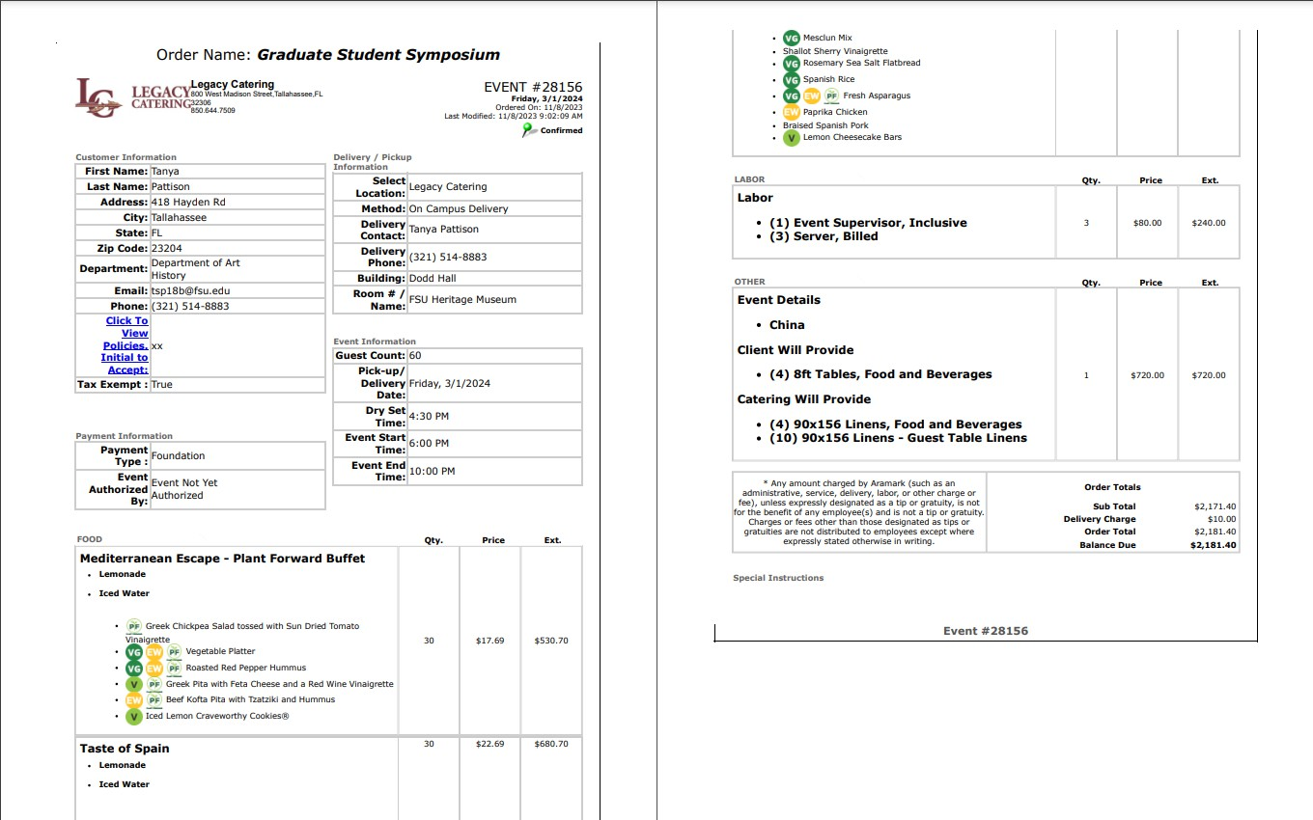

Dinner Option 2:
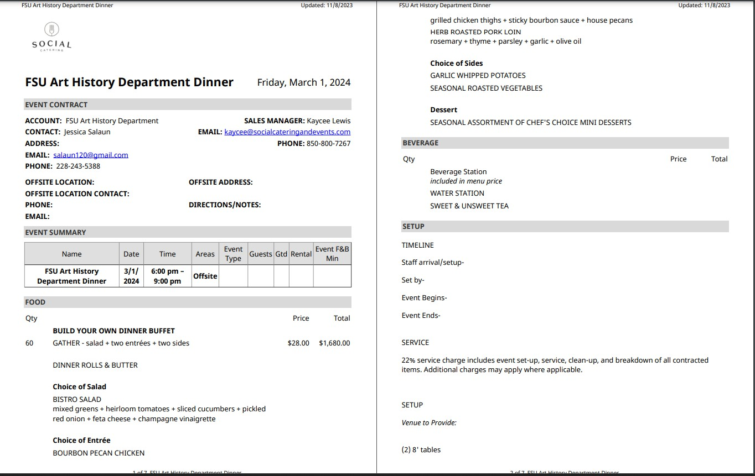

Dinner Option 3: Appetizers/Snacking Food:
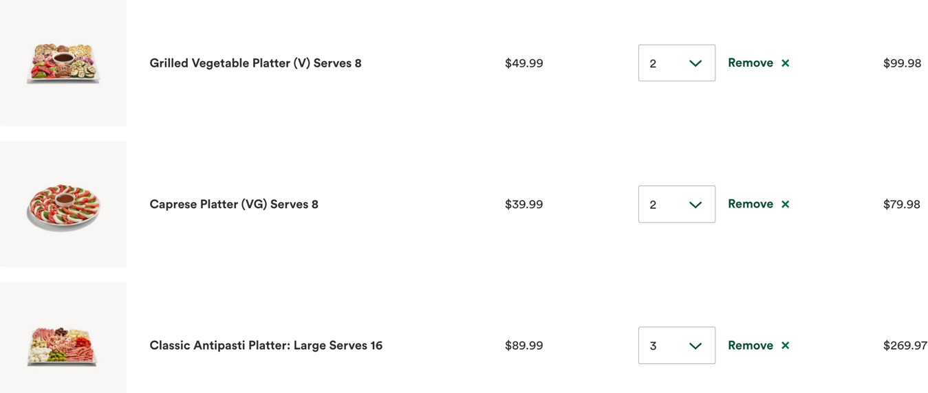

Dinner / Buffet Options:
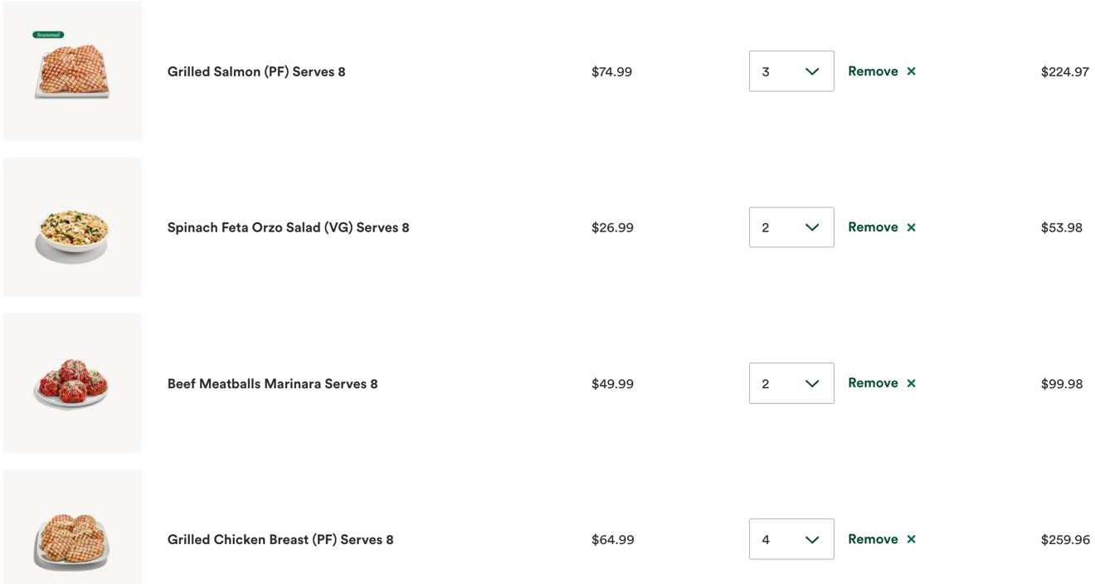

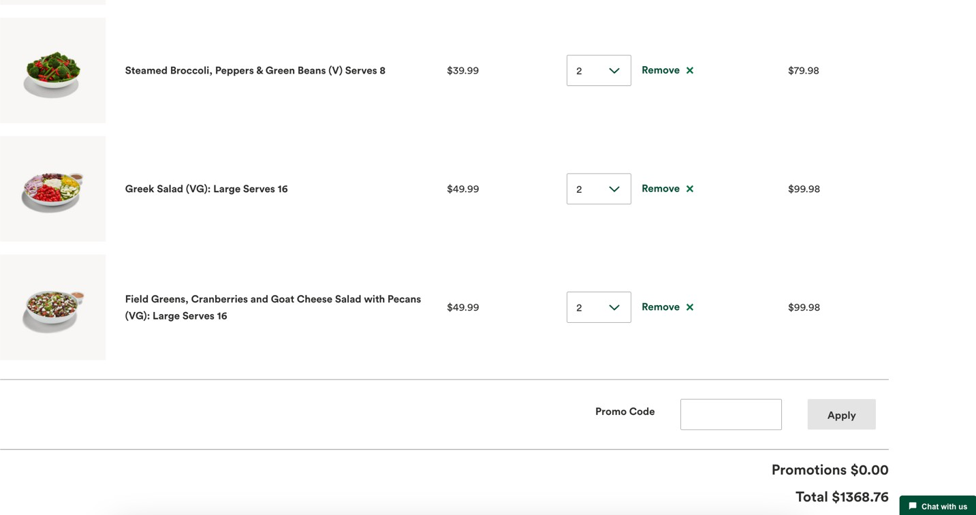
Coffee Break Option 1
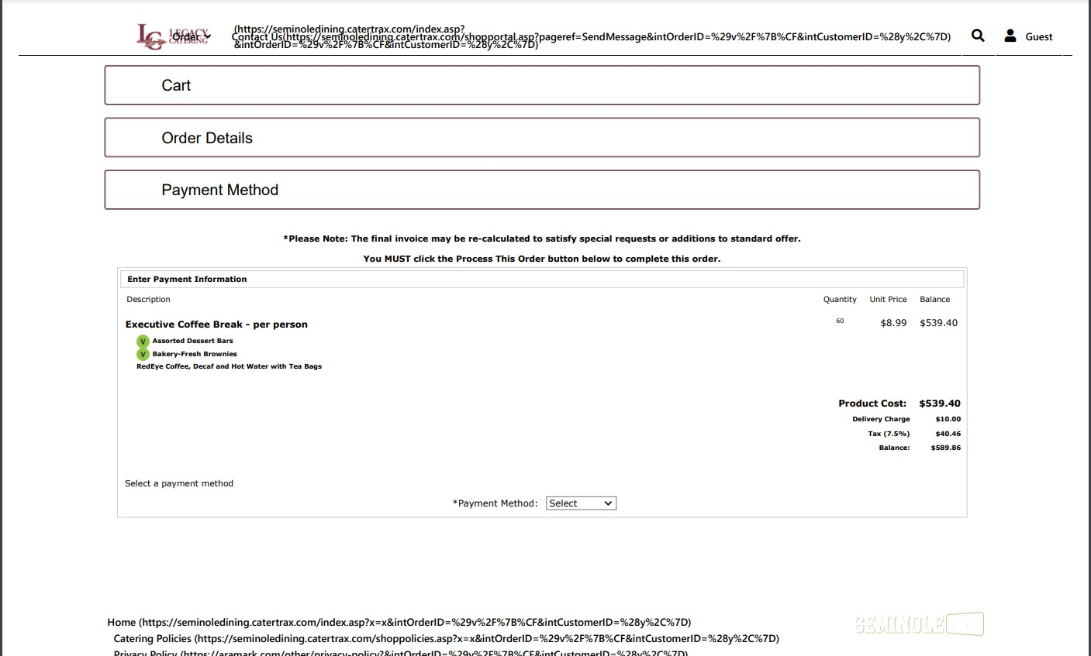
Coffee Break Option 2:

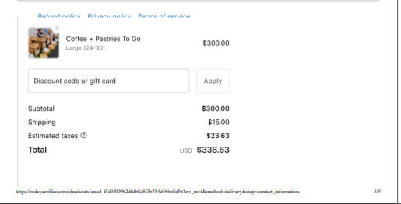
Coffee Break Option 3: 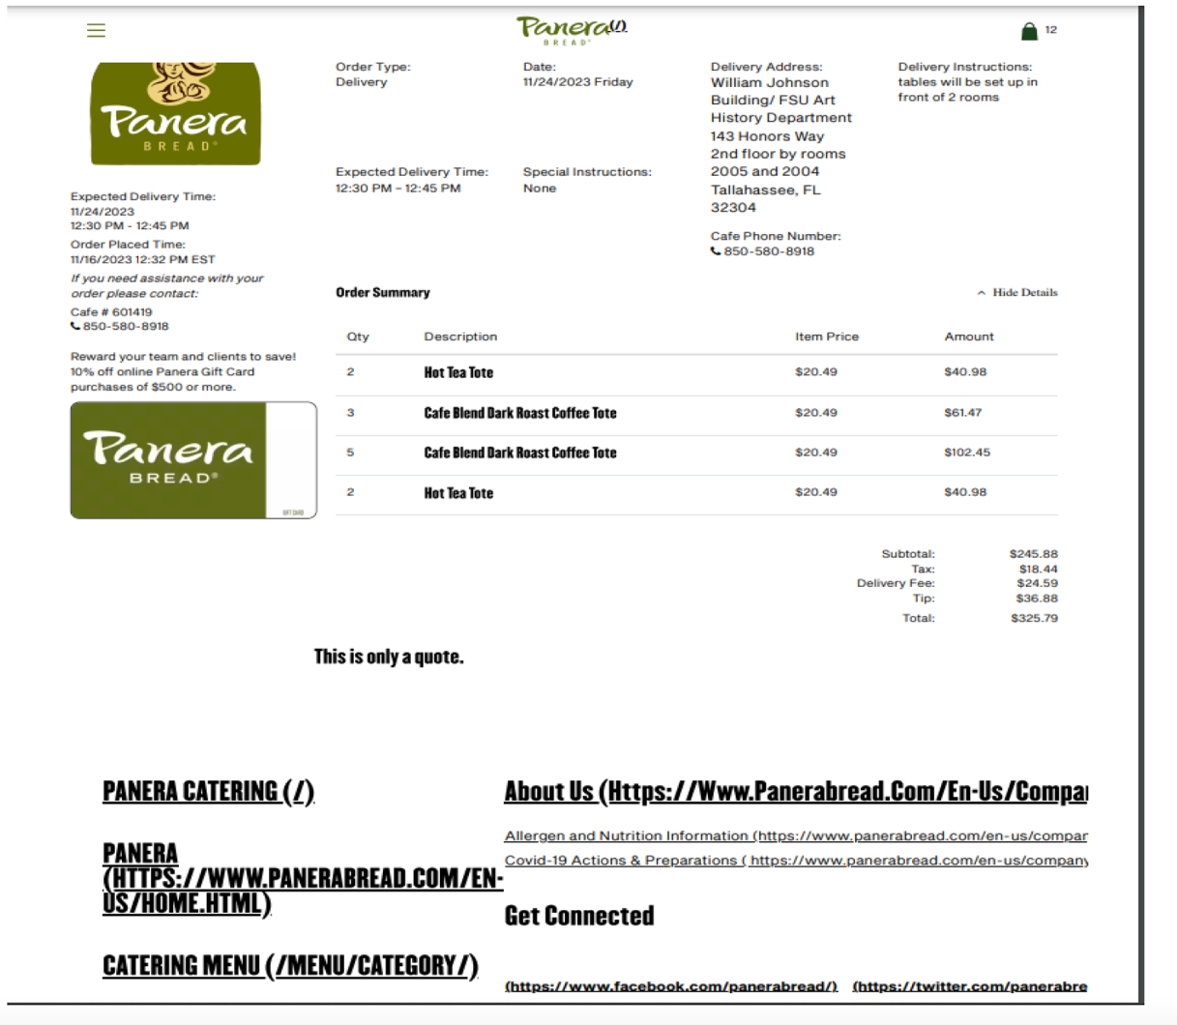
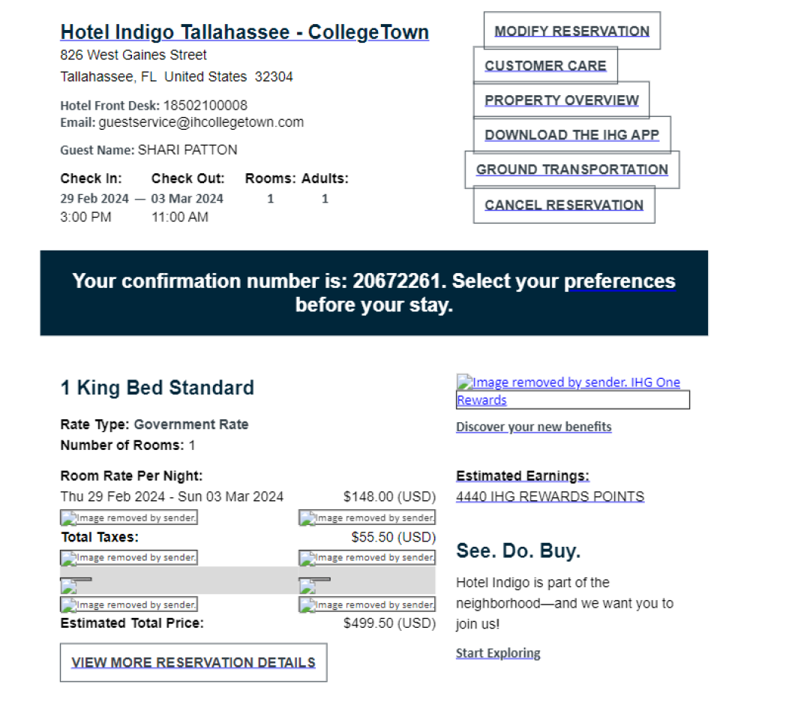
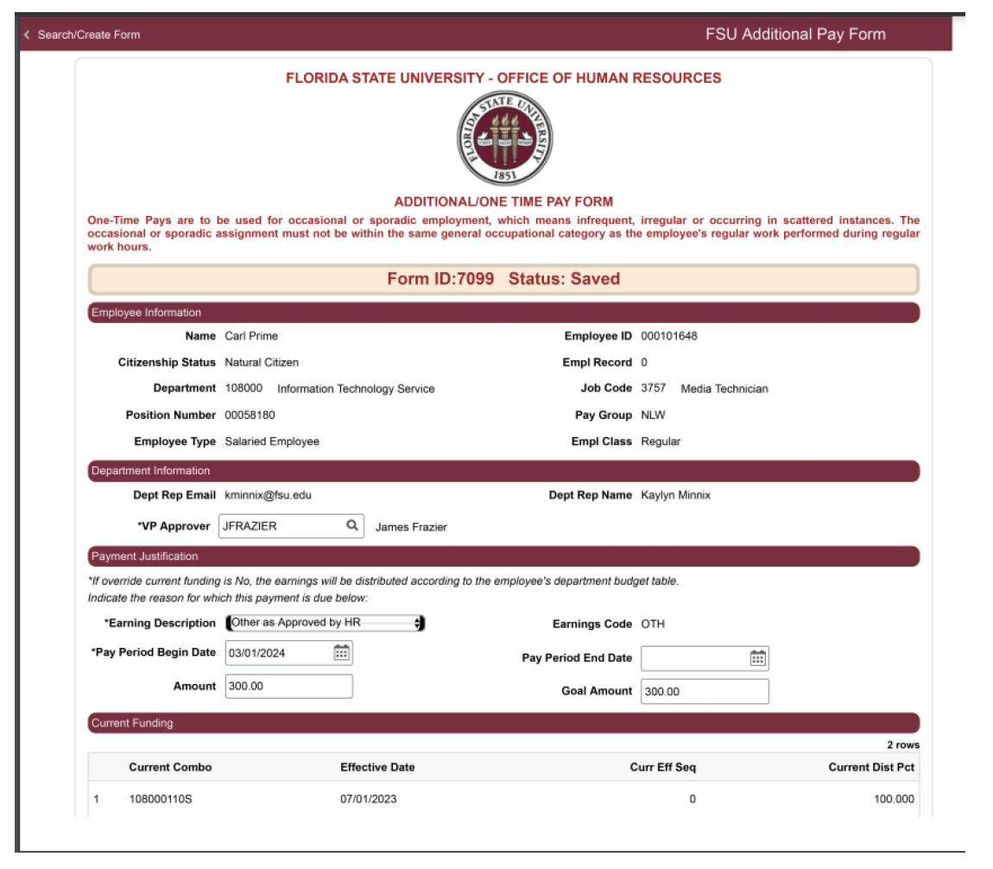
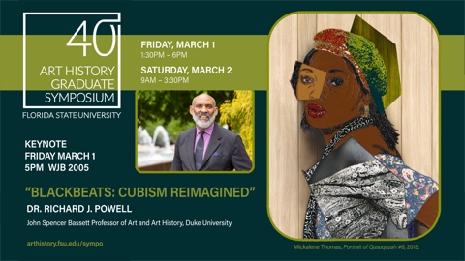

FLORIDA STATE UNIVERSITY
CONGRESS OF GRADUATE STUDENTS
Allocation, Revision, or Transfer

32nd Congress of Graduate Students

Bill #: 4

Sponsored by: Jordan Wheeler

Date: January 22, 2024

Amount: $376

From (account name): COGS Unallocated

To (account name): Public Administration Graduate Association

Purpose & Description:
Summary of Event: The semesterly social event for Masters and Ph.D. students, along with professors, is a highly anticipated gathering that serves as a platform for fostering social connections and keeping the academic community abreast of the latest developments in projects, research, and departmental affairs. This event plays a crucial role in building a sense of camaraderie among the academic community, providing an opportunity for individuals to come together in a more relaxed and informal setting.

Active Members: 200

Estimated Attendance: 40

Advertising Strategy: Nole Central; Social Media; and Email Listserve

Itemized Expenditures:

Quantity | Description | Unit Price
 | Food: Olive Garden (see attached receipt) | $376

Total: $376

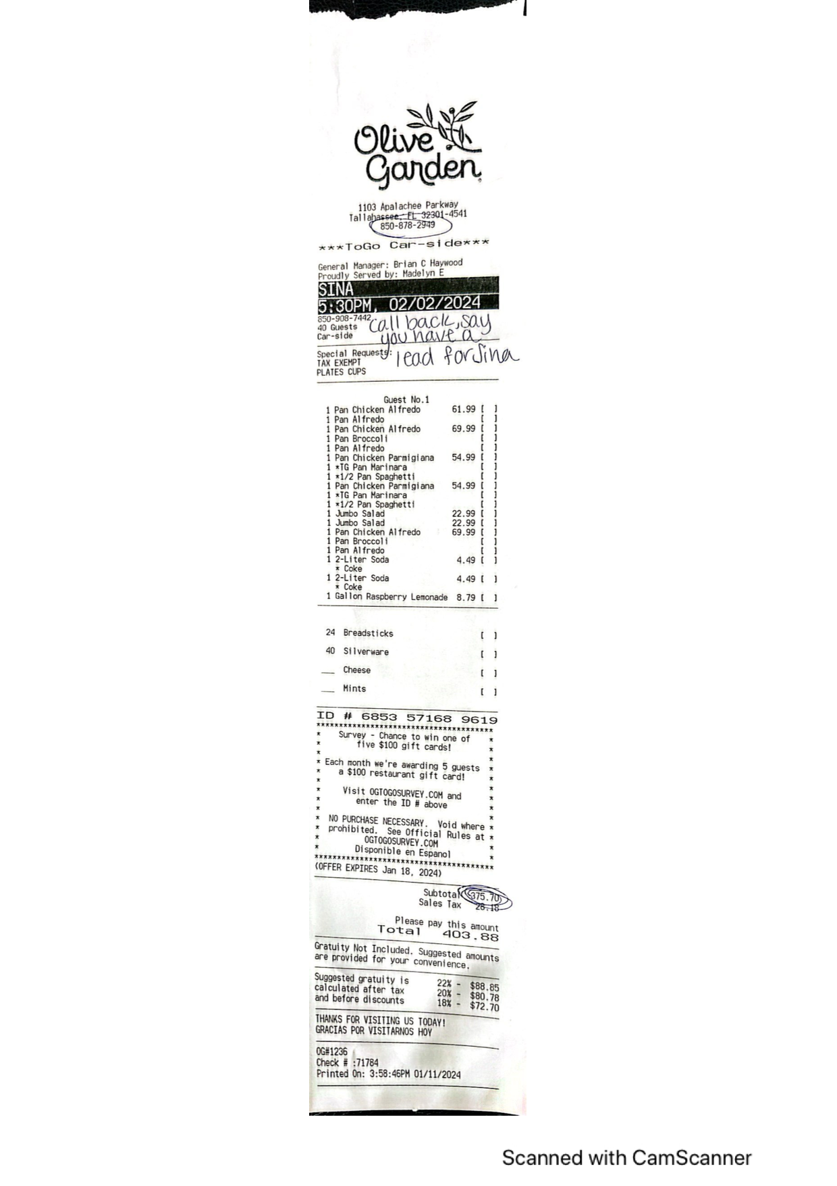
FLORIDA STATE UNIVERSITY
CONGRESS OF GRADUATE STUDENTS
Allocation, Revision, or Transfer

32nd Congress of Graduate Students

Bill #: 5

Sponsored by: Rep. Siegel

Date: 1/22/2024

Purpose and Description: Allocating LSC Funds for the Spring 2024 Semester

Be it enacted by the Thirty-Second Congress of Graduate Students:

Section 1: The Congress finds that the process by which the Law School Council can hear all budget requests for an entire semester and create a budget that takes into account all the needs of the College of Law is a positive step in ensuring fiscal transparency and accountability in a deeply important funding board.

Section 2: The Congress hereby approves the following allocations from the Law School Council for the Spring 2024 semester to the following organizations in the following categories:

LSC Budget Spring 2024
Allocation: $43,538.96
Organization |  |  |  | Cont. Serv | Expense | Food | Clothing & Awards | Total
LSC Administration
LSC Expense |  |  |  |  | $ 500.00 | $ 500.00 |  | $ 1,000.00
LSC Unallocated |  |  |  |  | 2,076.70 |  |  | $ 2,076.70
LSC Administration Total |  |  |  | $ - | $ 2,576.70 | $ 500.00 | $ - | $ 3,076.70
LSC Student Organizations
Asian Pacific American Law Student Association (APALSA) |  |  |  |  |  | $ 799.00 |  | $ 799.00
Association for Criminal Justice |  |  |  |  |  | $ 3,328.00 |  | $ 3,328.00
Business Law Society |  |  |  |  |  | $ 796.00 |  | $ 796.00
Cuban American Bar Association (CABA) |  |  |  |  |  | $ 1,896.00 |  | $ 1,896.00
Entertainment, Arts, and Sports Law Society (EASL) |  |  |  |  | $ 500.00 | $ 796.00 |  | $ 1,296.00
Environmental Law Society |  |  |  | $ 32.10 |  | $ 846.00 |  | $ 878.10
Federal Bar Association at FSU |  |  |  |  |  | $ 1,280.00 |  | $ 1,280.00
FSU Business Review |  |  |  |  |  | $ 2,830.00 |  | $ 2,830.00
Hispanic Law Students Association (HLSA) |  |  |  |  | $ 287.00 | $ 1,948.33 | $ 800.00 | $ 3,035.33
International Law Students Association (ILSA) |  |  |  |  |  | $ 1,000.00 | $ 300.00 | $ 1,300.00
Law Students Practicing Wellness |  |  |  |  | $ 730.83 | $ 1,330.00 |  | $ 2,060.83
OUTLaw |  |  |  |  |  | $ 956.00 |  | $ 956.00
Phi Alpha Delta |  |  |  |  |  | $ 696.00 |  | $ 696.00
Public Interest Law Students Association (PILSA) |  |  |  |  |  | $ 2,246.00 |  | $ 2,246.00
Real Property, Probate, & Trust Law Society at FSU (RPPTL) |  |  |  |  | $ 1,000.00 | $ 830.00 |  | $ 1,830.00
Law Review |  |  |  |  |  | $ 1,100.00 |  | $ 1,100.00
Journal of Land Use |  |  |  |  |  | $ 985.00 |  | $ 985.00
Student Bar Association (SBA) |  |  |  |  |  | $ 2,980.00 |  | $ 2,980.00
Women's Law Symposium (WLS) |  |  |  |  |  | $ 4,830.00 |  | $ 4,830.00
LSC Student Organizations Total |  |  |  | $ 32.10 | $ 2,517.83 | $32,354.00 | $ 1,100.00 | $36,003.93
LSC Competition Teams
Moot Court |  |  |  |  |  | $ 1,910.00 |  | $ 1,910.00
Trial Team |  |  |  |  |  | $ 2,830.00 | $ 600.00 | $ 3,430.00
LSC Competition Teams Total |  |  |  | $ - | $ - | $ 4,740.00 | $ 600.00 | $ 5,340.00
Total |  |  |  | $ 32.10 | $ 5,521.90 | $37,594.00 | $ 1,700.00 | $43,538.96

FLORIDA STATE UNIVERSITY
CONGRESS OF GRADUATE STUDENTS
Allocation, Revision, or Transfer

32nd Congress of Graduate Students

Bill #: 6

Sponsored by: Rep. Balak

Date: 1/22/2024

Purpose and Description: Allocating MSC Funds for the Spring 2024 Semester

Be it enacted by the Thirty-Second Congress of Graduate Students:

Section 1: The Congress finds that the process by which the Medical School Council can hear all budget requests for an entire semester and create a budget that takes all of the needs of the College of Medicine is a positive step in ensuring fiscal transparency and accountability in a deeply important funding board.

Section 2: The Congress hereby approves the following allocations from the Medical School Council for the Spring 2024 semester to the following organizations in the following categories:

MSC Budget Spring 2024
Allocation: $33,884.25
Organization |  |  |  | Cont. Serv | Expense | Food | Clothing & Awards | Total
MSC Administration
MSC Unallocated |  |  |  | $0.00 | $4,633.25 | $0.00 | $0.00 | $4,633.25
MSC Student Organizations
Anesthesiology Interest Group (AIG) |  |  |  |  | $200.00 | $600.00 | $300.00 | $1,100.00
American Medical Association (AMA) |  |  |  |  |  | $300.00 |  | $300.00
American Medical Student Association (AMSA) |  |  |  |  | $300.00 | $300.00 |  | $600.00
American Medical Women’s Association (AMWA) |  |  |  |  | $900.00 |  |  | $900.00
AMWA-Medical Students for Choice Subcommittee (MSFC) |  |  |  |  |  |  |  | $0.00
Business And Medicine (BAM) |  |  |  |  |  | $300.00 | $300.00 | $600.00
Biomedical Science Graduate Student Organization (BSGSA) |  |  |  |  | $300.00 | $1,100.00 |  | $1,400.00
Cardiology Interest Group (CIG) |  |  |  |  |  | $800.00 |  | $800.00
Christian Medical Association (CMA) |  |  |  |  |  | $1,000.00 |  | $1,000.00
Dermatology Interest Group (DIG) |  |  |  |  |  | $600.00 |  | $600.00
Emergency Medicine Interest Group (EMIG) |  |  |  |  |  | $600.00 |  | $600.00
EMIG-Aerospace Medicine Student and Resident Organization Subcommittee (AMSRO) |  |  |  | $400.00 |  |  |  | $400.00
Family Medicine Interest Group (FMIG) |  |  |  |  |  | $1,100.00 |  | $1,100.00
FMIG-Sports Medicine Subcommittee |  |  |  |  |  | $500.00 |  | $500.00
Florida Rural Health Association (FRHA) |  |  |  |  | $150.00 | $300.00 |  | $450.00
FSU Cares |  |  |  |  |  | $600.00 |  | $600.00
Geriatrics Interest Group (GIG) |  |  |  |  |  | $640.00 | $70.00 | $710.00
Humanities And Medicine (HAM) |  |  |  |  | $300.00 | $600.00 | $200.00 | $1,100.00
Internal Medicine Interest Group (IMIG) |  |  |  |  |  | $300.00 |  | $300.00
IMIG-Pulmonary & Critical Care Subcommittee |  |  |  |  |  | $300.00 |  | $300.00
IMIG-Hematology/Oncology Subcommittee |  |  |  |  |  | $300.00 | $300.00 | $600.00
Interprofessional Allies (IPA) |  |  |  |  | $300.00 | $300.00 |  | $600.00
Jewish Medical Student Association (JMSA) |  |  |  |  |  | $800.00 |  | $800.00
Latino Medical Student Association (LMSA) |  |  |  |  |  | $550.00 |  | $550.00
Medical Respect for Life Organization (MeRLO) |  |  |  |  |  | $300.00 |  | $300.00
Military and Veteran Medicine Interest Group (MVIG) |  |  |  |  | $700.00 | $300.00 |  | $1,000.00
Nutrition, Exercise, and Wellness Organization (NEW) |  |  |  |  | $600.00 | $500.00 |  | $1,100.00
Obstetrics and Gynecology Interest Group (OGIG) |  |  |  |  |  | $500.00 |  | $500.00
Ophthalmology Interest Group (OIG) |  |  |  |  |  | $200.00 |  | $200.00
Pediatrics Interest Group (PIG) |  |  |  |  | $250.00 | $600.00 |  | $850.00
Promoting Recognition of Identity, Dignity, and Equality in Healthcare (PRIDE in Healthcare) |  |  |  |  | $200.00 | $900.00 |  | $1,100.00
Psychiatry Student Interest Group (PSIG) |  |  |  |  |  | $300.00 | $200.00 | $500.00
PSIG-Addiction Medicine Interest Group Subcommittee |  |  |  |  |  | $300.00 |  | $300.00
Radiology Interest Group (RIG) |  |  |  | $300.00 | $600.00
Research Interest Group |  |  |  |  | $900.00
Student Academy of the American Academy of Physician Assistants (SAAAPA) |  |  |  | $512.00 |  | $988.00 |  | $1,500.00
Surgery Interest Group (SIG) |  |  |  |  | $100.00 | $450.00 | $300.00 | $850.00
SIG-Women in Surgery Subcommittee (WIS) |  |  |  |  | $100.00 | $150.00 |  | $250.00
SIG-Orthopedic Surgery Subcommittee |  |  |  |  |  | $300.00 |  | $300.00
Students Interested in Global Health (SIGH) |  |  |  |  |  | $452.00 |  | $452.00
Student Interest Group in Neurology (SIGN) |  |  |  | $119.00 | $81.00 | $600.00 | $300.00 | $1,100.00
Student National Medical Association (SNMA) |  |  |  |  | $419.00 | $400.00 | $250.00 | $1,069.00
Wilderness Medical Society (WMS) |  |  |  |  |  | $350.00 | $120.00 | $470.00
MSC Student Organizations Total |  |  |  | $1,031.00 | $4,900.00 | $20,680.00 | $2,640.00 | $29,251.00
Total |  |  |  | $1,031.00 | $9,533.25 | $20,680.00 | $2,640.00 | $33,884.25

FLORIDA STATE UNIVERSITY
CONGRESS OF GRADUATE STUDENTS
Allocation, Revision, or Transfer

32nd Congress of Graduate Students

Bill #: 7

Sponsored by: Representative Burns

Date: January 22nd, 2024

Amount: $26,447.27
From (account name): COGS Unallocated Account
To (account name): Presentation Grants (July – October 2023): $16,447.27; Attendance Grants (July – October 2023): $10,000.
Purpose & Description: The purpose of this transfer is to ensure sweeping funds, that are meant for 2022-2023 conference grants retroactive reimbursements, are safe from funding for current conference grants.
PROVISO: Funds placed in July – October 2023 attendance and presentation grants funding lines by this bill shall only be used for retroactive reimbursements for 2022-2023 conference grants, administered by the Deputy Speaker of Finance according to criteria set by the DSF in consultation with SG&A. Any use or transfer of these funds outside the purpose of the bill shall only occur by COGS bill.

FLORIDA STATE UNIVERSITY
CONGRESS OF GRADUATE STUDENTS
THIRTY-SECOND CONGRESS OF GRADUATE STUDENTS
Assembly Meeting
December 4, 2023
6:30pm
Agenda
Call to Order: 6:32pm
Pledge of Allegiance: Rep. Siegel
Roll Call:
Present: Balak, Balogun, Cyrille, Delva, Galeano, Medarev, Pakdehi, Rogowski, Rowan, Siegel, Solmaz, Vaughn, Wesner, Velez
Absent Excused: Barber, Beavon, Burns, Ebuara, Hussain, Wardlow, Wheeler,
Absent Unexcused: Bettley
Reading and approval of the Minutes: Siegel; 2nd - Solmaz
Swearing in of Representatives
Passing out of Certificates for Elected Congress Members
Petitions into the Assembly:
Madison McCraney - Graduate Student Housing Advocate
Gave a long resume at the end of the 31st Congress and want to continue that.
Q&A:
Rogowski - will you be free during meeting times in the Spring? Yes
Solmaz - Motion to extinguish time; 2nd - Galeano
Pros:
Solmaz - She's great.
Solmaz - Call to question; 2nd - Rogowski
Vote: 13-0-0
Swearing in.
Profilia Nord - Students with Disabilities Advocate - Moved to January meeting
Special Introductions and Student Comments: N/A
Messages from Student Government: Introduction to our new liaison from the Student Senate - Senator Hine from the College of Social Work. Want to bridge the gap between the Senate and COGS. Some updates are that the 76th Senate has started and Joseph Cofer was elected and a new Pro-Tempore Jason Goerlic was also elected. Excited to work with us.
Report from the Office of Governmental Affairs:
Report of Officers:
- Report of the Speaker: Sorry about the food, there was an issue with the purchase order. We will try to get it here before the end of the meeting. The main thing is that committee preferences need to be filed out by winter break. Our first meeting for the spring is January 22nd. Will be meeting with the childcare center this week on what they are doing and how they are helping graduate students. Please let me know if you have any specific questions to ask them. Please run for Judicial Affairs seat if you are interested.
- Report of the Deputy Speaker for Finance: If you have RSOs reaching out about funding requests, make sure that they are putting in those requests 2-3 weeks ahead of time so that it gives us time to get those requests filled.
- Report of the Deputy Speaker for Judicial Affairs:
- Report of the Deputy Speaker for Communications: Please start thinking of events that COGS can put together in the Spring.
Committee Report:
- Committees will be assigned by the first meeting in January
Funding Requests:
Unfinished Business:
Deputy Speaker for Judicial Affairs - call for nominees
Seeing none, this will be moved to the next meeting. If you have any type of interest in this role, please reach out to the Executive Board or the previous Deputy Speaker for Judicial Affairs.
New Business:
Round Table:
Adjournment: 7:37pm
Next Meeting: January 22, 2023 at 6:30 p.m. Senate Chambers (3rd floor Student Union)

