FLORIDA STATE UNIVERSITY
CONGRESS OF GRADUATE STUDENTS
THIRTY-FIRST CONGRESS OF GRADUATE STUDENTS
Assembly Meeting
October 16, 2023
6:30pm
Agenda
Call to Order:
Pledge of Allegiance:
Roll call:
Reading and approval of the Minutes:
Petitions into the Assembly:
At Large Seat - Steven Medarev
Special/Undecided Seat - Madison McCraney
Social Sciences and Public Policy Seat 1: Taylor Barber
Special Introductions and Student Comments:
Messages from Student Government:
Report from the Office of Governmental Affairs:
Report of Officers:
- Report of the Speaker:
- Report of the Deputy Speaker for Finance:
- Report of the Deputy Speaker for Judicial Affairs:
- Report of the Deputy Speaker for Communications:
FSU Votes’ Rock the Vote event on November 1st from 6-8pm Volunteers needed
Committee Report:
- C-SAC:
- Internal Affairs:
- Student Advocacy:
- Student Affairs:
Funding Requests:
Bill #31: Southeast Review
Bill #32: Music Theory Society
Bill #33: Transfer from Presentation Grants to Attendance Grants
Unfinished Business:
New Business:
Resolution #4: A&S Fee Increase
Resolution #5: Support of Graduate Student Veterans
Round Table:
Adjournment:
Next Meeting: November 6, 2023 at 6:30 p.m. in the Senate Chambers

COGS Financial Report, Fiscal Year 2023-2024
ACCOUNT | ALLOCATION AMOUNT | DESCRIPTION | BALANCE
UNALLOCATED | $21,318 | For RSO funding requests at COGS meetings | $20,413
ORGANIZATIONAL (C-SAC) | $3,000 | RSO funding for allocations less than $1000 for the fiscal year | $3,000
LSC | $61,000 | Funding allocations from Law School Council to Law School Student Organizations | $43,831.00
MSC | $84,817 | Funding allocations from Medical School Council to Medical School Student Organizations | $43,420.72
PRESENTATION GRANTS (Jul-Oct) | $66,250 | Presentation Grant balance for the July-October funding period | $11,123.62
PRESENTATION GRANTS (Nov-Feb) | $75,000 | Presentation Grant balance for the November-February funding period | $64,550
PRESENTATION GRANTS (Mar-Jun) | $58,750 | Presentation Grant balance for the March-June funding period | $58,750
ATTENDANCE GRANTS (Jul-Oct) | $9,000 | Attendance Grant balance for the July-October funding period | $0
ATTENDANCE GRANTS (Nov-Feb) | $9,000 | Attendance Grant balance for the November-February funding period | $8,550
ATTENDANCE GRANTS (Mar-Jun) | $7,500 | Attendance Grant balance for the March-June funding period | $7,500

FLORIDA STATE UNIVERSITY
CONGRESS OF GRADUATE STUDENTS
Allocation, Revision, or Transfer

31st Congress of Graduate Students

Bill #: 31

Sponsored by: Representative Beavon

Date: October 2nd, 2023

Amount: $3,500

From (account name): COGS Unallocated

To (account name): Southeast Review

Purpose & Description: Southeast Review (SER) is requesting $3,500 for their event for a speaker honorarium. This organization aims to showcase literary works of both established and emerging or underrepresented artists. The organization consists of 40 members.

SER is hosting their annual reading event with a creative writer whose work centers on the issues of diversity, equity, and inclusion. Funding provided would help to secure a reader for the event. The event would include a Q&A with the writer and the reading itself.

Name of Event: Diversity and Inclusion Spring Reading Event
Location of Event: Museum of Fine Arts
Date(s) of Event: Early March 2024
Time(s) of Event: 7:00 pm
Estimated Attendance: 60

Free and open to all FSU students & faculty. Advertised via social media, word of mouth, and flyers.

Itemized Expenditures:

Quantity | Description | Unit Price
1 | Contractual Service (Speaker) | $3,500

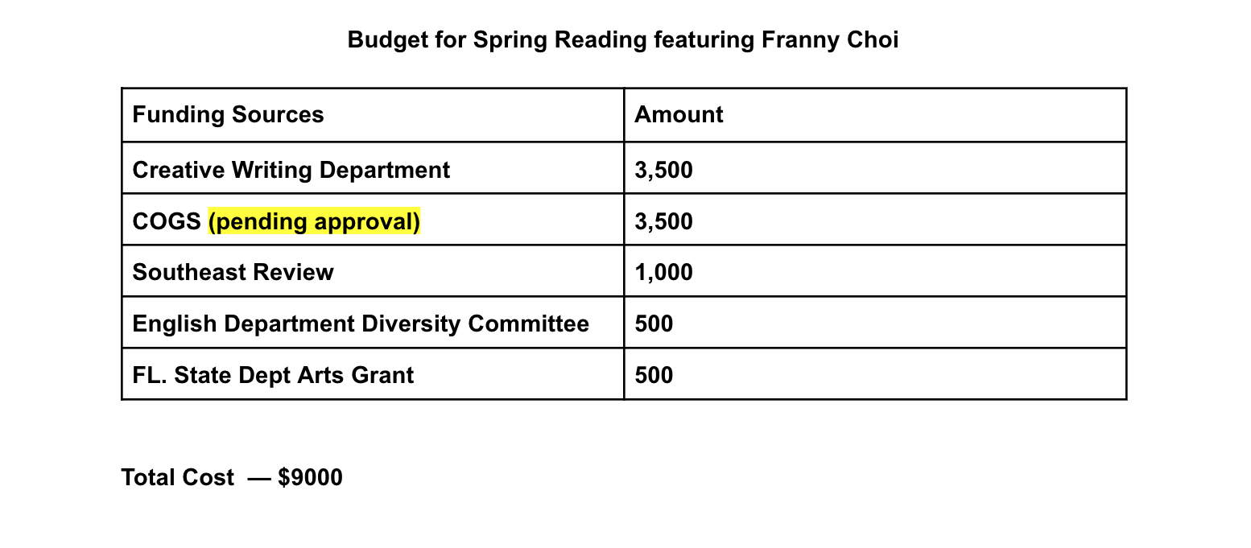
Franny Choi: https://www.frannychoi.com/about-1

FLORIDA STATE UNIVERSITY
CONGRESS OF GRADUATE STUDENTS
Allocation, Revision, or Transfer

31st Congress of Graduate Students

Bill #: 32

Sponsored by: Rep. Francis Ebuara

Date: October 16, 2023.

Amount: $2,200

From (account name): COGS Unallocated

To (account name): Music Theory Society

Purpose & Description:

The Music Theory Society is currently a 35-active member organization. The mission of the organization includes fostering the development of all aspects of the discipline of music theory, including research and teaching. It provides forums for the presentation of research, including workshops and other aspects of professional development.

They announce their 41st annual Music Theory Forum to be held online during the weekend of March 2-3, 2024. This conference will be entirely virtual on Zoom, and they would welcome two keynote speakers: Professor Horace J. Maxile, Jr. (Baylor University) and Professor Leigh VanHandel (The University of British Columbia). In addition to the two keynote presentations given by their invited speakers, the conference will feature paper presentations by early-career scholars and graduate students in the discipline of music theory (or related disciplines). The paper presentations will be chosen through a blind proposal review process by their program committee.
The group is expecting an attendance of between 30-50 attendees.

Finally, the group plans to advertise the event through the Society of Music Theory (SMT), their discipline's academic society. An email notification about the upcoming conference and the call for papers will be sent through the SMT listserv, SMT-announce.

Itemized Expenditures:

Quantity | Description | Unit Price
1 | Contractual Services - Speaker Honorarium | $2,200
Total: $2,200

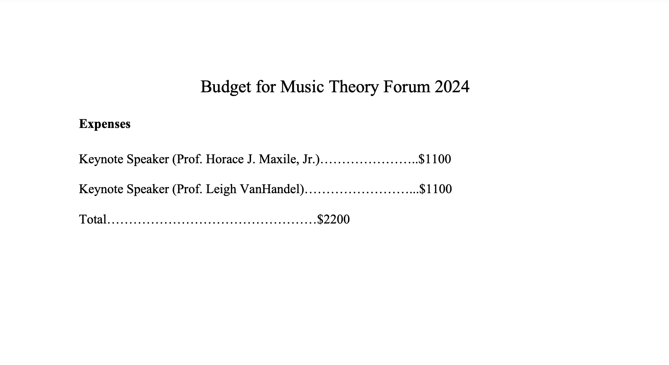

FLORIDA STATE UNIVERSITY
CONGRESS OF GRADUATE STUDENTS
Allocation, Revision, or Transfer

31st Congress of Graduate Students

Bill #: 33

Sponsored by: Rep. Burns

Date: Monday, October 16th , 2023

Amount: $2,400

From (account name): COGS Conference Presentation Grants July 2023 – October 2023

To (account name): COGS Conference Attendance Grants July 2023 – October 2023

Purpose & Description: The purpose of this transfer is to ensure adequate funds for the remaining attendance grants for the July 2023 – October 2023 conference funding period.

FLORIDA STATE UNIVERSITY
CONGRESS OF GRADUATE STUDENTS

Resolution

31st Congress of Graduate Students

Resolution #: 4

Sponsored by: Rep. Rowan

Date: October 16, 2023

Whereas the Local Fees Committee has been meeting over the last month to determine whether an increase in the Activity & Service Fee, the Health Fee, and the Athletics Fee is necessary for the betterment of the university student body, and

Whereas the upon meeting and considering many factors, including the fact that the Activity & Service Fee has not increased since 2014, the Local Fees Committee recommended an increase to the Activity & Service Fee of $0.65 per credit hour, bringing the total fee to $13.51 per credit hour, and

Whereas such an increase would increase the total budget of the Student Government Administration by approximately $700,000 per year and the budget of the Congress of Graduate Students by approximately $50,000 per year, and

Whereas this increase in revenues would be extremely beneficial to the student body as increasing expenses has caused budgets to be tightened across the board, reducing the quality and quality of services offered to the student body and to Registered Student Organizations by SGA, and

Whereas in order for this increase to take place, the recommendation of the Local Fees Committee must be approved by the University President and the Board of Trustees, the latter being by a two-thirds vote, therefore

Be it resolved by the Thirty-First Congress of Graduate Students: That the Congress, on behalf of the graduate student body of Florida State University, is in full support of the A&S Fee increase proposed by the Local Fees Committee for all of the reasons listed in this Resolution and respectfully asks that President Dr. Richard McCullough bring this recommendation to the University Board of Trustees, and
Be it further resolved: That the Congress respectfully asks the Florida State University Board of Trustees to approve the increase to the A&S Fee in order to allow the services of Student Government, ranging from providing places of community to recreational services to employing students in a manner that aids with affordability and provides the flexibility that external employment opportunities may not provide, to continue and flourish, and
Be it further resolved: That the Congress expresses its full support for the conversations occurring in the meantime surrounding opportunities that may relieve the budgetary stresses faced by every aspect of the Student Government and hopes that the interests of graduate students and their ability to be represented are actively sought out and considered throughout these conversations, and
Be it further resolved: That the Congress remains committed to take all actions and engage in all advocacy necessary to encourage the proper funding of the necessary programs that SGA undertakes for the benefit of the undergraduate and graduate student bodies and that the Congress informs the Student Body President of its willingness to lobby for the recommendations of the Local Fees Committee, and
Be it finally resolved: That a copy of this resolution be sent to:
Dr. Richard McCullough, President of Florida State University,
Mr. Jackson “Jack” Hitchcock, Trustee and Student Body President of Florida State University,
Mr. Peter Collins, Chair of the Florida State University Board of Trustees,
Mr. Maximo Alvarez, Trustee of Florida State University and Chair of the Audit and Compliance Committee,
Mrs. Kathryn Ballard, Trustee of Florida State University,
Mrs. Bridgett Birmingham, Trustee and Faculty Senate President of Florida State University,
Ms. Vivian de las Cuevas-Diaz, Trustee of Florida State University and Chair of the Academic Affairs Committee,
Mr. Jorge Gonzalez, Trustee of Florida State University and Chair of the University Research Committee,
Mr. Jim Henderson, Trustee of Florida State University and Chair of the Finance and Business Committee,
Mr. Justin Roth, Trustee of Florida State University,
Ms. Deborah Sargeant, Trustee of Florida State University,
Mr. Bob Sasser, Trustee of Florida State University and Chair of Governance Committee,
Mr. John Thiel, Trustee of Florida State University and Chair of the Advancement Committee,
Mr. Drew Weatherford, Trustee of Florida State University and Chair of the Student Affairs Committee, and
Dr. Amy Hecht, Vice President of Student Affairs of Florida State University.

FLORIDA STATE UNIVERSITY
CONGRESS OF GRADUATE STUDENTS
Resolution

31st Congress of Graduate Students

Resolution #: 5

Sponsored by: Representative Wesner

Date: October 16th, 2023

Whereas: Florida State University’s current FSU Graduate Bulletin under Standard Full-Time Load and Underload Definitions deems full-time graduate student status at twelve credit hours which adversely affects graduate student veterans, graduate students who married to veterans, and the children of veterans; and;

Whereas: this policy causes the Department of Veterans Affairs to prorate their G.I. Bill housing stipends to graduate students who are taking less than twelve credits; and;

Whereas: this policy results in the reduction of G.I. Bill payments by several hundred dollars each month to graduate students, even if they are considered to be enrolled full time by their department; and;

Whereas: the average age of student veterans at Florida State University is 34, and many of these student veterans are employed and have children which hinders their ability to enroll in twelve credits; and;

Whereas: most graduate programs on campus consider students to be in full time status with a 9-credit course load; and;

Whereas: this policy is contrary to the stated values of Florida State University and its student body, which professes to support and honor our veterans and their families.

Be it resolved by the Thirty-First Congress of Graduate Students of Florida State University that: it hereby proclaims full support in favor of Florida State University changing its full-time enrollment policy for graduate students from considering 12-credits to be full time to considering 9-credits or the amount of credits which is considered full time by their department.

Be it finally resolved: That a copy of this resolution be sent to:
Dr. Richard McCullough, President of Florida State University,
Mr. Jackson “Jack” Hitchcock, Student Body President of Florida State University,
Dr. Jim Clark, Provost of Florida State University,
Dr. Mark Riley, Dean of the Graduate School of Florida State University,
Dr. Amy Hecht, Vice President of Student Affairs of Florida State University,
Mr. William (Billy) Francis, Director of the Florida State University Veterans Center.

FLORIDA STATE UNIVERSITY
CONGRESS OF GRADUATE STUDENTS
THIRTY-FIRST CONGRESS OF GRADUATE STUDENTS
Assembly Meeting
October 2, 2023
6:30pm
Minutes
Call to Order: 6:37pm
Pledge of Allegiance: Rowan
Roll call:
Present: Balogun, Beavon, Burns, Delva, Ebuara, Galeano, Gui, Hussain, Joyner, Pakdehi, Risler, Rivers, Rogowski, Rowan, Salimi, Vaughn, Wesner
Absent Excused: Elmi, Solmaz
Reading and approval of the Minutes: Rowan; 2nd Rivers
Petitions into the Assembly:
Social Sciences and Public Policy Seat 1: Taylor Barber
Petitioner was absent
Social Sciences and Public Policy Seat 2: Megan Bettley
2nd year Masters of Public Administration program. 5th year at FSU. In undergrad was involved in SGA. Served as budget vice chair and chair. Wants to be in COGS to take that next step and work on behalf of graduate students in her program.
College of Law Seat 2: Jordan Wheeler
1st year Law student and wants to be in COGS because she wants to enhance her personal skills, help the FSU community, and make a difference. Has been involved in her undergraduate time on campus.
College of Health and Human Science Seat 1: Frank Velez
3rd year PhD in food science. No background in SGA, but I want to advocate for my college as we are a small college and I want to branch out and get the name out more. Founder of a food science club and wants to help promote that as well.

Questions for petitioners:
Rowan - What committee would you like to join? Bettley - Student Affairs, Wheeler - Student Affairs, Velez - Student Advocacy
Pakdehi - What are you going to do in COGS for students? Bettley - I want to have more events for graduate students where they can find common ground. Wheeler - want to get Law students more involved and get people more engaged. Velez - Hoping through COGS to get the name of his college out there. Has worked some with undergrads and wants to help use that to build up his college's graduate student population.
Rogowski - Are you available Monday evenings at this time? Yes
Rowan - Are you financially certified? Bettley and Velez - Yes; Wheeler - no
Delva - What are you most excited about with COGS? Bettley - want to get more RSOs to be aware of COGS resources; Wheeler - Excited for networking with other graduate students; Velez - Would like to network and in the works to get a certified kitchen to sell out of that kitchen to also give away the food to students. Would like to work to provide food for RSOs.
3 minutes debate in favor:
Rowan - Jordan is one of my classmates and she is a rockstar. She has been a great person within the entire Law School class.
Burns - With what Frank said, his point that there wasn't much representation was important and the kitchen sounds great.
Rivers - I've been working with Frank and he will do a good job. Megan is someone I've worked with and has that budget experience.
Delva - Excited to have 3 petitioners that we have needed seats filled for. Law has been empty and the nutrition representation is new. It's great to see all this increased representation.
Gui - For such a small program, he has a lot of vision.
Vote:
Bettley 16-0-0
Wheeler 16-0-0
Velez 16-0-0
New representatives sworn in.
Special Introductions and Student Comments:
Burns - I have an introduction for Gabi who is interning with student governance
Delva - I have brought visitors who are interested in joining COGS from the College of Medicine
Messages from Student Government: N/A
Report from the Office of Governmental Affairs: N/A
Report of Officers:
- Report of the Speaker:
- COGS Member Retreat on Sunday, October 8th at 1pm at the Rez
We will be sending out a form to fill out for box lunches. This will let us to all get to know each other and let new members know how COGS works. We will also have time to enjoy the Rez.
- There is a strategic planning committee coming which I will update about in two weeks.
- Report of the Deputy Speaker for Finance: Looking at the financial report, you can see that our presentation grants from July-October still have a balance, but the attendance grants are getting low. What I would like to check the room about is moving some of the funding in C-SAC to the attendance grants so that we can approve all of the grants. C-SAC fundings has not been used in a while.
Rowan - could we move the presentation grant funds to attendance?
Burns - Perhaps. I will have to finish getting through all the grant requests.
Rogowski - For the first time, we are running out of money at the end of the funding period. We have 14 applications that might get denied if we don't move around some money.
Burns - The new window for attendance grants is open, but the website isn't fully updated. We did have a RSO information session about funding and this will be posted to the website.
Hussain - So if people were approved in the previous fiscal year, can they still get their funding if they didn't get the message?
Rogowski - Once a fiscal year closes, we cannot reimburse anyone. They can apply for future funding for the funding period that is open.
Burns - Sometimes Survey Monkey does not send confirmation emails, so if you hear about it, they can go back into the platform to see their confirmation. We will send out a guide on how to find that confirmation.
- Report of the Deputy Speaker for Judicial Affairs: No update, but I want to urge everyone to come to the retreat so that they can learn how to make suggested code changes.
- Report of the Deputy Speaker for Communications: Make sure that you submit your candidacy declaration forms by Wednesday at 4pm if you want to keep your seat. I will continue to send information about the election process as we move forward.
Committee Report:
- C-SAC: N/A
- Internal Affairs: We met and the Medical School Counsel was asking about funding students who are not living in town, but still pay A&S fees. We want to restart the newsletter. Might be best for once a month. See if other committees can help out. Try to get the template from the Senate. Creating a minutes template for all committees to use. This will be a resolution that hopefully will come to the congress next meeting. Please make sure that you are sending your minutes to Ben Young. I have been emailing people around campus to get seats filled.
- Student Advocacy: We have Rep. Joyner as our vice chair. At our meeting we discussed exploring the possibility of teaching assistants get parking spots in staff spots. A previous issue concerning international student admissions changes for language qualifications was discussed. We looked at grants data and the information is a work in progress. Rep. Wesner shared an issue about veterans and we are making a resolution in support.
- Student Affairs: We met and discussed an event that was going to be held with CGE this Wednesday, but the event was unfortunately canceled. Rep. Wesner did bring up the same veterans issue and we want to help make a resolution in support of veterans. Rep. Beavon is the new vice chair.
Funding Requests:
Bill #31: Southeast Review
Rep. Beavon - Southeast Review showcases the work of emerging writer. They wish to have a writer for an event. The event will be in the spring at the Museum of Fine Arts. This magazine has a lot of experience putting on these events. We just recently became a RSO so this is why this is our first request.
Questions:
Delva - Is the $3,500 just the honorarium? Yes, it's just the honorarium. The total cost is more, so we are trying to get some of it covered.
Rowan - Is this covering the full cost of the honorarium? No, we are fundraising the rest of it. Point of information - Are you aware that this will need to be approved by the Senate after our approval because of the amount? Yes.
Rowan - How will you promote this? Social media and through fliers on campus.
Motion to extend time - Gui, Delva - 2nd.
Delva - Can you tell us more information about this speaker? We haven't secured the speaker yet due to funding, but the event isn't until March.
Hussain - What will the speaker be doing? Reading their own work.
Pakdehi - Is this an open event? Yes, this will be open to everyone. How did you come to the number ot 60 people? From past events.
Rivers - How do you know the cost if you don't have one yet? Based on past speakers.
Galeano - Will there be other expenses? Yes, but we are able to cover those costs.
Motion to extend time - Savoya; 2nd - Delva.
Rowan - Could you get a quote for the speaker? We could probably do that after a couple of week. Do you have people in mind? Yes, 5-6.
Joyner - Could we table this and discuss the funding after the speaker is picked? That is another part of the process.
Rogowski - Do you charge money for the event? It's free.
Gui - Who is covering food and lodging? The English department.
Beavon - Is my understanding of the process is that it's an invitation plus offer first? Yes, we invite them with an offer versus them giving a quote.
Hussain - How famous is the person? Last year we had someone who had won awards.
Pros:
Joyner - I'm for the event especially because of the importance of DEI. However, there are a lot of gray elements which is why we might want to discuss this in the future since this is so far out.
Point of information - we could potentially table this for later
Delva - I like this event because it has been going on for a long time.
Rogowski - The Southeast Review did come to me about this request. They have other money they are using for this event. Even though it's a large request, it's a small amount for the total cost of the full event.
Balogun - The backing they have from their department shows how serious this event is.
Bettley - It's important to have these types of events now with the uncertainty of DEI.
Cons:
Rowan - I'm saying this because of where this request is in the process. I understand why there isn't a quote right now, but with this large of a request, I have concerns about the uncertainty. I think it would be better to give them some time to reach out for quotes and then revisit this bill next meeting. The Senate will not look upon the resolution favorably at its current stage. Getting quotes would be a better action.
Delva - This is one of the biggest contractual services we've given in a long time. I want to see more people participating for it being this expensive. I would like it to be advertised more to get more attendants.
Rowan - I move to table this bill to the 16th; 2nd - Delva
Rowan - I withdraw my motion for now.
Rivers - I think the problem is that there is no name on the request and as someone who was on Senate, this would be voted no because without knowing the speaker, anyone could be brought on campus. We'd like a name for liability.
Balogun - The name is important or at least 2-3 names. We also need to know who else is paying how much of the cost.
Delva - Would you be ready with the information on the 16th? Would we need to get quotes or have someone locked in? Quotes and some summaries of who is being invited. A breakdown of how much has been raised would also be helpful.
Rowan - I move to table this bill to the 16th; 2nd - Delva
Rogowski - The bill will be tabled until the 16th with more information.
Unfinished Business: N/A
New Business: N/A
Round Table:
Adjournment: 8:04pm
Next Meeting: October 16, 2023 at 6:30 p.m. in the Senate Chambers

