FLORIDA STATE UNIVERSITY
CONGRESS OF GRADUATE STUDENTS
THIRTY-FIRST CONGRESS OF GRADUATE STUDENTS
Assembly Meeting
September 11, 2023
6:30pm
Agenda
Call to Order:
Pledge of Allegiance:
Roll call:
Reading and approval of the Minutes:
Petitions into the Assembly:
College of Arts and Sciences Seat 3: Savoya Joyner
College of Law Seat 1: Jack Rowan
College of Fine Arts Seat 1: Erick Rivers
Special Introductions and Student Comments:
Messages from Student Government:
Report from the Office of Governmental Affairs:
Report of Officers:
- Report of the Speaker:
- Report of the Deputy Speaker for Finance:
- Report of the Deputy Speaker for Judicial Affairs:
- Report of the Deputy Speaker for Communications:
- CGE Coffee Hour on September 15th at 5pm in the Globe
- Graduate Student Kickback event - Sept. 21 from 11:30am-2:30pm at Club Downunder
Committee Report:
- C-SAC:
- Internal Affairs:
- Student Advocacy:
- Student Affairs:
Funding Requests:
Bill #29: Iranian Student Association
Unfinished Business:
Deputy Speaker for Finance Call for Nominees
New Business:
Round Table:
Adjournment:
Next Meeting: September 18, 2023 at 6:30 p.m. in the Senate Chambers

COGS Financial Report, Fiscal Year 2023-2024
ACCOUNT | ALLOCATION AMOUNT | DESCRIPTION | BALANCE
UNALLOCATED | $21,318 | For RSO funding requests at COGS meetings | $19,815
ORGANIZATIONAL (C-SAC) | $3,000 | RSO funding for allocations less than $1000 for the fiscal year | $3,000
LSC | $61,000 | Funding allocations from Law School Council to Law School Student Organizations | $54,752.75
MSC | $84,817 | Funding allocations from Medical School Council to Medical School Student Organizations | $68,738.32
PRESENTATION GRANTS (Jul-Oct) | $66,250 | Presentation Grant balance for the July-October funding period | $28,183.79
PRESENTATION GRANTS (Nov-Feb) | $75,000 | Presentation Grant balance for the November-February funding period | $75,000
PRESENTATION GRANTS (Mar-Jun) | $58,750 | Presentation Grant balance for the March-June funding period | $58,750
ATTENDANCE GRANTS (Jul-Oct) | $9,000 | Attendance Grant balance for the July-October funding period | $3,450.00
ATTENDANCE GRANTS (Nov-Feb) | $9,000 | Attendance Grant balance for the November-February funding period | $9,000
ATTENDANCE GRANTS (Mar-Jun) | $7,500 | Attendance Grant balance for the March-June funding period | $7,500

FLORIDA STATE UNIVERSITY
CONGRESS OF GRADUATE STUDENTS
Allocation, Revision, or Transfer
31st Congress of Graduate Students
Bill #: 29
Sponsored by: Eric Wesner
Date: 9/11/2023

Amount: $138
From (account name): COGS Unallocated
To (account name): Iranian Student Association (ISA)

Purpose & Description: This money will go towards funding a commemorative event in remembrance of Mahsa Amini, a young Iranian woman who tragically lost her life due to her alleged violation of Iran's mandatory hijab law. This event will serve as a platform to raise awareness about human rights, gender equality, the importance of social activism, and to show our support for the protests that took place in Iran last year. Through a guest speaker session and communal engagement, they aim to honor Mahsa Amini's memory, inspire discussions on pressing societal issues, and stand in solidarity with the Iranian people's bravely struggle for justice and change of the government.

Itemized Expenditures:

Quantity | Description | Unit Price
1 | Publix Catering | $138.00
Total: $138.00

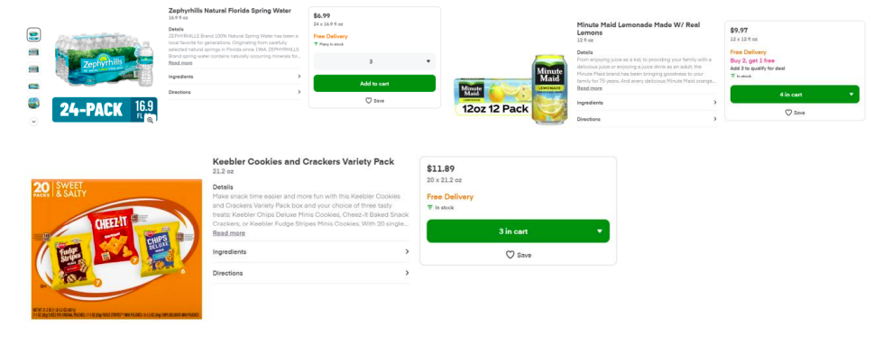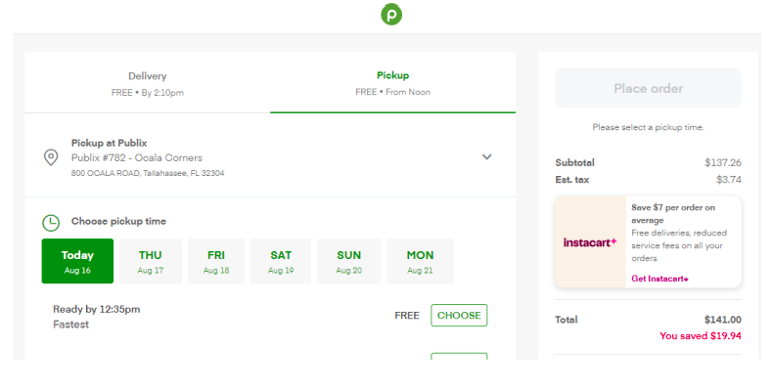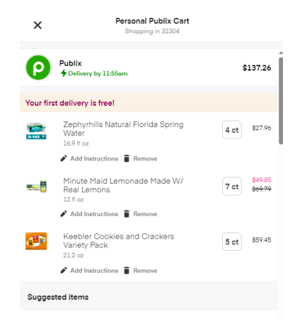

FLORIDA STATE UNIVERSITY
CONGRESS OF GRADUATE STUDENTS
THIRTY-FIRST CONGRESS OF GRADUATE STUDENTS
Assembly Meeting
July 17, 2023
6:30pm
Minutes
Call to Order: 6:33pm
Pledge of Allegiance: Rep. Beavon
Present: Balogun, Beavon, Delva, Ebuara, Galeano, Hussain, Rogowski, Vaughn
Absent Excused: Wesner
Reading and approval of the Minutes: Galeano, 2nd - Delva
Petitions into the Assembly: N/A
Special Introductions and Student Comments: N/A
Messages from Student Government: N/A
Report from the Office of Governmental Affairs: N/A
Report of Officers:
- Report of the Speaker: Got access to the Speaker email and working on catching up. Looking forward to Graduate Student Orientation on August 22nd. Let me know if there is anything specific to mention during this. As a reminder with the start of the Fall semester, reach out to those in your department to share that you are a member of COGS. Be an advocate for students.
Representative Ebuara - I am planning to talk to new students coming in to my program. What should I talk to them about?
Talk to them about RSOs and the presentation grants.
- Report of the Deputy Speaker for Finance: Everything is going well with the grants for the new fiscal year. The financial report has been updated for this new fiscal year. Presentation grants are being used and MSC is also using their funds for a big event in August. We do have a funding request tonight.
- Report of the Deputy Speaker for Judicial Affairs: No reports.
- Report of the Deputy Speaker for Communications: Will be reaching out to confirm people helping with International Student Orientation and will reach out to representatives on summer break for help. Will also be planning representative spotlights for Instagram - look out for emails soon.
Committee Report:
- C-SAC:
- Internal Affairs: N/A
- Student Advocacy: N/A
- Student Affairs: N/A
Funding Requests:
Bill #28: Office of Representation, Inclusion, Student Equity (RISE)
Rep. Galeano: The RISE Office is requesting $1,500 toward funding their 3rd Floor Thursday series event. This event works to help graduate students get to know each other. There are details attached for food quotes and photos from the events held last year. I yield the rest of my time.
Q&A: Vaughn - Do we know how many people came to these events last year? 30-40 people.
Delva - Would it be a Thursday event every other Thursday or one Thursday a month? I'm not sure how far apart these events are.
Speaker Rogowski - I can clarify this. The event was twice a month, but we are just funding the first 3 events and encourage them to go to sweepings for the rest of the year. We did not want to clear out our money so early, so they will request more money later from Sweepings.
Pros:
Vaughn - Would like us to offer to help market this event because I don't remember seeing it advertised last year. It's a good way for Graduate Students to meet each other and I would like to see more people attending.
Delva - I like this event because it helps grad students to meet each other.
Ebuara - Motion to extinguish the rest of the time.
Cons:
Hussain - This is the first I've heard about this, so they need to work on advertising.
Delva - Motion to Call to Question; Ebuara - 2nd.
Voting: 7-0-1
Unfinished Business:
Deputy Speaker for Finance Call for Nominees - None
New Business: N/A
Round Table:
Adjournment: 7:23pm
Next Meeting: September 11, 2023 at 6:30 p.m. in the Senate Chambers

