FLORIDA STATE UNIVERSITY
CONGRESS OF GRADUATE STUDENTS
THIRTY-FIRST CONGRESS OF GRADUATE STUDENTS
Assembly Meeting
April 17, 2023
6:30pm
Agenda
Call to Order:
Pledge of Allegiance:
Roll call:
Reading and approval of the Minutes:
Petitions into the Assembly:
Special Introductions and Student Comments:
Messages from Student Government:
Report from the Office of Governmental Affairs:
Report of Officers:
- Report of the Speaker:
- Report of the Deputy Speaker for Finance:
- Report of the Deputy Speaker for Judicial Affairs:
- Report of the Deputy Speaker for Communications:
Committee Report:
- C-SAC:
- Internal Affairs:
- Student Advocacy:
- Student Affairs:
COGS Spring Social - April 21st at 7pm
Funding Requests:
Bill #21: Amendments to COGS Code Number(s): 202.5, 202.7, and 208.2
Bill #22: Public Administration Graduate Association
Bill #23: African Graduate Student Association
Bill #24: COGS Presentation Grants Transfer
Bill #25: COGS Attendance Grants Transfer
Bill #26: COGS Unallocated Funds Transfer
Bill #27: COGS Administrative Expense Funds Transfer
Bill #28: Neurology Association Budget Transfer
Unfinished Business:
New Business:
Resolution #3: African Graduate Student Association
Round Table:
Adjournment:
Next Meeting: May 22, 2023 at 6:30 p.m. Senate Chambers (3rd floor New Student Union)

ACCOUNT | ALLOCATION AMOUNT | DESCRIPTION | BALANCE
UNALLOCATED | $24,593.00 | For RSO funding requests at COGS meetings | $12,266.65**
ORGANIZATIONAL (C-SAC) | $3,000 | RSO funding for allocations less than $1000 for the fiscal year | $500
LSC | $61,000 | Funding allocations from Law School Council to Law School Student Organizations | $6,363.64
MSC | $84,817 | Funding allocations from Medical School Council to Medical School Student Organizations | $14,154.01
PRESENTATION GRANTS (Jul-Oct) | $66,250 | Presentation Grant balance for the July-October funding period | $0
PRESENTATION GRANTS (Nov-Feb) | $75,000 | Presentation Grant balance for the November-February funding period | $14,124.61**
PRESENTATION GRANTS (Mar-Jun) | $58,750 | Presentation Grant balance for the March-June funding period | $37,644.16
ATTENDANCE GRANTS (Jul-Oct) | $9,000 | Attendance Grant balance for the July-October funding period | $3,759.63**
ATTENDANCE GRANTS (Nov-Feb) | $9,000 | Attendance Grant balance for the November-February funding period | $55.01
ATTENDANCE GRANTS (Mar-Jun) | $7,500 | Attendance Grant balance for the March-June funding period | $3,750.00
COGS Financial Report, Fiscal Year 2022-2023

**Will be Transferred!

FLORIDA STATE UNIVERSITY
CONGRESS OF GRADUATE STUDENTS

THE THIRTY-FIRST CONGRESS OF GRADUATE STUDENTS
Bill #: 21
Sponsored by: Representative Delva
Co-Sponsored By: Representatives Rogowski, Gui, and Basualdo
Date: Monday, April 17th, 2023

BE IT ENACTED BY THE THIRTY-FIRST CONGRESS OF GRADUATE STUDENTS THAT:

Amendments listed below are made to COGS Code Number(s): 202.5, 202.7, and 208.2
The purpose of this amendment is to restructure and clarify COGS CODE pertaining to travel and to improve readability.

COGS Code/Amendment Text:
Chapter 202

202.5
No RSO shall receive COGS Funds for travel as a group more than twice in a fiscal year. This can be waived by two-thirds (2/3) vote of the Assembly.
- Group travel is limited to tabling as a promotional entity on behalf of the RSO and Florida State University, or a panel discussion in which at least three-fourths (3/4) of the members are leading.

No RSO shall receive COGS Funds for travel as a group more than twice in a fiscal year.
- Group travel is limited to travel that serves the promotion of the mission and goal of the RSO as well as to the betterment of the FSU student body.
- All purchases for travel require the approval of the Assembly by resolution in a majority vote.

202.7
RSOs can send up to four (4) representatives from their organization to the event for which the travel request is intended. This rule can be waived by a two-thirds (2/3) vote of the Assembly and must be voted upon independent of the legislation for which the travel request is intended.
No RSO shall receive COGS Funds for career development and conference travel. All career development and conference travel may be funded through COGS Presentation and Attendance Grants (as defined in Chapters 208 and 209 of this code).

208.2
D) In the interests of fairness, the Speaker shall be authorized to permit a single $300.00 grant for students traveling to a conference over 300 miles from Tallahassee until June 30, 2011, at which point this provision 208.2(D) shall be stricken from the COGS Code.

FLORIDA STATE UNIVERSITY
CONGRESS OF GRADUATE STUDENTS
Allocation, Revision, or Transfer

31st Congress of Graduate Students

Bill #: 22

Sponsored by: Representative Mostbauer

Date: 04/17/2023

Amount: $469

From (account name): COGS Unallocated

To (account name): Public Administration Graduate Association

Purpose & Description: Spring Awards & Graduates Recognition
The Askew School and Public Administration Graduate Association will hold a Spring Awards & Graduates Recognition event on April 28th, 5-8 pm. It will take place at the DeVoe L. Moore Center at the FSU Main Campus. This event is to honor graduating students of the Askew School as well as award those who have done exemplary work throughout the year. Summer graduates will also be recognized. Professors and students of the school are encouraged to attend. This event is open and free for all to attend. Food and Drinks will be provided (Olive Garden Catering). Awards will be funded by the Askew School.

Itemized Expenditures:

Quantity | Description | Unit Price
1 | Food (Olive Garden) | $469
Total: $469
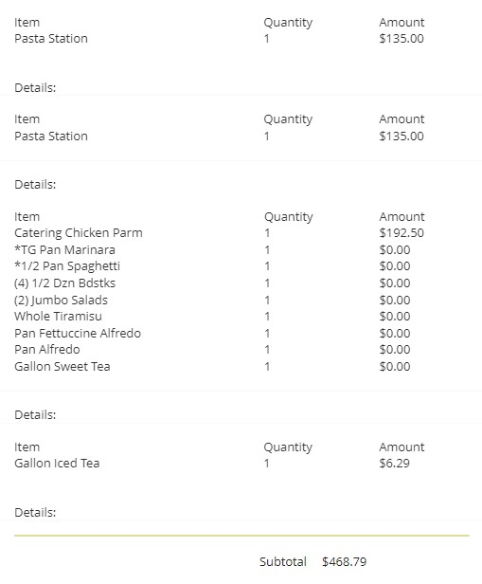

FLORIDA STATE UNIVERSITY
CONGRESS OF GRADUATE STUDENTS
Allocation, Revision, or Transfer

31st Congress of Graduate Students

Bill #: 23

Sponsored by: Representative Casseus

Date: 04/14/2023

Amount: $355

From (account name): COGS Unallocated

To (account name): African Graduate Students Association

Purpose & Description: The African Graduate Students Association (AGSA) at FSU aims to promote a greater understanding of African cultures across the FSU campus and the Tallahassee community. The Association shall facilitate forums where members can exchange ideas on academic, cultural, and social issues—a platform that will enrich each member’s personal and career growth. Additionally, the Association aims to provide its members with social and professional involvement opportunities. We plan to have a beach day event on May 13th at St George Beach to create a space for members of the organization to unwind, release stress and prepare for the upcoming summer semester. We also plan to use this event to celebrate our spring graduates. COGS has already approved our funding request for contractual services. For contractual services: we have hired Annett Bus Lines to convene our members from campus to the beach and back. This funding request is for food and drinks in the amount of $354.56.

Itemized Expenditures:

Quantity | Description | Unit Price
1 | Food (Publix) | $355
Total: $355

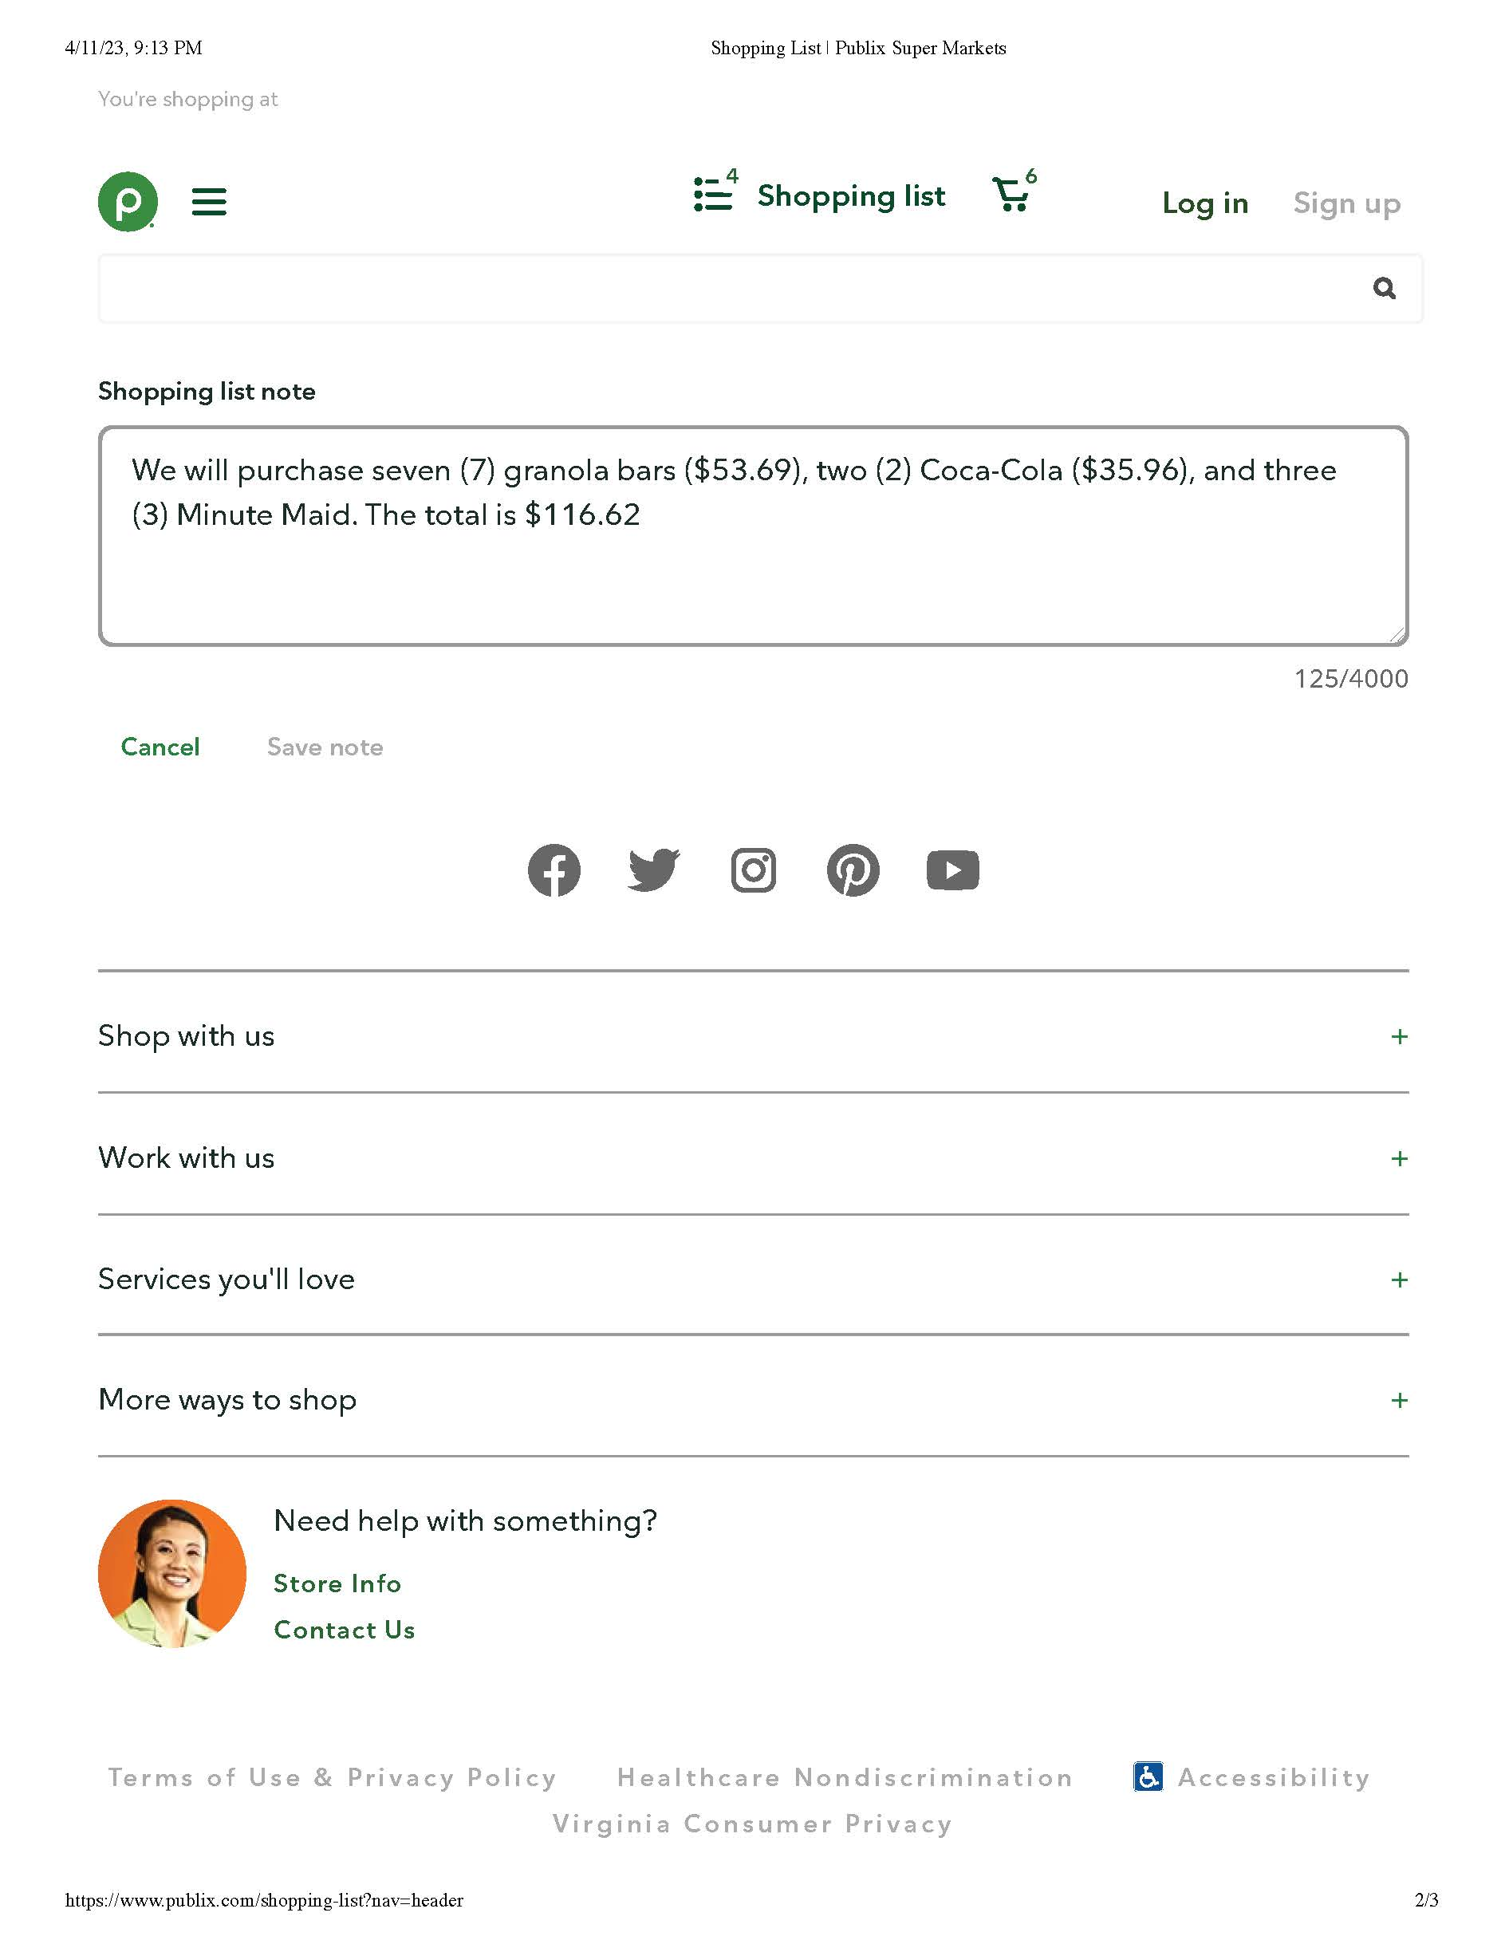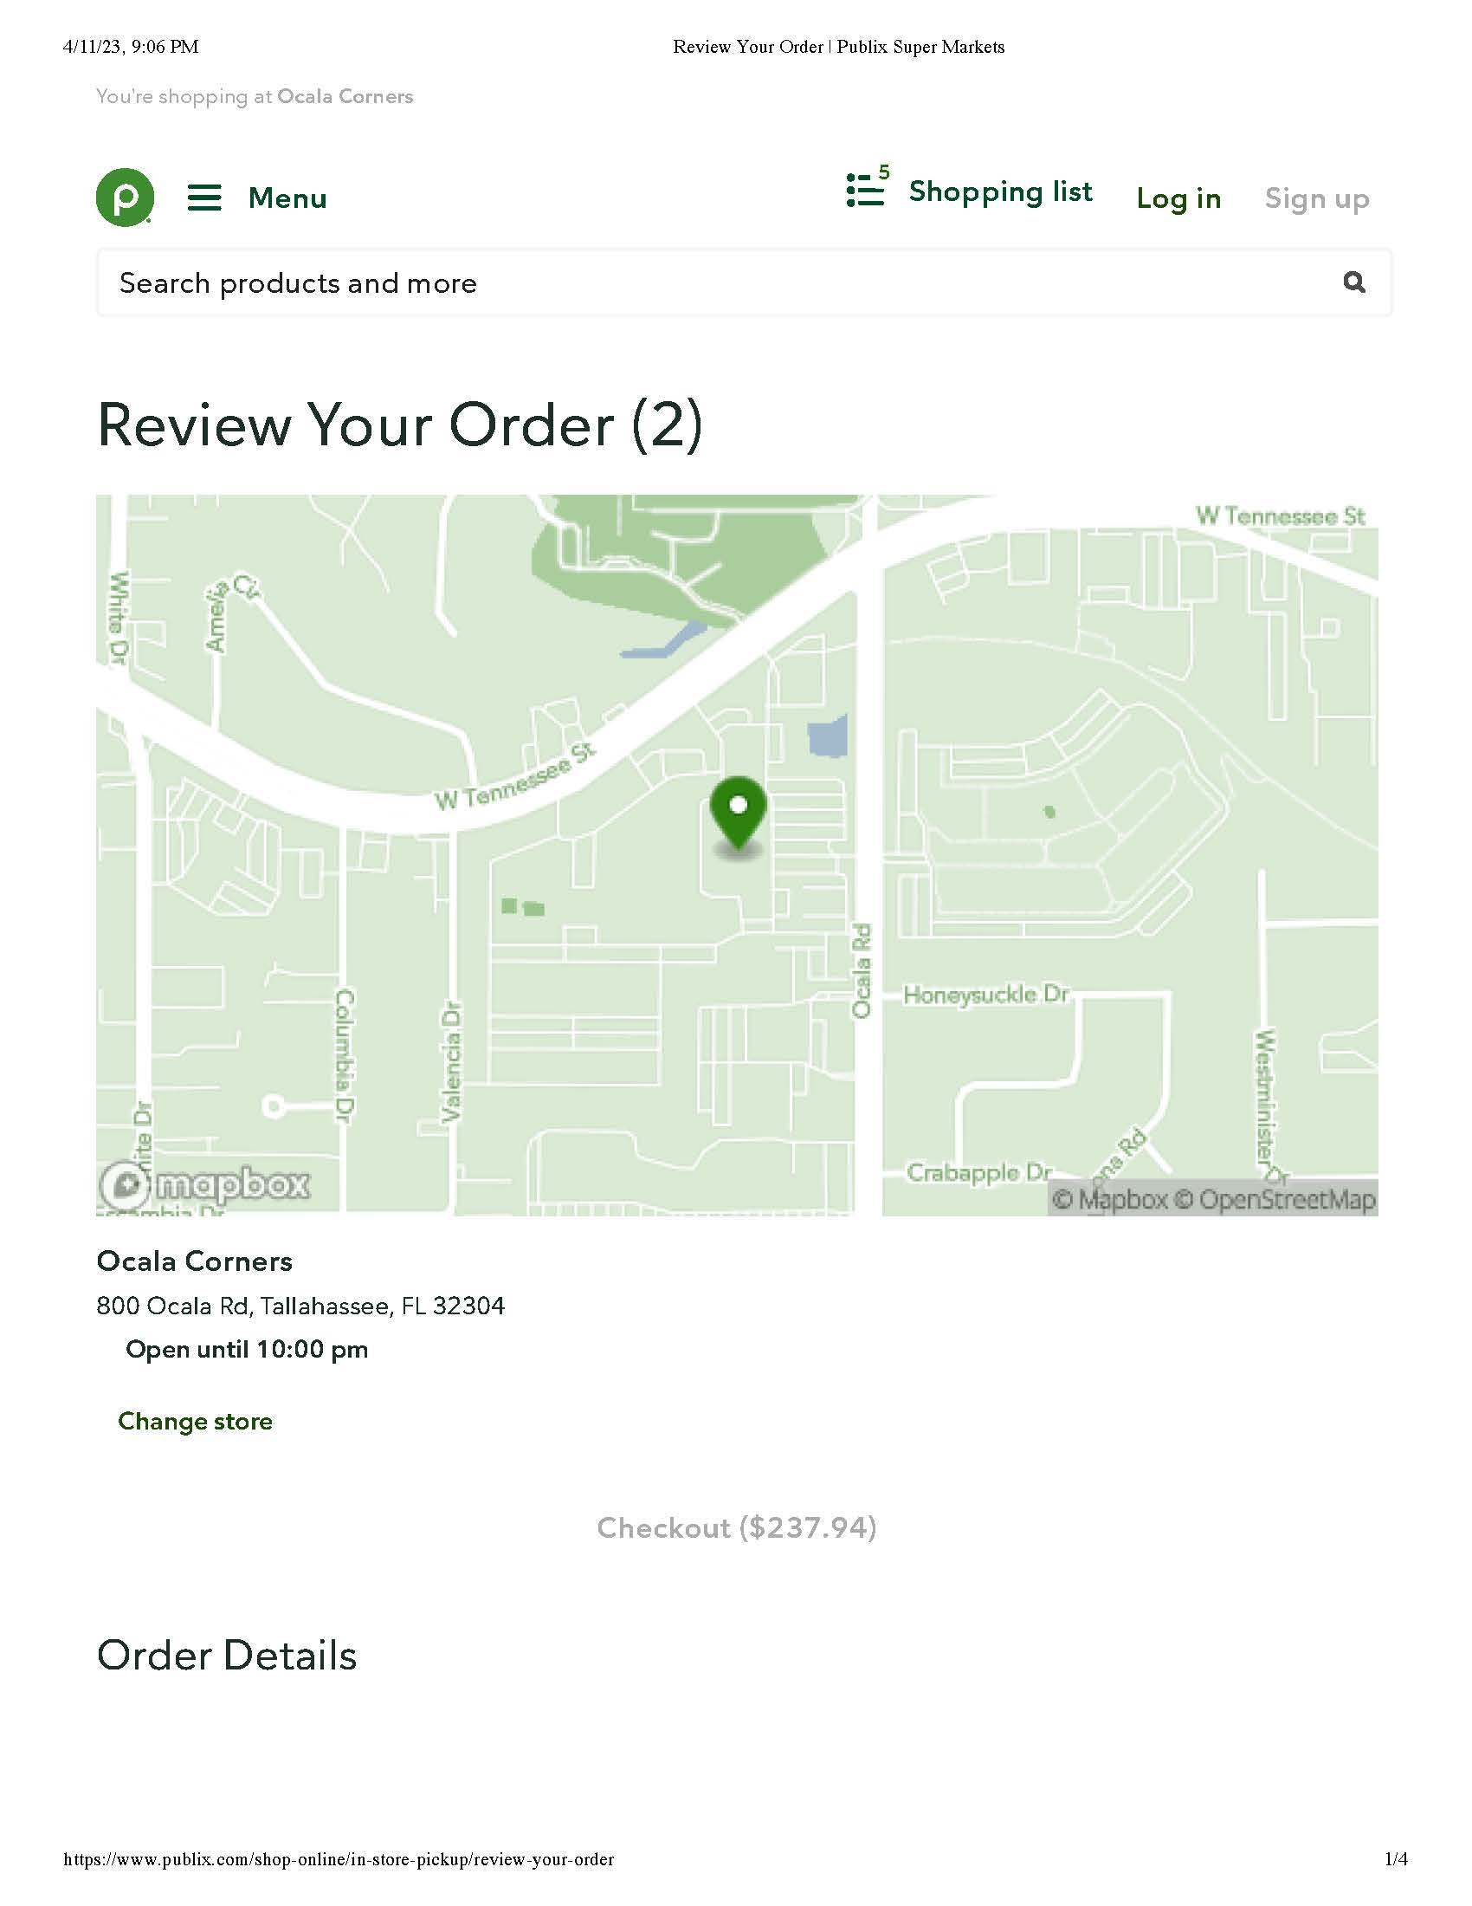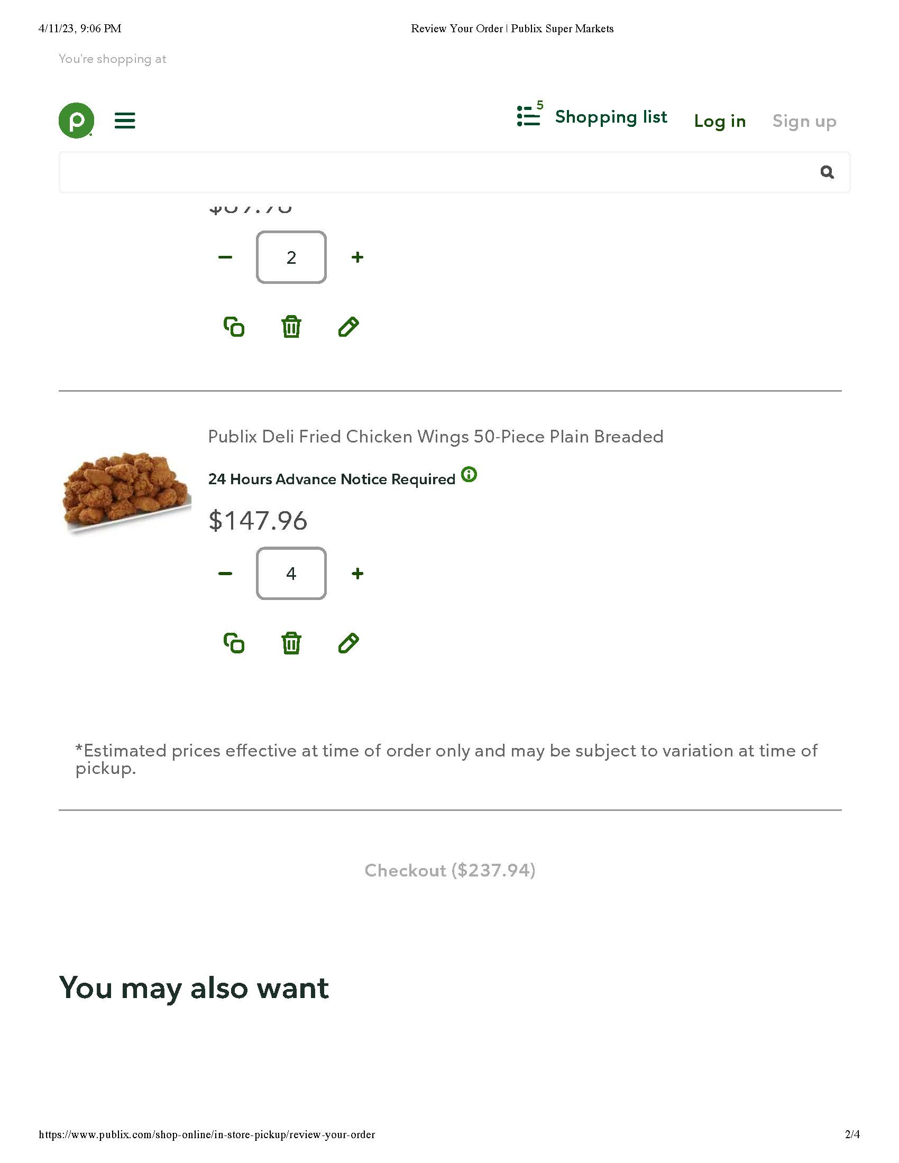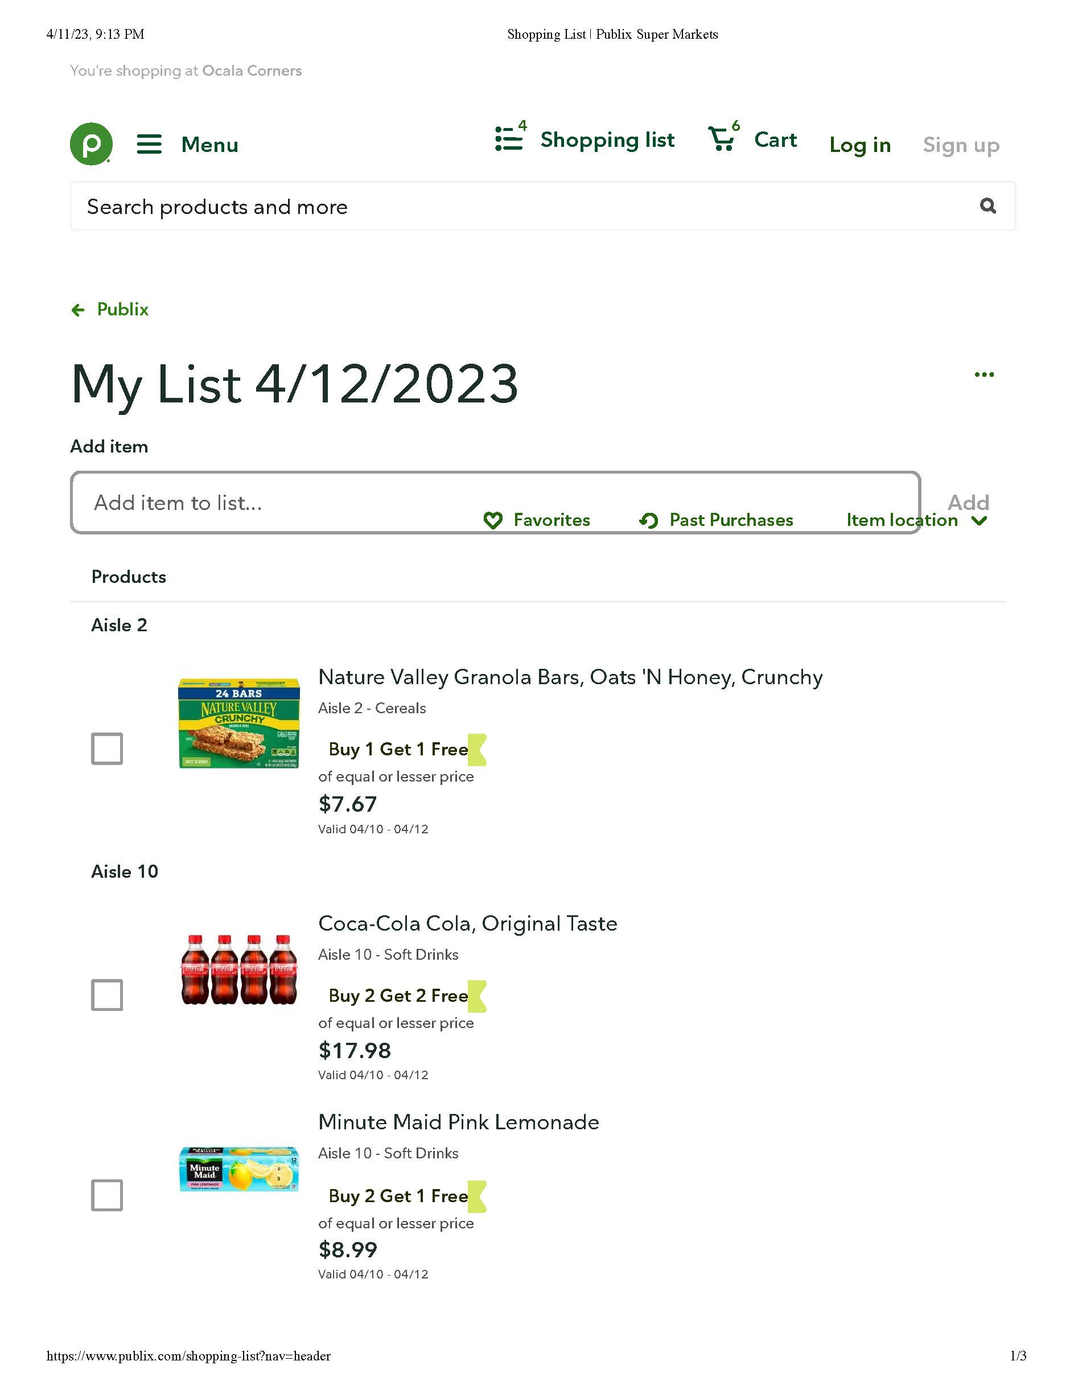

FLORIDA STATE UNIVERSITY
CONGRESS OF GRADUATE STUDENTS
Allocation, Revision, or Transfer

31st Congress of Graduate Students

Bill #: 24

Sponsored by: Dep Speaker Rogowski

Date: Monday, April 17th

BE IT ENACTED BY THE THIRTY-FIRST CONGRESS OF GRADUATE STUDENTS THAT:
A transfer of $14,124.00 from COGS Conference Presentation Grants November 2022 - February 2023 funding period to the COGS Conference Presentation Grants March - June 2023 funding period .

The purpose of this transfer is to ensure adequate funds for the remaining Presentation Grants funding period

Transfer: $14,124.00
Total: $14,124.00

FLORIDA STATE UNIVERSITY
CONGRESS OF GRADUATE STUDENTS
Allocation, Revision, or Transfer

31st Congress of Graduate Students

Bill #: 25

Sponsored by: Dep Speaker Rogowski

Date: Monday, April 17th

BE IT ENACTED BY THE THIRTY-FIRST CONGRESS OF GRADUATE STUDENTS THAT:
A transfer of $3,759.00 from COGS Conference Attendance Grants July - October 2022 funding period to the COGS Conference Attendance Grants March - June 2023 funding period .

The purpose of this transfer is to ensure adequate funds for the remaining Presentation Grants funding period

Transfer: $3,759.00
Total: $3,759.00

FLORIDA STATE UNIVERSITY
CONGRESS OF GRADUATE STUDENTS

Allocation, Revision, or Transfer

31st Congress of Graduate Students

Bill #: 26

Sponsored by: Dep Speaker Rogowski

Date: Monday, April 17th

BE IT ENACTED BY THE THIRTY-FIRST CONGRESS OF GRADUATE STUDENTS THAT:
A transfer of $10,000 from COGS Unallocated to the COGS Administration Expense Account.

The purpose of this transfer is to move funds to the COGS Expense category so that the Executive Board can buy some nice Swag items for upcoming and future COGS events.

Transfer: $10,000
Total: $10,000

FLORIDA STATE UNIVERSITY
CONGRESS OF GRADUATE STUDENTS

Allocation, Revision, or Transfer

31st Congress of Graduate Students

Bill #: 27

Sponsored by: Dep Speaker Rogowski

Date: Monday, April 17th

BE IT ENACTED BY THE THIRTY-FIRST CONGRESS OF GRADUATE STUDENTS THAT:
A transfer of $1,500.00 from COGS Administration Expense Account to the COGS Administration Food Account.

The purpose of this transfer is to ensure adequate funds for the remaining Food purchases for COGS events through the end of the Fiscal Year

Transfer: $1,500
Total: $1,500

FLORIDA STATE UNIVERSITY
CONGRESS OF GRADUATE STUDENTS

Allocation, Revision, or Transfer

31st Congress of Graduate Students

Bill #: 28

Sponsored by: Representative Elmi

Date: Monday, April 14th, 2023

Amount: $200.00

From (account name): Neuroscience Graduate Student Association Food Account

To (account name): Neuroscience Graduate Student Association General Expense Account

Purpose & Description: Funds under the food category would be unused due to our invited guest speakers' need to cancel their events. This leaves extra money that can be used for a much desired student event.

Total: $200.00

FLORIDA STATE UNIVERSITY
CONGRESS OF GRADUATE STUDENTS
Resolution
31st Congress of Graduate Students
Resolution #: 03
Primary Sponsor: Representative Ilesanmi
Date: April 17th, 2023

Whereas: COGS Code Chapter 201.6 regarding COGS General Restrictions on Spending states that “All events funded in whole, or in part, by COGS Funds or derivative resources must be equally accessible to all enrolled graduate students at Florida State University or serve a legitimate academic purpose. All purchases for events held off of the Florida State University campus require the approval of the Assembly by resolution in a majority vote.” This restriction included all RSO events on campus, requesting COGS funds.
Be it resolved by the 31st Congress of Graduate Students of Florida State University that: Upon the majority vote of this assembly, COGS Code Chapter 201.6 will then allow the African Graduate Students Association to hold their event End-of-Semester Picnic on May 13th, 2023 at St. George Island, an off-campus event. Details are shown below:

Name of RSO | Event Information  (Date, Location…)  Just the EVENT name | Food | Clothing/  Apparel | Contractual services | Travel | Expenses (i.e. Decorations, meeting space…) | Total
African Graduate Students Association | End-of-Semester Picnic  05/13/2023 at St. George Island |  |  | $1,346.00 |  |  | $1,346.00

Be it further resolved by the 31st Congress of Graduate Students of Florida State University that: COGS Code Chapter 201.6, from solely allows AGSA End-of-Semester Picnic on May 13th, 2023, at St. George Island, an off-campus event.

Be it further resolved that a copy of this resolution be sent to:
Dr. Amy Hecht, Vice President for Student Affairs
Dr. Felicia Williams, Director of Student Engagement
Nimna Gabadage, Student Body President

FLORIDA STATE UNIVERSITY
CONGRESS OF GRADUATE STUDENTS

THIRTY-FIRST CONGRESS OF GRADUATE STUDENTS
Assembly Meeting
April 3, 2023
6:30pm
Minutes
Call to Order: 6:37pm
Pledge of Allegiance:
Roll call:
Present: Basualdo, Burns, Delva, Elmi, Galeano, Gui, Ilesanmi, Mostbauer, Risler, Rogowski, Salimi, Vaughn, Wesner
Absent, Excused: Beavon, Casseus
Absent, Unexcused: Amaraneni, Lenchitz
Reading and approval of the Minutes: Rogowski, 2nd - Ilesanmi
Petitions into the Assembly:
Francis Ebuara, Arts and Sciences Seat 1
PhD student in biological science. I'm from Nigeria and I am here with my wife. When I learned about COGS, as someone who likes to participate and advocate for others who are minorities, I was interested. I filed a petition and everyone I talked to in my department were excited for me to join. I want to advocate to those in Arts and Sciences and that is why I am here.
Q&A:
Gui: How long do you want to serve? I want to join a group who can voice the needs of the students and I will be here a long time. I am only a first year in a five year program.
Delva: Have you thought about which committee you want to join? I like student advocacy.
Rogowski: Any time conflicts? No.
Pros:
Vaughn: He seems very passionate about being an advocate.
Burns: 1st year phd student so he might be here for many more years
Gui: He seems very thoughtful and would be a great contribution.
Basualdo: His research is very interesting.
Ilesanmi: Met Francis at the COGS setup at the CGE last year and he seems like an engaging person who wants to advocate.
Delva: I met him when he was applying and have kept in touch. He knows what he wants and how to create connections.
Vote: 13-0-0
Swearing in of Francis Ebuara.
Special Introductions and Student Comments: N/A
Messages from Student Government:
A mental health day has been passed and will start next year where FSU students will have a day off.
Report from the Office of Governmental Affairs: N/A
Report of Officers:
- Report of the Speaker: One more meeting for the spring semester after today. Have some important things to pass during our last meeting for the spring. Tiktok was banned on campus today.
- Report of the Deputy Speaker for Finance: Luis is graduating in August and will not be able to be the speaker. The line of succession is that when the current speaker steps down, the Deputy Speaker of Finance steps up until a new election occurs. It would be better to try to vote on a new speaker before everyone leaves in May. We don't want people to not have a voice if they aren't here for summer break. I am interested in the speaker role, but I don't want to be doing both roles at the same time. If anyone is interested in Speaker or Deputy Speaker for Finance, please let us know this week. They are both a 10 hour a week paid position. We have gotten a lot of requests, so we are working on using our money. We have $14,000 in travel grants to transfer next meeting, so we will likely transfer them to other sections so the money can be used. Happy to see the funding moving quickly for this period of funding. Keep advertising that we have money and only 1 more meeting.
- Report of the Deputy Speaker for Judicial Affairs: Working with Dr. Williams to make the code more inclusive.
- Report of the Deputy Speaker for Communications: Start thinking about will you be here for summer. Planning to host food trucks during finals week. Help spread funding info + join COGS info. Will be getting water bottles soon for COGS - more swag over summer likely. Remember COGS attendance policy. Will start publicizing Spring Social on April 21st very soon, so please help spread the word.
Committee Report:
- C-SAC:
- Internal Affairs: Will be bringing up a bill to change the code when it comes to group travel next meeting. The newsletter didn't get made due to code changes. Working with MSC on provisions. Will be funding group travel moving forward if the bill is passed after a pause on them for a while. Next meeting is this week.
- Student Advocacy: Met this past Friday and Rep. Salimi to push for parking policy change to give warnings for first time offenders. Rep. Burns will be working on how to improve participation of graduate students. Have COGS issue resolutions similar to SGA about the LGBTQIA+ community. Rep. Elmi working on project to connect international students to lawyers who can help with immigration policies. Rep. Ilesanmi is continuing conversations with the Globe to improve participations such as operating hours. Next meeting is April 28th at 5pm.
- Student Affairs: COGS Spring Social - April 21st at 7pm. No new updates. Met on March 20th and will be meeting again on April 17 at 5:30 to finalize social planning.
Funding Requests:
Bill #15: Association for Women in Mathematics
This is a small amount, but I've been a part of this association for a long time and it's been a goal of mine to connect them with COGS. We have a special speaker coming. This colloquium speaker occurs at the end of the year every year. Planning a luncheon for her. Will be using the Union and Legacy Catering. Lunch for around 15, but will be open to everyone with a RSVP to make sure that we are aware of numbers if we need to adjust.
Q&A
Galeano: Is this something the department normally organizes? Yes, the department is paying for her to come in, but there is nothing outside of that such as lunch covered.
Basualdo: When is it? April 21st
Delva: Do they have a budget? No. They have requested before, but were not given funds in the past. The reason was that there were more UG than Grads, but now it is more Graduate students.
Pros:
Vaughn: This is not an organization we normally fund and it's a good way to make that connection.
Delva: Seems like a good event and a modest bill.
Galeano: Sounds like a great speaker event and food is always good to reach students.
Point of Information - Gui: Shared what she studies from the speaker's facebook page.
Motion to extinguish time - Salimi, 2nd - Ilesanmi
Cons:
Motion to extinguish time - Ilesanmi; 2nd - Delva
Motion to call to question: Vaughn, 2nd - Delva
Closing words: Thank you for your support and it's great to have successful women for students to talk to.
Vote: 12-0-1
Bill #16: Anthropology Graduate Student Association
For a small university wide conference. Opportunity for them to share their research in a low stress environment. Will be getting catering from Publix. It's good to have these smaller events around campus to discuss research.
Q&A:
Basualdo: I am seeing talk about prizes. I am assuming that is funded by the department? This bill is only food, so prizes shouldn't be a part of it.
Gui: I was looking at the quote and it doesn't add up? They send updated information and it will be $250.
Basualdo: When and where is it? It will be in their department. Will be April 24th.
Pros:
Burns: It's straight and to the point. They just want to add food to their event.
Galeano: It's a great event and they aren't asking for much.
Vaughn: motion to extinguish the time; 2nd - Burns
Cons:
Motion to call to question: Galeano; Delva - 2nd
Closing Comments: It seems like a cool event and I like that a lot of students are involved. I think it'll be a nice event. They don't have any money in their NOLE Central account.
Vote: 13-0-0
Bill #17: Graduate Women in STEM
Organization is requesting money for food at end of the year social and the end of the art in STEM exhibit. One of the most important events this RSO has.
Q&A:
Basualdo: Where and when? April 21st at the Chemical Science Laboratory. Food is from Moe's? Yes.
Vaughn: Is Moe's an approved vendor? Yes.
Basualdo: Estimated attendance? 70.
Delva: They are getting stainless steel water bottles as swag? Yes.
Pros:
Rogowski - Been talking with this group and their events have been very successful. They had a galentines swing dance event. They are asking for extra money because they ran out. The food is higher than requested because they have a little bit of money in their account. This exhibit is great every year. The award has been fundraised that they are giving out.
Vaughn - Swag is a great way to use funds and I wish more organizations would request it.
Motion to extinguish time - Salimi; 2nd - Gui
Cons:
Motion to extinguish time - Salimi; 2nd - Rogowski
Motion to call to question - Salimi; 2nd - Delva
Closing statement - Great event and connecting art with STEM.
Vote: 12-0-0
Bill #18: African Graduate Students Association
This is for an event to St. George's beach. This is to help the members unwind and celebrate their spring graduates. Requesting funds for contractual services to charter a bus through an approved vendor to get them to the beach and back. Will hold 56 people and it will be free for all students.
Q&A:
Rogowski: You will have food at this event as well, right? That's the plan, but it's hard to figure out a food vendor because everything is closed.
Delva: You might consider looking at Publix. Okay, that's good to know. I might put in a bill and resolution next meeting if this passes.
Motion to Extinguish time: Rogowski; 2nd - Salimi.
Pros:
Risler: I appreciate how ambitious this is and asking for transportation and maybe food for this trip.
Rogowski - Great way to use money for a good off campus event. Providing transportation makes it very accessible for people. Happy to support it.
Delva - I really like this event. Would like to see more of these because it gives graduate students a setting to interact off campus.
Vaughn - I like the accessibility piece to allow international students to get out of Tallahassee.
Point of Information: 95% of our members do not have a car and many have not been outside of Tallahassee.
Cons:
Rogowski - motion to extinguish time; Delva - 2nd.
Motion to call to question: Galeano; 2nd - Salimi
Closing statement: There are many positives for this bill and there has been strong communication with this association.
Vote: 13-0-0
Bill #19: Bangladeshi Student Association
Seeking funds for their yearly Eid celebration at the Rez. There are 80 activity members and an estimated attendance of 150. It will be published around campus. There will be lunch and events. It is free and open to students. There was language on the past sheet about raffle giveaway, but that funding will now be on games and the water bottles will be replaced with other drinks.
Q&A:
Gui: There is a section for tax on one of the screenshots, can that be removed? The cost of food without the tax will still be the same amount.
Basualdo: I see that you have raffle prizes listed, but with the change to games, will that amount be the same? Yes, we will order 10 games and it should be around the same.
Rogowski: What is the cost of the food? It will be $2050. Is it an approved vendor? Yes, we are using the same vendor as a past event.
Rogowski: motion to extend time; Delva - 2nd
Vaughn: You can't offer prizes, but you can offer swag to give away.
Rogowski: Code says that you must have items given away to everyone first come first serve.
Rogowski: What kind of games would you get? Board games.
Basualdo: We will need to amend the bill.
Pros:
Rogowski: Seems like a fun event. We've done it before. It's a great way to end this religious holiday.
Basualdo: Sounds like a great event.
Delva - I like cultural events like this.
Vaughn - I also love cultural events and it'll be great once we get stuff amended.
Motion to extinquish time - Ilesamni; 2nd - Delva
Cons:
Motion to extinquish - Salimi, 2nd - Ilesanmi
Motion to amend - Risler; Remove clothing and awards increase expenses to $450. Also increasing food to $2,050. 2nd - Salimi.
Vote to amend: 12-0-0
Pros for amended bill:
Motion to extinquish time - Salimi; 2nd - Gui
Cons:
Motion to call to question: Galeano, 2nd - Ilesamni
Closing: This event is worth the investment and is a good use of funds.
Vote: 12-0-0
Bill #20: African Graduate Students Association
Opening Statement: Last meeting of the semester it's an important meeting, they'll be having their elections. It will be held at CGE which is great because we help to fund that building. We will have to slightly amend this bill because they have some money left over in their account, so they don't need as much as they thought they did.
Questions: Salimi Motions to Extinguish, Ilesanmi Seconds
Debate in Favor: Gui: great event, this is their first year of the organization so a great time to continue the legacy that they created.
Mostbauer: How many members? Ilesanmi: Whatsapp group has 93 people, we normally have 60 - 75 people show up to events, 250 people came to coffee hour event (before spring break!).
Rogowski: Happy to support an RSO that has been doing great work and activities this year.
Delva: I like the fact that the org is so new, but still so big. It states how much they can still continue to grow. It shows how much support the African students can get through this organization.
Debate in Opposition: Salimi motion to extinguish, Delva seconds
Second Debate in Favor: Vaughn motions to amend the amount requested in Food from $337 to $201 (because of leftover money remaining), Gui seconds
Vote for Amendment: 12-0-0, Amendment passes
First Debate in Favor for Amended Bill: Risler: Great that we can fund this for a little less and get the same quality
Salimi motions to extinguish time, Delva seconds
First Debate in Opposition: Risler calls to question, Salimi seconds
Closing Statement: I think it will be great to provide food for the event, it motivates those students to go to the event
Vote for Bill: 12-0-0
Unfinished Business: N/A
New Business: N/A
Round Table:
Adjournment: 8:50pm
Next Meeting: April 17, 2023 at 6:30 p.m. Senate Chambers (3rd floor New Student Union)

