FLORIDA STATE UNIVERSITY
CONGRESS OF GRADUATE STUDENTS
THIRTY-FIRST CONGRESS OF GRADUATE STUDENTS
Assembly Meeting
March 20, 2023
6:30pm
Agenda
Call to Order:
Pledge of Allegiance:
Roll call:
Reading and approval of the Minutes:
Petitions into the Assembly:
Eric Wesner, Veterans Advocate Seat
Special Introductions and Student Comments:
Messages from Student Government:
Report from the Office of Governmental Affairs:
Report of Officers:
- Report of the Speaker:
- Report of the Deputy Speaker for Finance:
- Report of the Deputy Speaker for Judicial Affairs:
- Report of the Deputy Speaker for Communications:
Committee Report:
- C-SAC:
- Internal Affairs:
- Student Advocacy:
- Student Affairs:
Graduate Student Bowling Social - April 21st at 7pm
Funding Requests:
Bill #14: Masters of Public Health Student Health Association
Unfinished Business:
New Business:
Resolution #2: MSC Travel Grant Allocations
Round Table:
Adjournment:
Next Meeting: April 3, 2023 at 6:30 p.m. Senate Chambers (3rd floor New Student Union)

ACCOUNT | ALLOCATION AMOUNT | DESCRIPTION | BALANCE
UNALLOCATED | $24,593.00 | For RSO funding requests at COGS meetings | $20997.65**
ORGANIZATIONAL (C-SAC) | $3,000 | RSO funding for allocations less than $1000 for the fiscal year | $500
LSC | $61,000 | Funding allocations from Law School Council to Law School Student Organizations | $12,151.57
MSC | $84,817 | Funding allocations from Medical School Council to Medical School Student Organizations | $25,063.18
PRESENTATION GRANTS (Jul-Oct) | $66,250 | Presentation Grant balance for the July-October funding period | $0
PRESENTATION GRANTS (Nov-Feb) | $75,000 | Presentation Grant balance for the November-February funding period | $14,119.67
PRESENTATION GRANTS (Mar-Jun) | $58,750 | Presentation Grant balance for the March-June funding period | $61,267.00**
ATTENDANCE GRANTS (Jul-Oct) | $9,000 | Attendance Grant balance for the July-October funding period | $3,759.63
ATTENDANCE GRANTS (Nov-Feb) | $9,000 | Attendance Grant balance for the November-February funding period | $55.01
ATTENDANCE GRANTS (Mar-Jun) | $7,500 | Attendance Grant balance for the March-June funding period | $7,050.00
COGS Financial Report, Fiscal Year 2022-2023
**After March 6th Bills

Allocation, Revision, or Transfer
FLORIDA STATE UNIVERSITY
CONGRESS OF GRADUATE STUDENTS

31st Congress of Graduate Students

Bill #: 14

Sponsored by: Katherine Gui

Date: 3/20/2023

Amount: $2,282.00

From (account name): COGS Unallocated

To (account name): Master of Public Health Association at FSU

Purpose & Description:
The Master of Public Health Student Association mission is to increase awareness of public health-related concerns and policies as well as facilitate and enhance the health status of Florida State University students, faculty, and its surrounding populations. With the involvement of Florida State University’s graduate students within the association, our goals are to create a professional networking experience for our students through mentorships, volunteer experiences in the community, monthly seminars and other opportunities to gain a comprehensive public health perspective in the program.

One of the longest traditional events of our RSO is the confirmation and hooding of our semester graduates. Our program director and other faculty hoods our graduating Masters' students following a cocktail hour with finger foods and socialization. These events allow us to celebrate together as an organization, not only our graduates but the end of another amazing semester! We have an FSU spotlight alumni as a prospective keynote speaker and Dean Chapin scheduled to attend. Event space is reserved at the FSU ballroom for May 5th.

Event is free and open to all students. Estimated attendance is 130 people.

Itemized Expenditures:

Number of attendees | Category | Price
130 | Expenses - Supplies and decorations | $473
 | Food | $1809

Total: $2,282

Itemized Expenditures:

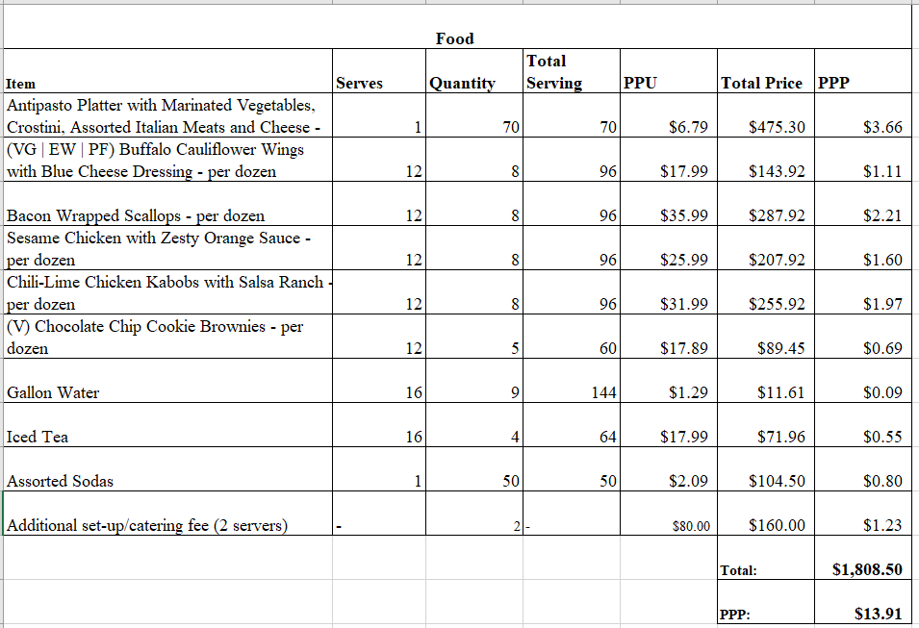

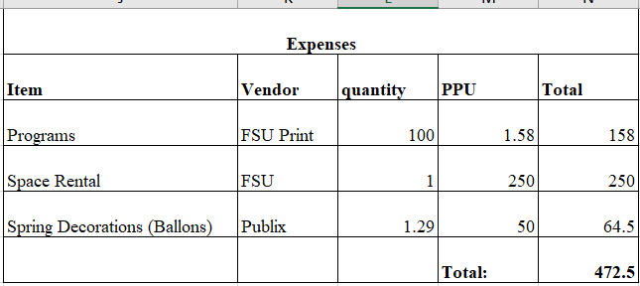

Total: $2,282.00

FLORIDA STATE UNIVERSITY
CONGRESS OF GRADUATE STUDENTS
Resolution
31st Congress of Graduate Students

Resolution #: 02

Primary Sponsor: Representative Delva

Date: March 20th, 2023

Whereas: COGS Code Chapter 202.5 regarding COGS regarding group travel states that “Group travel is limited to tabling as a promotional entity on behalf of the RSO and Florida State University, or a panel discussion in which at least three-fourths (3/4) of the members are leading”. This restriction included all RSO, requesting COGS group travel funds.

Be it resolved by the 30th Congress of Graduate Students of Florida State University that: COGS recognizes that due to the unique structure of programs at the College of Medicine, College of Medicine students in their clinical years are placed in satellite campuses where they are still charged standard A&S fees.

Be it further resolved by the 30th Congress of Graduate Students of Florida State University that
Due to this unique structure, students from the College of Medicine in their clinical years do not benefit from on-campus activities funded by the Medical Student Council and their own A&S fees.

Be it further resolved by the 30th Congress of Graduate Students of Florida State University that
The COGS assembly will, upon the majority vote of this assembly, change COGS Code Chapter 202.5 to then allow MSC (Medical Student Council) to access and receive funding for group travel for academic conferences for 3rd and 4th-year medical students upon the Medical Student Council’s commitment to the following: (1) MSC will reflect these changes within their constitution and make appropriate regulatory changes to abide by COGS CODE. (2) Specifically, MSC will not fund students beyond what is outlined in COGS Code Chapter 207: General Provisions for Grants. (3) The MSC president will work with the Deputy Speaker for Finances to build a strong reporting system for travel funding granted by MSC.

Be it further resolved that a copy of this resolution be sent to:
Dr. Amy Hecht, Vice President for Student Affairs
Dr. Felicia Williams, Director of Student Engagement
Karl Kramer, MSC President
Carla Dunn, MSC Advisor
Nimna Gabadage, Student Body President

FLORIDA STATE UNIVERSITY
CONGRESS OF GRADUATE STUDENTS
THIRTY-FIRST CONGRESS OF GRADUATE STUDENTS
Assembly Meeting
March 6, 2023
6:30pm
Minutes
Call to Order: 6:47pm
Pledge of Allegiance: Rep. Mostbauer
Representatives Present: Amaraneni, Basualdo, Beavon, Casseus, Delva, Elmi, Ilesanmi, Mostbauer, Vaughn
Representatives Absent, Excused: Burns, Galeano, Gui, Risler, Rogowski, Salimi
Representatives Absent, Unexcused: Lenchitz
Reading and approval of the Minutes: Vaughn, 2nd - Delva
Petitions into the Assembly: N/A
Special Introductions and Student Comments: N/A
Messages from Student Government: N/A
Report from the Office of Governmental Affairs: N/A
Report of Officers:
- Report of the Speaker: Met with Dr. Hecht and talked about COGS moving forward. Main goal to work to fill empty seats. Working on a resolution with the Medical School in the future along with some other changes to the code.
- Report of the Deputy Speaker for Finance: N/A
- Report of the Deputy Speaker for Judicial Affairs: COGS guide has been updated for 2022-23. The book has information on Robert's Rules of Order and other important information about COGS and SGA. Please take one.
- Report of the Deputy Speaker for Communications: Making nametags for new members- Elmi, Beavon, Casseus, Mostbauer need nametags. Please encourage RSOs you work with to send in requests for funding with their end of the year events and encourage others to apply for travel grants.
Committee Report:
- C-SAC:
- Internal Affairs: Rep. Delva - Finalized a draft to change the Code on group travel. Is not currently worded so that RSOs can travel as a group. It is focused on groups serving as a panel. Currently working on a newsletter to be put out by the end of the semester. Want to have continuity and give COGS more strength. Discussion on raising money concerning conference grants.
- Student Advocacy: Rep. Ilesanmi - no meeting since last time
- Student Affairs: Rep. Casseus - will be getting headshots and nametags for members. Planning a spring social for graduate students. Will be held at the Bowling alley and Proof on April 21st from 7-11pm. Discussed meeting with RSOs about the international student population on campus.
Funding Requests:
Bill #7: Applied Sports Psychology
Rep. Delva: Bill is for $5064 to use for a conference from 8am-9pm on March 24th. Wide range of activities and 2 keynote speakers. Will have poster and lecture presentations by current students and alumni. Very academically focused. Asking for money for office supplies, food, and keynote speaker honorarium. Open to all students.
Questions:
Ilesanmi - how many people on the honorarium? 4. There is a mistake on the calculation for contractual services. It should be $3,300.
Delva - That is correct. We will need to adjust the contractual services section.
Ilesanmi - How much is food per person? $15.
Pros:
Vaughn - I've seen posters all over the College of Education, so that's great.
Ilesanmi - Looks like a good event
Basualdo - I think it's great that you are hosting a conference here and we want to support it.
Beavon - Great for networking and finding a job.
Cons:
Amaraneni - Motion to amend contractual services to $3,300 from $2,550. 2nd - Mostbauer.
Voting: 9-0-0
2nd round pros:
Mostbauer - Motion to extinguish time, 2nd - Ilesanmi
Cons:
Amaraneni - The keynote speakers are expensive, more than the food.
Basualdo - This is pretty cheap per speaker. They can be $2000.
Ilesanmi - Is there department funding? No. Are you a RSO? Yes.
Delva - can you expand on the speakers? One is an alumni and the other are professionals in the field who work with Olympic committees. They are very important people in the field.
Ilesanmi - are they in Tallahassee? No. And they are flying in? Yes. That's a bargain.
Amaraneni - motion to call to question. 2nd - Ilesanmi
Closing Statement - Thank you. I think this is a great event and it gives students the chance to talk about their research and interact with alumni in their field.
Vote: 9-0-0
Bill #8: FSU Cares
Rep. Mostbauer - Organization is asking for food on event on March 15th. On campus event where they will have a speaker. Will be an informational meeting about future Spring Break opportunities.
Questions:
Basualdo - This should probably have gone through the MSC.
Delva - Did you email with the leaders? Yes. Did they mention talking with the MSC? Mostbauer - The email said that they had been approved by MSC, but it might have been for other things. It's not clear. They might only be asking us for food.
Delva - This is not up to code and funding needs to go through MSC.
Pros:
Delva - Good event, but they went through the wrong channel.
Delva - call to extinguish time; 2nd - Amaraneni
Cons:
Delva - they should have gone to MSC instead of us. We can't pass this because it's against code. Unfortunate, but against regulations.
Amaraneni - call to question; 2nd - Casseus.
Closing - Could only do what he could based on what he was sent.
Vote: 0-5-4 ; Bill does not pass
Bill #9: School of Teacher Education Graduate Student Association (STEGSA)
Rep. Casseus - Would like to have a gathering at the Rez. Don't have a date yet, it will be either April 29 or 30. Will be advertising through mailing list/fliers.
Questions:
Amaraneni - where are the details for the food? Where are they getting the food? Where are the details? They didn't give that information and they couldn't send anyone here tonight.
Motion to extinguish time - Ilesanmi; 2nd - Delva
Pros:
Basualdo - great event, but they need to be more specific.
Ilesanmi - motion to extinguish time; Amaraneni - 2nd
Cons:
Motion to call to question - Amaraneni; 2nd - Ilesanmi
Closing comments: It's a shame that they didn't give enough details, but I can work with them to fix this to present again later.
Vote: 0-1-8; fails to pass
Bill #10: Reallocation of COGS C-SAC to COGS Food Account
Delva - We have CSAC, but this committee has not been active. We need more money in our food account, so this money is being transferred.
Questions: Motion to extinguish - Amaraneni; 2nd - Ilesanmi
Pros:
Basualdo - we are shuffling around money so it can be better used. Most requests are going through the assembly, so CSAC hasn't been needed.
Motion to extinguish - Ilesanmi; 2nd - Amaraneni
Cons:
Motion to call to question - Ilesanmi; 2nd - Amaraneni
Closing Statements: Thank you everyone. Yay food.
Vote: 9-0-0
Bill #11: Reallocation of COGS Conference Presentation Grants July 2022 – October 2022 to COGS Unallocated
Vaughn: reallocating money from leftover presentation grants to cogs unallocated to have money to support organizations around campus. I hope that you will support this reallocation of money.
Questions: None
Pros:
Amaraneni: I will say that we need this transfer to help unallocated have money in order to be able to fund big events for RSO's like sports psychology.
Motion to extinquish time: Ilesanmi; 2nd. Elmi
Cons:
Call to question - Amaraneni; 2nd - Ilesanmi
Vote: 9-0-0

Bill #12: Reallocation COGS Conference Presentation Grants July 2022 – October 2022 to COGS Conference Presentation Grants March 2023 – June 2023
Vaughn: We just allocated some of the leftover money, the remaining money will go to March-June presentation grants. Encourage your friends to apply for these presentation grants for spring and summer conferences. Just reallocating money in order to use it better.
Questions:
Amaraneni - extinquish time; 2nd - Ilesanmi
Pros:
Basualdo - transfer of funds so that we can use them. Easy to do.
Extinguish - Ilesanmi; 2nd Delva.
Cons:
Motion to call to question: Ilesanmi; 2nd - Delva
CS: Hope you see the point to reallocating the funds and let's vote.
Vote: 9-0-0
Bill #13: Learn Funds Transfer
Vaughn: I apologize for the typo. On the request. We can adjust this during cons. Learn general expense account needs to be moved to the contractual services account. They need the money from one account to go to another in order for them to use it.
Question - Why wasn't this money in their contractual account? There was an error and it should have been put in contractual services so they can use it.
Pros -
Amaraneni - good to let them be able to use their funding
Delva - in favor of an organization working to spend their money
Extinguish - Delva; Elmi 2nd
Cons -
Ilesanmi - motion to amend from $15,000 to $1,500. Delva - 2nd.
Vote: 9-0-0
Pros: Motion to extinguish time - Amaraneni; Elmi - 2nd
Cons:
Motion to call to question - Amaraneni; 2nd - Ilesanmi
Closing Statements: I hope everyone supports LEARN
Vote: 9-0-0
Unfinished Business: N/A
New Business: N/A
Round Table:
Adjournment: 8:17pm
Next Meeting: March 20, 2023 at 6:30 p.m. Senate Chambers (3rd floor New Student Union)

