FLORIDA STATE UNIVERSITY
CONGRESS OF GRADUATE STUDENTS
THIRTY-FIRST CONGRESS OF GRADUATE STUDENTS
Assembly Meeting
March 6, 2023
6:30pm
Agenda
Call to Order:
Pledge of Allegiance:
Representatives Present:
Representatives Absent, Excused:
Reading and approval of the Minutes:
Petitions into the Assembly:
Special Introductions and Student Comments:
Messages from Student Government:
Report from the Office of Governmental Affairs:
Report of Officers:
- Report of the Speaker:
- Report of the Deputy Speaker for Finance:
- Report of the Deputy Speaker for Judicial Affairs:
- Report of the Deputy Speaker for Communications:
Committee Report:
- C-SAC:
- Internal Affairs:
- Student Advocacy:
- Student Affairs:
Funding Requests:
Bill #7: Applied Sports Psychology
Bill #8: FSU Cares
Bill #9: School of Teacher Education Graduate Student Association (STEGSA)
Bill #10: Reallocation of COGS C-SAC to COGS Food Account
Bill #11: Reallocation of COGS Conference Presentation Grants July 2022 – October 2022 to COGS Unallocated
Bill #12: Reallocation COGS Conference Presentation Grants July 2022 – October 2022 to COGS Conference Presentation Grants March 2023 – June 2023
Bill #13: Learn Funds Transfer
Unfinished Business:
New Business:
Round Table:
Adjournment:
Next Meeting: March 20, 2023 at 6:30 p.m. Senate Chambers (3rd floor New Student Union)

COGS Financial Report, Fiscal Year 2022-2023
ACCOUNT | ALLOCATION AMOUNT | DESCRIPTION | BALANCE
UNALLOCATED | $24,593.00 | For RSO funding requests at COGS meetings | $16,061.65
ORGANIZATIONAL (C-SAC) | $3,000 | RSO funding for allocations less than $1000 for the fiscal year | $3,000.00
LSC | $61,000 | Funding allocations from Law School Council to Law School Student Organizations | $20,081.57
MSC | $84,817 | Funding allocations from Medical School Council to Medical School Student Organizations | $30,314.70
PRESENTATION GRANTS (Jul-Oct) | $66,250 | Presentation Grant balance for the July-October funding period | $21,667.74
PRESENTATION GRANTS (Nov-Feb) | $75,000 | Presentation Grant balance for the November-February funding period | $17,948.95
PRESENTATION GRANTS (Mar-Jun) | $58,750 | Presentation Grant balance for the March-June funding period | $66,875.00
ATTENDANCE GRANTS (Jul-Oct) | $9,000 | Attendance Grant balance for the July-October funding period | $3,759.63
ATTENDANCE GRANTS (Nov-Feb) | $9,000 | Attendance Grant balance for the November-February funding period | $655.01
ATTENDANCE GRANTS (Mar-Jun) | $7,500 | Attendance Grant balance for the March-June funding period | $7,500.00

**Funding from July – Oct period needs to be transferred!

FLORIDA STATE UNIVERSITY
CONGRESS OF GRADUATE STUDENTS
Allocation

31st Congress of Graduate Students

Bill #: 7

Sponsored by: Rep. Delva

Date: March 6th, 2023

Amount: $5,064.00

From (account name): COGS Unallocated

To (account name): FSU Sport Psychology

About the organization
The Applied Sport Psychology at Florida State University Program (ASP-FSU) provides opportunities for interested graduate students to serve as sport/exercise psychology consultants with interested client organizations within Florida State University and the Tallahassee metropolitan area. The ASP-FSU program is designed to assist students in fulfilling requirements for certification as set forth by the Association for Applied Sport Psychology (AASP). The primary mission of ASP-FSU is to give interested students experience working with clients on sport and exercise psychology. Additionally, ASP provides clients with skilled consultants to assist them in developing and reaching their goals

Purpose & Description:
The Florida State University Sport Psychology conference is aimed to give the Florida State community more insight about the sport psychology field. All the Florida State community is invited, meaning undergraduate students, graduate students, doctoral students, faculty, staff and alumni. There will be a website for interested attendees to learn more information about the conference, and for those interested, there will be a link to register for the conference. The conference will be free to attend and will be held Friday March 24th of 2023. Friday will be an all-day event. On Friday morning, attendees who have registered for the conference will be able to receive a program for the conference, and their nametag at 8:00AM to 9:00PM before the first event of the day. The first event features an alumni panel will be held by previous students of the Florida State University Sport Psychology Master’s Program. These alumni will discuss how the program prepared them for the workforce and discuss what different workforces that they have or are working in currently. After this panel, there will be a short break with coffee and pastries. The next portion of the conference will be lectures presentations held by current students conducting research related to the sport field. Interested students will have to submit an abstract of their research, and a committee will blindly review and select appropriate research to be presented. After 4 lectures have been conducted, there will be a small break. There will be a final panel focusing on women in professional sports. During this keynote panel, the speakers will be discussing the problems that are associated with being a female in a male dominated field, or possibly working in a male dominated sport. After the women in sport panel, we will break for attendees to eat lunch, which will not be provided. The next portion of the conference will start at 2:35PM with lectures presentations will be held by current students conducting research related to the sport field. After 4 lectures have been conducted, there will be a small break, with coffee and tea provided. After the break, the poster presentations will continue for an hour. Researchers will be able to present their research informally, as their research poster will be displayed, and attendees of the conference can ask them questions. After the poster presentations, there will be a small break. The last keynote panel will be with researcher Dr. Edson Filho, discussing his research on high profile athletes and individuals. After Dr. Filho's panel, there will be a closing social with food and drinks provided.

Estimated attendance: 60

Itemized Expenditures:

Quantity | Description | Unit Price
1 | Office Supplies | $184.99
1 | Food | $2,329.01
1 | Contractual services | $ 2550.00
Total: $ 5,064.00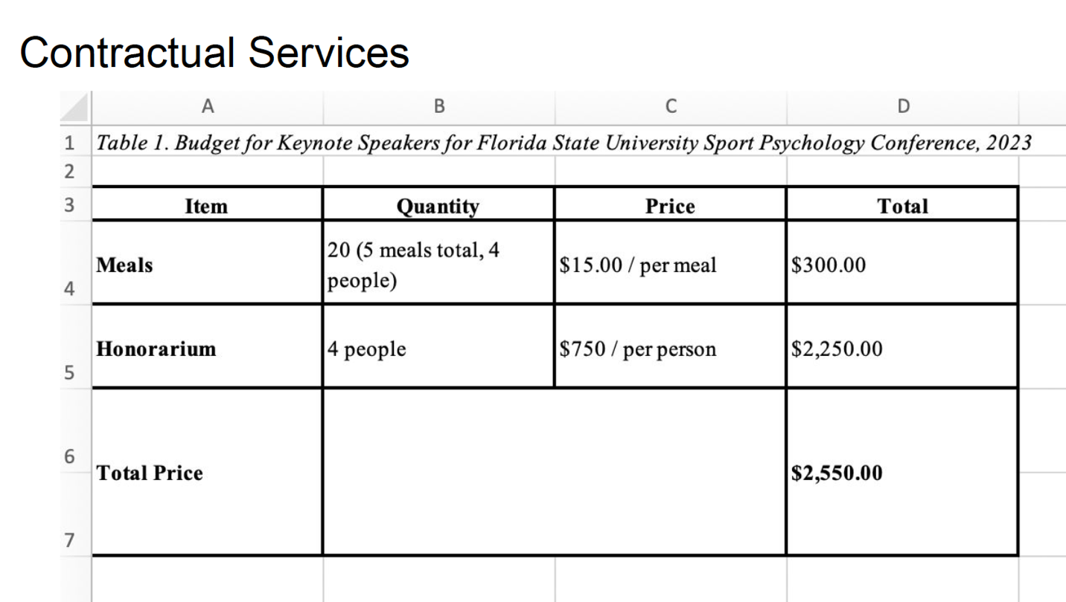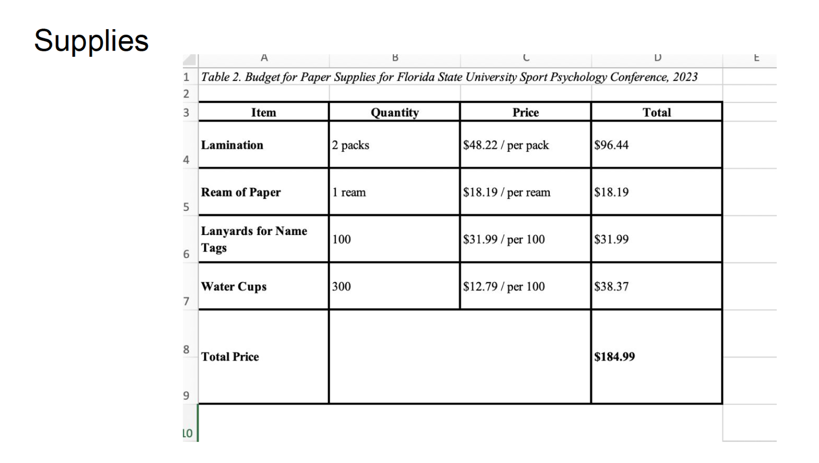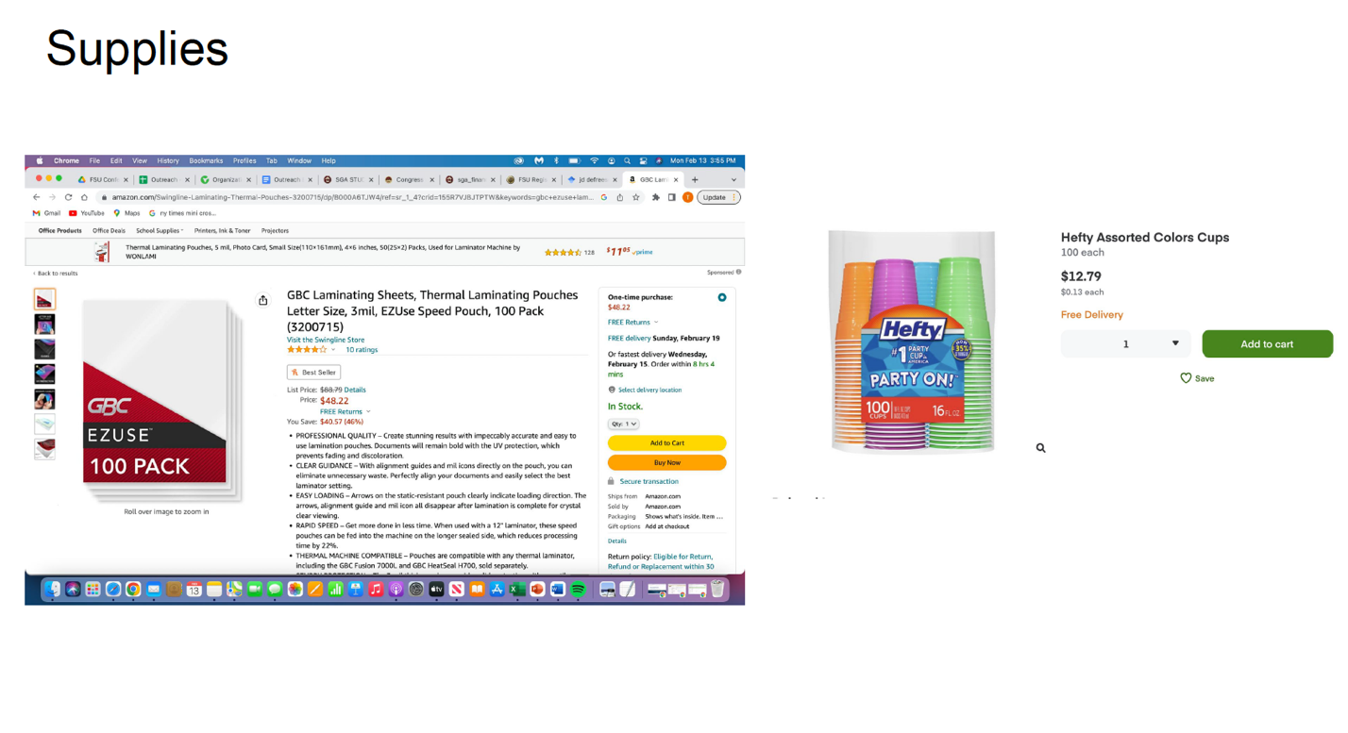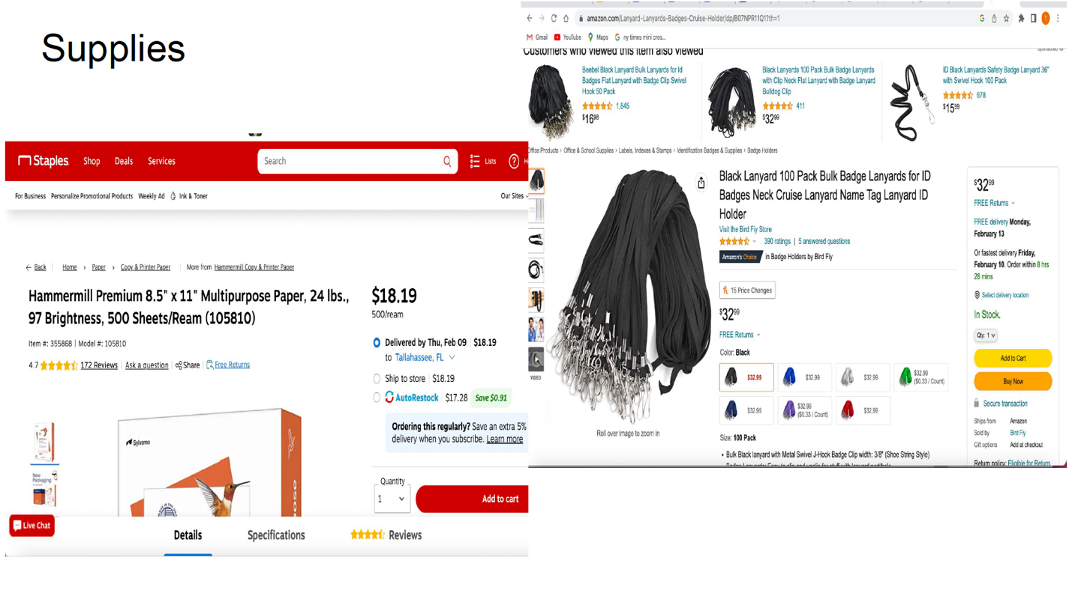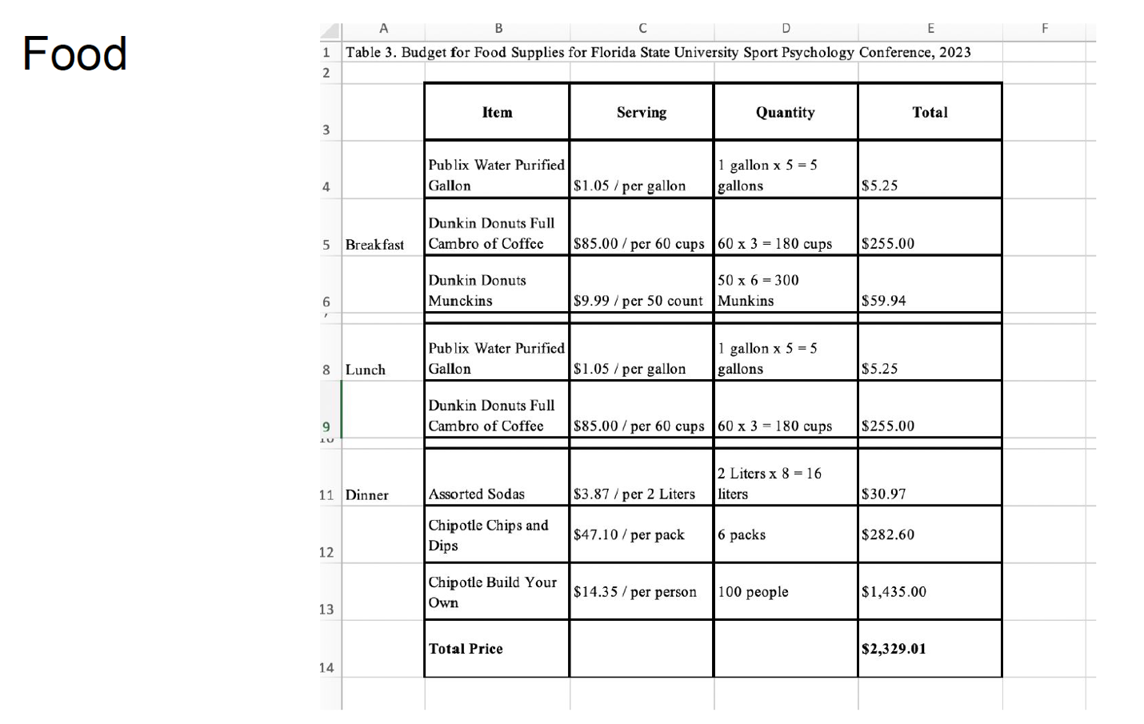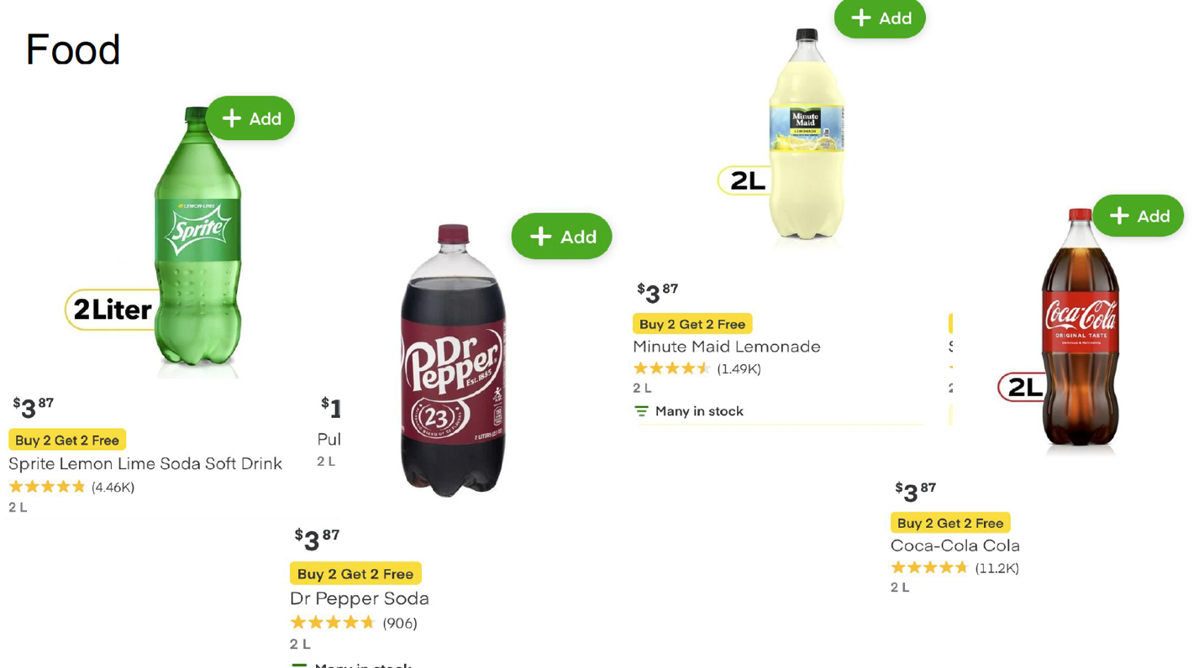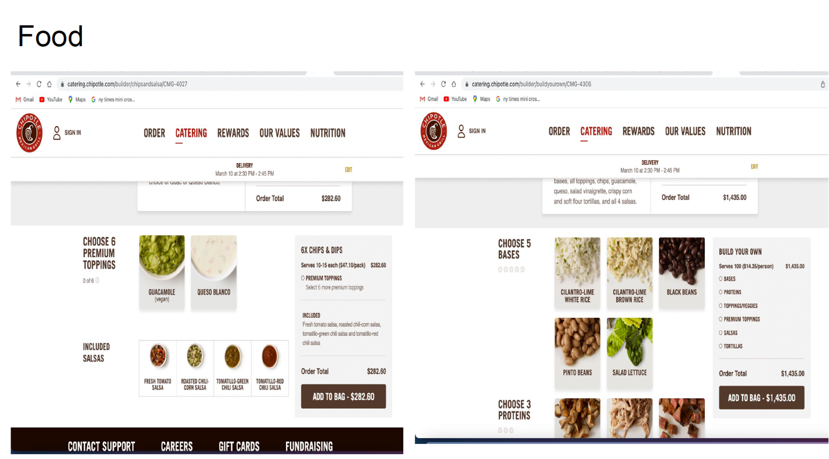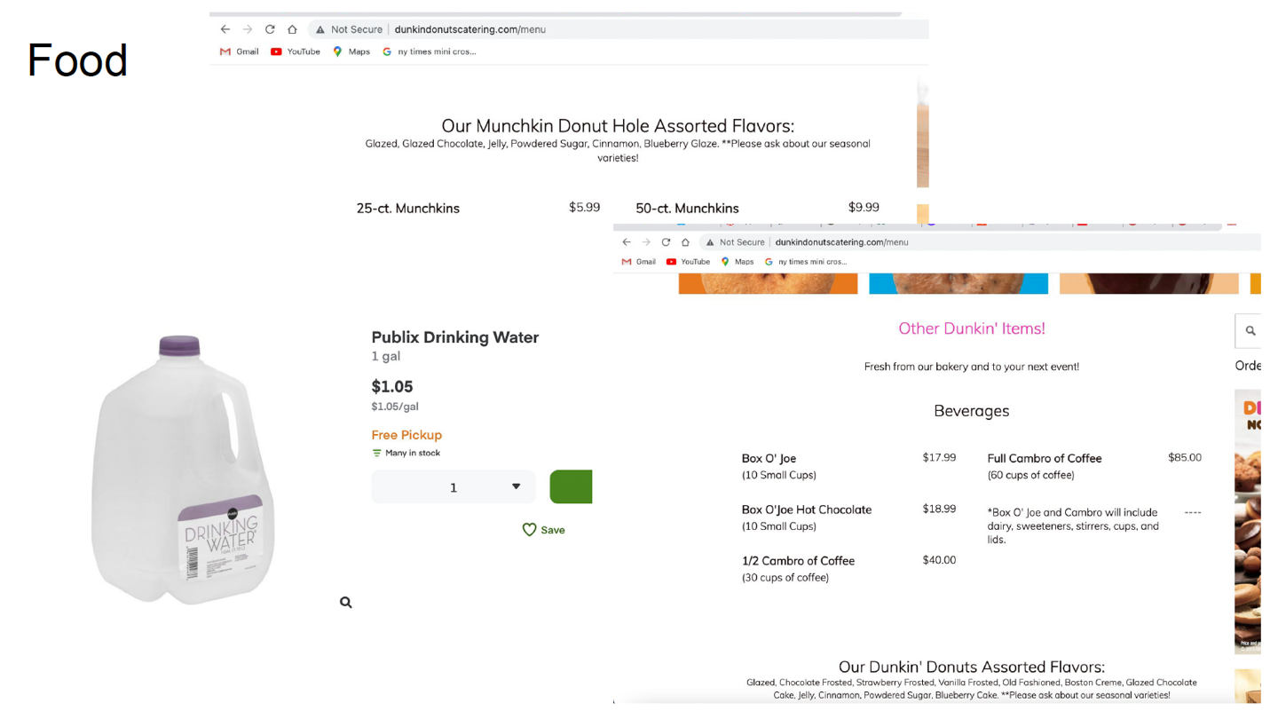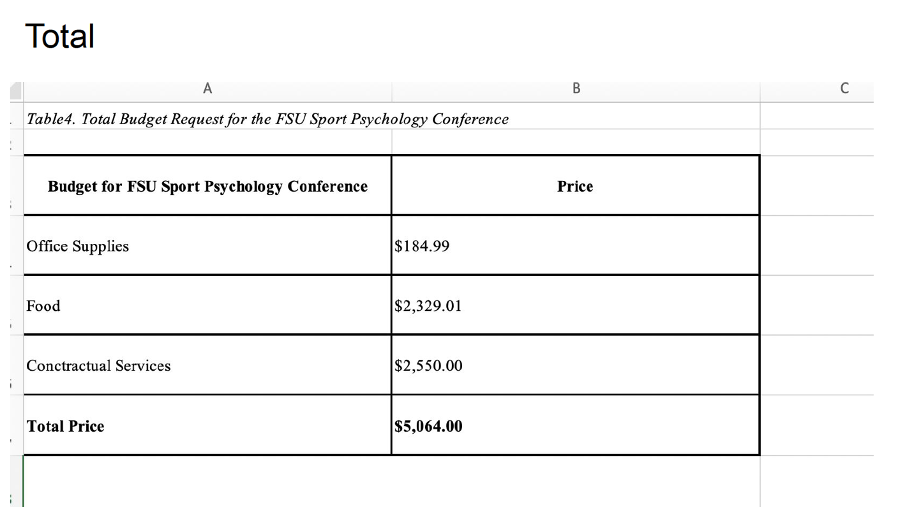

FLORIDA STATE UNIVERSITY
CONGRESS OF GRADUATE STUDENTS
Allocation, Revision, or Transfer

31st Congress of Graduate Students

Bill #: 8

Sponsored by: Rep. Mostbauer

Date: 3/6/2023

Amount: $569

From (account name): COGS Unallocated
To (account name): FSUCares

Purpose & Description: Immokalee Speaker Dinner
Location of Event: Medical School Building, Room 1200
Date(s) of Event: 3/15/2023
Time(s) of Event: 5-6pm
Estimated Attendance: 70
This is an on-campus event where the head of the Immokalee campus will be speaking to the College of Medicine students about Immokalee electives, spring break trip, and other opportunities at their campus. Immokalee allows students to go for rotations and other service-learning trips throughout the year and this will serve as an informational meeting for the campus as a whole. M1s, M2s, PA, and Bridge students are all welcome, as well as anyone else who may be interested. This event is being put on at the request of the director of the Immokalee campus.
How will you advertise the event?
Two emails will be sent to the student body about the event and flyers will be posted closer to the event date.
Is the event free and open to all Florida State University Students?
Yes
Is there a charge to attend for non-FSU students?
No
Itemized Expenditures:

Quantity | Description | Unit Price
1 | Food/catering | $569

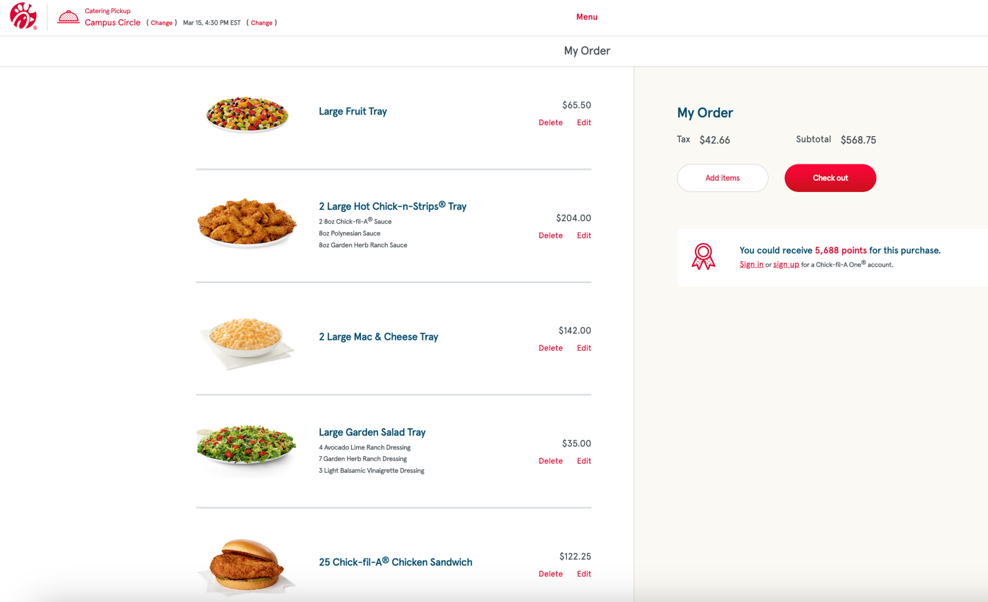

*note: The subtotal does not include the tax amount being shown

FLORIDA STATE UNIVERSITY
CONGRESS OF GRADUATE STUDENTS
Allocation, Revision, or Transfer

31st Congress of Graduate Students

Bill #: 9

Sponsored by: Representative Casseus

Date: 03/03/2023

Amount: $600.

From (account name): COGS Unallocated.

To (account name): School of Teacher Education Graduate Student Association (STEGSA)

Purpose & Description:
Name of Event: STEGSA Annual Celebration
- Event Location: FSU Rez
- Date(s) of Event: Beginning of May 2023
- Time(s) of Event: 1 pm- 4 pm
- Estimated Attendance: 40

STEGSA would like to host a picnic for the School of Teacher Education PhD students at the end of the Spring 2023 semester, at the FSU Rez location. We would provide food and non-alcoholic drinks, such as pizza, hamburgers, hot dogs, salad, soda. We would also need some supplies to set up the picnic such as tablecloths and cutlery. This would serve as a venue where PhD students could bring their families and children to socialize and celebrate the end of the school year. It would still be considered an on-campus event and students and families can engage in swimming, kayaking, climbing, and relaxing.

Advertising will be done via STE mailing list; and fliers will be put up in the Stone Building and STE office. Event is free and open to all FSU students, and there is no charge to attend the event.

Itemized Expenditures:

Quantity | Description | Unit Price
1 | Food | $600
Total: $600

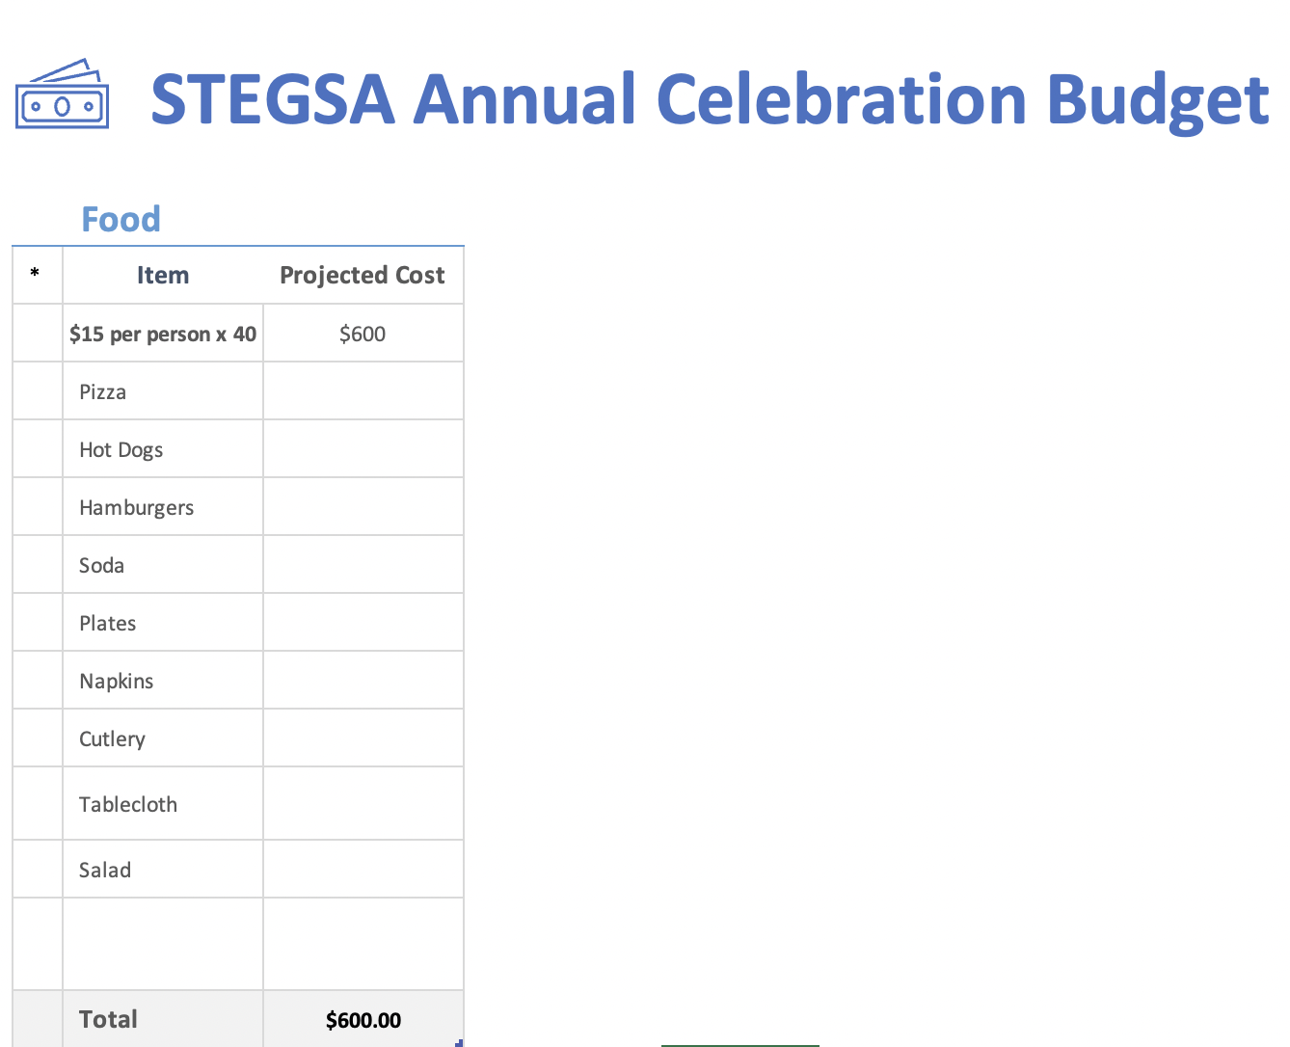

FLORIDA STATE UNIVERSITY
CONGRESS OF GRADUATE STUDENTS
Allocation, Revision, or Transfer

31st Congress of Graduate Students

Bill #: 10

Sponsored by: Rep. Delva

Date: Monday, March 6th, 2023

BE IT ENACTED BY THE THIRTY-FIRST CONGRESS OF GRADUATE STUDENTS THAT:
A transfer of $2,500 from COGS C-SAC Account to the COGS Food Account.

The purpose of this transfer is to ensure adequate funds for up-coming events until the end of the fiscal year. Any unused funds will be retained in the Speaker fund or can be transferred into
Unallocated.

Transfer: $2,500
Total: $2,500

FLORIDA STATE UNIVERSITY
CONGRESS OF GRADUATE STUDENTS
Allocation, Revision, or Transfer

31st Congress of Graduate Students

Bill #: 11

Sponsored by: Rep. Vaughn

Date: Monday, March 6th, 2023

BE IT ENACTED BY THE THIRTY-FIRST CONGRESS OF GRADUATE STUDENTS THAT:
A transfer of $10,000 from COGS Conference Presentation Grants July 2022 – October 2022 funding period to the COGS Unallocated.

The purpose of this transfer is to ensure adequate funds for up-coming events until the end of the fiscal year.

Transfer: $10,000
Total: $10,000

FLORIDA STATE UNIVERSITY
CONGRESS OF GRADUATE STUDENTS
Allocation, Revision, or Transfer

31st Congress of Graduate Students

Bill #: 12

Sponsored by: Rep. Vaughn

Date: Monday, March 6th, 2023

BE IT ENACTED BY THE THIRTY-FIRST CONGRESS OF GRADUATE STUDENTS THAT:
A transfer of $11,667 from COGS Conference Presentation Grants July 2022 – October 2022 funding period to the COGS Conference Presentation Grants March 2023 – June 2023 funding period.

The purpose of this transfer is to ensure adequate funds for summer conference funding period.

Transfer: $11,667
Total: $11,667

FLORIDA STATE UNIVERSITY
CONGRESS OF GRADUATE STUDENTS
Allocation, Revision, or Transfer

31st Congress of Graduate Students

Bill #: 13

Sponsored by: Rep. Vaughn

Date: Monday, March 6th, 2023

Amount: $1,5000

From (account name): LEARN General Expense Account

To (account name): LEARN Contractual Services Account

Purpose & Description: Honorarium for an invited speaker for the LEARN Conference planned for April 7, 2023

Total: $1,500

FLORIDA STATE UNIVERSITY
CONGRESS OF GRADUATE STUDENTS
THIRTY-FIRST CONGRESS OF GRADUATE STUDENTS
Assembly Meeting
February 20, 2023
6:30pm
Minutes
Call to Order: 7:00pm
Pledge of Allegiance: Basualdo
Representatives Present: Basualdo, Burns, Casseus, Delva, Galeano, Gui, Ilesanmi, Mostbauer, Risler, Rogowski, Salimi, Vaughn, Vouzas
Representatives Absent, Excused: Amaraneni, Beavon, Elmi, Lenchitz, Neale
Reading and approval of the Minutes: Vouzas, 2nd Salimi
Petitions into the Assembly: N/A
Special Introductions and Student Comments: N/A
Messages from Student Government: N/A
Report from the Office of Governmental Affairs: N/A
Report of the Budget Committee:
Bill #6: 2023-2024 Annual Budget Proposal
Rogowski - You should have the budget bill in front of you. We were allocated the same as last year. Actually, slightly less due to overhead costs. Budget committee met for a total of 24 hours over a 2 week period and I am happy with our budget bill. We have added new organizations including 2 new international organizations. Glad we could do that even with the lack of increase in the budget. Happy with the bill and since there was a lack of emails by organizations when sent the budget, they are likely happy about it as well. We would like to increase the travel grants, but considering the money given, we could not do that, but we also did not decrease the amount. There will be a planned audit on these grants to see what can be done in the future. Any comments from the committee?
Burns - Were there any organizations who emailed not happy about the budget?
Rogowski - I did not get any replies to the email sent to the organizations.
Consideration of the Annual Budget:
Opening statement:
Rogowski - Bill #6 is the annual budget and the committee worked very hard on this. I hope you will respect the work put into this and vote yes. I yield the rest of my time.
Technical non-debatable questions:
Salimi - motion to exhaust the rest of the time. 2nd - Galeano.
Pros:
Ilesanmi - Thank you to the budget committee. I think it's all about trust and if we choose you and trust you, I think that this trust should play out. I have served on 2 budget committees. The first in 2021 was very smooth and last year was hard to say the least. I think what happened last year was issues with trust because the committee works hard to put it together. I think everything looks good. Serving on the budget committee is the hardest job.
Salimi - Most organizations got most of what they wanted and it was equitable.
Basualdo - It's not easy putting everything together and even though it wasn't easy, they did a great job. We had 8 new RSOs apply. Thank you for your hard work and dedication for the school.
Cons:
Salimi - Motion to exhaust the rest of the time. 2nd - Burns
2nd round of Pros:
Delva - I appreciate how organized and understanding the committee was. We were focused on making sure that everyone gets what they needed.
Mostbauer - The communication has been easy to read and to check that everything adds up. Good job to the committee.
Ilesanmi, Basualdo, Vaughn - Susan did an amazing job with the budget committee.
Cons:
Vouzas - Motion to call to question, 2nd - Risler
Closing Statements:
Rogowski - I'm proud of the bill and I think we were able to add some very cool things despite no increase. There should be some great events on campus next year with the money. I yield the rest of my time.
Roll call vote:
Basualdo - Yes
Burns - Yes
Casseus - Yes
Delva - Yes
Galeano - Yes
Gui- Yes
Ilesanmi - Yes
Mostbauer - Yes
Risler - Yes
Rogowski - Yes
Salimi - Yes
Vaughn - Yes
Vouzas - Yes
Vote count: 13-0-0
Round Table:
Adjournment: 7:48pm
Next Meeting: March 6, 2023 at 6:30 p.m. Senate Chambers (3rd floor New Student Union)

