FLORIDA STATE UNIVERSITY
CONGRESS OF GRADUATE STUDENTS
THIRTY-FIRST CONGRESS OF GRADUATE STUDENTS
Assembly Meeting
January 23, 2023
6:30pm
Agenda

Call to Order:
Pledge of Allegiance:
Representatives Present:
Representatives Absent, Excused:
Representatives, Absent, Unexcused:
Reading and approval of the Minutes:
Petitions into the Assembly:
Zeinab Elmi, Engineering Seat 1
Katherine Gui, Medical School Seat 1
Joseph C. Risler, Medical School Seat 2
Kevin A. Salimi, Medical School Seat 3
Special Introductions and Student Comments:
Messages from Student Government:
Report from the Office of Governmental Affairs:
Report of Officers:
- Report of the Speaker:
- Report of the Deputy Speaker for Finance:
- Report of the Deputy Speaker for Judicial Affairs:
- Report of the Deputy Speaker for Communications:
Committee Report:
- Assignment of Committees for the 31st Congress and election of new chairs
- C-SAC:
- Internal Affairs:
- Student Advocacy:
- Student Affairs:
Funding Requests:
Bill 1: African Graduate Students Association (Rep. Galeano)
Unfinished Business:
Election of Deputy Speaker of Judicial Affairs
Confirmation of the Budget Committee
New Business:
Round Table:
Adjournment:
Next Meeting: Feb 6, 2023 at 6:30 p.m. Senate Chambers (3rd floor New Student Union)
COGS Financial Report, Fiscal Year 2022-2023
ACCOUNT | ALLOCATION AMOUNT | DESCRIPTION | BALANCE
UNALLOCATED | $24,593.00 | For RSO funding requests at COGS meetings | $21,839.00
ORGANIZATIONAL (C-SAC) | $3,000 | RSO funding for allocations less than $1000 for the fiscal year | $3,000.00
LSC | $61,000 | Funding allocations from Law School Council to Law School Student Organizations | $33,691.62
MSC | $84,817 | Funding allocations from Medical School Council to Medical School Student Organizations | $51,777.63
PRESENTATION GRANTS (Jul-Oct) | $66,250 | Presentation Grant balance for the July-October funding period | $25,916.79
PRESENTATION GRANTS (Nov-Feb) | $75,000 | Presentation Grant balance for the November-February funding period | $55,653.69
PRESENTATION GRANTS (Mar-Jun) | $58,750 | Presentation Grant balance for the March-June funding period | $66,875.00
ATTENDANCE GRANTS (Jul-Oct) | $9,000 | Attendance Grant balance for the July-October funding period | $3,922.12
ATTENDANCE GRANTS (Nov-Feb) | $9,000 | Attendance Grant balance for the November-February funding period | $9,000.00
ATTENDANCE GRANTS (Mar-Jun) | $7,500 | Attendance Grant balance for the March-June funding period | $7,500.00

Allocation, Revision, or Transfer

31st Congress of Graduate Students

Bill #: 1

Sponsored by: Representative Galeano

Date: 01/23/2023

Amount: $211.65
From (account name): COGS Unallocated
To (account name): African Graduate Students Association

Purpose & Description:
Name of Event: General Body Meeting
Location of Event: CGE, 3500
Date(s) of Event: 02/10/2023
Time(s) of Event: 5pm
Estimated Attendance 72

This meeting is our first General Body Meeting of this semester, the second for this school year. We plan to discuss upcoming events at this general meeting and seek ideas and volunteers. Firstly, we aim to brainstorm ideas and delegate duties for our forthcoming "Coffee Hour" event to be hosted with the CGE in March. Secondly, we also plan to discuss ways to advance our presence and impact on campus. Thirdly, we plan to discuss our election plans and prepare members on the procedure, as well as to prepare them to volunteer to run for office in our upcoming election in April.
Advertising through NOLE Central. Free to all students. No charge for the event.

Itemized Expenditures:

Quantity | Description | Unit Price
1 | Food | $211.65
Total: $211.65
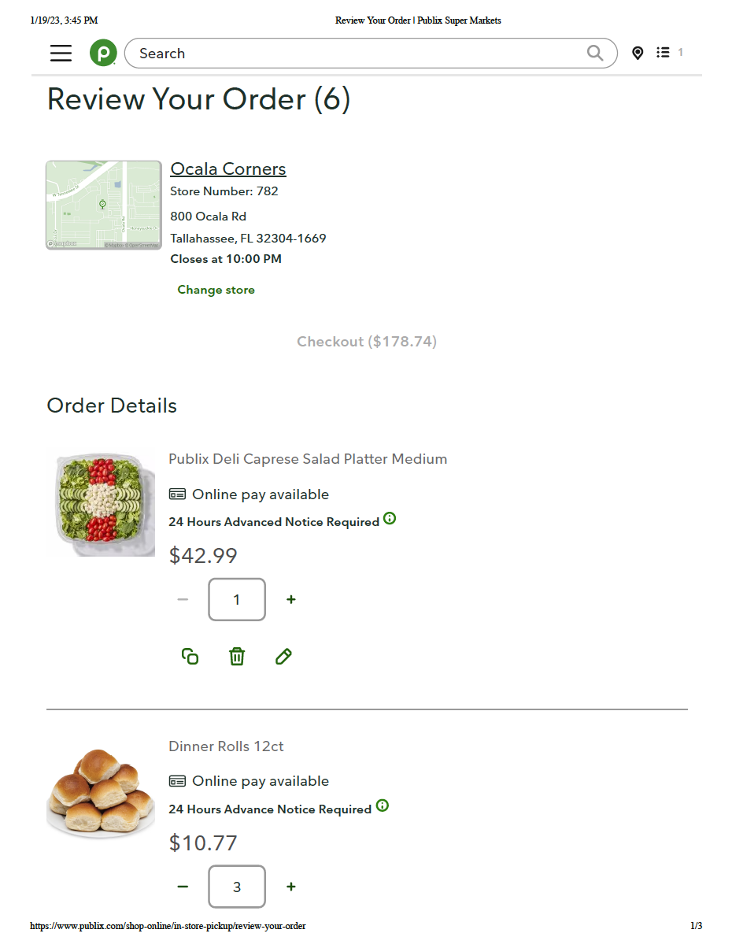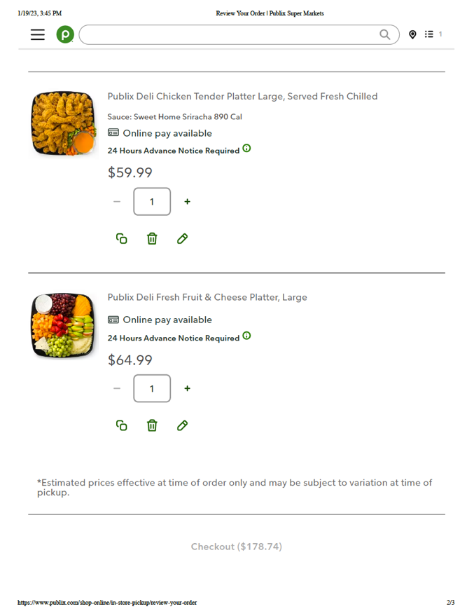

THIRTY-FIRST CONGRESS OF GRADUATE STUDENTS
Assembly Meeting
November 28, 2022
6:30pm
Minutes

First portion of the meeting conducted by Nimna Gabadage, Student Body President, until the election of a new Speaker.
Call to Order: 6:36pm
Pledge of Allegiance: Neale
Representatives Present: Beavon, Boatright, Burns, Casseus, Galeano, Gerhold, Ilesanmi, Myhre, Neale, Rogowski, Vaughn, Vouzas
Representatives Absent, Excused: Delva
Representatives, Absent, Unexcused: Amaraneni
Reading and approval of the Minutes: Boatright; 2nd - Neale
Swearing in of Representatives: Elected members who did not attend the 2022 SGA Inauguration
Petitions into the Assembly:
- Luis Basualdo, Social Sciences & Public Policy, Seat 1
- Jordan Lenchitz, College of Music, Seat 1
- Oleksander Mostbauer, Arts and Sciences, Seat 3
Q&A:
Neale - Can you commit to meetings on Mondays from 6:30pm until they end? Yes
Rogowski - What committees are you interested in? All were interested in Student Affairs
Neale - Are you aware that you need to be financially certified? Yes
Pros:
Galeano - Luis and Jordan have been a part of COGS and we know they both are enthusiastic. Oleksander also seems to care about graduate student issues. It would be exciting to work with them.
Ilamsami - We need new members and they all seem interested.
Vaughn - They all look like they will be a good part of the Congress and we know two of them already.
Motion to call to question for Basualdo - Vaughn; 2nd - Rogowski
Motion to call to question for Lenchitz - Rogowski; 2nd - Neale
Motion to call to question for Mostbauer - Boatright; 2nd - Rogowski
All pass 12-0-0
Motion to adopt the 31st Congress Rules of Procedure: Neale; 2nd - Vouzas.
Elections for Executive Board:
• Speaker: Nomination for Luis Basulado - Neale; 2nd Rogowski
3rd semester in COGS and dedicated to making COGS even better. This position isn't for him, it's to make it better for all of us. Rachel will help to guide him. Will be here for the next 2 semesters and leave it better than he started. Likes to joke around, but will take it seriously.
Q&A - You will be here in the Spring and Fall? It will be Spring and Summer.
Will you be open for communication? Yes.
What activities do you have outside of COGS? Full time job at the Department of Health and is Treasurer of another student organization. Work is very understanding of the need to be flexible.
COGS has had a lot of turmoil in the last several semesters, will you follow the rules according to code? Yes, I will follow Rachel's footsteps in following code. Hope to make congress bigger and more connected.
What strategies do you have for expanding COGS? Priority is to fill the congress and reach out to parts of the campus that have not been covered. Friends don't know what COGS is, so want to reach out to everyone including the new graduate students.
Pros:
Vaughn - He has the experience and the willingness to serve.
Lenchitz - Has enthusiasm.
Neale - Open to discussion and training.
Vote: 15-0-0
• Deputy Speaker for Financial Affairs
Nomination for Susan Rogowski - Vaughn; 2nd is Galeano
Currently serving in this role and is enjoying this role. Looking to continue this to create stability in the executive board with the budget hearings in January.
Q&A:
Aren't you a math major? Yes.
How long do you see yourself in COGS? Expected graduation in May 2024 and planning to stay on COGS as long as possible. Can foresee needing to step down in the summer as dissertation happens.
Motion to extinguish time: Vouzas; 2nd - Neale
Pros:
Vouzas: Has been doing this for a few months already and has experience. This role is hard and has a steep learning curve at the start. Rep. Rogowski is suited for this role.
Ilesanmi: She is organized.
Lenchitz: I appreciate her vision for the future.
Neale: A wonderful teammate who is always willing to help out and go above and beyond. Willing to take on serious and challenging issues. Has a creative approach to her problem solving.
Motion to call to question: Boatright, 2nd - Ilesanmi.
Vote: 14-0-0
• Deputy Speaker of Judicial Affairs
Pushed to Unfinished business for next meeting
• Deputy Speaker of Communications
Nomination for Laura Vaughn - Neale, Rogowski -2nd
Currently serving and have been enjoying it. Hopefully you've been seeing that our social media has been more active and that you've been receiving emails in a timely manner.
Q&A:
Neale: How long do you plan to stay on in COGS?
Vaughn: I have a long time before I graduate, I'm only in my second year, so I plan to stay on for a while
Motion to call to Question: Illesanmi, 2nd - Galeano
Pros: Laura has been great at communicating with me as a new member especially preparing for Inauguration, Illesanmi: She's been doing a great job especially with social media. Neale: She's been a great supporter within the executive board, has been checking the code and making sure she is doing all of her duties diligently.
Motion to call to Question: Rogowski 2nd - Boatright
Vote: 14-0-0
Special Introductions and Student Comments: N/A
Messages from Student Government:
Sam Diaz, Student Senate President
Looking forward to working with the new Speaker and elected officers. SGA is here to collaborate and work together. Contact information is on the SGA website.
Report from the Office of Governmental Affairs: N/A
Report of Officers:
- Report of the Speaker: Has some big boots to fill. You are all amazing people to work with. There will be a learning period, but will make sure that things run smoothly and please have patience during the learning process.
- Report of the Deputy Speaker for Finance: Everything is going well and looking forward to next semester. Will be forming a budget committee ASAP. If you are interested, please send an email. It will be a busy two weeks around the end of January/early February, but will have an impact on campus. Looking for around 5 volunteers. Will be sending out emails. Also still needs a C-SAC committee - for the small funding requests that are less than $1000.
- Report of the Deputy Speaker for Judicial Affairs: N/A
- Report of the Deputy Speaker for Communications: Watch out for emails coming out after finals about committee preferences and communication preferences.
Committee Report:
- C-SAC: N/A
- Internal Affairs: Will be putting out a newsletter on behalf of COGS. Want to send out information to RSO's about funding requests. Focus on advertising open seats to help put out information and how to apply. COGS code will be looked at heavily in the next few months for updates. Internal affairs will be putting something together for training for new representatives. Make sure to review the code and FSU student body statues until then.
- Student Advocacy: Nothing new since early November and will be meeting in early December.
- Student Affairs: No meeting since last time.
Funding Requests: N/A
Unfinished Business: N/A
New Business:
Vaughn - FSU Childcare got a multimillion-dollar grant where they will provide free tuition for 75 slots for FSU students needing childcare. This does address some of the concerns brought up by the Student Advocacy committee earlier in the year.
Round Table:
Adjournment: 7:50pm
Next Meeting: January 23, 2023 at 6:30 p.m. Senate Chambers (3rd floor New Student Union)

