FLORIDA STATE UNIVERSITY
CONGRESS OF GRADUATE STUDENTS
THIRTIETH CONGRESS OF GRADUATE STUDENTS
Assembly Meeting
November 7, 2022
6:30pm
Agenda

Call to Order:
Pledge of Allegiance:
Representatives Present:
Representatives Absent, Excused:
Reading and approval of the Minutes:
Petitions into the Assembly:
Jordan Lenchitz, Music Seat 1
Special Introductions and Student Comments:
Messages from Student Government:
Report from the Office of Governmental Affairs:
Report of Officers:
- Report of the Speaker
- Report of the Deputy Speaker for Finance
- Report of the Deputy Speaker of Judicial Affairs
- Report of the Deputy Speaker of Communications
Committee Report:
- C-SAC:
- Internal Affairs:
- Student Advocacy:
- Student Affairs:
Funding Requests:
Bill 28: Music Theory Society at Florida State University (Rep. Galeano)
Bill 29: International Studies Graduate Association (Rep. Mekala)
Bill 30: Master of Public Health Student Association (Rep. Vaughn)
Unfinished Business:
New Business:
Round Table:
Adjournment:
Next Meeting: November 28th, 2022 at 6:30 p.m. Senate Chambers (3rd floor New Student Union)

COGS Financial Report, Fiscal Year 2021-2022
ACCOUNT | ALLOCATION AMOUNT | DESCRIPTION | BALANCE
UNALLOCATED | $27,617 | For RSO funding requests at COGS meetings | $25,891.00
ORGANIZATIONAL (C-SAC) | $3,000 | RSO funding for allocations less than $1000 for the fiscal year | $3,000.00
LSC | $44,000 | Funding allocations from Law School Council to Law School Student Organizations | $34,277.22
MSC | $44,000 | Funding allocations from Medical School Council to Medical School Student Organizations | $61,522.73
PRESENTATION GRANTS (Jul-Oct) | $53,000 | Presentation Grant balance for the July-October funding period | $26,413.18
PRESENTATION GRANTS (Nov-Feb) | $60,000 | Presentation Grant balance for the November-February funding period | $70,300.00
PRESENTATION GRANTS (Mar-Jun) | $47,000 | Presentation Grant balance for the March-June funding period | $66,875.00
ATTENDANCE GRANTS (Jul-Oct) | $6,000 | Attendance Grant balance for the July-October funding period | $5,100.00
ATTENDANCE GRANTS (Nov-Feb) | $6,000 | Attendance Grant balance for the November-February funding period | $8,500.00
ATTENDANCE GRANTS (Mar-Jun) | $5,000 | Attendance Grant balance for the March-June funding period | $8,000.00

Allocation, Revision, or Transfer

30th Congress of Graduate Students

Bill #: 28

Sponsored by: Representative Galeano-Cabral

Date: November 7, 2022

Amount: $2,000

From (account name): COGS Unallocated

To (account name): Music Theory Society at Florida State University

Purpose & Description: The purpose is to pay an honorarium to a keynote speaker for the FSU Music Theory Forum, which is going to be held in the Longmire Recital Hall on January 14th, 2023. This event is the longest-running graduate student-led music theory conference in the United States (this year will be our 40th) and has an expected attendance of at least 40 to 50 people. Every year, the Music Theory Society at FSU solicits proposals on any music-theoretical topic to be presented live at FSU to an audience of regional music theory faculty, music theory graduate students, and FSU undergraduates. A keynote speaker is also invited, who is a distinguished scholar in the field to deliver an hour-long talk on a topic of their choice. This year's speaker is Dr. Noriko Manabe, Associate Professor of Music Theory at Temple University. Her research focuses on the intersections between music and social movements, popular genres, and music and trauma in Japan and Latin America. This cutting-edge work merges music-theoretical techniques with ethnographic methodologies, and so it's highly likely that her presentation will be instructive not only for music theorists in attendance, but also ethnomusicologists and historical/critical musicologists. Presenters who are not the keynote speaker submit proposals that are evaluated by a program committee made up of Music Theory Society members. In the past, 8 and 10 presenters (not including the keynote speaker) have been invited to the forum. This event presents an important professional development opportunity for graduate students in the Department of Music Theory and Composition. In addition to the benefits of experiencing firsthand how conferences work by helping to organize one, graduate students can network with scholars at universities that they may not yet know. Finally, faculty use the forum as an important recruiting tool, since presenters are often Master level students who are considering FSU as an option to pursue doctorate degrees.

Itemized Expenditures:

Quantity | Description | Unit Price
1 | Contractual Service (keynote speaker honorarium) | $2,000

Total: $2,000

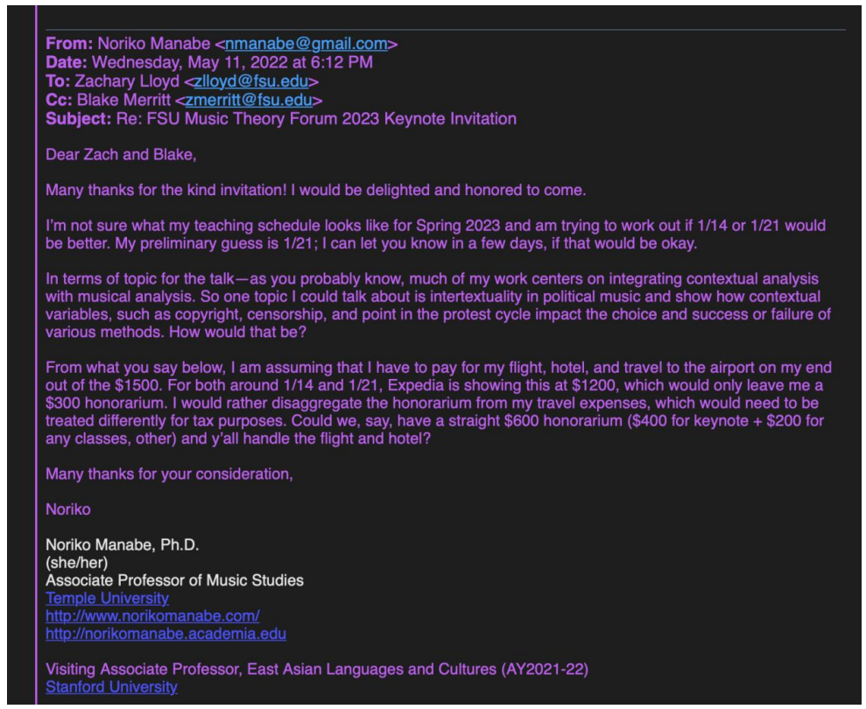

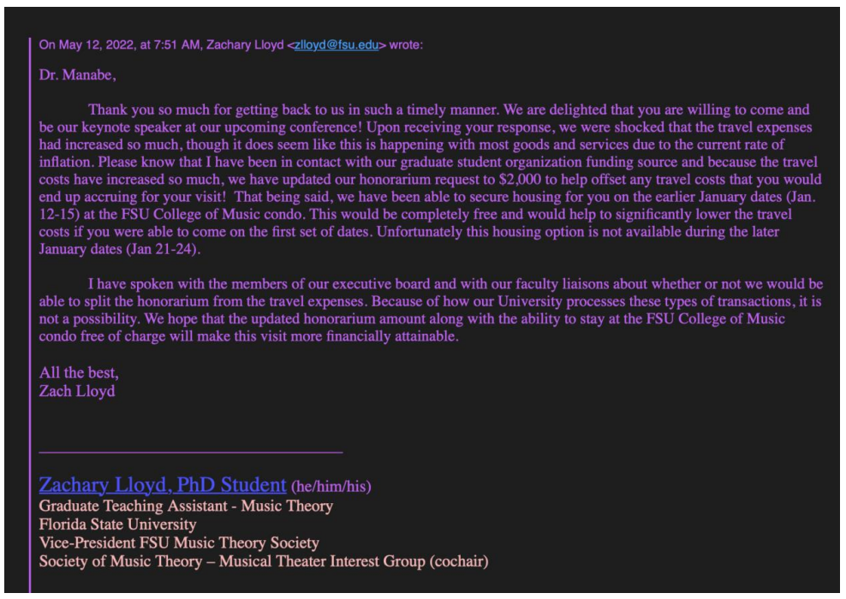

Allocation, Revision, or Transfer

30th Congress of Graduate Students

Bill #: 29

Sponsored by: Rep. Mekala

Date: 11/7/2022

Amount: $1448

From (account name): COGS Unallocated

To (account name): International Studies Graduate Association

Purpose & Description:

The purpose of ISGA is to facilitate inter-program student communication, facilitate understanding and appreciation of international cultures, provide an environment of support for incoming and returning program students, and establish a medium for students in which to demonstrate their scholastic abilities and achievements. We will have an end of semester celebration on Landis Green to come together and celebrate finishing the semester. The professors and most of the students in our programs (International Affairs, Russian and Eastern European Studies, and Asian Studies) will be in attendance, and anyone who wants to attend is welcome to. We will give out our t-shirts and play icebreaker games so the students in our programs and the professors can get to know each other better, and there will be an opportunity for networking between students and professors. We will also send off our graduating students. This event will be advertised on Nole Central, Instagram, and our email list.

Itemized Expenditures:

Number of attendees | Category | Price
80 | Clothing and Awards: 144 T-shirts  *Please see attached quotes | $1448

Total: $1448

Quote 1: T formation-Preferred

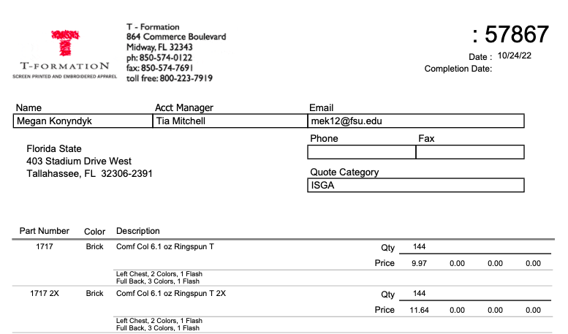

137 S-XL at 9.97 each = 1365.89
7 XXL at 11.64 each = 81.48
Total: 1447.37 for 144 shirts sizes S-XXL

Quote 2: Clothesline
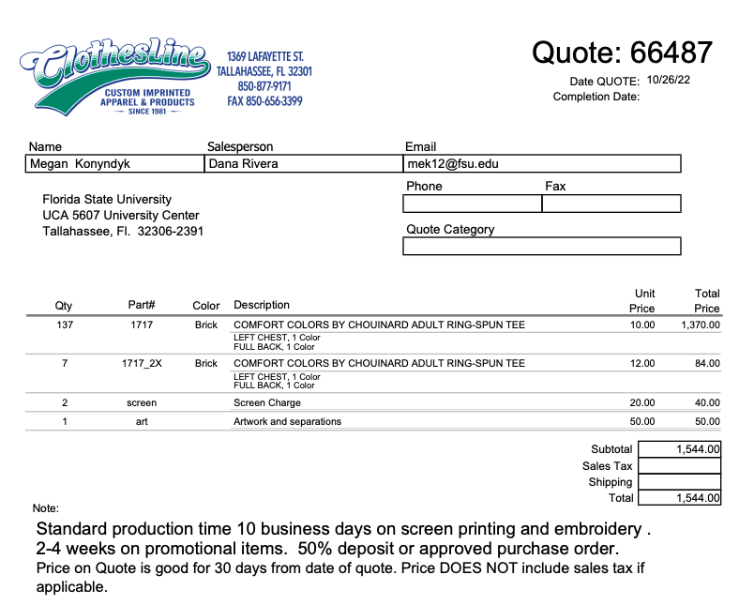

Total: 1544.00 for 144 shirts Sizes S-XXL

Quote 3: Full Press
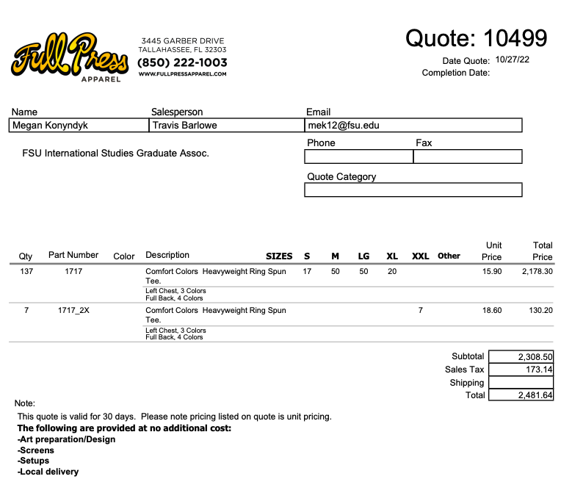

Allocation, Revision, or Transfer

30th Congress of Graduate Students

Bill #: 30

Sponsored by: Rep. Vaughn

Date: 11/7/2022

Amount: $601.61

From (account name): COGS Unallocated

To (account name): Master of Public Health Student Association

Purpose & Description: MPHSA Hooding Ceremonies
The MPHSA Hooding Ceremony is an event that honors our graduates and the program for the success of the semester. The traditional Masters hooding confers a special recognition upon graduates receiving masters or doctoral degrees, this is done by a faculty of our program. Although we are honoring graduates the purpose of this event is celebrate the success of MPHSA students, faculty, and staff. All hooding supplies are provided by the graduates themselves, the MPHSA is producing an event that allows us to all celebrate more intimately with peers, faculty, and family than a graduation commencement ceremony. We have done this event in the past and are trying to receive funding to host as a student organization and recognize the students within our organization. Graduating students will be able to celebrate with their peers, and refreshments and food will be provided. The event is open to all, but students should register to ensure attendance tracking for food.
This event will be posted on Nolecentral, our instagram, to students through GroupMe, and reaching out to esteemed faculty, like the president of the College of Social Sciences and Public Policy, for his attendance, and through the TVs in the COSSPP.

Expected attendance: 35

Itemized Expenditures:

Number of attendees | Category | Price
35 | Expenses - Supplies and decorations | $169.96
 | Food | $433.65

Total: $601.61

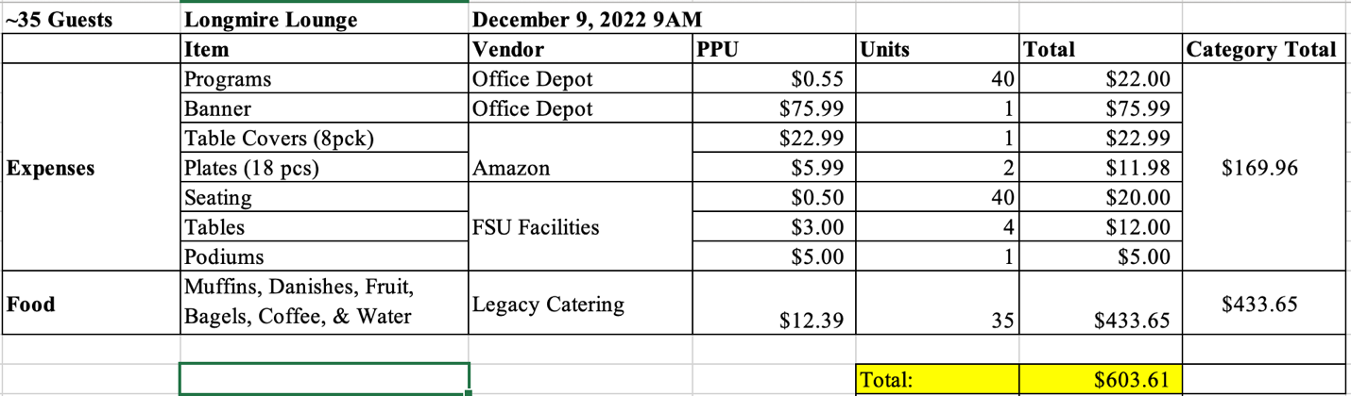

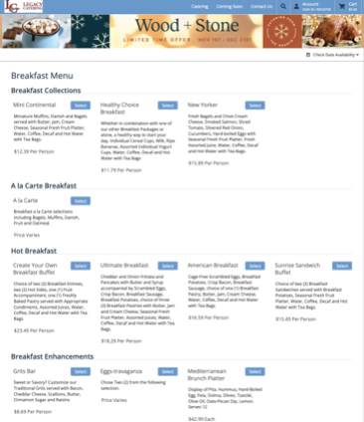

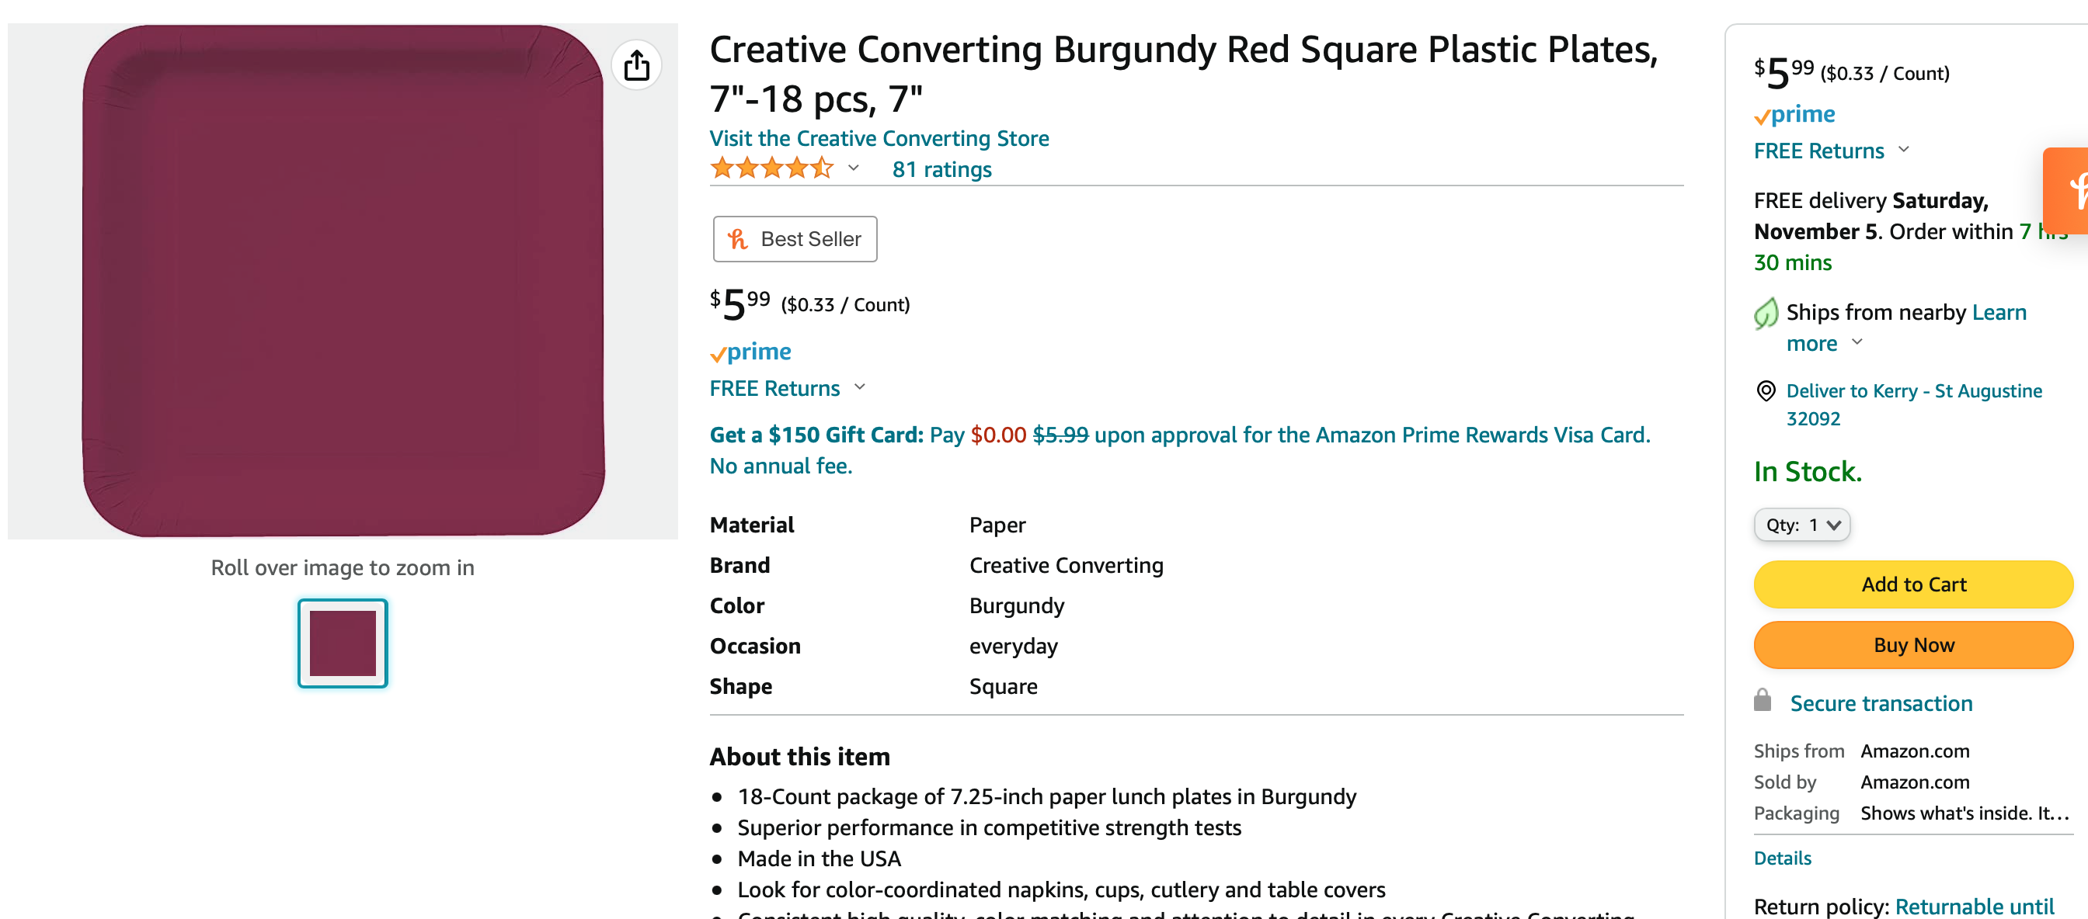
THIRTIETH CONGRESS OF GRADUATE STUDENTS
Assembly Meeting
October 17, 2022
6:30pm
Minutes

Call to Order: 6:36pm
Pledge of Allegiance: Ilesanmi
Representatives Present: Amaraneni, Basualdo, Boatright, Galeano, Gerhold, Ilesanmi, Myhre, Rogowski, Vaughn
Representatives Absent, Excused: Delva, Neale, Vouzas
Representatives Left Early, Unexcused: Mekala
Reading and approval of the Minutes: Boatright, 2nd - Gerhold
Special Introductions and Student Comments:
Keith McCall, Office of Graduate Fellowships and Awards (OGFA)
Presentation on the Office of Graduate Fellowships and Awards and how students can apply for fellowships and grants. Walked through the OGFA website. COGS can help to report outside fellowships and grants to OGFA. Also needs COGS help in spreading the word of OGFA's services. Would also like to build graduate student profiles to show who is a graduate student at FSU - for recruitment. They are always looking for new people to submit profiles. Will be sharing the presentation via email.
David Orozco, FSU Intellectual Capital Management Training and Certificate Program
Shared information about a Certificate Program for doctoral students who have finished their exams. It's a free program, nonacademic credit, and aimed at professional development. Will learn about intellectual property and technology. If you are a Masters student, then email David Orozco about your interest.
Iranian Student Association
Sharing about what is going on in Iran and the history of how they got to that point. All of the Iranian students at FSU are trying to do something about what is happening. Encourages COGS to help support by sharing information and supporting the Iranian students on campus.
Medical Student Council
MSC officers are visiting COGS and introducing themselves to COGS. They have a suggested changed to the COGS code. They cannot fund conference attendance in the way that is needed. Other departments have funds for travel, but the medical school does not offer this funding. Looking at changing 202.5A and 202.7 since those COGS code lines contradict each other. One of MSC's purpose for being given funding is to promote conferences. They wish to be able to fund conferences through their own funds. Want to share this with the whole of COGS while changes go through Internal Affairs.
Petitions into the Assembly:
Jordan Lenchitz, Music Seat 1 - will be moved to November 7th meeting since the Deputy Speaker of Judicial Affairs is out
Messages from Student Government: N/A
Report from the Office of Governmental Affairs: Representative Basualdo will be the representative moving forward.
Report of Officers:
- Report of the Speaker - N/A
- Report of the Deputy Speaker for Finance
Hopefully we will be getting $20,000 from sweepings pending final approvals. They were excited to fund us, but did not have as much money to fund.
Survey monkey is having some issues, so people approved for conference grant funding are not getting notification emails. Please reach out to Rep. Rogowski to check on your status.
- Report of the Deputy Speaker of Judicial Affairs - N/A
- Report of the Deputy Speaker of Communications
Turn in Expense Reports by Friday at noon. Election Day is the 19th.
Committee Report:
- C-SAC: Please respond to emails asking you to be on C-SAC.
- Internal Affairs: The code changes talked about by MSC will be worked on through Internal Affairs. They will be updating the code.
- Student Advocacy: Produce Distribution on Thursday, please stop by. Will be following up with the Globe about it not being used. Will be meeting again within the next two weeks.
- Student Affairs: Meeting last week. Chair is Amaraneni and Basualdo is Vice Chair. Will be meeting again soon.
Funding Requests: N/A
Unfinished Business: N/A
New Business:
Resolution #6: Student Bar Association Off Campus Event
Basualdo: Will be having a Halloween Social at Ology where everyone is invited. There will be a costume contest.
Rogowski: Why do you need this resolution? It is off campus and there is a provision that says events can only be on campus. Will need a resolution to be allowed to have the event off campus. Want to get away from everything and relax.
Amaraneni: How many students expected? Roughly 300 since they have been opening events to everyone and more Law Students.
Galeano: So you already have the funding? Yes, the funding is through the LSC, we just need permission to be off campus.
Rogowski: How do students without cars get there? There will be a Lyft discount code. Will also encourage people to ride together.
Point of Information from Myhre: Is this from Unallocated? No.
Pros: Galeano - Sounds fun and should be fine to have it off campus.
Ilesanmi: I support it.
Extinguish time: Amaraneni; 2nd - Boatright
Cons: Galeano - we need to amend who the bill is being sent to
Extinguish time: Sham; 2nd - Ilesanmi
Rogowski: 5 minute recess at 5:47
Call to order 3:52
Galeano: Motion to amend who will be sent the resolution. Send to the president of the RSO, President of the organization, COGS speaker, COGS Advisor, LSC.
Does the sponsor find it friendly? Yes.
2nd - Ilesanmi
Pros: extinguish time - Ilesanmi and Amaraneni
Cons: Call to question - Boatright, 2nd Galeano
Closing statement for the motion to amend - Galeano
We don't need to send the president and higher ups things that are not important. Should only be sent to those who should see it.
Voting on Amendment: 8-0-0
2nd rounds cons: Boatright call to question, Galeano 2nd.
Closing Statements: Lets vote on this.
Voting on amended resolution: 8-0-0

Resolution #7: Iranian Resolution
Galeano: Sharing the human right abuses occurring in Iran and encouraging the FSU community to support the Iranian community.
Non-Debatable questions:
Basualdo - Motion to extinquish time, 2nd - Gerhold
Pros:
Basualdo - This is a good resolution and we should do it.
Vaughn - This is a historical event and we should support our Iranian students on campus.
Ilesanmi - We should support the Iranian community
Cons:
Ilesanmi - call to question, Basualdo 2nd
Closing Statements from Sponsor:
These events are generating a lot of stress on our Iranian students and this is the least we can do to support our students.
Voting: 8-0-0

Round Table:
Adjournment: 8:17pm
Next Meeting: November 7th, 2022 at 6:30 p.m. Senate Chambers (3rd floor New Student Union)

