**FSU Childcare & Early Learning Program**

**Introduction**

The FSU Childcare & Early Learning Program provides care and education to student, faculty, and staff families through promoting a life-long love of learning using play-based curriculum and age-appropriate practices. The program serves to support the university mission so that student, faculty, and staff can achieve their academic and professional goals. The program also serves as a hands-on learning and teaching environment for academic departments and students where they can apply classroom learning and theories in a real-world setting.

**Highlights**

* Deviation from typical operations (COVID-19)
  + During the reopening of the center, the program had to significantly alter operations to ensure that staff and children attending the center were as safe as possible and that program operation adhered to strict Department of Children and Families (DCF) and CDC guidelines for childcare facilities. This included finding creative ways to socially distance infants and children under 5 years old. The program purchased, via University Housing funding, individual tables for each child. In addition, the staff spent a significant amount of time cleaning and disinfecting throughout the day.
* Childcare Core Values
  + Childhood Education and Skill Building: Provide a quality educational environment that instills a love of learning and prepares children for school through education and skill building.
    - During the closure of the center (April-July 2020) due to COVID-19, the program created the Family Connection Canvas site for families studying or working remotely. The purpose of the site was help children and families remain connected to the center and teachers, and to promote continued learning through book readings, activities, music and movement activities, and virtual filed trips that were uploaded by teachers. The site received a high demand from families for more content that it reached its storage limit. In response individual classroom canvas pages were created.
    - Virtual circle times were developed through Zoom meetings in response to receiving information from other Florida ERCCDs that families were reporting signs of depression in their children. The purpose of the virtual circle times was to create a live forum for children to interact with each other and their teachers while at home, and to try to reduce depression in children through virtual social interactions.
    - Student Development: Facilitate experimental learning opportunities for training, professional development, relationship building and career preparation.
      * The program developed a Canvas training site for all staff in order to access training modules online during the remote work period. Throughout the year the site was updated to contain more content for training staff and currently serves as the primary location for training.
      * Emily Thompkins, Infant & Crawler Faculty Lead Teacher, began project of making own training videos for student teachers to promote and educate staff on the program’s high standards for infant care.
    - Access & Success: Provide an affordable, accessible, and sustainable program that supports students, faculty, and staff in reaching their goals at the University.
      * USDOEd authorized $112,359 in CCAMPIS grant carryover funds from 2019-2020 to be used in the 2020-2021 grant year for childcare tuition assistance for student parents. This resulted in program being able to fully fund all childcare tuition for student families enrolled in the program (total of $206,148 in assistance).
    - Caring Community: Promote an environment that is safe, supportive, welcoming, inclusive and cultivates a sense of belonging for each child, family, student, and staff member.
      * Revised mission statement and Core Values
      * Revised menus to ensure they are diverse and culturally reflective of the families enrolled in the program.

**Staffing Structure**

|  |  |  |  |  |  |
| --- | --- | --- | --- | --- | --- |
| **Name** | **Type of staff** | **Position (s)** | **Number of staff** | **Education** | **Years of Experience** |
| Multiple | OPS | Kitchen Staff | 2 | High School / GED and BAs | varies |
| Multiple | OPS | Assistant Teachers | 76 | AAs and BAs | varies |
| Multiple | OPS/FWS | Front Desk | 7 | AAs and BAs |  |
| Tiffany Karnisky | A & P | Associate Director | 1 | Master Degree | 18 |
| Dana O’Connor | Faculty | Academic and Faculty Director | 1 | Bachelors Degree | 19 |
| Bill Stacey | A & P | Program Coordinator | 1 | Master Degree | 22 |
| Brenda Thompkins | USPS | Program Associate | 1 | Bachelors Degree | 13 |
| Emily Thompkins | Faculty | Faculty Lead Teacher | 1 | Bachelors Degree | 7 |
| Deby Vargas | Faculty | Faculty Lead Teacher | 1 | Bachelors Degree | 7 |
| Taylor Sheplak | Faculty | Faculty Lead Teacher | 1 | Master Degree | 4 |
| Suzanne Cloud | Faculty | Faculty Lead Teacher | 1 | Bachelors Degree | 11 |
| Lindsey Fasce | Faculty | Faculty Lead Teacher | 1 | Master Degree | 1 |
| Stephanie Walker | Faculty | Faculty Lead Teacher | 1 | Bachelors Degree | 5 |

**Strengths of your functional area(s)**

* Retention of professional staff (105 total years of service)
* Highly qualified professional staff, all with BA or Masters degrees
* University departments provide strong foundation and financial support
* Staff dedicated to the mission of the program

**Challenges**

* Balancing affordability with continuity of care
* Hiring and funding fulltime teachers to ensure continuity of care
* Fluctuating funding sources
* Creating an understanding of the importance of childcare services on campus and role in helping the University to meet its mission

**Staff Notable Moments**

* Committee Membership – List the committee, member, any special role (i.e., Chair) and organization (if applicable).
  + Tiffany Karnisky, Member and Nominations and Awards Chair, National Coalition of Campus Children’s Centers, August 2020
  + Tiffany Karnisky, Member Chair, National Coalition of Campus Children’s Centers
  + Dana O’Connor, Member Chair, National Coalition of Campus Children’s Centers
  + Bill Stacey, Member Chair, National Coalition of Campus Children’s Centers
  + Emily Thompson, Member Chair, National Coalition of Campus Children’s Centers
  + Deby Vargas, Member Chair, National Coalition of Campus Children’s Centers
  + Taylor Sheplak, Member Chair, National Coalition of Campus Children’s Centers
  + Suzanne Cloud, Member Chair, National Coalition of Campus Children’s Centers
  + Lindsey Fasce, Member Chair, National Coalition of Campus Children’s Centers
  + Stephanie Walker, Member Chair, National Coalition of Campus Children’s Centers
* Degree or Certificate Completion – List the staff member, the program, and the degree. Undergraduate staff can be presented as aggregate numbers.
  + Undergraduate graduates (25)
  + Masters degree graduates (5)
* Conference Virtual Attendance
  + Tiffany Karnisky, National Coalition of Campus Children’s Centers, March 2021
* Development opportunities
  + Faculty (Emily Thompkins, Deby Vargas, Taylor Sheplak, Suzanne Cloud, Lindsey Fasce, Stephanie Hall) developed and facilitated Guidance and Discipline Training for student teachers.
  + Professional staff and student teachers attended “Let’s Talk About it: Reducing Bias in Early Education & Connecting with Our Communities” panel discussion (June 2020)
* Staff Changes (i.e. new staff, staff who resigned)
  + Lindsey Fasce, new Faculty, August 2020
* Other
  + Brenda Thompkins, Program Associate, recognized by United Way for their fundraising efforts during the United Way campaign.

**Campus Partners & Collaborations**

* Collaborated with SGA to host socially distanced Trunk or Treat for Fall Festival
* Collaborated with various Housing and University staff to host virtual book readings for Women’s History Month and Dr. Seuss Celebration.
* Created partnership with ElderCare Services, the center provides child artwork each month to be delivered to shut-in/homebound seniors through the Meals on Wheel Program
* Hosted for “Traveling Crib” to promote a visual of safe sleep environment for children.
* Partnered with United Way, raised $225 to help families and children in the community.
* Partnered with state of Florida Educational Research Centers for Child Development (ERCCDs) to develop anti-bias discussion forum “Let’s Talk About it: Reducing Bias in Early Education & Connecting with Our Communities” panel discussion (June 2020).

**Diversity, Equity, & Inclusion Initiatives**

* Partnered with state of Florida Educational Research Centers for Child Development (ERCCDs) to develop anti-bias discussion forum “Let’s Talk About it: Reducing Bias in Early Education & Connecting with Our Communities” panel discussion (June 2020).
* Revised family and staff newsletters to include family and staff spotlights that celebrate the diversity in the center.
* Revised menus to ensure they are diverse and culturally reflective of the families enrolled in the program.
* Purchased books to educate children on the contributions of women and people of color as well as books that celebrate differences and kindness.
* Developed ADA procedures and program response to providing learning opportunities for children with exceptional needs.

**Goals**

* Hire and onboard new Assistant Director for Faculty and Academics to oversee and coordinate staff training and learning plans for children with exceptional needs.
* Revise and update professional development program for staff.
* Explore and develop family engagement group to ensure that center is meeting the social and educational needs of families, and assist in creating diversity, equity and inclusion initiatives that are meaningful to families and appropriate for children.
* Increase enrollment to pre-COVID 19 numbers.

**Photos**

Photo 1: Virtual Circle Time during COVID-19 stay at home

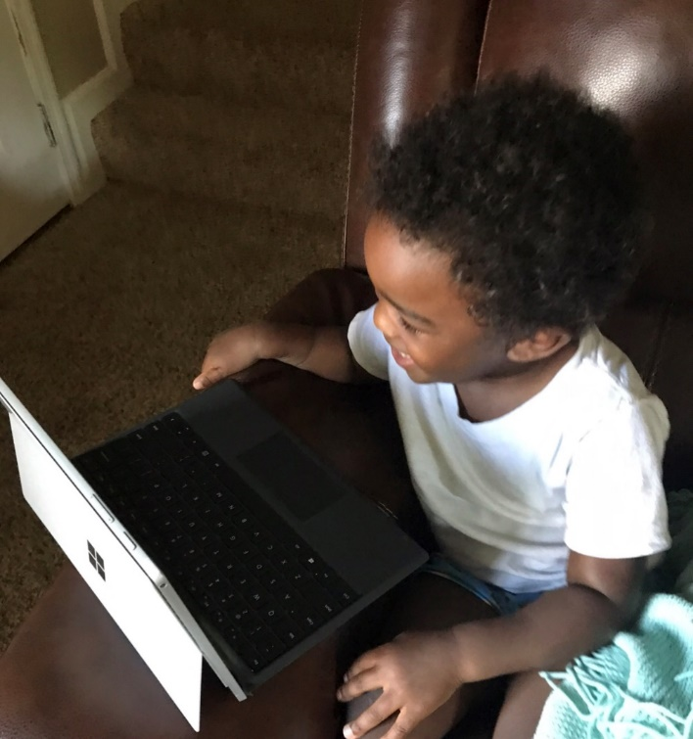

Photo 2: SGA & Childcare Trunk or Treat

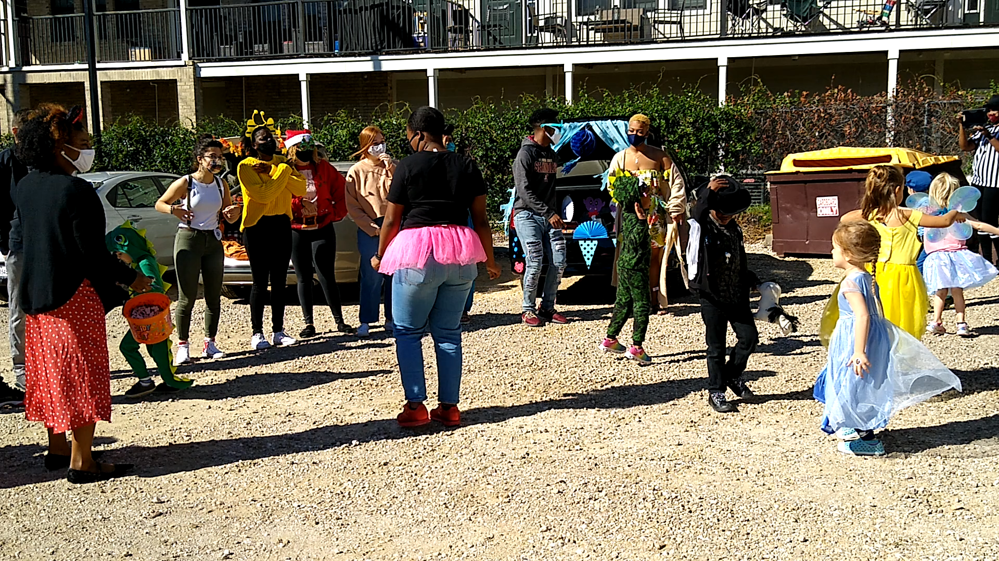

Photo 3: Celebrating Women’s History Month

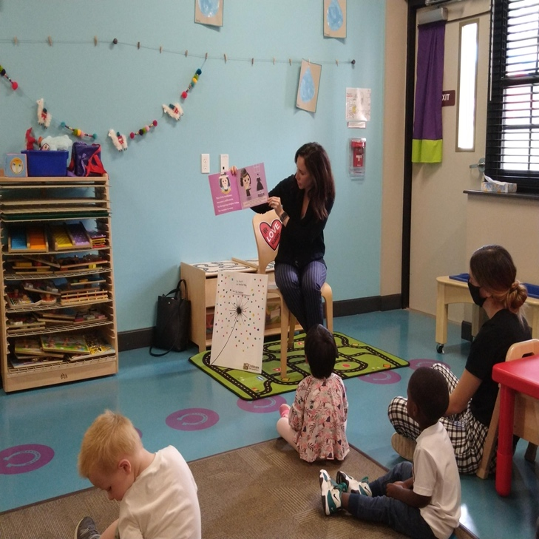

Photo 4: COVID-19 Disinfecting

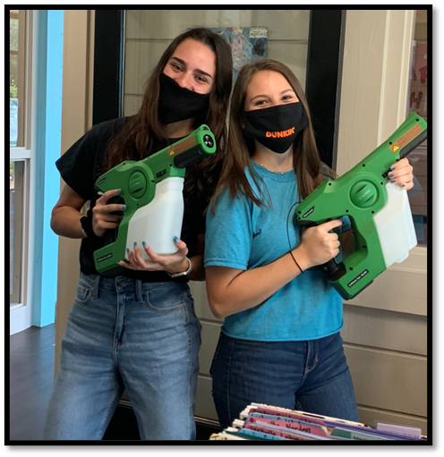

**Additional Information for DSA Annual Report**

1. During the closure of the center (April-July 2020) due to COVID-19, the program created the Family Connection Canvas site for families studying or working remotely. The purpose of the site was help children and families remain connected to the center and teachers, and to promote continued learning through book readings, activities, music and movement activities, and virtual filed trips that were uploaded by teachers. The site received a high demand from families for more content that it reached its storage limit. In response individual classroom canvas pages were created.
2. Virtual circle times were developed through Zoom meetings in response to receiving information from other Florida ERCCDs that families were reporting signs of depression in their children. The purpose of the virtual circle times was to create a live forum for children to interact with each other and their teachers while at home, and to try to reduce depression in children through virtual social interactions.
3. The program developed a Canvas training site for all staff in order to access training modules online during the remote work period. Throughout the year the site was updated to contain more content for training staff and currently serves as the primary location for training.
4. Revised menus to ensure they are diverse and culturally reflective of the families enrolled in the program.
5. Signature data points
   1. Received 3-year continuation CCAMPIS grant for $341,812.
   2. USDOEd authorized $112,359 in CCAMPIS grant carryover funds from 2019-2020 to be used in the 2020-2021 grant year for childcare tuition assistance for student parents. This resulted in program being able to fully fund all childcare tuition for student families enrolled in the program (total of $206,148 in assistance).
   3. Annual Pre-Kindergarten graduation (August 2020); 60 attending
   4. Fall Festival (October 2020); 65 attending, 10 volunteers
   5. Dr. Seuss Birthday Celebration (March 2021); 63 attending, 5 guest readers
   6. Women’s History Month Celebration (March 2021); 63 attending, 3 guest readers
   7. Extended Care (May 2021), cared for 44 children during semester breaks for faculty, staff and doctoral students.
   8. Enrollment
      1. Total child enrollment (based on child spaces)- 101
      2. Withdrew because of COVID-19- 34
   9. FSU Student Parents/Guardians served- 109
   10. Faculty and Staff Parents/Guardians served-53
   11. Waiting List-440
       1. FSU Student Parents/Guardians-175
       2. Faculty and Staff Parents/Guardians-168
       3. Alumni- 47
       4. Community - 50