TomProject

Mission: Raise cardiovascular health awareness around the FSU campus in honor of Tom Idowu who passed away last year from a sudden cardiac arrest (SCA) at age 22

Cardiac Arrest rates in young adults have been RISING nationwide for some time

Recovered COVID-19 patient reveal ongoing heart abnormalities that could have unknown consequences to SCA in the future
- Study in AMA journal showed 60% of recovered patients had myocarditis (inflammation of the heart)
- “severe devastating complications of COVID-19 are cardiac in nature and may result in lingering cardiac dysfunction beyond the course of the viral illness itself” -Mitchel Elkind, President of American Heart Association

Is SCA likely to occur on campus?
- SCA is very unlikely to occur in young adults; however, FSU has students of all ages, faculty, and visiting families all throughout the year
- Study by University of Washington on SCA revealed there is likely to be almost 2 SCA cases per year on a majority University campus
- A persons survival from SCA decreases by 10% EVERY MINUTE without help.
- Rapid response is essential for survival

3 Main Parts to the Project:

- Install more AEDS on campus
- Free ECG testing on campus (Run by “Who We Play For”)
  - Took place March 31st at COM with a great turnout
  - Testing was limited by machine availability
  - Could be turned into a research study to reevaluate the screening efficacy in young adults
- Free CPR training on campus
  - Project run by Campus Recreation

Fundraising Progress:
- $20,000 given to Who We Play For from the sweeping committee to perform free on campus ECG testing.
  - Might use left over money to purchase ECG machines to lower testing prices for future events
- FSU Student Body Executive Branch allocated $20,000 to Campus Recreation for CPR Training
- Fundraised $15,000 from the Great Give for AEDs
- Congress of Graduate Students (COGS) contributing $150,000 for AED program

AED Program:

Automated External Defibrillator (AED)
- They work and proven cost effective
- A persons survival from SCA decreases by 10% EVERY MINUTE without help.
- Simple to use with step by step vocal instructions to guide any civilian through the process
- AED will measure heart rate and will not administer a shock if unnecessary
- Florida Statutes 768.1325 Cardiac Survival Act; immunity from civil liability
- CS/HB 7011- Florida High School Athletic Association FHSAA requires AEDs on school grounds for each athletic contest and practice (2020)
  - More and more legislation being passed all around the US raising requirements and regulation for AEDS in school (starting with high schools)

Current Program:
FSU has 82 AEDs on their main campus, not nearly enough relative to other prominent Universities
- Harvard EHS director told me they had over 315 on their campus
  - You can argue this is a luxury of a University with lots of money, but as students, we are offering FSU the money to buy and maintain the AEDS (an essentially cost free upgrade to FSU’s Health and Safety Program)
- FAMU just ordered 160 AEDs for their campus

AED.com recommends 1 per 70,000 sqft
FSU has 11,975,788 sqft of buildings (July 2016) = 1 AED per 146,046 sqft

Interactive map below
https://map.concept3d.com/?id=1235#!ce/32611?sbc/?ct/0,33183,32611,40210
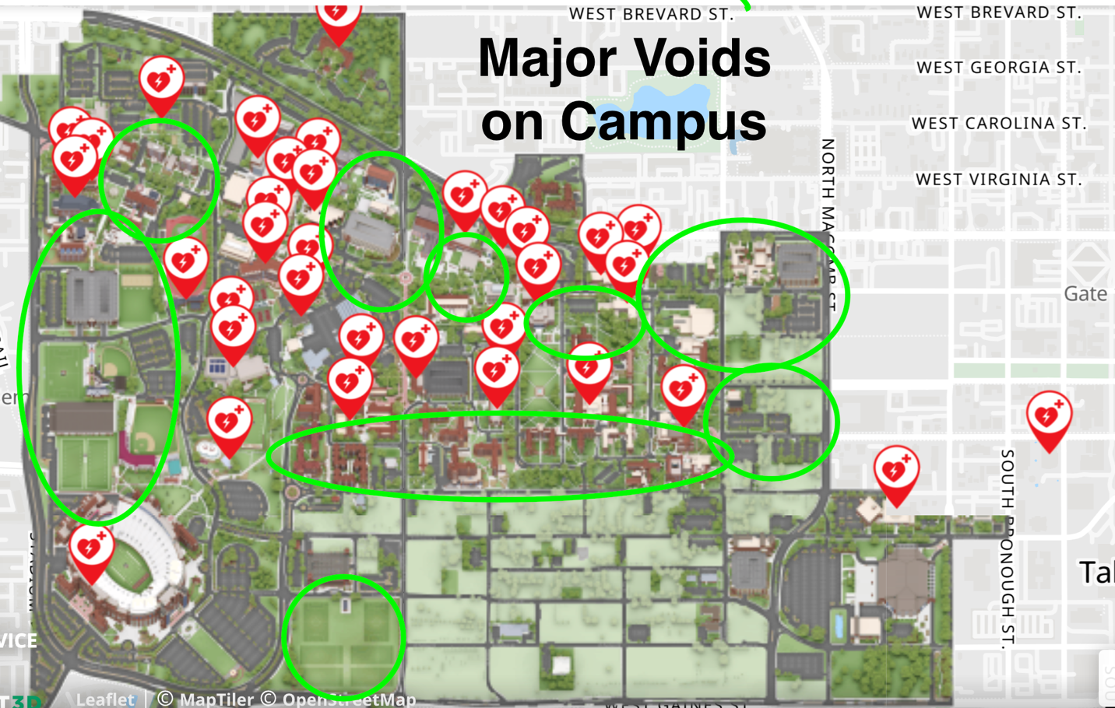

List Format (Revised 3/3/2020) (https://safety.fsu.edu/safety_manual/supporting_docs/AED%20public%20location.pdf )

FSU Buildings listed by square footage (See key in top left)
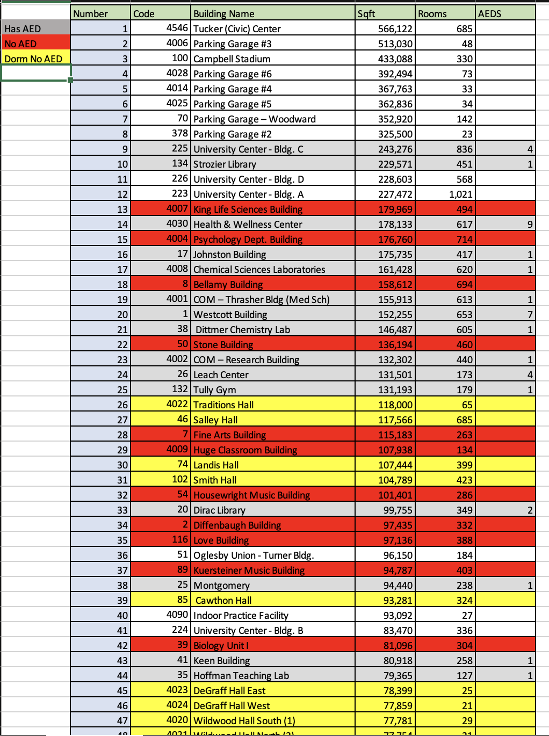

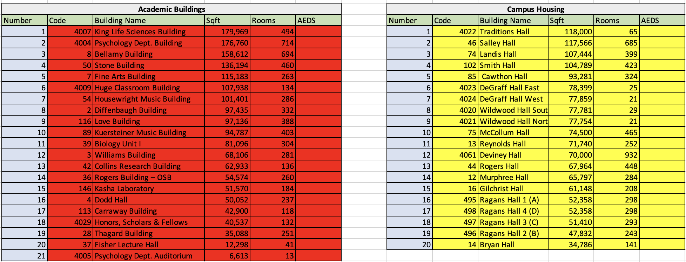
Prospective Locations (not finalized)

Logistics:
- AEDs need to be inspected monthly (can be done by custodial staff)
- Have pads and batteries replaced every 5 years

Attempting to purchase 37 new AEDs (capable of sustaining 55)
- 28 for Academic Buildings using $49,000 from COGS
- 9 for Campus Housing (future fundraising with Pi Kappa Alpha and the Great Give will supply the rest to get all 18 dorms or all 23 dorm buildings) using the $15,000 from the Great Give
  - While residence halls house the youngest campus population, they can pose difficult challenges for emergency response teams due their swipe access and number of floors. They are all also an area that has foot traffic 24 hours a day.
- These AED wall mounts also offer storage locations for stop the bleed kits and first aid kits if we choose to do so

Sustainability:
- Congress of Graduate Students will allocate ~$101,000 to an endowment fund through the FSU Foundation to ensure financial sustainability of the initiative
  - As time goes on, this fund will accumulate more money opening up more opportunities to by new AEDs
  - Oversite of fund must be a fiscal employee of a department dean
- Contractual agreements between department/building mangers must be made with Environmental Health and Safety Office to ensure proper upkeep
  - In Progress
  - Building by building strategy
  - One centralized oversite organization

Endowment Fund
- 4% Annual Payout (done quarterly)
- 1.5% Admin Fee
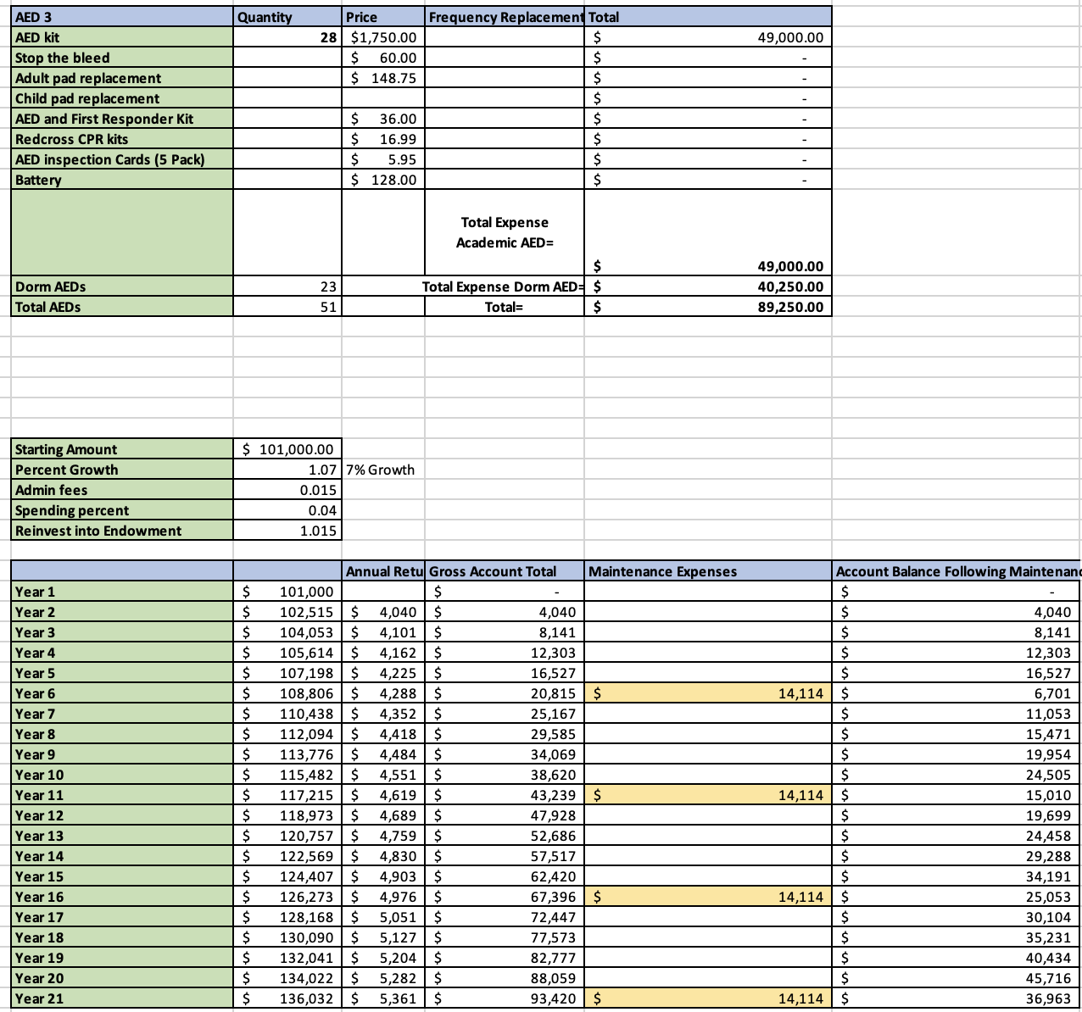
- 7% Predicted Market Growth

Maintenance expense numbers estimated based on 23 Dorm AEDs, not 9

Involved Parties
Chris Hagemeyer (Speaker of the Congress of Graduate Students)
Jonathan Levin (former Student Body President)
Kenley Adams (former Student Senator)
Col Stinson (Student Senator)

Have done our due diligence by seeking meetings and advice from the following people over the course of the last year:
Dr. Richard Le (Industrial Safety and Health Engineer for FSU)
Dr. Robert Campbell (COM Assistant Dean of Student Affairs)
Dr. Stephen Chelko (Sudden Cardiac Death Research in COM)
Kyle Clark (Vice President for Finance and Administration at FSU)
Dr. Felicia Williams (Director of Student Government Association)
Dr. Amy Hecht (Vice President of Student Affairs)
Dr. Brandon Bowden (Associate Vice President of Student Affairs)
Andy Jhanji (Executive Vice President of FSU Foundation)
Maclain Benton (Chief Financial Officer for Student Affairs)
Brandon McCray (Interim Vice President for Constituent Programs at FSU Foundation)
Mike Stewart (Medical Response Unit Supervisor)
Daniel Sheets (Associate Director University Housing Facility Services)
Shannon Staten (Excecutive Director for University Housing and Childcare Early Learning Program at FSU)
Mary McMillian (Accounting Associate FSU Foundation)
Laurel Mckinney (Student Government Association Business Manager)
Jeffery Perlow (Sales Representative from Zoll AED Manufacturer)
Doug Comstock (Director of Business development at AED Service America)
Jose Munguia-Lazo (Environmental Safety Officer for Harvard)
Dr. Mark Ellis (Executive Director of the International Bar Association)
Who We Play For (Recognized Student Organization)
Campus Recreation
Kahleel Gray (FSU Student Body Treasurer)

NEEDS TO BE COMPLETED THIS FISCAL YEAR OR THE $150,000 FROM COGS IS GONE (AKA Our Only Shot)

