The Florida State University Graduate School Presents:
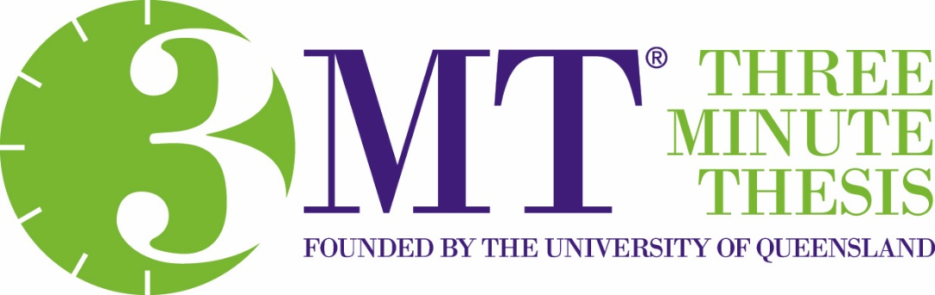
Doctoral student finalists will describe their research in just three minutes!
November 19th at 2:00 p.m.
Durell Peaden Auditorium, College of Medicine
Please attend in support of
Abigail Cullen – Nutrition, Food & Exercise Sciences
Yourri Dessureault – Industrial & Manufacturing Engineering
Joseph Harmon – History
Shar’Dane Harris – Family & Child Sciences
Peipei Hong – Family & Child Sciences
Sara Jones – Biomedical Sciences
Bryan Keller – Earth, Ocean & Atmospheric Science
Grace Kennedy – Psychology
Feilin Lai - Geography
Mohammadreza Paraan – Molecular Biophysics
Seyedahmad Rahimi – Educational Psychology & Learning Systems
Renee Richardson – Earth, Ocean & Atmospheric Science
Hila Sharon David – Educational Psychology & Learning Systems
Kirsten Tucker – Chemistry & Biochemistry

Each finalist will receive $100.
First Place ($1,000) and Second Place ($750) winners will be selected by a panel of judges.
Audience members will vote for the People’s Choice Award ($500)!

