**Dear Students**

**This is a request for donations of artworks for 621 Gallery fundraising auction.**

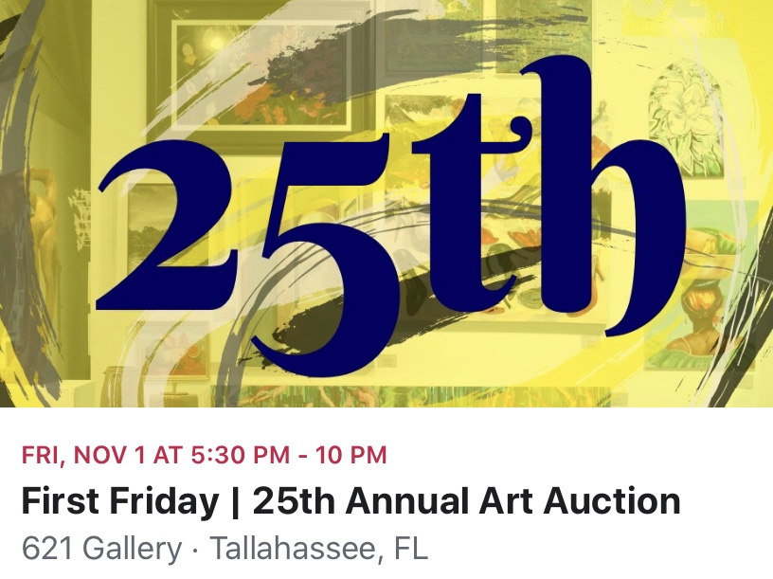

For those who don’t know me my name is Tom Hall (for those who do “Hi”) I am an artist, adjunct at FSU and new member of the board for 621 Gallery. I am writing to you all to continue the resurgence of student participation in 621 Gallery as a cultural hub, ‘own it!’ We need your help and kind donations of artworks. We are a not for profit organization championing artists and the cultural dialog around the creative industries. We are based in Railroad Square and will be celebrating our 40th anniversary soon. To survive and to keep bringing exciting shows into the area, providing artists talks for you all (yes you should use these opportunities) and provide a steppingstone to local artists to build professional profiles we rely on hard work from our dedicated volunteers, fund raising at the gallery, memberships and **in this request** donations of artworks from artists that share our positive cultural inclusivity, aspirations and drive to promote cultural discussion as an integral part of our cities community. Next month is our annual fund raising event, The 621 Art Auction. This will be my first and I’m very excited. Please would you consider donating a piece of work to the auction, your support means so much to us. For all those who have enjoyed 621 in the past it is a chance to give something back and for those who have not yet visited it is a chance to come and join us through achieving something meaningful.

All works will be on sale to the highest bidder, mostly through our silent “Stars of Tomorrow” auction but a few really great works might make it into the live bidding. Either way your support means so much. We need works of quality as this is a gallery show and will be on display for the month of November, if you would like to donate more than one please do so. Consider the works salability, condition and artistic merit; it is a good line in your CV under sales.

Finally I would then encourage you and your friends to join us on First Friday for the opening, and participate in the bidding as it progresses.

Many thanks

Tom

The Process

We need to act now, so I will run a drop off point at CAB for the next two weeks. Please bring work to my studio; if the door is open then I’m in. Deadline 29th October!

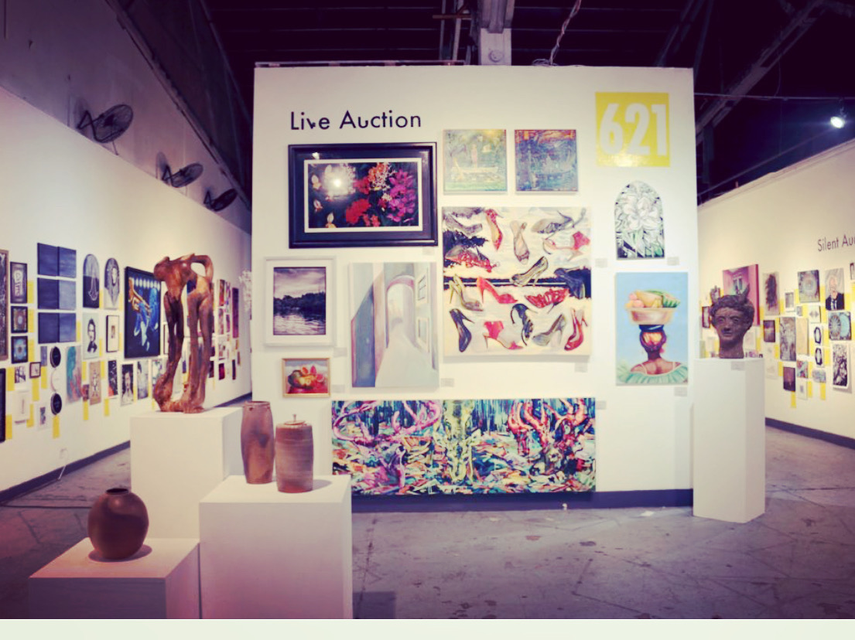

Please carefully attach a slip with your name, title, email, and an estimated price.

If you need any questions answered please contact me.

Again thank you, we work hard to bring you things you need, this is an opportunity to be part of that family in a meaningful way.