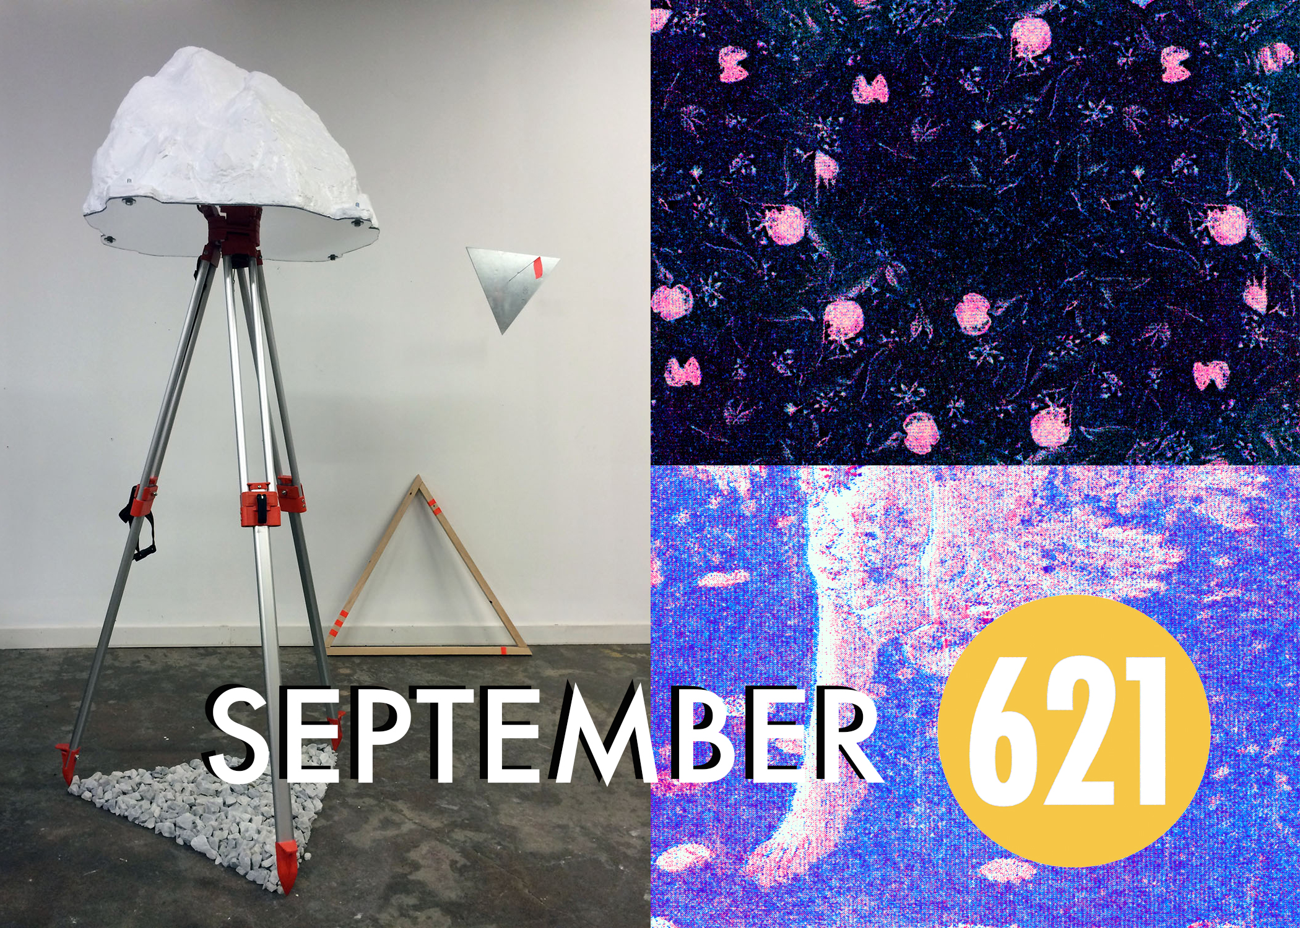

**Join us Thursday evening for the Soft Opening of "Mining the Landscape" by Jason Brown in the Main Gallery space. "Let me tell you this: someone in some future time will think of us" an exhibition by Annie May Johnston is opening in the Nan Boynton Gallery.**

**Jason Brown's sculptural exhibition questions the relationship humans share with the natural world. Brown received his MFA from the Rhode Island School of Design in 1999 and has been teaching Sculpture at the University of Tennessee since 2001.**

**Annie May Johnston uses printmaking, drawing, painting and digital processes to visually describe our surrounding environment. Johnston's exhibition has enlarged risograph prints.**

**Annie and Jason will be with us this evening to give a short lecture on their work. Please come to support these artists & make community connections!**

**Doors open at 6:30pm | Artist Talks start at 7pm**

**Can't make it that night?**

**First Friday is the very next evening!**

**Gallery will be open from 5:30pm - 10:00pm**

**Here are more events for 621 Gallery for the month of September:**

