**Dear Faculty**

**This is a request for donations of artworks for 621 Gallery fundraising auction.**

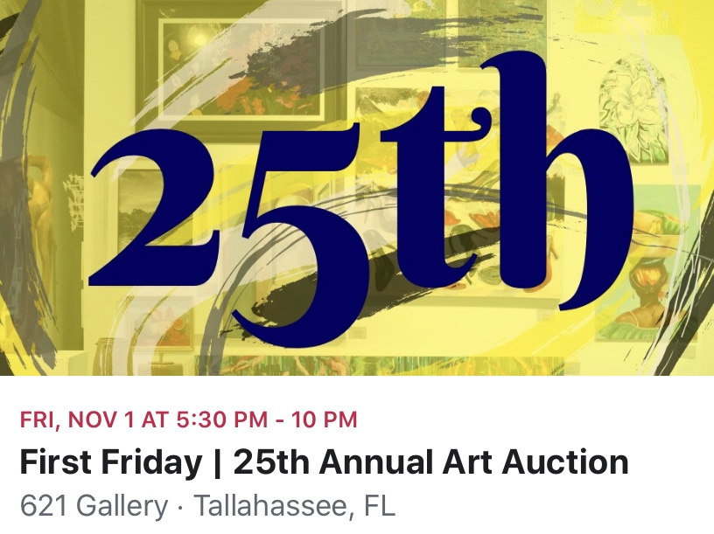

This is to follow up on my quick request at your last Faculty Meeting. I have recently joined the board at 621 Gallery in Railroad Square, believing in is importance to us and the students as a point of contact and dialog with professional artists. This year we are benefitting directly with two faculty showing right now, a number of recently graduated students having big solo shows and premiered performances of which one has gone onto exhibition in NYC and possibly next Miami. We have had a long and personal relationship with the space and it would be great to continue it. We are a not for profit organization championing artists and the cultural dialog around the arts and will be celebrating our 40th anniversary soon. To survive and to keep bringing exciting shows into the area and provide a steppingstone to local artists to exhibit and build professional profiles we rely on hard work from our dedicated volunteers, fund raising at the gallery, memberships and in this request, donations from artists that we respect and share our positive cultural inclusivity, aspirations and drive to promote cultural discussion as an integral part of our cities community. Next month is our annual fund raising event, The 621 Art Auction. This will be my first and I’m very excited. Please would you consider donating a piece of work to the auction, your support means so much to us. And finally I would like to invite you and friends to join us on the auction night; it should be a splendid evening.

I am happy to receive work at FAB if it is dropped off to Steph’s office before October 29th. Please contact me directly if you need further information or help.

Please carefully attach a slip with your name, title, email, and an estimated price. We do have an option for high value works where the gallery will take a charitable commission of 60% but if you do chose this please make that clear to me.

Again I want to really thank you for your support.

Many thanks

Tom