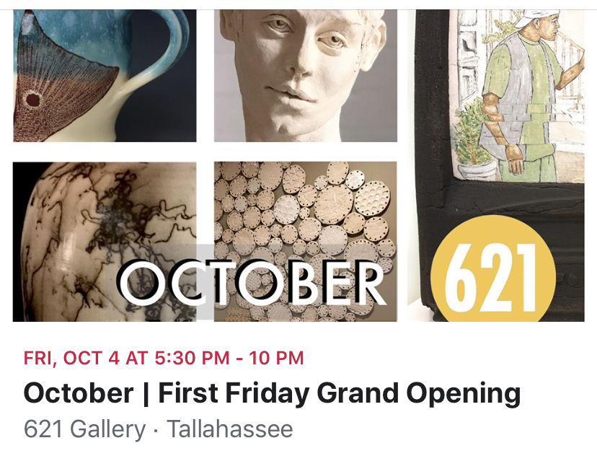

A real treat for all those lovers of clay, craft expression, thoughtful utility and provocative thought; Tallahassee Clay Arts “Shape Glaze Fire” is on in the Main Gallery with a massive mixed exhibition and in the Nan Boynton Gallery Amy Smoot brings her questioning response to her human geography of upbringing, place and society. There are truly questions and thoughts for everyone.
Please come along and join in First Friday, Be Part Of The Conversation. If you want to hear Amy talk on her work and meet all the artists from Tallahassee Clay join us for the soft opening on Thursday – doors open at 6:30pm and talks start at 7:00pm

I’ll see you there

Tom

